Astrophysics | IB Physics Content Guide

Big Ideas
- A variety of measurements from earth can be used to calculate the distance of stars and galaxies
- The scale of our universe is so vast that we need to define new units to help conceptualize its overall size
- It is possible to measure the emission or absorption spectrum of a star to determine its composition
- The properties of stars can be organized into a chart and used to predict the future life cycles

Content Objectives

1 – The Scale of Astrophysics
I can describe the relative scale of the solar system
I can identify the defining characteristics required for a celestial body to be a planet
I can define a light year (ly) as a unit of distance in terms of meters
I can define the meaning of one astronomical unit (AU)
I can relate degrees and seconds as units of angular measurement
I can describe the meaning of 1 parsec as a unit of distance

2 – Stellar Quantities
I can describe the phenomenon of stellar parallax and how it can be used to measure distance
I can calculate distance in parsecs of a nearby star when given the parallax angle in arc seconds
I can compare the definitions of brightness and luminosity
I can conceptually describe the relationship between a star’s brightness and distance from viewer
I can calculate the brightness of a star with a known luminosity and distance
I can describe how different stars can appear the same brightness on earth
I can use Wien’s Displacement Law to mathematically relate peak wavelength and temperature
I can use Stefan-Boltzmann’s Law to mathematically relate luminosity, radius and temperature

3 – H-R Diagrams and Stellar Spectra
I can place a star on an axis showing luminosity vs temperature
I can describe the organization of the Hertzsprung-Russell Diagram
I can use the main sequence to calculate the distance of a star from its wavelength and brightness
I can proportionally relate a star’s luminosity to its mass
I can identify the chemical makeup of a star from its absorption spectrum

4 – Evolution of Stars
I can predict the relative life span of a star based on its type
I can explain the process of stellar equilibrium and how the temperature affects size
I can describe the life cycle of a low mass star like the Sun and plot it on an H-R Diagram
I can describe the nature and formation process of a white dwarf star
I can define the Chandrasekhar Limit as the maximum mass of a core that can become a white dwarf
I can define the Oppenheimer-Volkhoff Limit as the maximum mass of a neutron star
I can predict the fate of a star based on its mass

5 – The Expanding Universe
I can describe the nature of Cephid Variables
I can use a table to relate the luminosity and period of a Cephid Variable
I can outline the process that results in a Type IA Supernova
I can describe the value of a “standard candle” in making measurements about distance
I can use wavelength shift to calculate the relative speed of an object
I can describe the important discovery that Hubble made when analyzing redshift of distant stars
I can relate the distance of an object to its relative velocity using the Hubble Constant
I can calculate redshift based on the expansion of the universe

6 – The Beginning and The End
I can describe the different methods to find the distances of objects based on magnitude
I can use Hubble’s constant to estimate the age of the universe
I can outline the steps in the Big Bang
I can describe the CMB and why it is important evidence of the Big Bang
I can provide the peak wavelength and average temperature of the CMB
I can describe the current theory about the expansion of the universe

Astrophysics | Shelving Guide

The Scale of Astrophysics
Unit Conversion | Definition
1 light year (ly) = 9.46 × 10¹⁵ m | The distance the light travels in an earth year
1 parsec (pc) = 3.26 ly | The distance at which the mean radius of the earth’s orbit subtends an angle of 1 arc second
1 astronomical unit (AU) = 1.50 × 10¹¹ m | The average distance between the  earth and the sun

Stellar Quantities
Brightness | Luminosity
Star intensity to an observer on earth  Units: W m⁻² | How much total power a star emits  Units: W

 | Variable Symbol | Unit |  | Data Booklet Equations:
Distance | d | pc |  | $$d \left(parsec\right)= \frac{1}{p (arc-second)}$$
Parallax Angle | p | sec
Brightness | b | W m⁻² |  | $$b=\frac{L}{4πd^{2}}$$
Luminosity | L | W
Max Wavelength | λ_{max} | m |  | $$λ_{max}T=2.9×{10}^{-3} m K$$
Temperature | T | K |  | $$L=σAT^{4}$$
Surface Area | A | m² |  | $$σ=5.67×{10}^{-8} W{ m}^{-2} K^{-4}$$

Describe the process of Stellar Parallax:  Observe how far a star moves relative to distant stars six months apart so that earth has its maximum displacement and an angle can be measured | 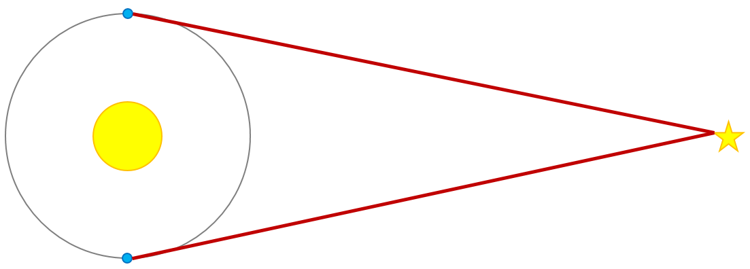

H-R Diagrams and Life Cycle of a Star
Label the Following:  - Main Sequence  - White Dwarfs  - Red Giants  - The Sun  - Line representing the life cycle of our sun | 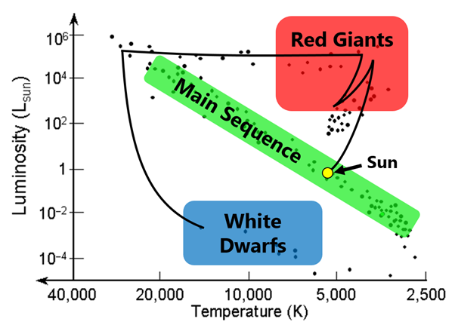

Chandrasekhar Limit |  | Oppenheimer-Volkhoff Limit
The maximum mass of a core that can become a white dwarf is 1.4 times the mass of the sun (1.4 M_{ʘ}) |  | The maximum mass of a core that can become a neutron star is 3 times the mass of the sun (3 M_{ʘ})
Sun Like Stars (< 1.5 M_{ʘ})  ⬇  White Dwarf | Huge Stars (1.5 – 3 M_{ʘ})  ⬇  Neutron Star |  | Giant Stars (> 3 M_{ʘ})  ⬇  Black Hole

The Expanding Universe
Standard Candles | Evidence for Expanding Universe
Objects of known luminosity that can be used with the apparent brightness to measure distance from earth  Cephid Variables and Type Ia Supernovas | Hubble discovered that the farther away stars and galaxies are, the more their light is redshifted.  This means, more distant objects are traveling faster than nearer objects.

 | Variable Symbol | Unit |  | Data Booklet Equations:
Redshift | z | --- |  | $$z=\frac{∆λ}{λ_{0}}≈\frac{v}{c}$$
Change in Wavelength | Δλ | m
Original Wavelength | λ₀ | m |  | $$z=\frac{R}{R_{0}}-1$$
Relative Velocity of Source | v | m s⁻¹
Speed of Light | c | m s⁻¹ |  | $$v=H_{0}d$$
Current Scale Factor | R | ---
Scale Factor when Emitted | R₀ | --- |  | $$c=3.00×{10}^{8} m s^{-1}$$
Hubble’s Constant | H₀ | km s⁻¹ Mpc⁻¹ |  | $$H_{0}≈70 km s^{-1} {Mpc}^{-1}$$

The Big Bang
 | Peak Wavelength | Temperature
Cosmic Microwave Background Radiation | $$\sim 0.001 m (1 mm)$$ | $$\sim 2.9 K$$

Describe why the CMB is evidence of the Big Bang:

The CMB is the heat signature from the early universe. As the universe has expanded to its current size, the wavelength stretched out to the current value seen in the CMB. This radiation is fairly uniform and it can be observed in every direction.

