Astrophysics Design Problem
You see two stars in the night sky that have the exact same brightness. Choose a star #1 calculate properties so you can design a star #2 so that it has the same brightness.
1 light year (ly) = 9.46 × 10¹⁵ m | 1 parsec (pc) = 3.26 ly |  | σ = 5.67 × 10⁻⁸ W m⁻² K⁻⁴
$$d (parsec)=\frac{1}{p (arcsecond)}$$ | $$L=σAT^{4}$$ | $$b=\frac{L}{4πd^{2}}$$ |  | $$λ_{max}T=2.9×{10}^{-3}$$

Star #1 (circle one)
 | Sirius B | Altair | 61 Cygni A | Barnard’s Star
 |  |  |  | 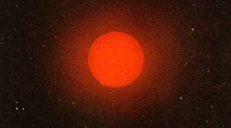
Parallax Angle | 0.375 arcseconds | 0.198 arcseconds | 0.294 arcseconds | 0.543 arcseconds
Max Wavelength | 271 nm | 362 nm | 690 nm | 1035 nm
Stellar Radius | 9.94 × 10⁶ m | 1.20 × 10⁹ m | 3.82 × 10⁸ m | 6.29 × 10⁷ m

Temperature | Luminosity | Distance | Brightness
Star #2 (designed by you )
Determine the luminosity of a main sequence star that is farther away from your calculated star but has the exact same brightness. The distance of this star must be based on your birthday. (for example, a birthday of August 3rd would be written 8.03 × 10¹⁸ m). Estimate the temperature by locating its position within the main sequence of the H-R Diagram (L_{sun} = 3.828 × 10²⁶ W).
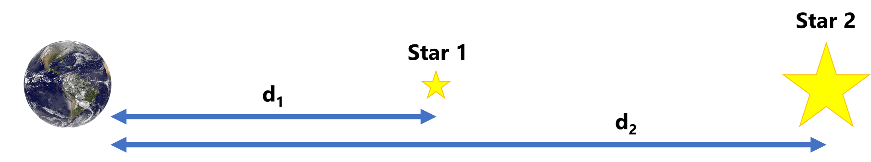
Star Name
Distance [m] | m m . d d × 10¹⁸ m
Luminosity [W]
Temperature [K]
