Atomic Physics | IB Physics Content Guide

Big Ideas
- Atomic nuclei decay to form more stable configurations and produce radiation in the process
- The rate of decay can be predicted for different materials and used to determine age based on isotope count
- Mass and energy are different manifestations of the same thing
- More energy efficient configurations mean that fission and fusion reactions release energy
- It is believed that all matter is made up of fundamental particles called quarks and leptons
- There is a symmetry between all matter with particles and their corresponding anti-particles
- The standard model has helped spur discoveries of new particles, but it may not yet be complete

Content Objectives

1 – Radiation and Decay
I can interpret isotope notation to determine the number of protons and neutrons
I can describe why the nucleus of an atom stays together despite the electrostatic repulsion
I can predict the products of alpha and beta decay
I can describe the impact of ionizing radiation and the ionizing effect of different types of decay
I can predict the penetration of the radiation byproducts of nuclear decay
I can describe the deflection of the radiation byproducts moving through a magnetic or electric field
I can predict the percentage of an isotope remaining after a given number of half-lives
I can calculate the age of a sample when given the percentage of an isotope remaining

2 – Energy and Mass Defects
I can relate units of mass between kilograms (kg) and atomic mass units (u)
I can use the mass/energy equivalence to mathematically relate mass and energy
I can convert between Joules (J) and electron-volts (eV)
I can describe how MeV c⁻² is a valid unit for mass
I can define mass defect and explain how it is related to energy
I can calculate the mass defect of a nuclide
I can calculate binding energy from mass defect
I can interpret a chart showing binding energy per nucleon to locate stable nuclei

3 – Atomic Spectra
I can describe the concept of emission and absorption spectra and their role in identifying elements
I can describe what it means for light to be quantized
I can mathematically relate energy and frequency by Planck’s constant
I can describe the process of electrons dropping energy levels and emitting photons
I can calculate the energy and wavelength emitted from an electron as it transitions
I can use the wavelength of light to determine the electron transition

4 – Particles & the Standard Model
I can identify the general categories of particles in the standard model
I can classify particle categories into an organized family tree with examples of each
I can describe how quarks can be combined to create whole number charges
I can identify the quarks required to form protons and neutrons
I can calculate the charge of a given baryon or meson
I can describe the phenomenon of Quark Confinement
I can analyze a reaction based on conservation of Baryon #, Lepton #, Charge, and Strangeness
I can describe forces in terms of exchange particles
I can rank the fundamental forces based on strength
I can describe the role of the Standard Model in the discovery of new particles

5 – Feynman Diagrams and the Higgs Boson
I can describe key features of the Large Hadron Collider and its role in the Higgs Boson discovery
I can follow the general rules for creating a Feynman Diagram
I can describe a particle interaction using Feynman Diagram

Atomic Physics | Shelving Guide

Types of Decay
Alpha |  |  |  |  |  | Beta-Negative |  |  |  |  |  |  |  | Beta-Positive
$${}_{Z}^{A}X$$ | $$→$$ | $${}_{Z-2}^{A-4}X$$ | $$+$$ | $${}_{2}^{4}{He}$$ |  | $${}_{Z}^{A}X$$ | $$→$$ | $${}_{Z+1}^{A}X$$ | $$+$$ | $${}_{-1}^{0}e$$ | $$+$$ | $${\overline{v}}_{e}$$ |  | $${}_{Z}^{A}X$$ | $$→$$ | $${}_{Z-1}^{A}X$$ | $$+$$ | $${}_{+1}^{0}e$$ | $$+$$ | $$v_{e}$$
Parent  Nuclide |  | Daughter Nuclide |  | Alpha Particle |  | Parent  Nuclide |  | Daughter Nuclide |  | Electron |  | Anti-neutrino |  | Parent  Nuclide |  | Daughter Nuclide |  | Positron |  | Neutrino

Property | Alpha  (α) | Beta  (β+ or β-) | Gamma  (γ) | 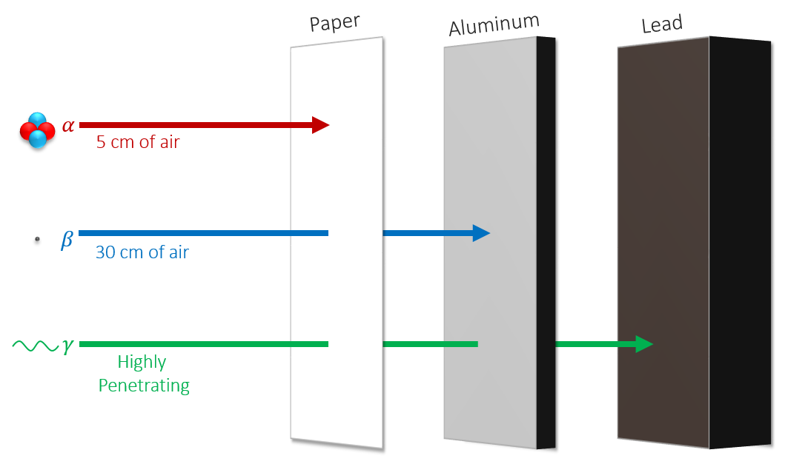
Relative Charge | +2 | +1 or -1 | 0
Relative Mass | 4 | 0.0005 | 0
Typical Speed | 10⁷  m s⁻¹ | 2.5 × 10⁸  m s⁻¹ | 3.0 × 10⁸ m s⁻¹
Ionizing Effect | Strong | Weak | Very Weak

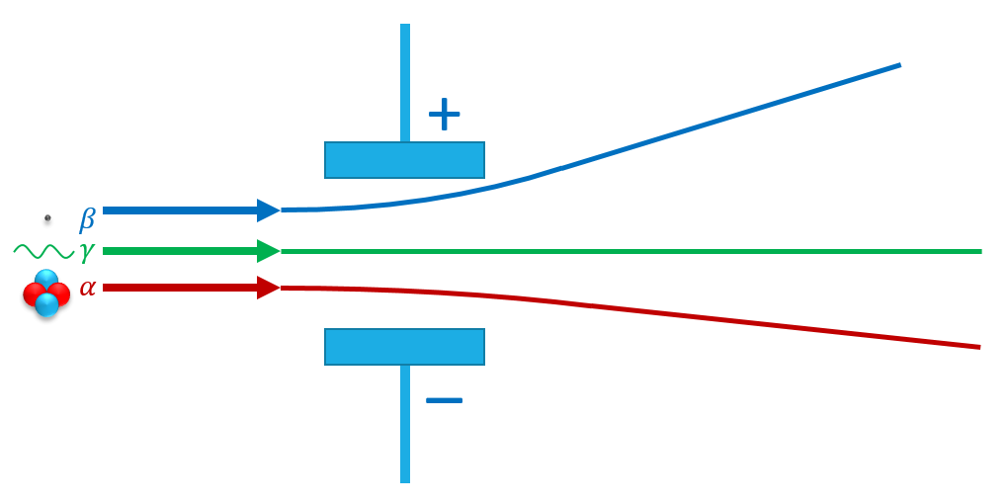 | 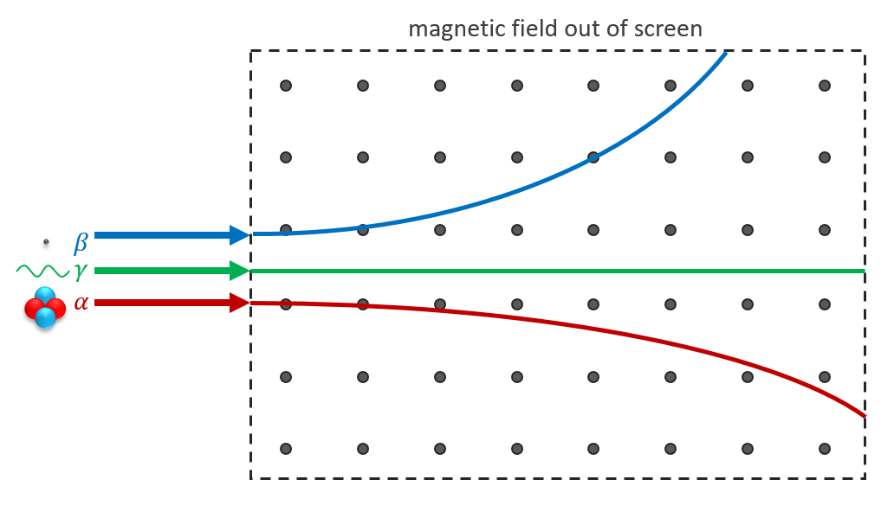

Half Life
# of  Half-Lives | Fraction  Remaining | Percentage Remaining | 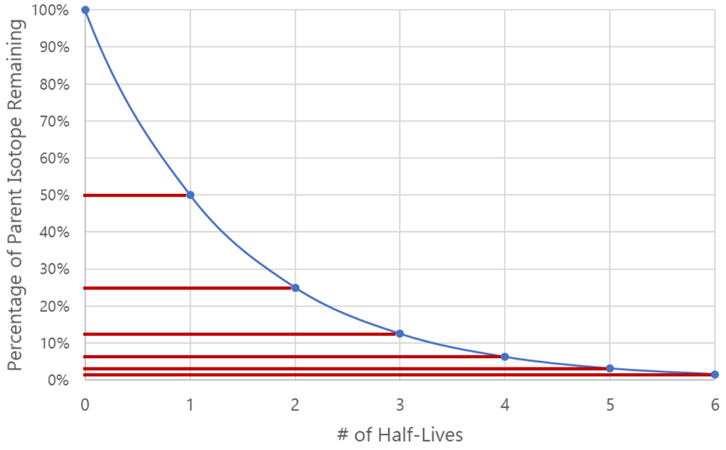
0 | 1 | 100%
1 | 1/2 | 50%
2 | 1/4 | 25%
3 | 1/8 | 12.5%
4 | 1/16 | 6.25%
5 | 1/32 | 3.125%
6 | 1/64 | 1.5625%

Mass-Energy Equivalence | Variable Symbol | Unit |  | Data Booklet Equation:
Energy | E | J |  | $$E=mc^{2}$$
Mass | m | kg
Speed of Light | c | m s⁻¹ |  | $$c=3.00×{10}^{8} m s^{-1}$$

Unified Atomic Mass Unit | $$u$$ | 1.661 × 10⁻²⁷ kg | 1.000000 u | 931.5 MeV c⁻²
Electron Rest Mass | $$m_{e}$$ | 9.110 × 10⁻³¹ kg | 0.000549 u | 0.511 MeV c⁻²
Proton Rest Mass | $$m_{p}$$ | 1.673 × 10⁻²⁷ kg | 1.007276 u | 938 MeV c⁻²
Neutron Rest Mass | $$m_{n}$$ | 1.675 × 10⁻²⁷ kg | 1.008665 u | 940 MeV c⁻²

Converting between Joules and Electron-Volts
$$\left\{Energy in eV\right\}=\frac{\left\{Energy in J\right\}}{1.60×{10}^{-19}}$$ | $$\left\{Energy in J\right\}=\left\{Energy in eV\right\}×1.60×{10}^{-19}$$

Process for Calculating Binding Energy
- Add up the “before and after” masses
- Find the mass defect by taking the difference
- Convert atomic mass units (u) into MeV c⁻² by using the conversion factor 1 u = 931.5 MeV c⁻²
- The c⁻² cancels out when converting to energy using E = mc² so this is your binding energy

Atomic Spectra
 | Variable Symbol | Unit |  | Data Booklet Equations:
Energy | E | J or eV |  | $$E=hf$$
Planck’s Constant | h | J s |  | $$λ=\frac{hc}{E}$$
Frequency | f | Hz
Speed of Light | c | m s⁻¹ |  | $$h=6.63×{10}^{-34} J s$$
Wavelength | λ | m |  | $$c=3.00×{10}^{8} m s^{-1}$$

$$hc$$ | $$1.99×{10}^{-25} J m$$ | $$1.24×{10}^{-6} eV m$$

Fundamental Particles
The following two tables are provided in the IB Physics Data Booklet
Charge | Quarks |  |  | Baryon Number |  | Charge | Leptons
$$\frac{2}{3}$$ | $$u$$ | $$c$$ | $$t$$ | $$\frac{1}{3}$$ |  | $$-1$$ | $$e$$ | $$μ$$ | $$τ$$
$$-\frac{1}{3}$$ | $$d$$ | $$s$$ | $$b$$ | $$\frac{1}{3}$$ |  | $$0$$ | $$v_{e}$$ | $$v_{μ}$$ | $$v_{τ}$$
All quarks have a strangeness number of 0 except the strange quark that has a strangeness number of –1 |  |  |  |  |  | All leptons have a lepton number of 1 and antileptons have a lepton number of –1

Quarks |  |  |  |  | Leptons
Symbol | Name | Charge | Baryon # |  | Symbol | Name | Charge | Lepton #
$$u$$ | Up | $$+\frac{2}{3}$$ | $$\frac{1}{3}$$ |  | $$e$$ | Electron | $$-1$$ | $$1$$
$$d$$ | Down | $$-\frac{1}{3}$$ | $$\frac{1}{3}$$ |  | $$μ$$ | Muon | $$-1$$ | $$1$$
$$c$$ | Charm | $$+\frac{2}{3}$$ | $$\frac{1}{3}$$ |  | $$τ$$ | Tau | $$-1$$ | $$1$$
$$s$$ | Strange | $$-\frac{1}{3}$$ | $$\frac{1}{3}$$ |  | $$v_{e}$$ | Electron Neutrino | $$0$$ | $$1$$
$$t$$ | Top | $$+\frac{2}{3}$$ | $$\frac{1}{3}$$ |  | $$v_{μ}$$ | Muon Neutrino | $$0$$ | $$1$$
$$b$$ | Bottom | $$-\frac{1}{3}$$ | $$\frac{1}{3}$$ |  | $$v_{τ}$$ | Tau Neutrino | $$0$$ | $$1$$
Anti-Quarks |  |  |  |  | Anti-Leptons
Symbol | Name | Charge | Baryon # |  | Symbol | Name | Charge | Lepton #
$$\overline{u}$$ | Antiup | $$-\frac{2}{3}$$ | $$-\frac{1}{3}$$ |  | $$\overline{e}$$ | Antielectron (positron) | $$+1$$ | $$-1$$
$$\overline{d}$$ | Antidown | $$+\frac{1}{3}$$ | $$-\frac{1}{3}$$ |  | $$\overline{μ}$$ | Antimuon | $$+1$$ | $$-1$$
$$\overline{c}$$ | Anticharm | $$-\frac{2}{3}$$ | $$-\frac{1}{3}$$ |  | $$\overline{τ}$$ | Antitau | $$+1$$ | $$-1$$
$$\overline{s}$$ | Antistrange | $$+\frac{1}{3}$$ | $$-\frac{1}{3}$$ |  | $${\overline{v}}_{e}$$ | Electron Antineutrino | $$0$$ | $$-1$$
$$\overline{t}$$ | Antitop | $$-\frac{2}{3}$$ | $$-\frac{1}{3}$$ |  | $${\overline{v}}_{μ}$$ | Muon Antineutrino | $$0$$ | $$-1$$
$$\overline{b}$$ | Antibottom | $$+\frac{1}{3}$$ | $$-\frac{1}{3}$$ |  | $${\overline{v}}_{τ}$$ | Tau Antineutrino | $$0$$ | $$-1$$

Explain the phenomenon of Quark Confinement:
Quarks have never been observed on their own. The amount of energy required to overcome the strong nuclear force holding the quarks together gets converted into mass and forms a new quark pair.

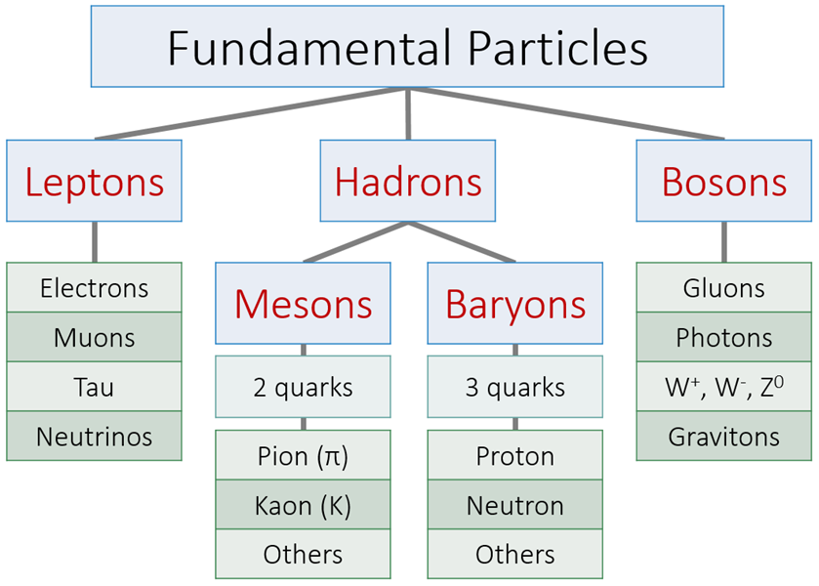
Fundamental Forces  Strength Distance  Gravitational Weakest Long Range  Weak Weak Short Range  Electromagnetic Strong Very Long Range  Strong Strongest Very Short Range | Particle Configurations  Proton Neutron  Total Charge +1 Total Charge 0

Feynman Diagrams
You can only draw two kinds of lines | You can only connect these lines if you have two lines with arrows meeting a single wiggly line | The x-axis represents time and is read from left to right. Everything left of the vertex is the “before” condition.

Beta-Negative Decay | Beta-Positive Decay
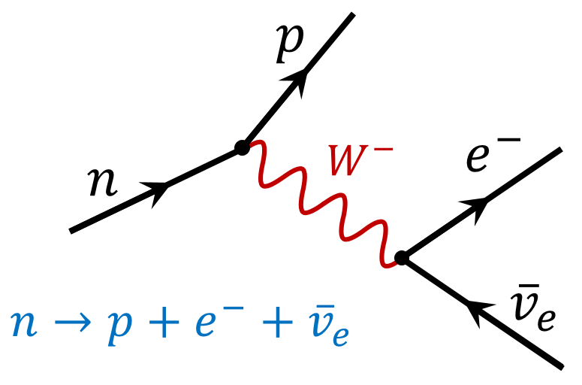 | 