Circular Motion | IB Physics Content Guide

Big Ideas
- Objects moving in a circle are experiencing acceleration since the direction of the velocity is constantly changing
- Centripetal acceleration and centripetal force are always directed toward the center of the circle
- The net force for a body in circular motion is equal to the centripetal force
- It is useful to draw a free body diagram to determine what forces are present at a given position

Content Objectives

1 – Defining Circular Motion
I can convert between angular displacement in revolutions and radians
I can describe and calculate the properties of period and frequency
I can calculate angular velocity
I can describe and calculate tangential velocity based on the angular velocity and radius
I can determine the direction and magnitude of centripetal acceleration and centripetal force

2 – Vertical Circular Motion
I can draw correctly proportioned free body diagrams for horizontal and vertical circular motion
I can compare the forces on an object at different positions in vertical circular motion
I can identify the combination of forces that make up the net force that results in circular motion.
I can determine the magnitude and direction of the forces needed to move in a vertical circle

3 – Circular Motion, Friction, and Angles
I can draw a free body diagram when circular motion is produced by a reaction or friction force
I can solve problems that involve friction to create circular motion
I can solve circular motion problems that incorporate components of an angled force

Circular Motion | Shelving Guide

 | Variable Symbol | Unit |  | Draw in  vectors  for v, a_{c},  and F_{c} | 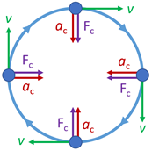
Distance | d | m
Angular Distance | θ | rad
Angular Velocity | ω | rad s⁻¹ |  | Data Booklet Equations:
Linear Velocity | v | m s⁻¹ |  | $v=ωr$
Centripetal Acceleration | a | m s⁻² |  | $a=\frac{v^{2}}{r}=\frac{4π^{2}r}{T^{2}}$
Centripetal Force | F_{c} | N |  | $F=\frac{mv^{2}}{r}=mω^{2}r$

Defining Circular Motion
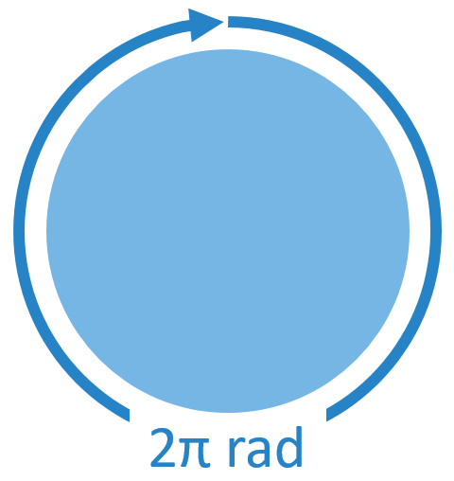 | Period | T | s | Angular Velocity | ω | rad s⁻¹
 | Time per revolution |  |  | $$ω=\frac{2π}{T}$$

Vertical Circular Motion
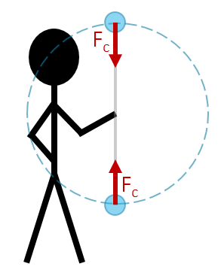 |  | Top:  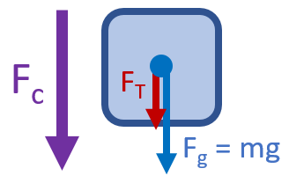 |  | Bottom:  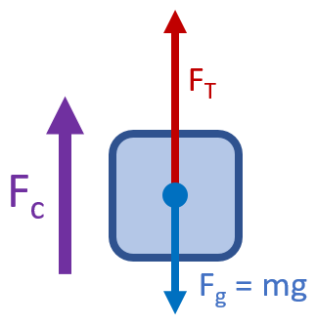
 |  | F_{net} = F_{c} = F_{T} + F_{g} |  | F_{net} = F_{c} = F_{T} - F_{g}
Top: |  |  | Bottom:
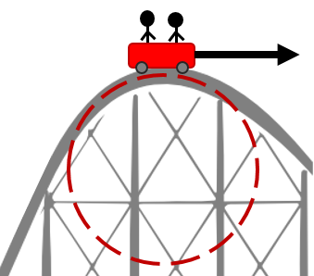 | 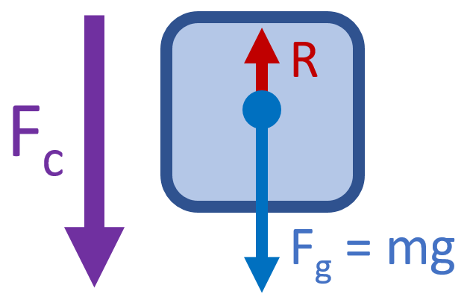 |  | 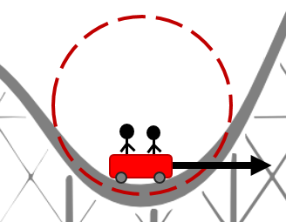 |  | 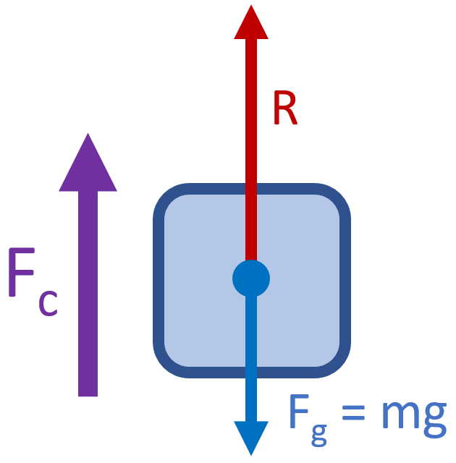
F_{net} = F_{c} = F_{g} - R |  |  | F_{net} = F_{c} = R - F_{g}

Circular Motion with Friction and Angles
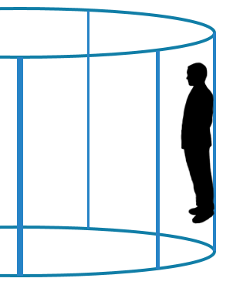 | 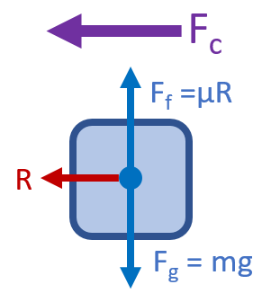 | Relationships between variables:  $$F_{f}=F_{g}$$  $$F_{c}=R$$

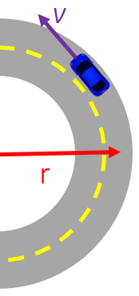 | 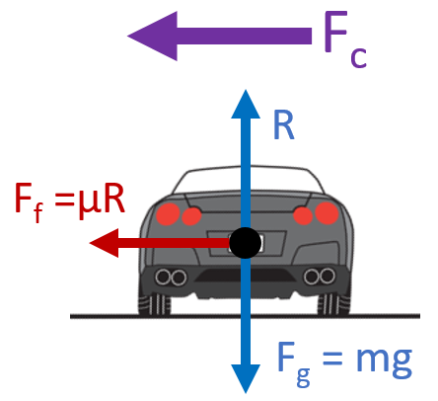 | Relationships between variables:  $$R=F_{g}$$  $$F_{c}=F_{f}$$

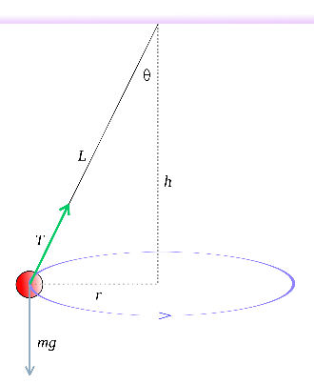 | 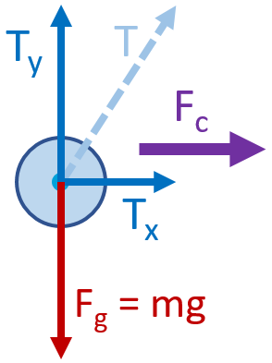 | Relationships between variables:  $$T_{y}=F_{g}$$  $$F_{c}=T_{x}$$

