Circular Motion Design Problem
Warm Up Question:
Use the roller coaster diagrams below to indicate which features correspond with the following scenarios (circle all correct answers)

Can result in riders feeling lighter than usual (Low Normal Reaction Force) A B C

Can result in riders feeling heavier than usual (High Normal Reaction Force) A B C

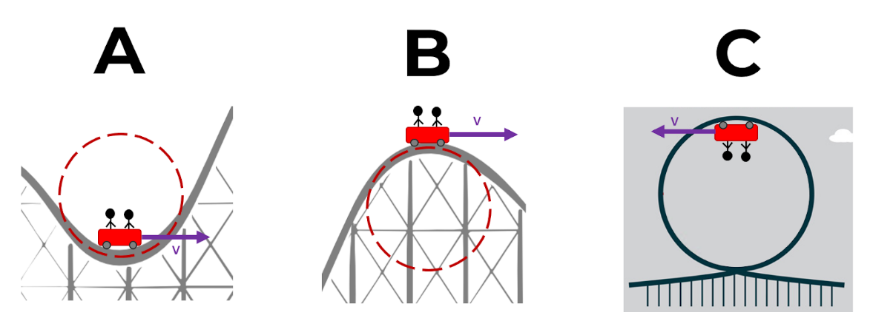

Design problem:
You are hired by an amusement park to create a roller coaster inspired by a non-Earth planet in the solar system. As part of the ride, you decide to design a feature (like those in the previous problem) allowing riders to experience an apparent weight matching their weight on this planet.

Planet (circle one)
Mercury | Venus | Mars | Jupiter | Saturn | Uranus | Neptune
 |  |  | 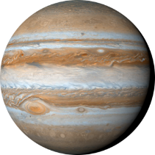 | 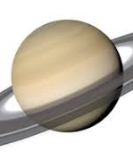 | 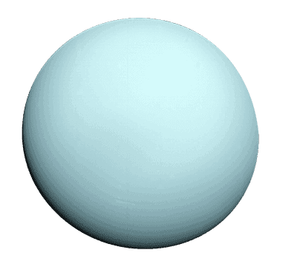 | 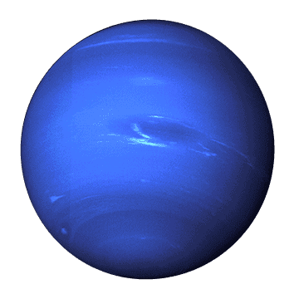
g = 3.59 m/s² | g = 8.87 m/s² | g = 3.77 m/s² | g = 25.95 m/s² | g = 11.08 m/s² | g = 10.67 m/s² | g = 14.07 m/s²

Rider Statistics:
Mass | 75 kg
Weight on Earth
Weight on Planet

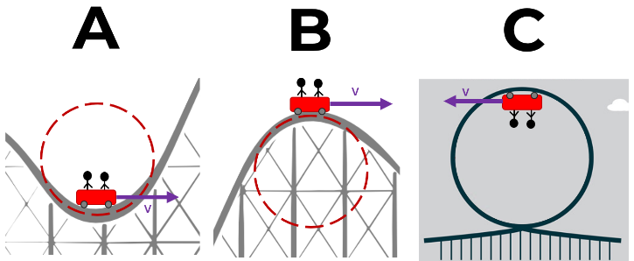
Ride Design:
Design a roller coaster feature that (when built on earth) results in an apparent weight (normal reaction force) that matches the weight of the rider on the theme planet.

Circle the feature that you plan on designing →

Property | Range to Choose From | Selected/Calculated Values
Linear Velocity | 1 m/s - 30 m/s
Radius of Feature | 1 m - 20 m

Draw a free body diagram and show all work below. Write final design values that result in the desired outcome in the table above

