Electricity | IB Physics Content Guide

Big Ideas
- Electricity consists of charged particles moving in a continuous circuit
- Voltage, Current, and Resistance are related to each other though Ohm’s Law
- The total current flowing into a junction must equal the total current flowing out of that same junction
- The voltage dropped around a continuous loop traced in a circuit must equal the voltage provided
- Resistors can be combined in different ways to produce different results
- It is possible that the act of taking a measurement will change the value being measured
- The resistance of a wire is affected by its thickness, length, and material resistivity

Content Objectives

1 – Electrical Current
I can quantify charge in terms of Coulombs
I can calculate the charge of a certain # of electrons and the # of electrons for a given charge
I can describe current in terms of amps and coulombs per second
I can describe the subatomic properties of a conductor to allow charge to flow
I can the electron drift speed for a given current and wire

2 – Electrical Properties
I can describe the properties of Voltage, Current, Resistance, and Power
I can use Ohm’s Law to mathematically relate these electrical properties and solve for an unknown

3 – Circuits
I can describe the direction of conventional current compared to the movement of charges
I can identify component combinations as parallel or series
I can describe how current flows through parallel and series resistors
I can describe the set up to measure current and voltage in a circuit

4 – Calculating Resistance
I can describe the property of resistivity and how it and the wire dimensions affect resistance
I can calculate the equivalent resistance for combinations of resistors in series and parallel
I can step through the calculation of the equivalent resistance for a complex combination

5 – Voltage Dividers and Batteries
I can use Kirchhoff’s First Law to determine an unknown current at a junction
I can use Kirchhoff’s Second Law to determine an unknown current at a junction
I can calculate voltage, current, and resistance for every component in a series or parallel circuit
I can compare and contrast the properties for simple series and parallel circuits

6 – Potential Dividers
I can identify the different circuit diagram symbols for different types of resistors
I can describe how environmental changes can affect the resistance of LDRs and Thermistors
I can describe how changing resistor values can affect the voltage drop in a potential divider circuit
I can design a potential divider circuit to perform a certain task

7 – Voltage Dividers and Batteries
I can connect a meter to measure current or voltage
I can describe the conditions required for an ideal ammeter or voltmeter
I can calculate for a situation when the meter isn’t ideal

8 – Batteries
I can describe the difference between primary and secondary cells
I can define the electromotive force and describe how is it is different than terminal voltage
I can solve for a circuit that includes a battery with internal resistance

Electricity |  |  |  |  |  |  | Shelving Guide
 | Charge |  |  |  |  | Current
 | Symbol |  | Unit |  |  | Symbol |  |  | Unit
 | Charge of 1 Electron |  |  |  |  | Unit in terms of Coulombs
 | # of Electrons per Coulomb

Drift Speed | Variable Symbol | Unit |  | Data Booklet Equation:
Current |  |  |  | $$I=nAvq$$
# of Electrons per m³ |  | ---
Cross Sectional Area
Drift Speed |  |  |  | Cross Sectional Area:  $$A=$$
Charge

Electrical Properties
Property | What is it? | Symbol | Unit
Voltage
Current
Resistance

Power
In terms of V and I | In terms of I and R | In terms of V and R
$$P=$$ | $$P=$$ | $$P=$$

Ohm’s Law
$$V=$$ | $$I=$$ |  | $$R=$$
Measuring Circuits |  | Ammeter |  | Voltmeter
Ideal Resistance
How is it connected to the component being measured?
Drawing of meter measuring R₁ |  | 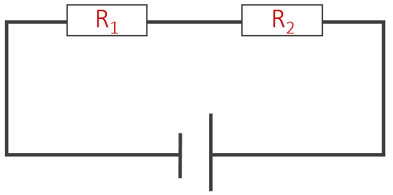

Resistivity | Variable Symbol | Unit |  | Data Booklet Equation:
Resistivity |  |  |  | $$ρ=\frac{RA}{L}$$
Resistance
Cross Sectional Area |  |  |  | Cross Sectional Area:  $$A=$$
Length
Ohmic Resistor  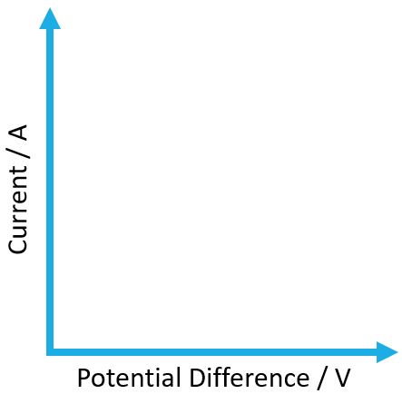 | Non-Ohmic Resistor

Equivalent Resistance
 | Drawing with R₁ and R₂ | Equation
Series
Parallel

Kirchhoff’s Laws
$$ΣI=0 (junction)$$ |  |  |  | $$ΣV=0 (loop)$$
 |  |  |  | Across resistors
Entering Junction |  | ● |  | Negative to Positive
Exiting Junction | ● |  |  | Positive to Negative

Voltage Dividers
 | Light-Dependent Resistor |  | Thermistor
Symbol
Relationship | Light | Increases | Heat | Increases
 | Resistance |  | Resistance
Circuit | Switch turns on in the dark: |  | Switch turns on in a fire:

Batteries
Primary Cells | Secondary Cells

 | Variable Symbol | Unit |  | Data Booklet Equation:
Electromotive Force (e.m.f) |  |  |  | $$ε=I(R+r)$$
Current
Circuit Resistance
Internal Resistance

