Electricity Mini Labs Name: ____________________________
The first two parts of this lab use a virtual circuit tool to create and test different circuit designs.

Click Here for the PHET Circuit Construction Kit

Part 1: Building Circuits
For each challenge, build a working circuit in the PHET Circuit Construction Kit and screenshot
Three lightbulbs each lit up with a different brightness

Hint: you may need to adjust resistances in the bulbs by clicking on them

Three lightbulbs and a switch that turns off one but leaves the others on
Design a piece of art that involves the lightbulbs in a clever way.

Lightbulbs must light up

Part 2: Measuring Circuits
Build each of the circuits diagrammed below in the PHET circuit builder and use the ammeter and voltmeter to measure the properties in the tables on the right.

Circuit 1
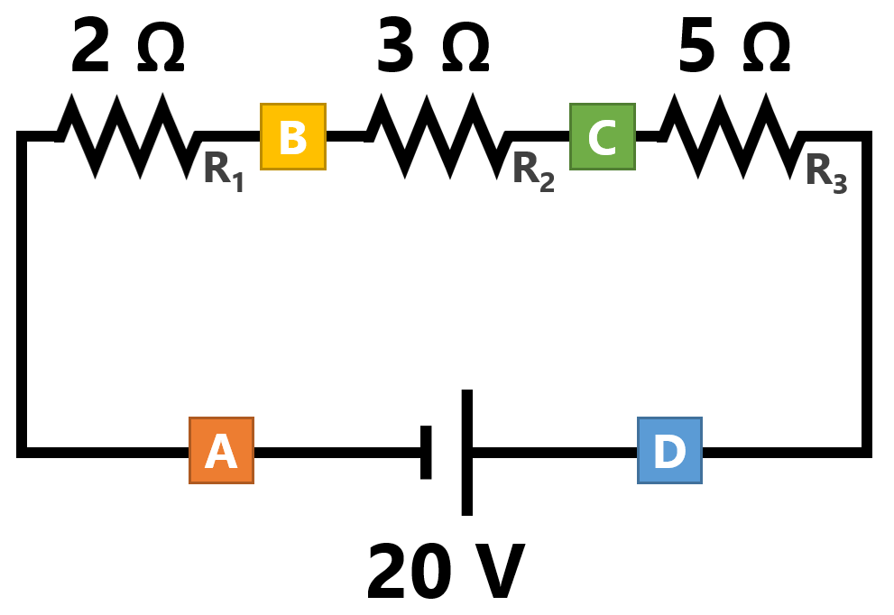 | Measure the voltage using the Voltmeter
 | Voltage across R₁
 | Voltage across R₂
 | Voltage across R₃
 | Measure the current using the Ammeter
 | Current at point A
 | Current at point B
 | Current at point C
 | Current at point D

Circuit 2
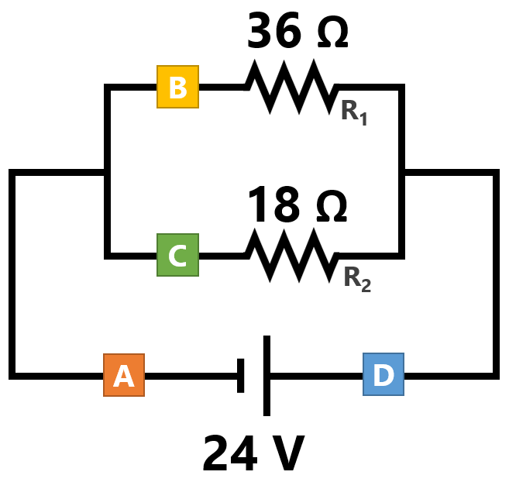 | Measure the voltage using the Voltmeter
 | Voltage across R₁
 | Voltage across R₂
 | Measure the current using the Ammeter
 | Current at point A
 | Current at point B
 | Current at point C
 | Current at point D

Part 3: Electrical Scavenger Hunt
Find three different examples or items around your house that have electrical properties printed on them. (for example, most chargers or appliances have power/voltage/current ratings). Take pictures of these items showing the label and the object itself and include in the table below

