Energy & Momentum | IB Physics Content Guide

Big Ideas
- The total energy of a closed system must be constant
- Energy is neither created nor destroyed, it just changes form
- Work is done when a force is applied to an object and the object moves in the same direction as the applied force
- The total momentum of an isolated system is always constant
- The force on an object when speeding up or slowing down can be affected by changing the time for the force
- The impulse of a collision is equal to the change in momentum

Content Objectives

1 – Energy
I can use evidence (speed, stretch, height) to describe and calculate all types of energy present.
I can describe and calculate kinetic energy
I can describe and calculate gravitational potential energy
I can explain the implications of the conservation of energy
I can show that the TOTAL energy in a closed system is always the same
I can interpret a scenario and set up an equality based on the energies present at different locations
I can use the conservation of energy to solve for an unknown energy or variable in a problem

2 – Work and Power
I can define and calculate the property of work
I can identify situations where there is motion but no work being done
I can calculate work when the force is at an angle to the direction of the motion
I can equate work done on a system to the change in energy of an open system.
I can use the work-energy theorem to solve for an unknown
I can calculate power from work or velocity

3 – Elastic Potential
I can derive a ‘Joule’ and ‘Watt’ from the fundamental units kg, m, and s.
I can use Hooke’s Law to calculate the elastic force at a given displacement
I can use area under the curve to calculate the work of a variable force
I can describe and calculate elastic potential energy

4 – Conservation of Momentum
I can define and calculate momentum
I can calculate “before” and “after” momentums for multiple objects
I can use the conservation of momentum to solve for missing variables in linear collisions
I can describe the process required for explosion, hit and bounce, and hit and stick scenarios
I can describe the difference between elastic and non-elastic collisions
I can describe how energy is not always conserved within a system
I can calculate the amount of energy retained in a non-elastic collision

5 – Momentum and Impulse
I can describe the meaning of impulse and how it is related to momentum change
I can use impulse and momentum to solve for an unknown in a collision problem
I can conceptually describe how to decrease the force experienced in a collision
I can determine the impulse of a collision from a force vs time graph

Energy & Momentum | Shelving Guide

 | Variable Symbol | Unit |  | Data Booklet Equations:
Work | W | Joules [J] |  | $$W=Fs cosθ$$
Power | P | Watts [W] |  | $$E_{k}=\frac{1}{2}mv^{2}$$
Kinetic Energy | E_{k} | J |  | $$E_{p}=\frac{1}{2}k{∆x}^{2}$$
Elastic Potential Energy | E_{p} | J |  | $${∆E}_{p}=mg∆h$$
Gravitational Potential Energy | ΔE_{p} | J |  | $$power=Fv$$
Spring Constant | k | N m⁻¹
Spring Stretch | Δx | m

Types of Energy
Kinetic Energy | Elastic Potential Energy | Gravitational Potential Energy
$$\frac{1}{2}mv^{2}$$ | $$\frac{1}{2}k{∆x}^{2}$$ | $$mg∆h$$

Conservation of Energy
Total Energy Before = Total Energy After

Work-Energy Theorem
Work Energy Energy Work
$Fs=\frac{1}{2}mv^{2}$ $\frac{1}{2}mv^{2}=Fs$

Calculating Work
Constant force at an angle:  $$W=Fs\cos{θ}$$ | 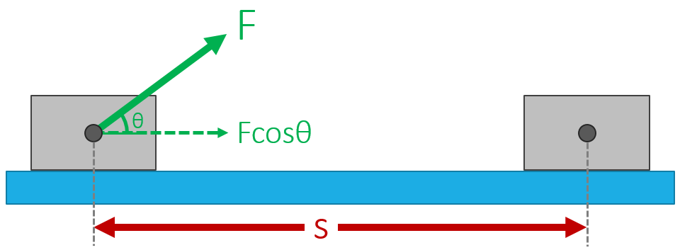
Varying Force:  Area under the curve | 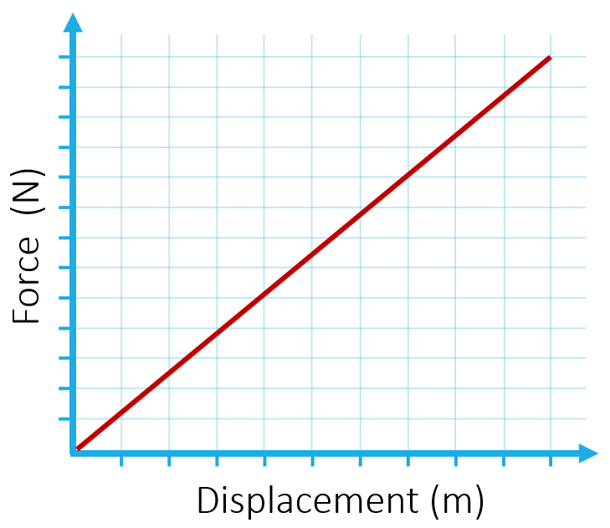 | 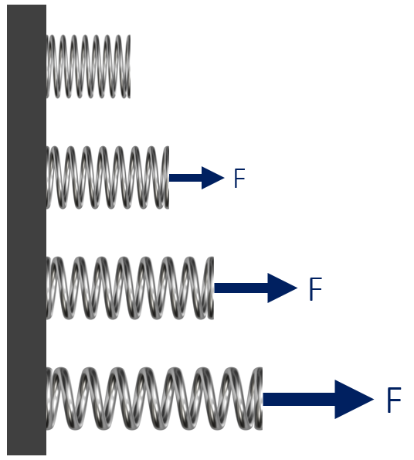

Examples of no work being done for an object in motion:
- Pushing something that doesn’t move (no displacement, no work)
- Waiter carrying a tray horizontally (force is vertical, motion is horizontal)
- Orbiting object (velocity is tangent to path, force is toward the center)

Calculating Power
In terms of work and time:  $$Power= \frac{Work}{Time}$$ | In terms of force and velocity:  $$Power= Force × Velocity=Fv$$

Units
 | Standard Unit | From Equation | Fundamental SI Units
Work | J | N m | kg m² s⁻²
Power | W | J s⁻¹ | kg m² s⁻³

Momentum
 | Variable Symbol | Unit |  | Data Booklet Equations:
Momentum | p | kg m s⁻¹ |  | $$p=mv$$
Mass | m | kg |  | $$F=\frac{∆p}{∆t}$$
Velocity | v | m s⁻¹
Time | t | s |  | $$E_{K}=\frac{p^{2}}{2m}$$
Kinetic Energy | E_{K} | J
Impulse | Impulse | N s or kg m s⁻¹ |  | $$Impulse=F∆t=∆p$$

Conservation of Energy Problems
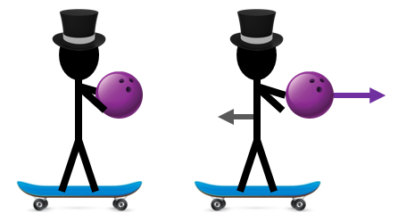 | “Explosion”  p_{AB} = p_{A} + p_{B}
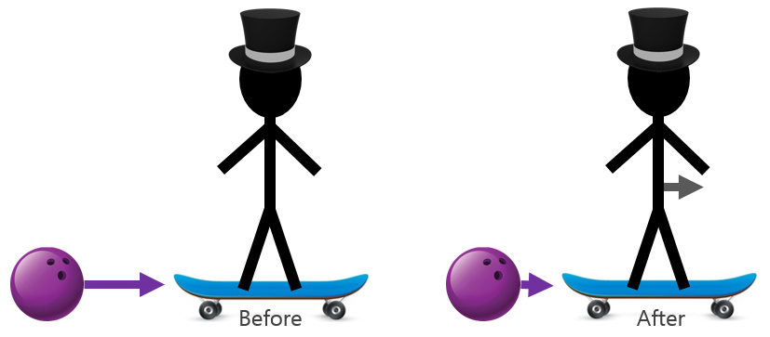 | “Hit and Bounce”  p_{A} + p_{B} = p_{A} + p_{B}
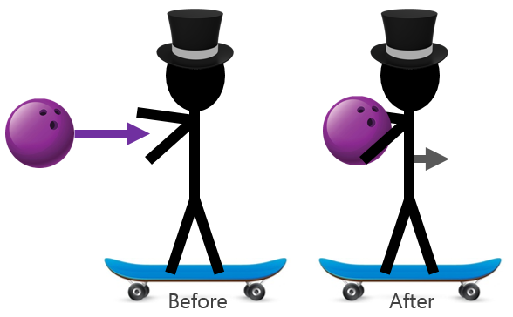 | “Hit and Stick”  p_{A} + p_{B} = p_{AB}

Types of Collisions
Elastic | Kinetic Energy is conserved (perfect hit and bounce)  *Typically just found in particle collisions
Inelastic | Kinetic Energy is not conserved

Calculating Impulse
Constant force:  Force × Time  FΔt | 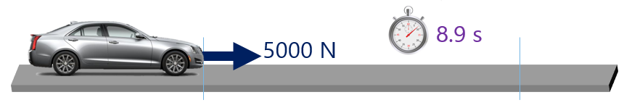
Varying Force:  Area under a  Force vs Time Graph | 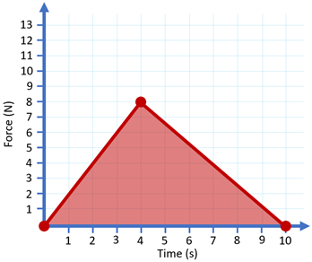

Impulse-Momentum Equation
$$F∆t=∆p=m∆v=mv-mu$$

Collision Safety
Explain (using impulse, force, and time) how to decrease the force acting on an object undergoing a collision:

Impulse is the same overall regardless of the impact style because the object has a set mass and impact velocity. The force can be decreased by increasing the time of the impact.

Impulse = FΔt or Impulse = FΔt

