Energy Production | IB Physics Content Guide

Big Ideas
- Most energy sources can be traced back the sun, our ultimate primary source
- No energy source can be converted to electricity with 100% efficiency
- All energy sources have advantages and drawbacks and it important to understand the complete picture
- Every object with a temperature above 0 K emits thermal radiation
- Radiation intensity is related to separation distance by the inverse square law (similar to force fields)
- The Earth’s climate relies on a delicate thermal energy balance where total energy in equals total energy out

Content Objectives

1 – Energy Sources Overview
I can list the top 6 most common sources in the global energy supply and general % of total
I can distinguish between primary and secondary energy sources
I can define power as a rate of energy usage in terms of watts
I can calculate the efficiency as the percentage of useful energy of the total
I can interpret energy flow from a Sankey Diagram
I can define specific energy and energy density with proper units
I can use specific energy to calculate the amount of fuel needed for a given amount of power

2– Nuclear Power
I can describe the chain reaction that occurs to support a self-sustaining fission reactor
I can describe the concentration of U-235 as a sample is enriched into fuel-grade uranium
I can outline the process of enriching uranium
I can explain how a nuclear reactor transforms the energy of a fission reaction into electricity
I can describe the role of the moderator and control rods in a nuclear reactor
I can discuss the challenges of disposing of nuclear waste

3 – The Renewables
I can list examples of energy sources that are considered renewable
I can list examples of energy sources that are known carbon dioxide emitters
I can calculate the power produced by a wind turbine
I can compare the different styles of solar power and what each is used for
I can calculate the power from a solar panel from the panel area and solar intensity
I can describe the factors that affect the solar intensity in different locations on Earth
I can outline the operation of a hydropower generator
I can explain how a hydropower plant can incorporate pumped storage to store energy
I can list challenges that are facing a future of renewable energy

4 – Thermal Energy Transfer
I can provide examples of conduction, convection, and radiation
I can define black-body radiation in terms of absorption and emission of light
I can describe an object based on its emissivity
I can calculate the power emitted by a black body radiation using the Stefan-Boltzmann Law
I can describe the shape of the emission spectra in terms of radiation wavelength
I can mathematically relate peak wavelength and temperature using Wien’s displacement law

5 – Radiation from the Sun
I can define intensity with proper units
I can describe how intensity changes according to the surface area of a sphere
I can derive the Solar Constant from the sun’s power and distance from earth
I can calculate the average solar intensity on earth from the solar constant and earth’s radius
I can compare the properties of albedo and emissivity
I can list the gases that have the largest impact on the greenhouse effect

6 – Climate Change
I can describe the greenhouse effect as absorption and re-emission of thermal energy
I can describe the concept of thermal equilibrium and how it pertains to earth
I can recognize trends in the climate model based on different factors
I can describe the long term and seasonal trends in the carbon dioxide concentration
I can list examples of positive and negative feedback loops in terms of the climate discussion
I can engage in an evidence-based conversation about climate change

Energy Production | Shelving Guide

Global Energy Usage
Rank | Energy Source | %
1 | Oil | 31%
2 | Coal | 27%
3 | Natural Gas | 23%
4 | Biomass | 9%
5 | Nuclear | 5%
6 | Hydropower | 2.5%

Efficiency
$$Efficiency=\frac{useful work out}{total work in}=\frac{useful power out}{total power in}$$ | 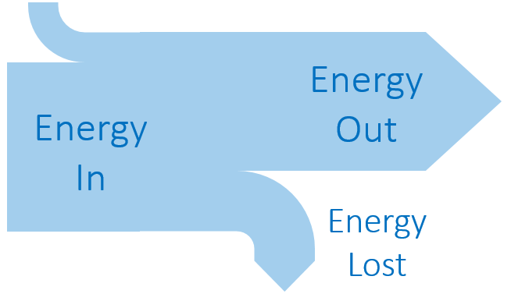
Sankey Diagram Rules:
Width of the arrow proportional to the amount of energy

Energy Density
 | Definition | Units
Specific Energy | Energy transferred per unit mass | J kg⁻¹
Energy Density | Energy transferred per unit volume | J m⁻³

Primary and Secondary Sources
Primary Energy Sources | Secondary Energy Sources
Energy sources found in the natural environment  (fossil fuels, solar, wind, nuclear, hydro, etc.) | Useful transformations of the primary sources  (electricity, pumped storage for hydro, etc.)

Nuclear Power
 | Describe | Examples | Challenges
Fission | Lighter elements are created by splitting heavier elements | Nuclear Power  Nuclear Weapons | Proper amounts of fissionable elements required to maintain chain reaction
Fusion | Heavier elements are created by combining lighter elements | The Sun/Stars | Requires high heat and high pressure

 | % of U-235 |  | Why is the concentration of U-235 important?  Only U-235 can undergo a fission chain reaction
Uranium Ore | 0.7%
Fuel-Grade | 3.5% |  | What is done with the nuclear waste?  Stored on-site in spent fuel pools and/or concrete dry cask storage
Weapons-Grade | 90%

Moderator | Control Rods
Slows down neutrons to be absorbed by U-235  Made from Water or Graphite (carbon) | Absorbs neutrons to limit number of chain reactions  Made from Boron

Renewable Energy
 | Variable Symbol | Unit |  | Data Booklet Equations:
Power | P | W |  | $$Power=\frac{1}{2}Aρv^{3}$$
Cross-Sectional Area | A | m²
Air Density | ρ | kg m⁻³ |  | $$A=πr^{2}$$
Air Speed | v | m s⁻¹

Photovoltaic Cells | Solar Concentrator | Solar Heating Panel
Converts solar energy directly into electricity. Useful in solar panels on top of building or solar farms connected to the energy grid | Mirrors focus sunlight onto a central tower. The high thermal energy is converted to steam and runs turbines to produce electricity | Sun’s radiation is absorbed by black pipes that transfer thermal energy to the water flowing through them. Replaces hot water heater.

 | Biomass | Coal | Geothermal | Hydropower | Natural Gas | Nuclear | Petroleum | Solar | Wind
Renewable | ✓ |  | ✓ | ✓ |  |  |  | ✓ | ✓
Produces CO₂ | ✓ | ✓ |  |  | ✓ |  | ✓

Thermal Energy Transfer
Conduction | Convection | Radiation
Energy is transferred through molecular collisions | Energy circulates through the expansion and rising of hot fluids | Energy is transferred through electromagnetic radiation. Can travel through a vacuum

 | Emissivity |  | Black Body Radiation | 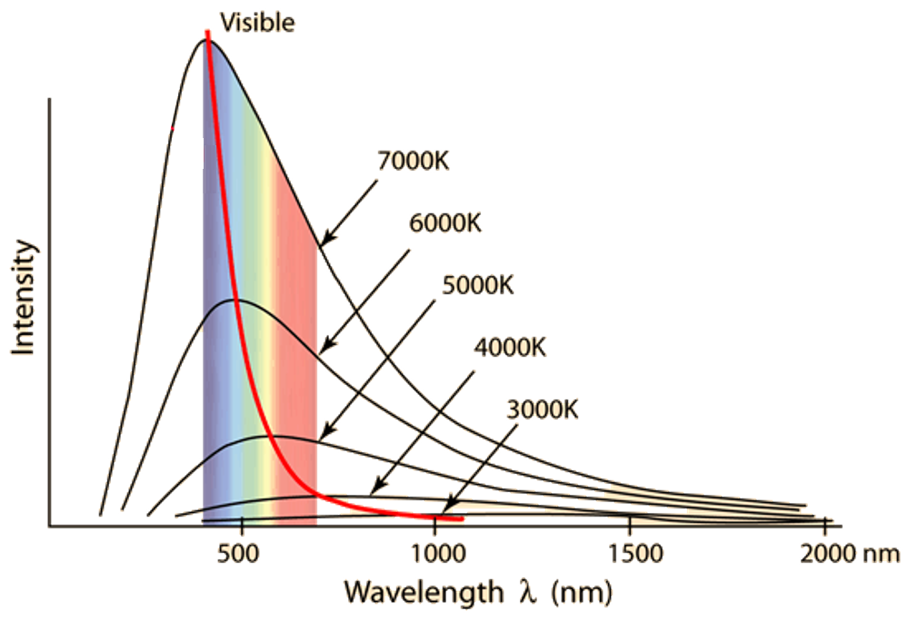
Sun | ~1 |  | An idealized object that absorbs all the electromagnetic radiation the falls on it
Earth | ~0.6
Black-Body | 1

Power Emissivity | Variable Symbol | Unit |  | Data Booklet Equations:
Power | P | W |  | $$P=eσAT^{4}$$
Emissivity | e | ---
Surface Area | A | m² |  | $$λ_{max}=\frac{2.90×{10}^{-3}}{T}$$
Temperature | T | K
Max Wavelength | λ_{max} | m |  | $$σ=5.67×{10}^{-8} W{ m}^{-2} K^{-4}$$

Solar Radiation and Climate Change
Intensity | Variable Symbol | Unit |  | Data Booklet Equations:
Intensity | I | W m⁻² |  | $$I=\frac{power}{A}$$
Power | P | W
Area | A | m² |  | $$A_{sphere}=4πr^{2}$$

Greenhouse Gases |  | Positive Feedback Loop | Negative Feedback Loop
Water Vapor (H₂O) |  | Melting ice (decreases albedo) | Cloud formation (increases albedo)
Carbon Dioxide (CO₂) |  | Melting permafrost (releases methane) | Increased photosynthesis (uses CO₂)
Methane (CH₄) |  | Rising ocean temp releases methane | Climate Change leads to renewables

