Energy Scavenger Hunt – Outline

Game Name: What is the name or title of the game you are designing?
Energy Scavenger Hunt

Game Designer: Your Name
Joe Cossette

Content Standards: What must students be able to do in order to complete the task
- Calculating Work and Power
- Calculating Kinetic and Potential Energy
- Conservation of Energy

Suggested Time: How long do you anticipate players needing to complete this task?
30-40 minutes

Running the Task
Students will should work in small groups of 3-5. Each group will start with envelope 1 on their desk. The objective is to complete checkpoints by interpreting the clues and determining the secret passwords. Once groups think they have correctly filled in their checkpoint password, they must check in with the gamemaster (most likely the teacher), and if correct, receive their next envelope. Groups successfully complete the scavenger hunt by completing all 5 checkpoints and correctly answering their final problem.

Checkpoint Answers
Checkpoint #1 | PUSH
Checkpoint #2 | 685
Checkpoint #3 | 6354
Checkpoint #4 | 425
Checkpoint #5 | Varies depending on group’s problem

Process Overview: Diagram representing the path to each checkpoint answer
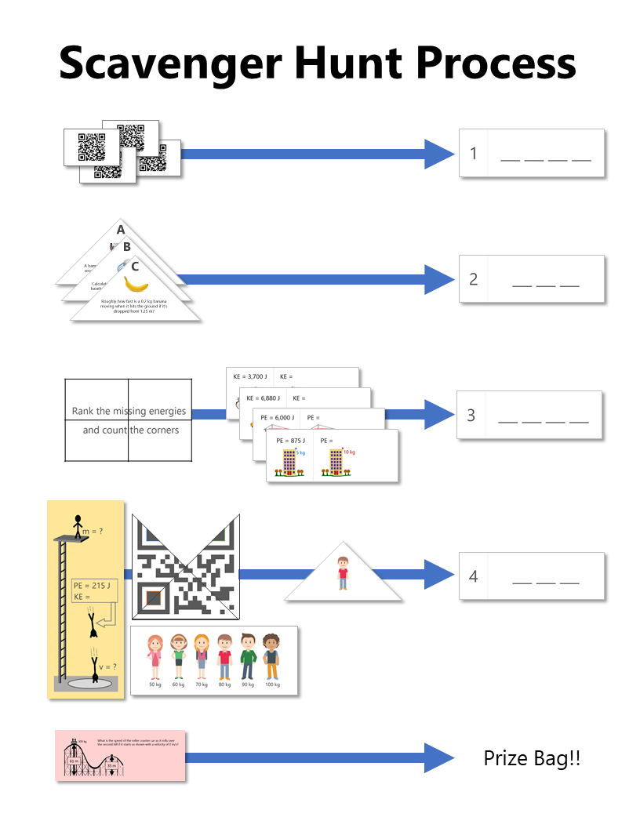

The Clues: Describe the path required to answer each checkpoint
Checkpoint #1  [4 blanks] | Groups are provided with 4 QR code cards and a line up of different characters to start out the challenge. The character lineup won't mean anything until later in checkpoint #4 but the QR codes can be used right away to determine the first code.  Each of the QR codes brings students to a different Google Form with one question that has been set up with data validation so that the form cannot be submitted unless the answer is correct. Once the form has been successfully submitted, the confirmation screen will show one of the four letters needed to create the answer for Checkpoint #1. Students should find that the four letters, when put in the right order, spell out a word that will gain them access to the next envelope.
Checkpoint #2  [3 blanks] | The cards needed to solve for checkpoint #2 can be found in the second envelope. Each of these problems are focused on work, power, and energy and require more than one step to complete. Depending on the level of the students, it might be worth providing hints so that students don't get stuck without being able to open the small box to unlock more clues.  ​  Each of the questions should come out to a single digit answer (if 9.8 is used for gravity instead of 10, then problem C needs to be rounded) and when placed in ABC order, should form the password to gain access to the next envelope.
Checkpoint #3  [4 blanks] | For checkpoint #3, students have access to the puzzle clue written on the backs of the QR code cards since the start of the task, but they don't have the clues needed to interpret this message until they have received the third envelope.  With this new envelope, they have access to the four clue cards shown on the right. Each of these is an energy equation relationship question asking about how the total energy changes if one of the variables is also changed  Once they find all of the missing energy values, all they need to do is follow the clue and rank them from smallest to largest. On the back of each card is a shape. Counting the corners in this ranked order provides the 4 digit answer to gain access to the next envelope
Checkpoint #4  [3 blanks] | Checkpoint #4 is probably one of the most involved to open because it requires several different clues. Ultimately, the answer required is the kinetic energy of the diver at the position shown in the clue on the right. This clue is missing some information required to solve it which is where some of the older clues come back in to the mix  The three triangle clues used for checkpoint #2 are also puzzle pieces to complete a QR code. Of course, the QR code won't work until they have all of the pieces and the fourth piece is found in the fourth envelope. The colored outlines are there to help students assemble the puzzle correctly. Once they have the pieces assembled, the code takes them to a google site with information about the diver's impact velocity  The final piece of information that is required is the mass of the diver. The line up of people is from the very beginning of the task but the group doesn't know which mass to use until they find the final triangle clue in the fourth envelope. This clue is simply a picture of the person, and it is up to the group to make the connection that this is the same person as the diver in the problem  ​With the impact velocity and the mass, it should be possible to use the conservation of energy to solve for the missing kinetic energy.
Checkpoint #5 | To complete this challenge, groups need to solve one last problem that they find in the fifth envelope. In the breakout version of this task, each group receives a different version of this final problem. This isn't necessary for the scavenger hunt but could make the final challenge feel more individualized.  ​  ​Since this task was designed to be used in several different levels of classes, there are two versions of this clue. Level 1 is a simple conservation of energy ramp question where students need to find the missing energy while Level 2 requires more calculation to find the velocity of a roller coaster at a certain location.

Printing the Clues: Any special instructions about printing any of the clues? (i.e. double-sided, color, etc.)
- Clue 1 is double-sided so that the QR cards make up the puzzle message on the back. (there are two sets of 4 cards included in this file)
- Clue 2 requires color printing include the colored outlines on the QR code to help students assemble it correctly
- Clue 3 is double-sided so that the missing energy cards have shapes on the back
- Clue 5 includes two levels of problems for eight different groups

Setting up the Breakout Task: What goes where?
1st Clue Envelope  on table | - Checkpoint #1 answer card with 4 blanks  - Character Line-up  - 4 QR code cards
2nd Clue Envelope | - Checkpoint #2 answer card with 3 blanks  - 3 triangle cards
3rd Clue Envelope | - Checkpoint #3 answer card with 4 blanks  - 4 KE/PE before and after cards
4th Clue Envelope | - Checkpoint #4 answer card with 3 blanks  - Final triangle card (the one with the character on it)  - High dive problem

Reset Instructions: Diagram for groups to reset after solving
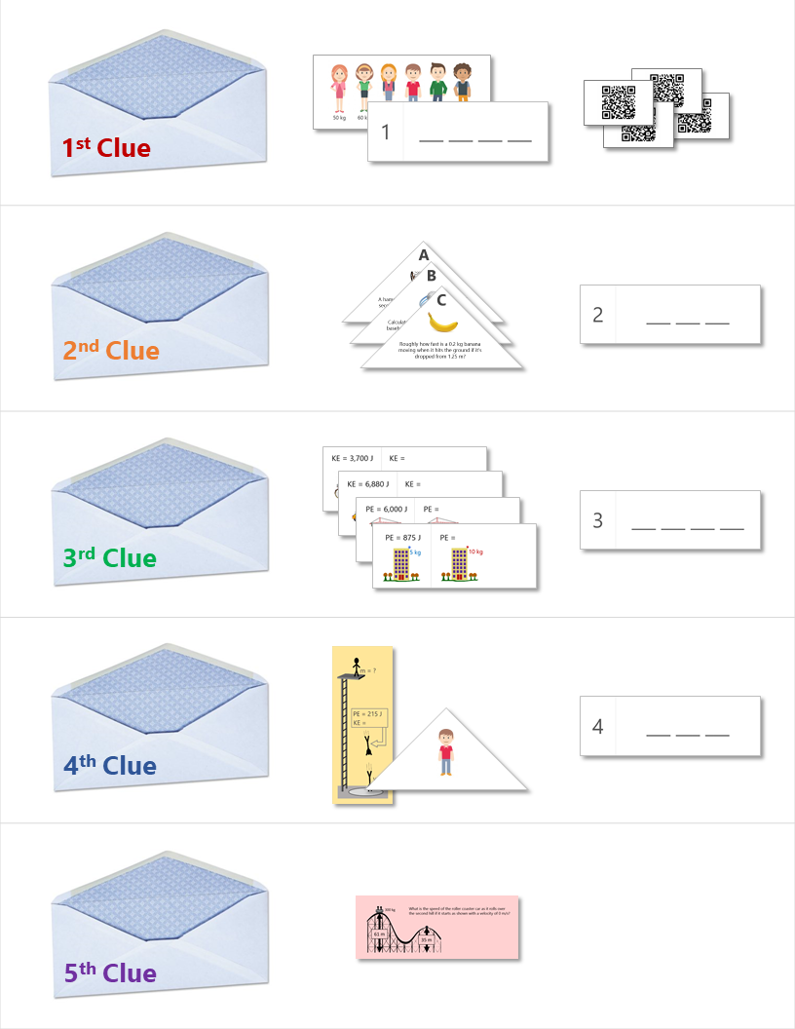

Solutions
