Force Fields | IB Physics Content Guide

Big Ideas
- Opposite charges/poles attract while like charges/poles repel
- The force between charged particles demonstrates the same relationship as the force between bodies with mass
- A force field describes the force at a location per unit mass, charge, or current
- A current flowing through a conductor produces a magnetic field
- The relative directions of current, magnetic field, and electromagnetic force can be found using the right-hand rules

Content Objectives

1 – Static Electricity
I can explain how objects can become charged
I can qualitatively describe the reactions between charged particles
I can describe the process of grounding a charged object

2 – Electrostatic and Gravitational Force
I can use Coulomb’s Law to relate electrostatic force to particle charge and separation distance
I can use the Law of Gravitation to relate gravitation force to object mass and separation distance
I can determine the units of Coulomb’s Constant and the Gravitation Constant using unit analysis
I can describe how the sign of the calculated electrostatic force indicates attraction or repulsion
I can compare and contrast electrostatic and gravitation forces
I can discuss the impact of permittivity on Coulomb’s Constant

3 – Force Fields
I can calculate force between objects with a net charge or mass
I can draw the vector force field for electric and gravitational fields
I can describe the role of a test charge or test mass in representing force fields
I can describe how the magnitude of a force changes with distance from an object
I can calculate field strength with proper units around a single object
I can calculate the net field strength based on two or more objects
I can determine the location where the net field strength is zero

4 – Magnetism and Right Hand Rule
I can describe the pole conditions required for magnetic attraction and repulsion
I can explain what happens when a dipole magnet is cut into pieces
I can describe the role of magnetic domains in magnetizing and de-magnetizing a material
I can draw in magnetic field lines around a magnet with a north and south pole
I can describe the layout of the Earth’s magnetic poles
I can use the right-hand rule to draw in a magnetic field around a current carrying wire
I can use the right-hand rule to predict the current direction through a wire with a surrounding field
I can indicate a vector that is pointing into or out of the page
I can describe some applications of electromagnets in use today
I can describe the design factors that affect the strength of an electromagnet

5 – Electromagnetic Force
I can use the right-hand rule to predict the force direction on a charge moving through a field
I can use the right-hand rule to predict the force direction on a current carrying wire placed a field
I can describe the general functions of electric motors and generators
I can calculate the magnetic field strength and force on a wire or moving charged particle
I can predict the trajectory of a charged particle moving through a magnetic field at different speeds

Force Fields | Shelving Guide

Forces between objects

Coulomb’s Law
 | Variable Symbol | Unit |  | Data Booklet Equations:
Electrostatic Force |  |  |  | $$F=k\frac{q_{1}q_{2}}{r^{2}}$$
Object 1 Charge
Object 2 Charge |  |  |  | $$k=\frac{1}{4πε_{0}}$$
Separation Distance
Coulomb Constant |  |  |  | k =
Permittivity of Free Space |  |  |  | ε₀ =

Universal Law of Gravitation
 | Variable Symbol | Unit |  | Data Booklet Equation:
Gravitational Force |  |  |  | $$F=G\frac{m_{1}m_{2}}{r^{2}}$$
Object 1 Mass
Object 2 Mass
Separation Distance
Gravitational Constant |  |  |  | G =

Force Fields
Electric Field |  |  | Gravitational Field
 |  |  |  |  | 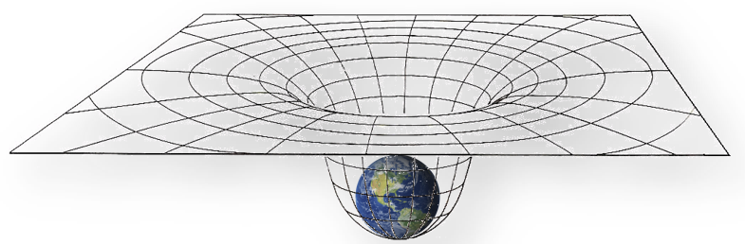
Symbol |  | Data Booklet Equation:  $E=\frac{F}{q}$ | Symbol |  | Data Booklet Equation:  $g=\frac{F}{m}$ $g=G\frac{M}{r^{2}}$
Units |  |  | Units

Magnetic Fields
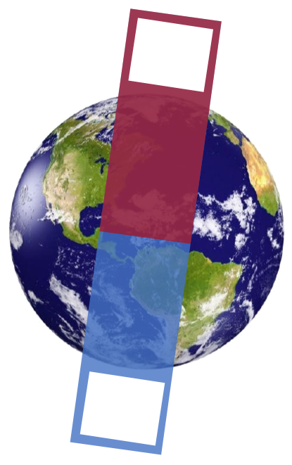

Right Hand Rule
Right Hand Rule #1 |  |  |  | Right Hand Rule #2
Magnetic field around a current carrying wire |  |  |  | Electromagnetic force direction on a wire or moving particle
Thumb |  |  |  | Thumb
Fingers |  |  |  | Fingers
 |  |  |  | Palm

Electromagnetic Force
 | Variable Symbol | Unit |  | Data Booklet Equations:
Magnetic Force
Magnetic Field Strength |  |  |  | Wire:
Current |  |  |  | $$F=BIL\sin{θ}$$
Wire Length
Angle to Field |  |  |  | Particle:
Particle Charge |  |  |  | $$F=qvB\sin{θ}$$
Particle Velocity

Charged Particles Moving through a Magnetic Field
 | Magnetic Field | Out of Screen | Magnetic Field | Into Screen
Positive Particle | 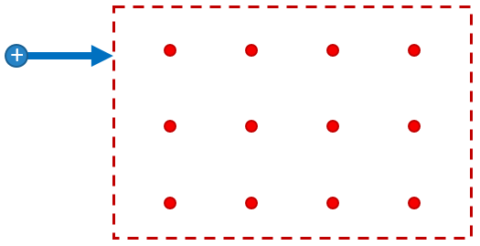 | 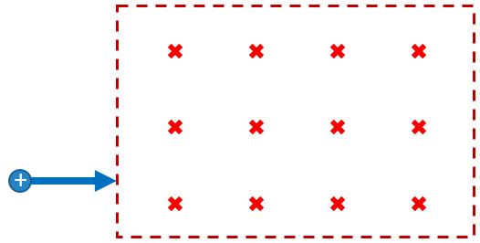
Negative Particle | 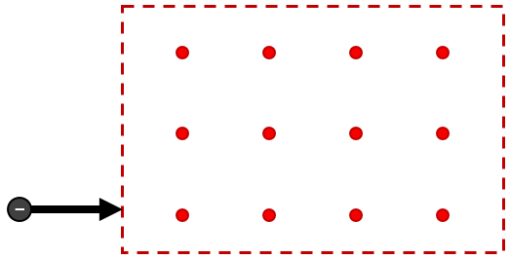 | 