Forces | IB Physics Content Guide

Big Ideas
- Many forces acting on an object can be simplified down into one net force
- Acceleration is zero when net force is zero (could mean stopped or constant velocity)
- If you have the acceleration of an object, you can find the net force causing that acceleration and vice versa
- Force of friction is related to the normal reaction force
- For objects on a sloped surface, the weight must be broken down into its perpendicular and parallel component

Content Objectives

1 – Newton’s First Law and Free Body Diagrams
I can define a force (with proper units) in terms of the interaction between two objects
I can describe Newton’s first law
I can calculate the net force on an object
I can calculate an unknown force for an object in equilibrium

2 – Newton’s Second Law
I can describe Newton’s second law in terms of momentum
I can calculate force given mass and acceleration and calculate acceleration given force and mass
I can combine Newton’s second law with the kinematic equations to solve force/motion problems
I can explain the connection between constant velocity and balanced forces

3 – Weight, Normal Reaction, and Tension
I can calculate the weight of an object
I can describe the difference between mass and weight
I can use a diagram to identify the direction of tension and normal reaction forces
I can draw a free body diagram with weight, normal reaction force, friction, and any other forces

4 – Calculating Friction
I can calculate the force of friction when given the reaction force and coefficient of friction
I can quantitatively compare surfaces based on their coefficients of friction
I can calculate the acceleration of an object with friction based on the external force and mass

5 – Air Resistance
I can describe the factors that affect air resistance and how the resistance changes with velocity
I can define Terminal Velocity in terms of net force
I can graph the change in position and velocity for an object falling with air resistance

6 – Forces on a Ramp
I can calculate parallel and perpendicular components of the force due to gravity on a ramp
I can calculate the force of friction required to keep an object in equilibrium
I can calculate the acceleration of an object with known mass on a ramp of known angle and friction
I can calculate parallel and perpendicular components of the force due to gravity on a ramp

Forces | Shelving Guide

Name of Force | Variable | Description/Important Properties | Equation
 | F_{g}
 | F_{T}
 | R
 | F_{f}
 | F_{air}

If an object has a net force of zero its motion is either:
or

Newton’s Laws
Newton’s
First Law
Newton’s
Second Law
Newton’s
Third Law
Data Booklet  Equations: |  |  | Variable Symbol | Unit
 |  | Force
$$F=ma$$ |  | Mass
$$F_{f}≤μ_{s}R$$ |  | Acceleration
$$F_{f}=μ_{d}R$$ |  | Normal Reaction Force
 |  | Coefficient of Kinetic Friction
 |  | Coefficient of Static Friction

Terminal Velocity
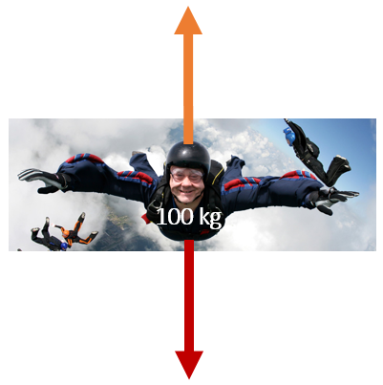 |  | 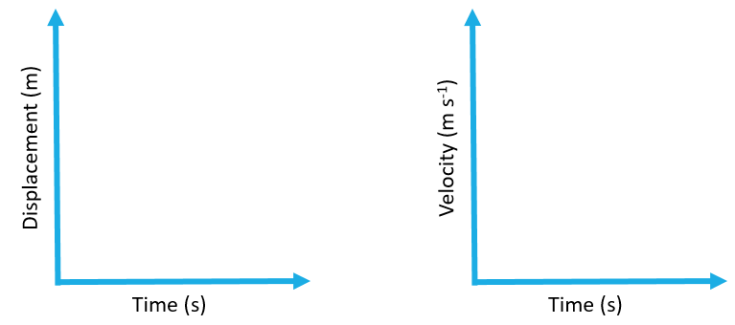
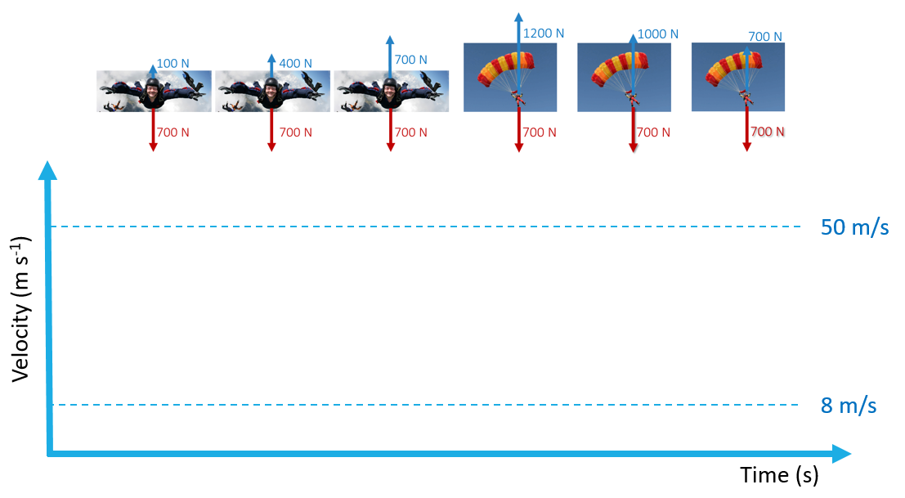
Sliding to a Stop |  |  | Constant Velocity
F_{net} = |  |  | F_{net} = | F_{pull} =

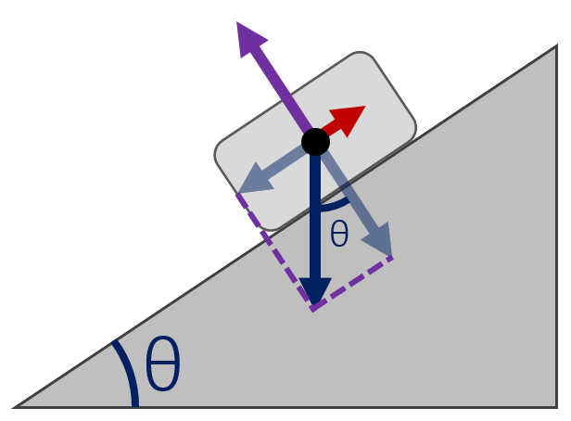 |  | Forces on a Ramp
 |  |  | Equilibrium |  |  | Accelerating
 |  |  | R |  |  | R
 |  |  | F_{f} |  |  | F_{f}
F⊥ |  |  | F_{net} |  |  | F_{net}
F∥ |  |  | a |  |  | a

