Free Fall Mini Labs Name: ____________________________
For each of these mini labs, complete the task provided and show all work.

The Videos:
One key variable that you will want to measure precisely and accurately is time. To make this job a little easier, a running stopwatch has been added to the video. Please note that this stopwatch starts at the beginning of the video so you will need to determine an initial and final time to calculate the overall duration of the event. The video will run once in real time and again in slow motion. It is recommended to collect timestamps from the slow motion footage for the most precise measurements.

Equations and Constants
$$v=u+at$$ | $$s=ut+\frac{1}{2}at^{2}$$ | $$v^{2}=u^{2}+2as$$ | $$s=\frac{\left(v+u\right)t}{2}$$ | $$g=9.81 m s^{-2}$$

Part 1: Tik Tok Cliff Dive
During the summer of 2020, this clip went viral on the video sharing app Tik Tok. People were astonished by how this cliff diver seems to fall forever before hitting the water.

CLICK HERE to access the Tik Tok Cliff Dive video

Your Task: Determine the height of the cliff

Record all assumptions and show all work below ↓

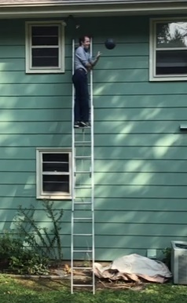
Part 2: Bowling Ball Drop
Studying physics provides a beautiful opportunity to climb to the top of a ladder and drop bowling balls. Luckily, only the bowling ball experienced free fall in the making of this video.

CLICK HERE to access the Bowling Ball Drop video

Your Task: Plot the position of the bowling ball over time

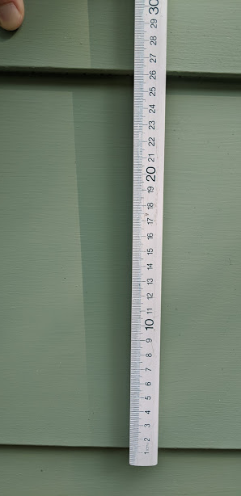
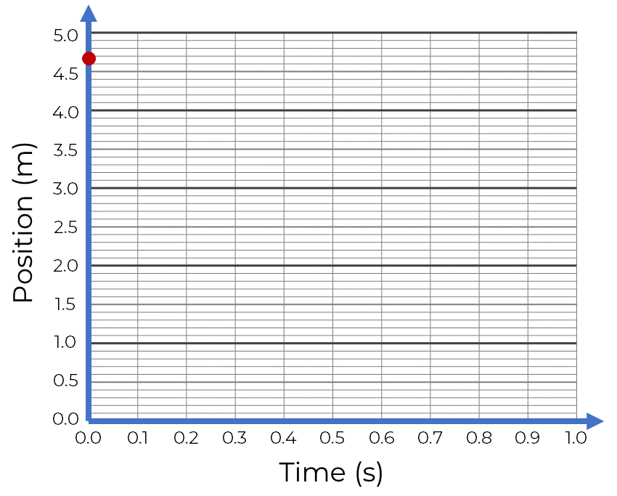
For this video, the stopwatch starts at the moment that the ball is released and so you can easily record the time stamp at several different positions as it falls. It is dropped from a height of 4.68 meters and the measurement of the house’s siding is shown in the photo on the right. Assume that the ground is a position of zero. Use the video to collect some data and graph the points below ↓
Position (m) | Time (s)
4.68 | 0.00

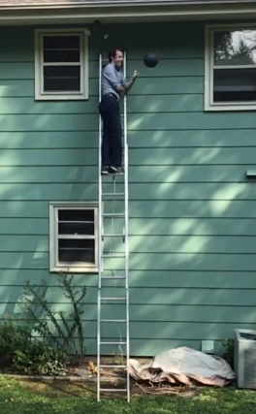
Part 3: Bowling Ball Impact
Now that I’m watching this bowling ball smack the ground so close to the house, it’s got me wondering, how fast did it hit??

CLICK HERE to access the Bowling Ball Drop video

Your Task: Calculate the impact velocity of the bowling ball

Record all assumptions and show all work below ↓

Part 4: Air Time
Some athletes have some pretty impressive hops. If we know how high they jump, we should also be able to figure out how long they are airborne.

CLICK HERE to access the Vertical Jump Video

Your Task: Calculate the total air time based on the jump height of 47.1 inches

Record all assumptions and show all work below (don’t forget to convert to meters) ↓

Once you have a value calculated based on his total height, use the stopwatch on the video to get an estimate for how long he was in the air. If your answer is not in this ballpark, revisit your calculation. Remember that the total hang time is the time to go up and come back down

Hang Time measured with Hudl

