Graphing Mini Labs | Name: ______________________ Period: __

#1 | Put a Lid on it!
Diameter (cm) | Circumference (cm)
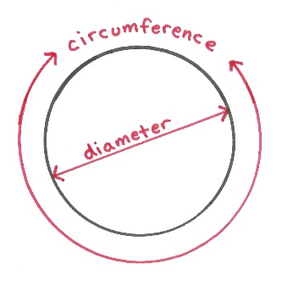
Measure the diameter and circumference of nine different lids and record your measurements in a data table on excel. It helps to use a piece of paper or a string to wrap around the circumference and then straighten out the string and measure it with a meter stick
You can use the table on the right as an example when you set up your worksheet. When you are entering in your data, do not put units with the numbers (that’s what the column headings are for)
Create a scatter plot of the data and add a trendline with an equation. Diameter should end up on the x-axis.

Analysis
- What is the equation given by Excel?

- What is the slope of the data?

- What is the mathematical equation you generally use to find the circumference of a circle when you know the diameter? (google it if you don’t know)

- As you might have noticed from the circumference equation and the value of your slope, we expect this slope value to be close to the value of π (3.14). Calculate your percent error using pi as the accepted value

$$\% error= \left|\frac{Accepted value-Experimental Value}{Accepted value}\right| x 100$$

#2 | All Tied Up in Knots!
# of Knots | String Length (cm)
0
5
10
15
20
25
30
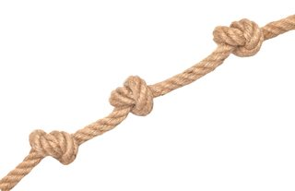
Obtain a piece of string between 75 cm and 100 cm long and measure its length using a meter stick.
Tie 5 knots in the string and measure again. Repeat for a total of 10, 15, 20, 25, and 30 knots
Create a scatter plot of the data and add a trendline with an equation.

Analysis
- What is the equation given by excel?

- What is the slope of the data (with units) and what does it mean?

- What is the Y-Intercept? What does the y-intercept represent in this string example?

- Rewrite the equation using N to represent the number of knots and L to represent the string length.

- How would the equation change if you started with a string that was 500 cm long?

- According to your equation, how much length would the 500 cm string theoretically lose after tying 100 knots?

