Internal Resistance Lab Name: ____________________________
In this lab, you will be investigating the internal resistance and emf of a battery by collecting and graphing voltage and current measurements from a simple circuit.

Video Tutorial | PHET Circuit Builder

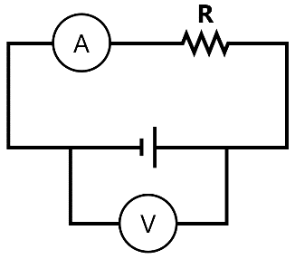
Part 1: Setting up your circuit
Using the PHET Circuit Construction kit, use a battery, resistor, ammeter, and voltmeter to build the circuit design shown in the schematic diagram on the right
On the right of the simulation window there is a dropdown menu for “Battery Resistance”. Choose an internal resistance and circle your selection in the table below
Battery Resistance (circle one)
1 Ω | 2 Ω | 3 Ω | 4 Ω | 5 Ω | 6 Ω | 7 Ω | 8 Ω | 9 Ω | 10 Ω
Display the circuit values by making sure that the “values” checkbox is marked
Battery emf
(between 1 V – 120 V)
Click on the battery to choose a voltage between 1 V – 120 V and record your selection below. The value that you are setting is your battery’s emf

Part 2: Collecting Data
With this set up, you are measuring the total current flowing through the circuit as well as the terminal voltage of the battery. To collect multiple measurements, adjust the external resistance and record the resulting current and voltage in the table below. (see the video tutorial above for an example)
External Resistance (Ohms) | Current (A) | Terminal Voltage (V)
2.5
5
10
20
40
80
Part 3: The Mathematical Model
Copy the table from part 2 into Excel and create a scatterplot from only the “Current” and “Terminal Voltage” columns. Add a trendline with an equation to your graph. Make sure that the current is graphed on the x-axis.
Scatterplot:

Mathematical Model
(trendline equation)

Part 4: Analysis of the Model
Compare your mathematical model with the battery values that you selected in part 1:
- What electrical property does the slope represent?

- What electrical property does the y-intercept represent?

Part 5: Extending our Understanding
If we were to do this lab in real life, we wouldn’t have a simulation displaying the emf and internal resistance of our battery. Analyze the data shown in the screenshots below to determine the mystery battery’s properties that are covered up by the emoji.
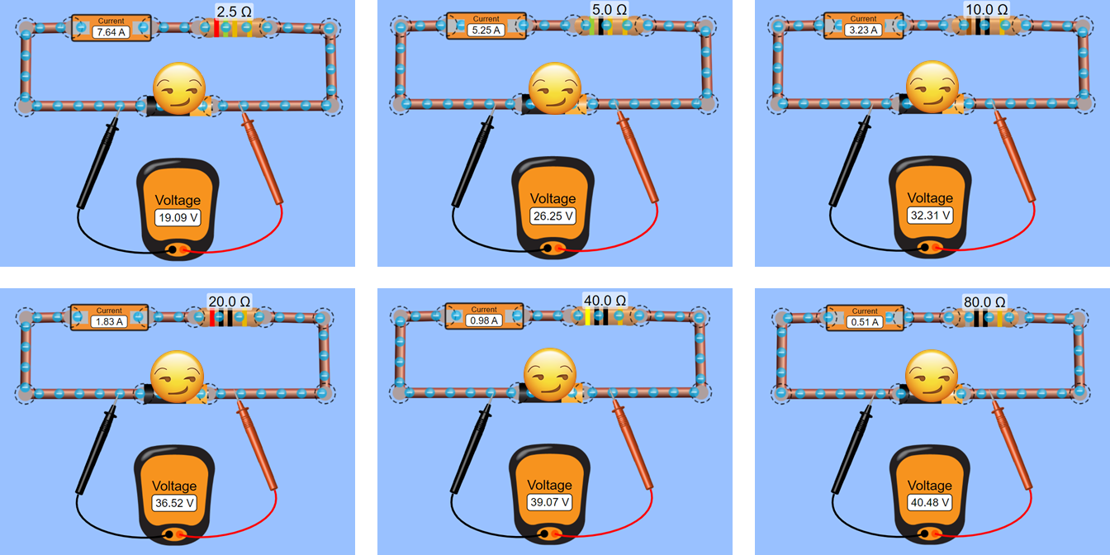
Screenshot of data/scatterplot:

Battery emf |  |  | Battery Resistance
Part 6: Checking your Work
To check if your values for the mystery battery are correct, create a test circuit with your battery values to recreate one of the example configurations shown in part 5. All values and measurements should match.
Screenshot of test circuit with ammeter and voltmeter:

