Kiss the Egg
As the lead engineers for a new bungee jumping attraction, you have been tasked with designing a proof of concept for this high precision thrill ride.

Your Task
Design and build a bungee jump that, when dropped from a predetermined height, stamps a mark on a raw egg without breaking it.

Considerations
- Every group will be provided with a different spring to use as your elastic portion of the bungee system. This means you will need to determine your spring’s resting length and spring constant (k) before designing the rest of your components
- You will be granted the opportunity for one practice round with a golf ball before attempting to stamp your egg

The Set Up
Our bungee jump consists of a spring connected to a non-elastic rope that can be adjusted for the conditions. All the measurements are laid out in the diagram below:
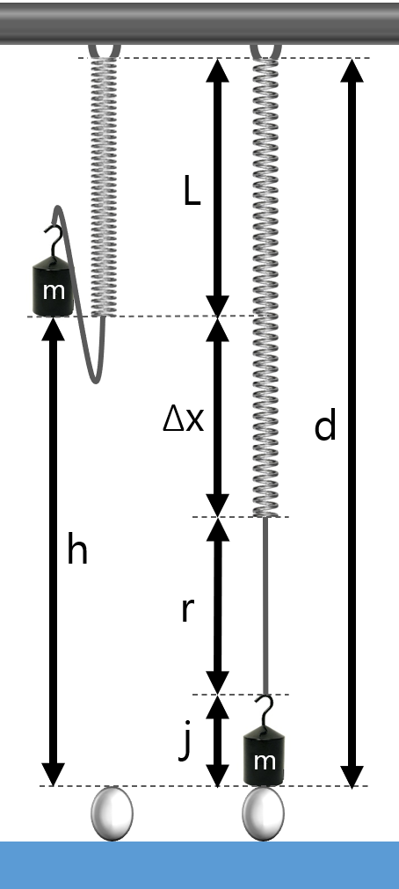 | d
 | Total distance between
 | h
 | Drop height for the jumper
 | L
 | Resting spring length
 | Δx
 | Stretch of the spring
 | r
 | Length of rope
 | j
 | Height of jumper
 | m
 | Mass of jumper

The Energy
The jumper will be dropped from a height right below the resting length of the unextended spring and (hopefully) come to a stop at the top of the egg (height of 0 m).
Determine the conservation of energy equation representing these initial and final conditions

The Spring

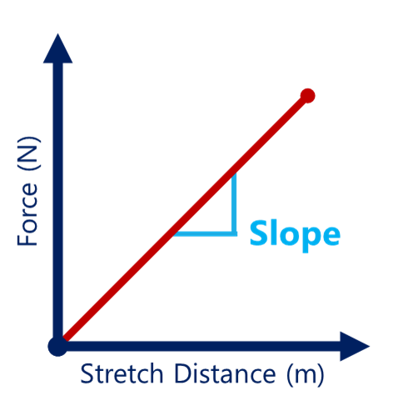
Choose a spring from the collection provided. Record the ID number below
Spring ID #

Create a table of data of Stretch Distance (Δx) and Force (F)
Stretch Distance (m) | Force (N)

The slope of the trendline should be equal to the spring constant of your spring in N/m
Spring Constant (k)

The Rope
Based on your provided values, spring properties, and conservation of energy equation, calculate the stretch of the spring and how much non-elastic string is required for the bungee jump to go as planned. When everything is calculated, measure and build your bungee system.

