Light Mini Labs Name: ________________________________
In this lab, you will investigate the mathematical models for refraction due to a medium change and diffraction in double slit experiment.

Part 1: Refraction of an Unknown Material
Light bends when traveling from medium into another. The amount of this bend is related mathematically to the material’s index of refraction through Snell’s Law.
$$\frac{n_{1}}{n_{2}}=\frac{sinθ_{2}}{sinθ_{1}}=\frac{v_{2}}{v_{1}}$$
Use a simulation to collect data and calculate the index of refraction for an unknown material

Click Here for the Simulation

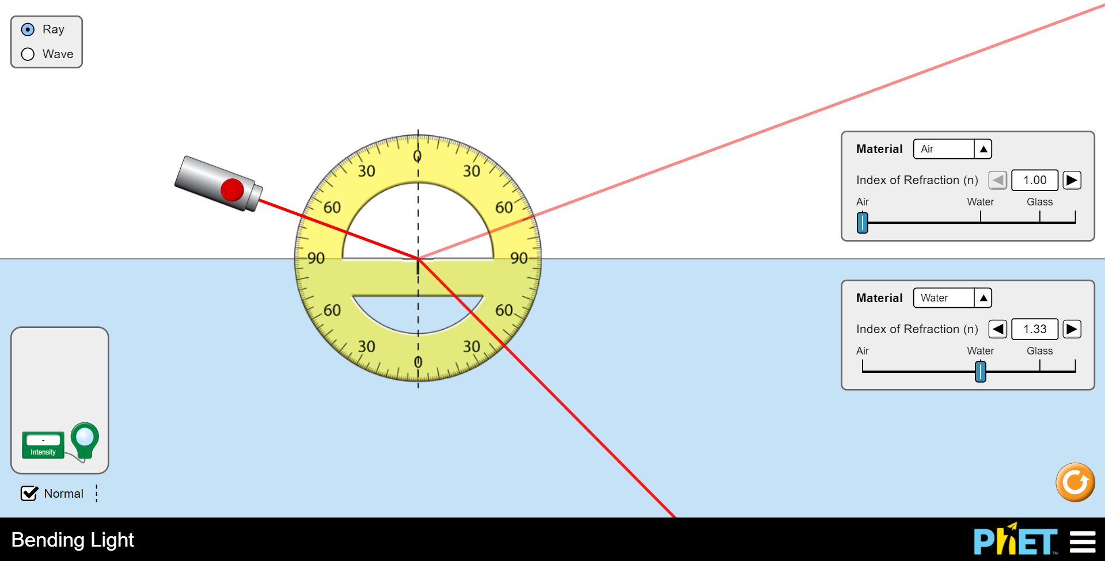

Start by exploring the simulation and see what effect different set ups have on the path of the light. For example, what sorts of configurations result in the largest or smallest change in angle?
Once you have a feel for the simulation, go to the next page to do some calculations ↓

Set up the simulation according  to the settings listed here to investigate the optical properties of Mystery A | Top Material | Air (n = 1.00)
 | Bottom Material | Mystery A

Drag around the laser and use the protractor to collect 2 different angles of incidence and refraction. (make sure you are measuring relative to the normal line)
 | Angle #1 | Angle #2
Angle of Incidence
Angle of Refraction

Calculate the unknown index of refraction of Material A for each of these set ups in the space below. Average these calculated values together and record below
Angle #1:
Angle #2:

Mystery A - Index of Refraction

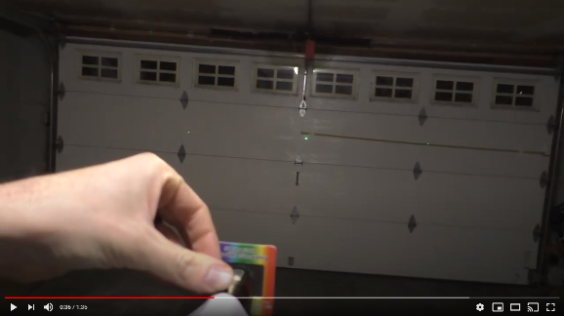
Part 2: Calculating the Wavelength of a Laser
When light travels through narrow slits, it produces a pattern of light and dark fringes. If you know the relationship between the different distances, you can calculate for an unknown. In this lab, your task is to calculate the wavelength of the laser used in this video.
Click Here for the Lab Video

Using data from the video, identify the variables and calculate for the wavelength of the laser in nm. List variables and show all work in the space below. (Note: be extra cautious with your units)
$$s=\frac{λD}{d}$$
s
D
d

Wavelength (in nm)

Check your answer:
Using this website, type in your calculated wavelength in nanometers. If you are close, you should see a color similar to the green laser used in the investigation
academo.org/demos/wavelength-to-colour-relationship/ | 