Science Skills | Practice | Name: ________________ Period: __

Units
- Rewrite the following fraction units in the “European Standard” exponent notation
$$\frac{m}{s}$$ |  |  | $$\frac{J}{K}$$
$$\frac{kg × m}{s^{2}}$$ |  |  | $$\frac{J}{K×mol}$$
$$\frac{kg}{s^{2}A}$$ |  |  | $$\frac{1}{s}$$

- List the seven fundamental base units and their abbreviations
Length
Mass
Time
Electric Current
Temperature
Amount of Substance
Luminous Intensity

Unit Conversion
- Convert 167 g to kg

- Convert 0.0043 GW (gigawatts) to mW (milliwatts)

- Convert 10,853 cm to km

- Convert 439,000 cm² to m²
1 in = 2.54 cm

- Convert 125 in³ to cm³

- Express 61,200 in normalized scientific notation.

- Express .00004203 in normalized scientific notation.

Dimensional Analysis
- Is this equation valid? Note that t is in s, v is in m s⁻¹, a is in m s⁻², x is in m, F is in kg m s⁻² and m is in kg.
v² = ax

- Is this equation valid? Note that t is in s, v is in m s⁻¹, a is in m s⁻², x is in m, F is in kg m s⁻² and m is in kg.
t = v / F

- What are the units of the constant g this equation? (be sure to write with negative exponents if needed)
$$g=G\frac{m}{r^{2}}$$ | Variable | Unit
 | Mass  m | Kilogram  [kg]
 | Radius  r | Meter  [m]
 | Gravitation Constant  G | [N m² kg⁻²]
Gravity
g

Significant Digits
- Record the number of significant digits for the numbers below
0.23 |  |  | 1.0020
1.23 |  |  | 12 × 10⁻²
1.203 |  |  | π
1.230 |  |  | 0.00010000
0.002 |  |  | 5.98 × 10²⁴
1.002 |  |  | 1.60 × 10⁻¹⁹

Uncertainty
- Complete the following table with checkmarks or X’s
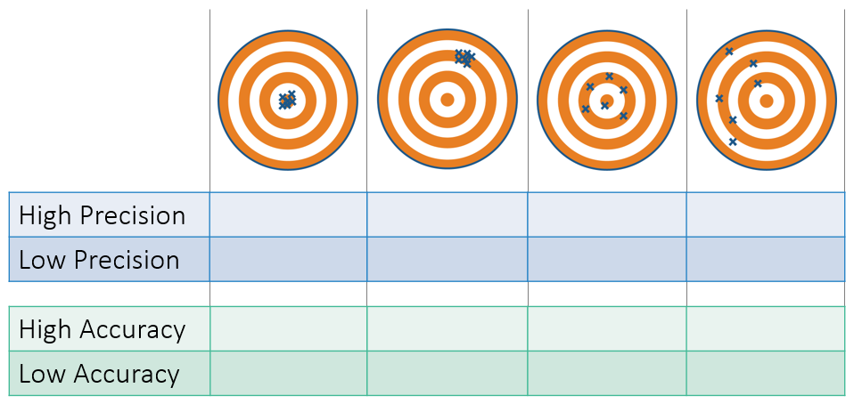

- What is the measured length of this line in cm? Use the amount of significant figures a wooden meter stick is capable of supplying and include the uncertainty as well.

- You use an electronic balance to find that your action figure weighs 4.52 grams.
  - What is the absolute uncertainty in the measurement?

  - What is the percentage uncertainty in the measurement?

- Calculate the Absolute and Percentage Uncertainty for the following set of data
22.5 s
20.8 s
19.6 s
28.3 s
21.7 s
20.4 s
Absolute:
Percentage:

- Kinetic Energy is calculated using the equation E_{K} = ½mv², you measure the mass to be 50 ± 0.5 kg and the velocity to be 20 ± 0.4 m s⁻¹. Calculate the value and uncertainty for the kinetic energy.
Absolute:
Percentage:

- You stack two blocks on top of each other, what is the uncertainty of the overall height?
Block A: 28.1 ± 0.8 cm | Block B: 12.6 ± 0.6 cm
Absolute:
Percentage:

