Stop Motion Face Off 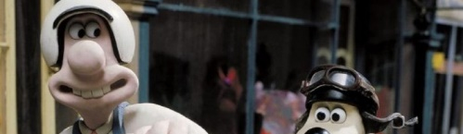

Your Task
Create a stop motion video that accurately depicts a head to head race between two objects (LEGO characters, matchbox cars, clay sculptures, photos of your favorite teacher, etc.). The motion of the two racers will be determined by the challenge that is presented to your group and must play out in real time according to the given values.

The Racers
Object A  Moves at a constant velocity for duration of the race. This racer will be moving at their listed velocity from the moment the race begins |  |  | Object B  Starts with an initial velocity of 0 cm/s but accelerates at a constant rate from there, moving a greater distance for each successive time interval.
Your team will be presented with one of the following challenges to depict in a stop motion video:
The Challenges: | Challenge #1 | Challenge #2 | Challenge #3 | Challenge #4
Object A | Constant Velocity | 5 cm/s | 5 cm/s | 7 cm/s | 7 cm/s
Object B | Constant Acceleration | 5.5 cm/s² | 4.5 cm/s² | 5.5 cm/s² | 4.5 cm/s²

The Equations
Constant Velocity | Constant Acceleration
$$v=\frac{d}{t}$$ | $$v_{f}=v_{i}+at$$ | $$d=\frac{1}{2}\left(v_{f}+v_{i}\right)t$$ | $$d=v_{i}t+\frac{1}{2}at^{2}$$ | $${v_{f}}^{2}={v_{i}}^{2}+2ad$$

The Video
Your stop motion video must depict the race from three different perspectives: Top view, side view, and front view. These videos may be captured at separate times but must be compiled to create one video file playing either one after the other or together in “split screen” format.

Video Specifications
In order to present a smooth motion, the stop motion video should be set to capture at 10 fps (frames per second). This means that the time between images will be 0.1 seconds.
The video should continue until one of the racers finishes the race

The Data
In order to ensure that the positioning of your racers correctly depicts the assigned motion, the position from the starting line (displacement) must be calculated for each object at each time interval. This could be done by hand but performing a calculation many times in a row is an ideal task for a spreadsheet program like Microsoft Excel.
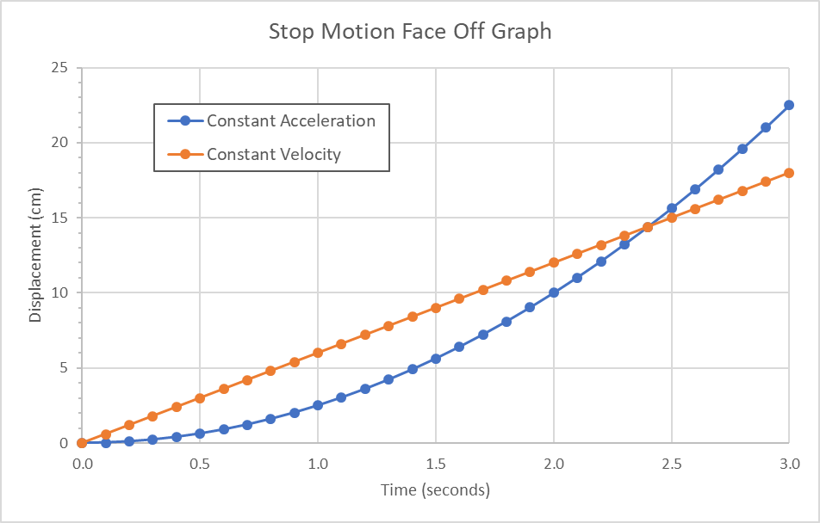
To best present the data, it is recommended to create a single table with the time (in 0.1 second increments) and object positions calculated for each row. Once the data has been completed, it should be used to create a scatterplot showing the motion of racers in a motion graph similar to the one shown here.
Time (s) | A – Position (cm) | B – Position (cm)
0.0
0.1
0.2
…

The Race Track
You will be provided with a race track that contains two lanes measuring a total distance of 25 centimeters. There are incremental markings every 0.1 cm to enable more precise measurements
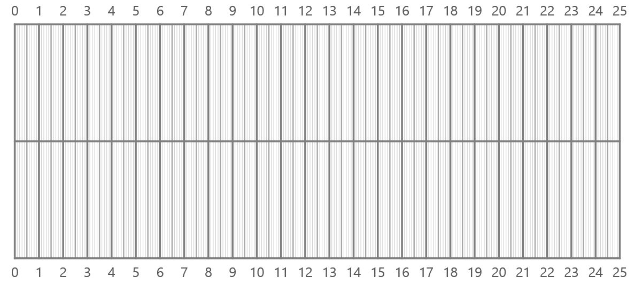

Final Product
Final video submission must contain the following:
- Description of each object’s motion requirements set by the challenge (i.e. include the constant velocity and constant acceleration values for your challenge). This should be a visual display like labels on the track or a title slide in the video rather than a voice over.
- Stop motion video showing the entire race in three different perspectives (top view, side view, and front view) set to a framerate of 10 frames per second. The video should continue until one of the racers “wins” by crossing the finish line, but this can be extended to include a celebration or some other final motion.
- A full screen image of the position graph describing the race, complete with title and axis labels
- Credits listing the names of all students in the group

Rubric
Your score will be determined using the following rubric:
Total points possible = 16 |  | Proficient  (2) | Developing  (1) | Incomplete  (0)
Motion Description | Values for constant velocity and constant acceleration are displayed
Video | Frame rate set to 10 fps and video is smooth and doesn’t jump around
 | Top View is included and well done
 | Side View is included and well done
 | Front View is included and well done
Data and Graph | Graph is presented full screen, complete with title and axis labels
 | Graph and video present the correct relative motion and cross-over point
Credits | All group members listed in credits

