The Floating Balloon Name: ________________________ Period: ___

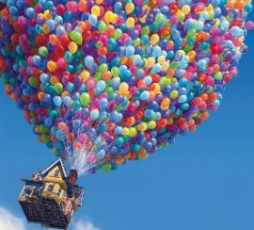
Objective
Calculate the number of balloons that would be required to allow the house in the movie “UP” to float motionless in equilibrium

Set Up Your Balloon
Pick out a helium balloon and attach a paperclip to the ribbon. Use the paperclip to hang a piece of cardstock to the balloon. This added mass will be enough to keep the balloon on the ground.

Achieve Equilibrium
Free Body Diagram:

Draw a free body diagram to represent what forces are acting on the balloon when it is hovering motionless in midair. (equilibrium)
Carefully tear or cut the piece of cardstock until the balloon has just enough added mass that it hovers in midair

Measure the Buoyant Force
Using an electronic balance, find the mass that you added to your balloon to make it hover (this includes the cardstock AND the paperclip. With this value, calculate the weight (in Newtons) of this added amount. Assuming that a hovering balloon is in equilibrium, what is the buoyant force that the helium balloon provides?
Added Mass (kg)
Added Weight (N)
Buoyant Force (N)

Could “Up” Occur in Real Life?
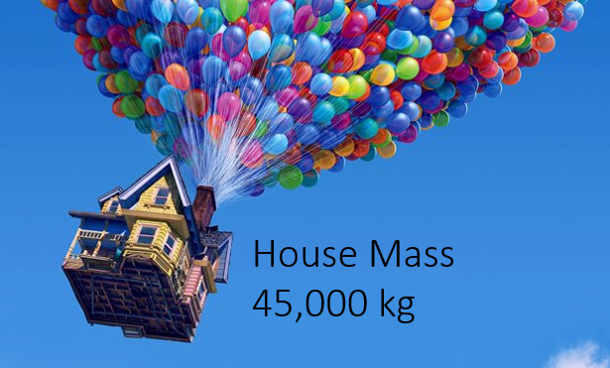
In the movie “Up”, the main characters, float away in a house supported by many many helium balloons. Assuming that the balloons and rigging don’t and any noticeable mass to the 45,000 kg total, what is the buoyant force required from the balloons for the house hover motionless in the air?

Net Force | 0 N
House Weight (N)
Buoyant Force (N)

Using the buoyant force of a single helium balloon measured in this lab, how many balloons would be required to make this happen?

Bonus
In the movie, when the 45,000 kg house first lifts off of the ground, it rises with an upward acceleration of 0.5 m/s². Since there is a non-zero acceleration, this means that the buoyant force from the balloons must be greater than the weight of the house. Draw a free body diagram and solve for the balloons’ buoyant force.

Net Force
House Weight (N)
Buoyant Force (N)

Using the buoyant force of a single helium balloon measured in this lab, how many balloons would be required to make this happen?

