Waves - Light | IB Physics Content Guide

Big Ideas
- Light waves can be transformed through reflection, refraction, and diffraction
- Light travels at different speeds through different material

Content Objectives

1 – Light and the EM Spectrum
I can describe how the properties of electromagnetic waves change as frequency changes
I can identify and use the speed of light to solve wave problems with the wave equations
I can estimate the wavelength magnitude for the different EM waves
I can provide real world examples for each of the electromagnetic waves

2 – Reflection and Refraction
I can identify the angle of incidence and angle of reflection for a reflected wave ray
I can use the law of reflection to predict the way light bounces off of a plane mirror
I can relate the index of refraction of a material to the speed of light as it travels through
I can qualitatively describe how light bends when transitioning between boundaries
I can predict the direction that light will bend at a medium transition

3 – Snell’s Law and Critical Angle
I can mathematically relate the angles of refraction to the indices of refraction for the materials
I can describe the phenomenon of Total Internal Reflection
I can calculate the critical angle of incidence so that the light cannot escape the medium
I can identify applications of total internal reflection and describe their importance

4 – Diffraction
I can describe how light bends around a boundary
I can describe the interference pattern formed by two coherent waves
I can predict the resulting image from a double slit experiment
I can calculate the spacing between bright spots for the double slit experiment
I can conceptually relate band spacing with wavelength and gap distance

5 – Polarization
I can describe the transformation that takes place when unpolarized light is polarized
I can describe the interaction between two polarized filters at different orientations
I can use Malus’s Law to calculate the change in intensity when passing through polarized filters

Waves - Light | Shelving Guide

Electromagnetic Spectrum
A | Radiowaves | 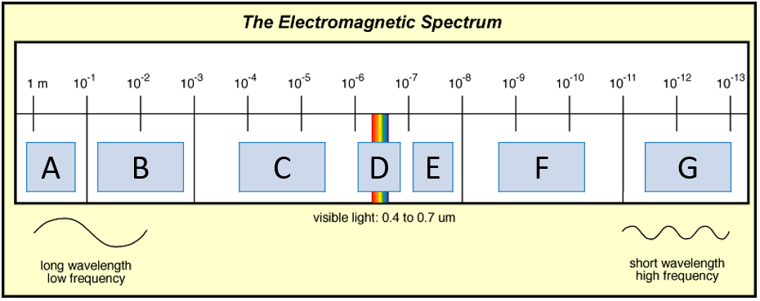
B | Microwaves
C | Infrared
D | Visible Light
E | Ultraviolet
F | X-Rays
G | Gamma Waves

Index of Refraction
Medium | Wave Speed (v) | Index of Refraction (n) | $$\frac{n_{1}}{n_{2}}=\frac{v_{2}}{v_{1}}$$
Vacuum | 3.00 × 10⁸ m s⁻¹ | 1.0000
Air | 2.999 × 10⁸ m s⁻¹ | 1.0003
Water | 2.256 × 10⁸ m s⁻¹ | 1.33
Glass | 1.974 × 10⁸ m s⁻¹ | 1.52

Refraction
$$\frac{n_{1}}{n_{2}}=\frac{sinθ_{2}}{sinθ_{1}}$$  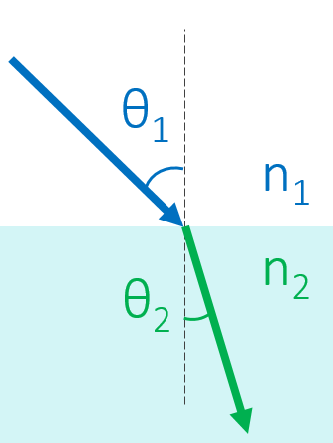 | 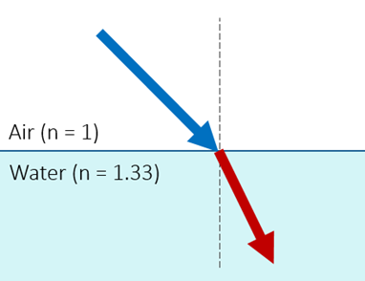 | 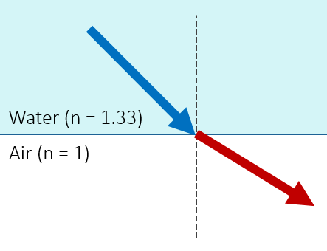
 | 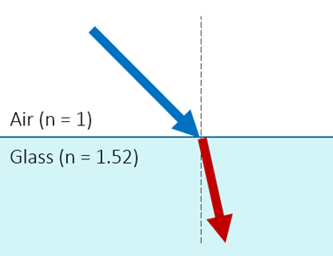 | 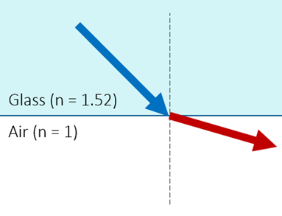

Reflection
Law of Reflection | 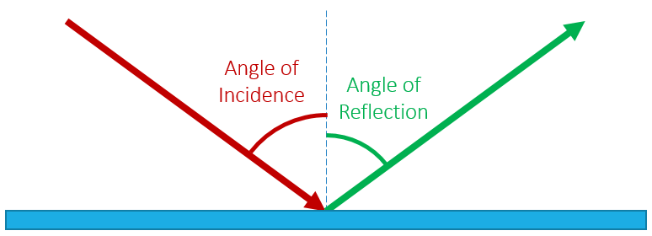
Angle of Incidence = Angle of Reflection
Critical Angle
When $θ_{1}=θ_{c}$  $$θ_{2}=90°$$ | $$θ_{c}= \sin^{-1}\left(\frac{n_{2}}{n_{1}}\right)$$ | 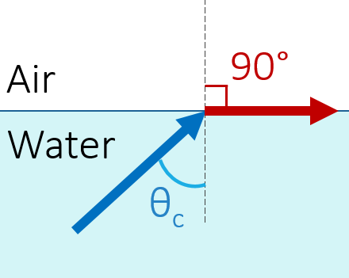
Polarized Light
$$I=I_{0}\cos^{2}θ$$ |  | 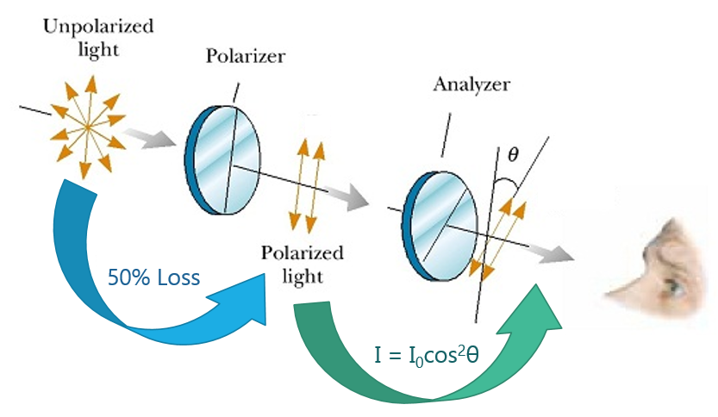
I | Intensity Observed
I₀ | Original Intensity
θ | Difference in Angle

Double Slit Experiment
$$s=\frac{λD}{d}$$ |  | Label this diagram:  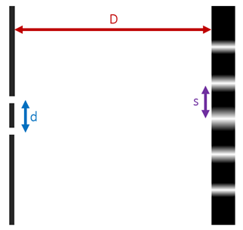
s | Distance between fringes
λ | Wavelength
D | Distance to Screen
d | Distance between slits

