1 | Science Skills | IB Physics Content Guide

Big Ideas
- Units are an arbitrary construct invented by humans to communicate quantitative measurements
- All units can be made up of the 7 Fundamental SI Units
- Metric prefixes and scientific notation can be used to make large or small values easier to communicate
- Units can cancel out when being divided by like units
- Unit analysis can be used to determine the validity of a formula or determine the unit of an unknown solution
- No measurement or calculation from measurement is exact. There is a certain range of uncertainty

Content Objectives

1.2 – Units
I can describe the difference between quantitative and qualitative observations
I can identify the 7 Fundamental SI units
I can define and give an example of a derived unit
I can represent fractional units with negative exponents
I can convert metric units between prefixes

1.3 – Dimensional Analysis
I can convert fraction units and exponential units using Dimensional Analysis
I can use dimensional analysis to verify a formula
I can use dimensional analysis to determine the units for a solution
I can represent large and small numbers using scientific notation
I can compare quantities by orders of magnitude

1.4 – Uncertainty
I can define and compare the terms precision and accuracy
I can define and compare random and systematic error
I can report a measurement to the appropriate level of precision (decimal places)
I can report a measurement with the proper uncertainty for the instrumentation used
I can determine the number of significant digits in a reported value

1.5 – Uncertainty in Calculations
I can calculate the uncertainty of an average taken from repeated measurements
I can define and calculate absolute, fractional, and percent uncertainty
I can determine the uncertainty when adding or subtracting two numbers
I can determine the uncertainty when multiplying or dividing two numbers

1 | Science Skills | Shelving Guide

List the seven fundamental base units and their abbreviations:
 | Unit | Abbreviation
Length | Meter | m
Mass | Kilogram | kg
Time | Second | s
Electric Current | Ampere | A
Temperature | Kelvin | K
Amount of Substance | Mole | mol
Luminous Intensity | Candela | cd

Metric Prefixes – List the unit prefixes in their appropriate decimal position
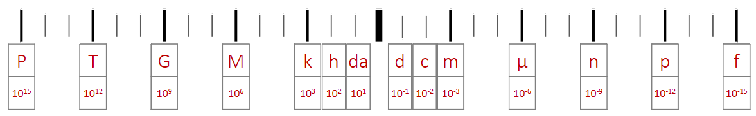

Dimensional Analysis
Convert the following:
20 mi hr⁻¹ m s⁻¹
$$\frac{20 mi}{1 hr}×\frac{1609 m}{1 mi}×\frac{1 hr}{60 min}×\frac{1 min}{60 s}=8.9\frac{m}{s}=8.9 m s^{-1}$$
0.0007 km² m²
$0.0007 {km}^{2}×\frac{1000 m}{1 km}×\frac{1000 m}{1 km}=700 m^{2}$ or $0.0007 {km}^{2}×{\left(\frac{1000 m}{1 km}\right)}^{2}=700 m^{2}$

Determine the units for Q:
Q = mc ΔT  $$Q=\left(kg\right)\left(J {kg}^{-1} K^{-1}\right)\left(K\right)=\frac{\left(kg\right)\left(J\right)\left(K\right)}{kg K}=J$$ | m (mass) | kg
 | c (specific heat) | J kg⁻¹ K⁻¹
 | ΔT (change in temp) | K

Error and Measurements
Define the following terms:
Precision | Accuracy
The degree of exactness in a measurement | The closeness of a measured value to the standard

Random Error | Systematic Error
Imprecise measurements above or below “true” value – Human factor | Error/offset in the instrumentation used to make measurement

Record the rules for recording measurements to the proper precision and uncertainty:
 | Measurement Precision | Measurement Uncertainty
Analog | Estimate 1 digit beyond smallest marking | ± (half the smallest division)
Digital | Go to the lease significant digit’s place | ± (smallest division)
*the precision in the measurement and uncertainty MUST match

Significant Digits
- All zeros between non-zero digits are significant
- Filler zeros to the left of an understood decimal place are not significant.
- Filler zeros to the right of a decimal place are not significant.
- All non-filler zeros to the right of a decimal place are significant.

IB grading will award full credit for answers within 1 significant digit of the actual so round to 3 significant digits

Uncertainty
Absolute Uncertainty:  $$2.0±0.3 g$$ | Data Booklet Equations:
 | If: $y=a±b$  Then: $∆y=∆a+∆b$ | Addition or subtraction: Add up the absolute uncertainties
Fractional Uncertainty:
$$±\frac{0.3}{2.0}$$
 | If: $y=\frac{ab}{c}$  Then: $\frac{∆y}{y}=\frac{∆a}{a}+\frac{∆b}{b}+\frac{∆c}{c}$ | Multiplication or division: Add up the fractional or  percent uncertainties
Percentage Uncertainty:
$$±\left(\frac{0.3}{2.0}×100\%\right)$$

