1 | Science Skills | IB Physics Content Guide

Big Ideas
- Units are an arbitrary construct invented by humans to communicate quantitative measurements
- All units can be made up of the 7 Fundamental SI Units
- Metric prefixes and scientific notation can be used to make large or small values easier to communicate
- Units can cancel out when being divided by like units
- Unit analysis can be used to determine the validity of a formula or determine the unit of an unknown solution
- No measurement or calculation from measurement is exact. There is a certain range of uncertainty

Content Objectives

1.2 – Units
I can describe the difference between quantitative and qualitative observations
I can identify the 7 Fundamental SI units
I can define and give an example of a derived unit
I can represent fractional units with negative exponents
I can convert metric units between prefixes

1.3 – Dimensional Analysis
I can convert fraction units and exponential units using Dimensional Analysis
I can use dimensional analysis to verify a formula
I can use dimensional analysis to determine the units for a solution
I can represent large and small numbers using scientific notation
I can compare quantities by orders of magnitude

1.4 – Uncertainty
I can define and compare the terms precision and accuracy
I can define and compare random and systematic error
I can report a measurement to the appropriate level of precision (decimal places)
I can report a measurement with the proper uncertainty for the instrumentation used
I can determine the number of significant digits in a reported value

 | 1.5 – Uncertainty in Calculations
 | I can calculate the uncertainty of an average taken from repeated measurements
 | I can define and calculate absolute, fractional, and percent uncertainty
 | I can determine the uncertainty when adding or subtracting two numbers
 | I can determine the uncertainty when multiplying or dividing two numbers
1 | Science Skills |  | Shelving Guide

List the seven fundamental base units and their abbreviations:
 | Unit | Abbreviation
Length
Mass
Time
Electric Current
Temperature
Amount of Substance
Luminous Intensity

Metric Prefixes – List the unit prefixes in their appropriate decimal position
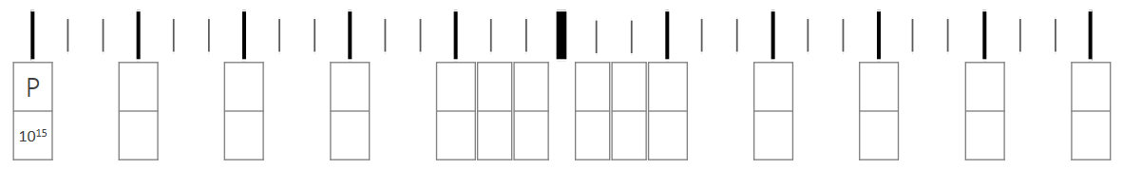

Dimensional Analysis
Convert the following:
20 mi hr⁻¹ m s⁻¹

0.0007 km² m²

Determine the units for Q:
Q = mc ΔT | m (mass) | kg
 | c (specific heat) | J kg⁻¹ K⁻¹
 | ΔT (change in temp) | K

Error and Measurements
Define the following terms:
Precision | Accuracy

Random Error | Systematic Error

Record the rules for recording measurements to the proper precision and uncertainty:
 | Measurement Precision | Measurement Uncertainty
Analog
Digital
*the precision in the measurement and uncertainty MUST match

Significant Digits
- All zeros between non-zero digits are significant
- Filler zeros to the left of an understood decimal place are not significant.
- Filler zeros to the right of a decimal place are not significant.
- All non-filler zeros to the right of a decimal place are significant.

IB grading will award full credit for answers within 1 significant digit of the actual so round to 3 significant digits

Uncertainty
Absolute Uncertainty: | Data Booklet Equations:
If: $y=a±b$
Then: $∆y=∆a+∆b$
Fractional Uncertainty:
If: $y=\frac{ab}{c}$
Then: $\frac{∆y}{y}=\frac{∆a}{a}+\frac{∆b}{b}+\frac{∆c}{c}$
Percentage Uncertainty:

