2 | Motion | IB Physics Content Guide

Big Ideas
- Motion is described relative to a chosen coordinate system.
- Displacement-time, velocity-time, and accel-time graphs are connected in the representation of physical motion.
- When an object is at constant velocity, displacement-time is linear.
- When an object is at constant acceleration, displacement-time is quadratic (curved), and velocity-time is linear.
- Kinematic equations can take three of the suvat variables to solve for the remaining two
- Vector quantities can be combined to find resultant vectors or divided into their component parts
- X and Y motion are independent of each other for a two-dimensional projectile

Content Objectives

2.1 – Velocity
I can describe the difference between distance and displacement
I can calculate distance and displacement for 1D and 2D straight line motion
I can describe the difference between speed and velocity
I can compare the difference between a vector and scalar quantity
I can solve problems using the mathematical definition of constant velocity
I can plot constant velocity on a displacement vs time graph
I can calculate velocity from a displacement vs time graph
I can describe the difference between speed and velocity

2.2 – Acceleration
I can define acceleration in terms of velocity
I can graphically compare “average” and “instantaneous” velocity
I can calculate constant acceleration from a velocity vs time graph
I can calculate displacement from a velocity vs time graph
I can use the kinematic equations to solve for an unknown variable
I can describe when the kinematic equations are no longer valid

2.3 – Free Fall
I can identify the constant acceleration due to gravity neglecting air resistance
I can interpret a free fall problem to identify hidden values
I can use the kinematic equations to solve free fall problems
I can experimentally determine the acceleration due to gravity

2.4 – Graphing Motion
I can describe an object’s motion by interpreting its displacement vs time and velocity vs time graphs
I can create d vs t, v vs t, and a vs t graphs for an object in freefall
I can create a velocity vs time graph when given a displacement vs time graph
I can create a displacement vs time graph when given a velocity vs time graph

2.5 – Horizontal Projectiles
I can add and subtract vectors to find a resultant
I can calculate an angle from two components of a right triangle
I can calculate the x and y components of a vector given the magnitude and angle
I can identify hidden values for a horizontal projectile problem
I can use information about a horizontal projectile’s motion to calculate the initial velocity
I can use the x and y velocity components to calculate a projectile’s impact velocity and angle

2.6 – Projectiles at an Angle
I can identify hidden values for a projectile launched at an angle
I can calculate the x and y components for an initial velocity at an angle
I can calculate max height for a projectile launched at angle
I can calculate distance traveled for a projectile launched at angle
I can calculate total air time for a projectile launched at angle

2 | Motion | Shelving Guide

 | Scalar | Vector
How far (m) | Distance | Displacement
How fast (m s⁻¹) | Speed | Velocity

 | Displacement vs Time | Velocity vs Time | Acceleration vs Time
Meaning of the Graph | Slope:  Velocity | Slope: Acceleration  Area under the Curve:  Displacement | Area under the Curve:  Velocity
Constant Displacement | 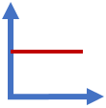 | 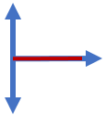 | 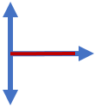
Constant Positive Velocity | 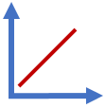 | 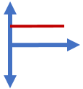
Constant Negative Velocity | 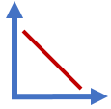 | 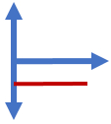
Constant Positive Acceleration  (speeding up) | 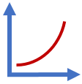 | 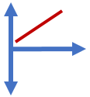 | 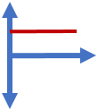
Constant Negative Acceleration  (slowing down) | 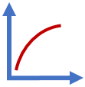 | 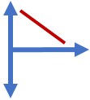 | 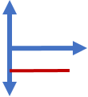

 | Variable Symbol | Unit |  | Kinematic Equations | s | u | v | a | t
Displacement | s | m |  | $$v=u+at$$ |  | ✔️ | ✔️ | ✔️ | ✔️
Initial Velocity | u | m s⁻¹ |  | $$s=ut+\frac{1}{2}at^{2}$$ | ✔️ | ✔️ |  | ✔️ | ✔️
Final Velocity | v | m s⁻¹ |  | $$v^{2}=u^{2}+2as$$ | ✔️ | ✔️ | ✔️ | ✔️
Acceleration | a | m s⁻² |  | $$s=\frac{\left(v+u\right)t}{2}$$ | ✔️ | ✔️ | ✔️ |  | ✔️
Time | t | s

Horizontal Component | $$A_{H}=A\cos{θ}$$ | 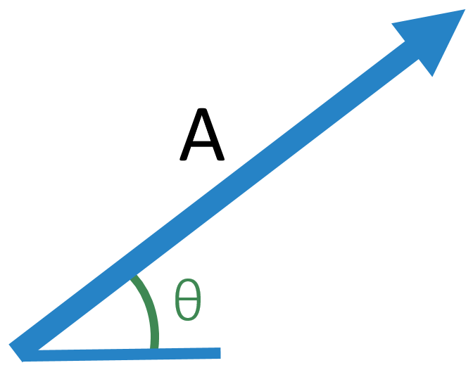
Vertical Component | $$A_{V}=A\sin{θ}$$

 | Vertical | 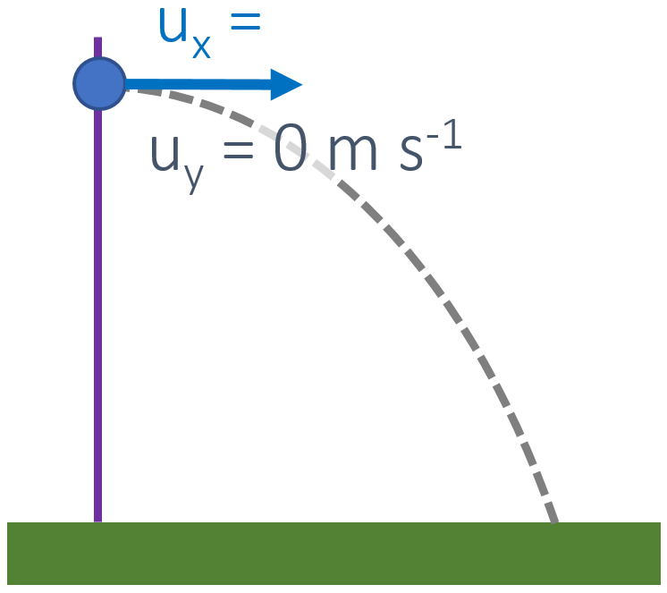
s
u | 0 m s⁻¹
v
a | -9.81 m s⁻²
t

 | Vertical | 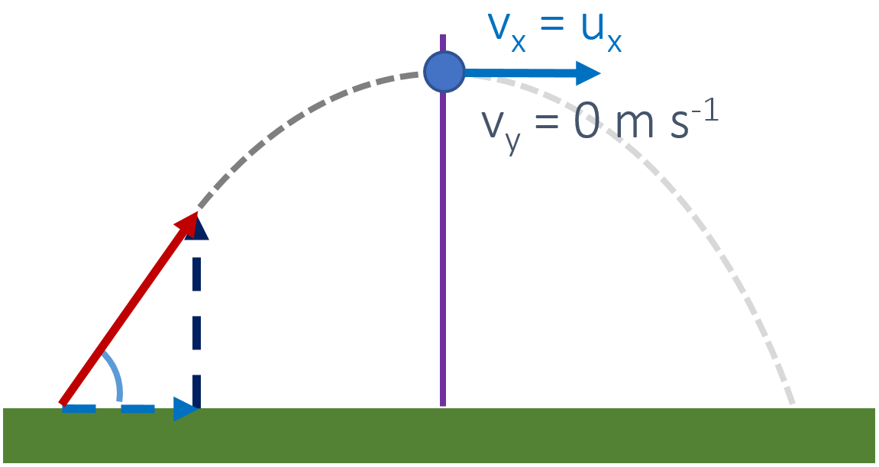
s
u | u sinθ
v | 0 m s⁻¹
a | -9.81 m s⁻²
t

