2 | Motion | IB Physics Content Guide

Big Ideas
- Motion is described relative to a chosen coordinate system.
- Displacement-time, velocity-time, and accel-time graphs are connected in the representation of physical motion.
- When an object is at constant velocity, displacement-time is linear.
- When an object is at constant acceleration, displacement-time is quadratic (curved), and velocity-time is linear.
- Kinematic equations can take three of the suvat variables to solve for the remaining two
- Vector quantities can be combined to find resultant vectors or divided into their component parts
- X and Y motion are independent of each other for a two-dimensional projectile

Content Objectives

2.1 – Velocity
I can describe the difference between distance and displacement
I can calculate distance and displacement for 1D and 2D straight line motion
I can describe the difference between speed and velocity
I can compare the difference between a vector and scalar quantity
I can solve problems using the mathematical definition of constant velocity
I can plot constant velocity on a displacement vs time graph
I can calculate velocity from a displacement vs time graph
I can describe the difference between speed and velocity

2.2 – Acceleration
I can define acceleration in terms of velocity
I can graphically compare “average” and “instantaneous” velocity
I can calculate constant acceleration from a velocity vs time graph
I can calculate displacement from a velocity vs time graph
I can use the kinematic equations to solve for an unknown variable
I can describe when the kinematic equations are no longer valid

2.3 – Free Fall
I can identify the constant acceleration due to gravity neglecting air resistance
I can interpret a free fall problem to identify hidden values
I can use the kinematic equations to solve free fall problems
I can experimentally determine the acceleration due to gravity

2.4 – Graphing Motion
I can describe an object’s motion by interpreting its displacement vs time and velocity vs time graphs
I can create d vs t, v vs t, and a vs t graphs for an object in freefall
I can create a velocity vs time graph when given a displacement vs time graph
I can create a displacement vs time graph when given a velocity vs time graph

2.5 – Horizontal Projectiles
I can add and subtract vectors to find a resultant
I can calculate an angle from two components of a right triangle
I can calculate the x and y components of a vector given the magnitude and angle
I can identify hidden values for a horizontal projectile problem
I can use information about a horizontal projectile’s motion to calculate the initial velocity
I can use the x and y velocity components to calculate a projectile’s impact velocity and angle

2.6 – Projectiles at an Angle
I can identify hidden values for a projectile launched at an angle
I can calculate the x and y components for an initial velocity at an angle
I can calculate max height for a projectile launched at angle
I can calculate distance traveled for a projectile launched at angle
I can calculate total air time for a projectile launched at angle

2 | Motion | Shelving Guide

 | Scalar | Vector
How far (m)
How fast (m s⁻¹)

 | Displacement vs Time | Velocity vs Time | Acceleration vs Time
Meaning of the Graph | Slope: | Slope:  Area under the Curve: | Slope:  Area under the Curve:
Constant Displacement
Constant Positive Velocity
Constant Negative Velocity
Constant Positive Acceleration
(speeding up)
Constant Negative Acceleration
(slowing down)

 | Variable Symbol | Unit |  | Kinematic Equations | s | u | v | a | t
Displacement
Initial Velocity
Final Velocity
Acceleration
Time

Horizontal Component | A_{H} = | 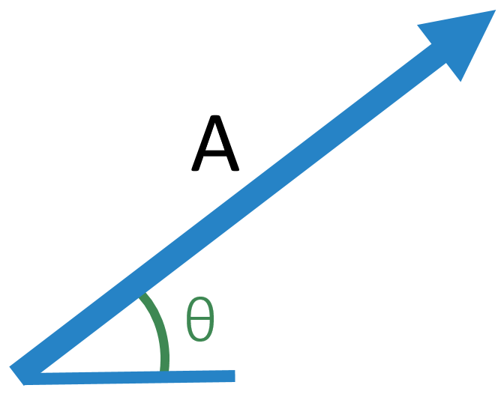
Vertical Component | A_{V} =

 | Vertical | 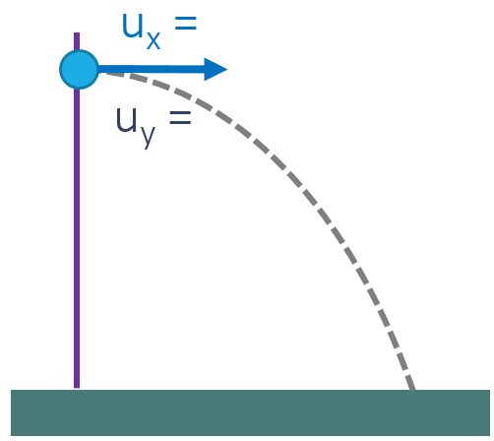
s
u
v
a
t

 | Vertical | 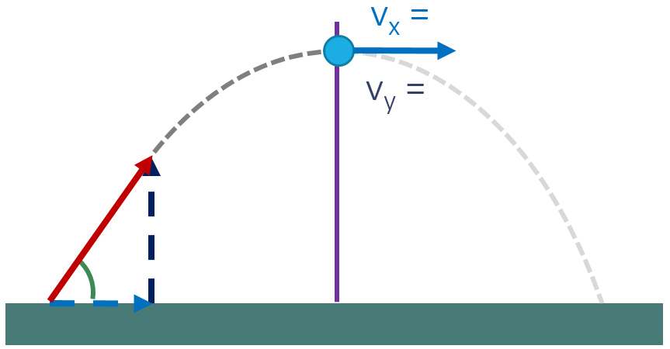
s
u
v
a
t

