Astrophysics | IB Physics Content Guide

Big Ideas
- A variety of measurements from earth can be used to calculate the distance of stars and galaxies
- The scale of our universe is so vast that we need to define new units to help conceptualize its overall size
- It is possible to measure the emission or absorption spectrum of a star to determine its composition
- The properties of stars can be organized into a chart and used to predict the future life cycles

Content Objectives

1 – The Scale of Astrophysics
I can describe the relative scale of the solar system
I can identify the defining characteristics required for a celestial body to be a planet
I can define a light year (ly) as a unit of distance in terms of meters
I can define the meaning of one astronomical unit (AU)
I can relate degrees and seconds as units of angular measurement
I can describe the meaning of 1 parsec as a unit of distance

2 – Stellar Quantities
I can describe the phenomenon of stellar parallax and how it can be used to measure distance
I can calculate distance in parsecs of a nearby star when given the parallax angle in arc seconds
I can compare the definitions of brightness and luminosity
I can conceptually describe the relationship between a star’s brightness and distance from viewer
I can calculate the brightness of a star with a known luminosity and distance
I can describe how different stars can appear the same brightness on earth
I can use Wien’s Displacement Law to mathematically relate peak wavelength and temperature
I can use Stefan-Boltzmann’s Law to mathematically relate luminosity, radius and temperature

3 – H-R Diagrams and Stellar Spectra
I can place a star on an axis showing luminosity vs temperature
I can describe the organization of the Hertzsprung-Russell Diagram
I can use the main sequence to calculate the distance of a star from its wavelength and brightness
I can proportionally relate a star’s luminosity to its mass
I can identify the chemical makeup of a star from its absorption spectrum

4 – Evolution of Stars
I can predict the relative life span of a star based on its type
I can explain the process of stellar equilibrium and how the temperature affects size
I can describe the life cycle of a low mass star like the Sun and plot it on an H-R Diagram
I can describe the nature and formation process of a white dwarf star
I can define the Chandrasekhar Limit as the maximum mass of a core that can become a white dwarf
I can define the Oppenheimer-Volkhoff Limit as the maximum mass of a neutron star
I can predict the fate of a star based on its mass

5 – The Expanding Universe
I can describe the nature of Cephid Variables
I can use a table to relate the luminosity and period of a Cephid Variable
I can outline the process that results in a Type IA Supernova
I can describe the value of a “standard candle” in making measurements about distance
I can use wavelength shift to calculate the relative speed of an object
I can describe the important discovery that Hubble made when analyzing redshift of distant stars
I can relate the distance of an object to its relative velocity using the Hubble Constant
I can calculate redshift based on the expansion of the universe

6 – The Beginning and The End
I can describe the different methods to find the distances of objects based on magnitude
I can use Hubble’s constant to estimate the age of the universe
I can outline the steps in the Big Bang
I can describe the CMB and why it is important evidence of the Big Bang
I can provide the peak wavelength and average temperature of the CMB
I can describe the current theory about the expansion of the universe

Astrophysics | Shelving Guide

The Scale of Astrophysics
Unit Conversion | Definition
1 light year (ly) =
1 parsec (pc) =
1 astronomical unit (AU) =

Stellar Quantities
Brightness | Luminosity

 | Variable Symbol | Unit |  | Data Booklet Equations:
Distance |  |  |  | $$d \left(parsec\right)= \frac{1}{p (arc-second)}$$
Parallax Angle
Brightness |  |  |  | $$b=\frac{L}{4πd^{2}}$$
Luminosity
Max Wavelength |  |  |  | $$λ_{max}T=2.9×{10}^{-3} m K$$
Temperature |  |  |  | $$L=σAT^{4}$$
Surface Area |  |  |  | $$σ=5.67×{10}^{-8} W{ m}^{-2} K^{-4}$$

Describe the process of Stellar Parallax:

H-R Diagrams and Life Cycle of a Star
Label the Following:  - Main Sequence  - White Dwarfs  - Red Giants  - The Sun  - Line representing the life cycle of our sun | 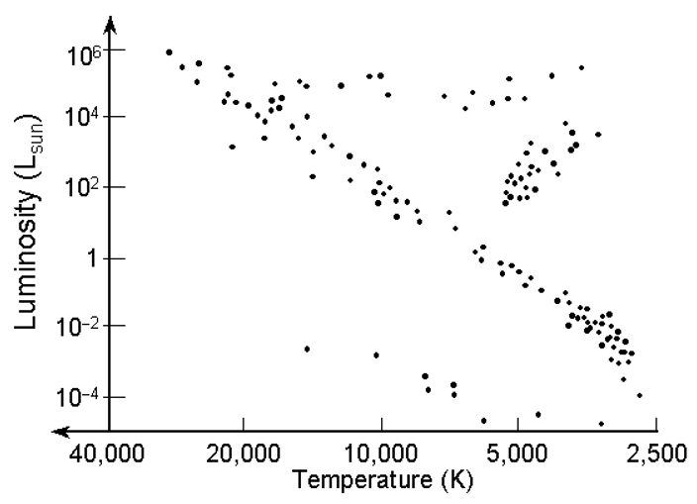

Chandrasekhar Limit |  | Oppenheimer-Volkhoff Limit
Sun Like Stars (< 1.5 M_{ʘ})  ⬇ | Huge Stars (1.5 – 3 M_{ʘ})  ⬇ |  | Giant Stars (> 3 M_{ʘ})  ⬇

The Expanding Universe
Standard Candles | Evidence for Expanding Universe

 | Variable Symbol | Unit |  | Data Booklet Equations:
Redshift |  | --- |  | $$z=\frac{∆λ}{λ_{0}}≈\frac{v}{c}$$
Change in Wavelength
Original Wavelength |  |  |  | $$z=\frac{R}{R_{0}}-1$$
Relative Velocity of Source
Speed of Light |  |  |  | $$v=H_{0}d$$
Current Scale Factor |  | ---
Scale Factor when Emitted |  | --- |  | $$c=3.00×{10}^{8} m s^{-1}$$
Hubble’s Constant |  |  |  | $$H_{0}≈$$

The Big Bang
 | Peak Wavelength | Temperature
Cosmic Microwave Background Radiation

Describe why the CMB is evidence of the Big Bang:

