Bonding Breakout – Outline

Game Name: What is the name or title of the game you are designing?
Bonding Breakout

Game Designer: Your Name
Joe Cossette

Content Standards: What must students be able to do in order to complete the breakout
- Drawing Lewis Dot Diagrams
- Creating neutral compounds from ions
- Naming ionic compounds
- Multivalent Metals
- Polyatomic Ions
- Covalent Bonding

Suggested Time: How long do you anticipate players needing to complete this game?
30-40 minutes

Lock Combinations: What codes will open the locks on the box?
3-Digit Lock - 3 Numbers | 458
4-Digit Lock - 4 Numbers | 1324
ABC Lock - 4 Letters for the ABC Multilock | NAOH
Lockbox - 3 Numbers | 743
Key Lock #1 - Where is the key hidden? | Taped on Periodic Table

Process Overview: Diagram representing the path to each lock
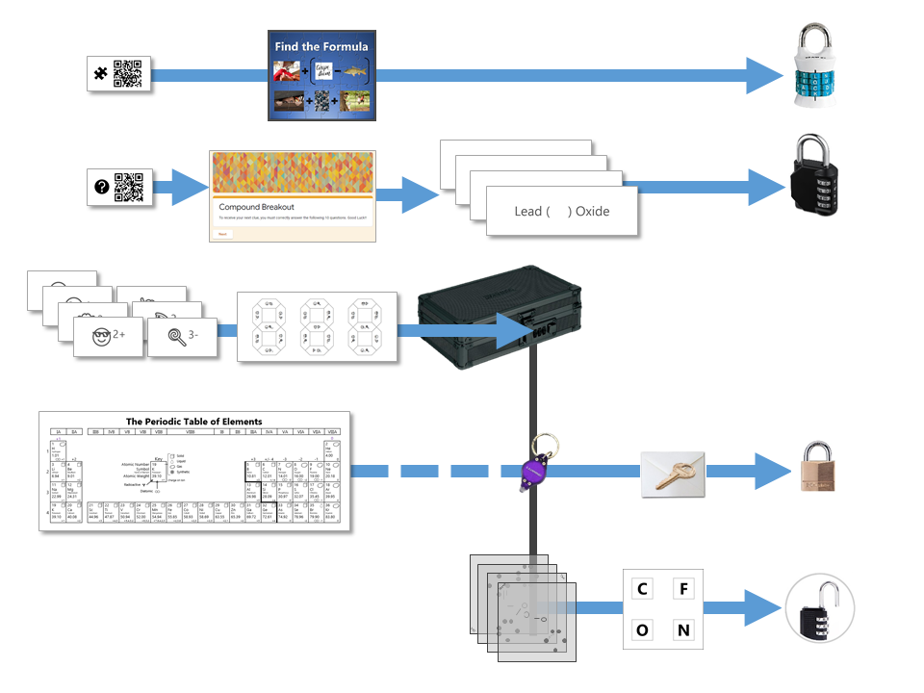

The Clues: Describe the path required to open each lock
Clue #1  [ABC Lock] | To access this clue, students must scan the QR code found on the back of one of the 7 ion cards hidden in the box's top compartments. This link will take them to an online jigsaw puzzle that they must complete to reveal the hidden message  This pictogram puzzle is intended to guide groups to the chemical formula of Sodium Hydroxide (NaOH) to open the 4 letter alpha lock.  Sew + (Carpe Diem - Carp)  Hide + Rocks + Hide
Clue #2  [4-Digit Lock] | Groups are given 4 cards at the start of the task with a multivalent ionic compound formula on one side and an incomplete name of that formula on the other. They must use the chemical formula to complete the missing roman numeral for the corresponding name.  The result of this step is that students should have the numbers 1-4 but don't know the sequence required for the combination. To discover that sequence, groups need to compete a google form quiz. The link to this form is linked through the QR code on the back of one of the seven cards stored in the top compartments of the toolbox.  The google form is set up with a series of multiple choice questions. Each question includes a photo of a chemical compound with its name or formula listed below it. Students are responsible for identifying the corresponding name or formula among a list of worthy distractors.  As they go through the form, they do not get any feedback until they complete the tenth and final question. If they did not answer every single question correctly, they will receive a message informing them that they made at least one error but doesn't provide them with any information about how many questions were wrong or which ones they missed.  If they correctly answer each question they get to the "Congratulations" with the ability to submit the form and retrieve their secret message.  When they submit the form, they receive the confirmation message shown below:  ​  “Can you feel the MERCURY rising? It's time to IRON out all of the kinks and keep working persistently through thick and TIN. Set the example and others will follow your LEAD!”  This clue corresponds to the metal used in each of the four multivalent compounds on the cards and indicates the order in which to organize the numbers to create the combination to unlock the 4-digit number lock.
Clue #3  [Small Box] | Students will locate the 7 ion cards in the top compartments of the toolbox. Each of these ion cards presents an emoji with a charge. From the four cations and 3 anions included in the deck of cards, there are 12 possible "compound formulas" that could be formed by neutralizing the charges with the proper ratio of each emoji.  Hopefully, students will recognize that there is a clue taped to the back of the toolbox that contains the same emoji symbols as the cards. If they fill in the shapes that contain viable compounds, they will reveal the 3 digit number combination to get into the small box.  This clue can be challenging so it might be necessary to provide some hints to students to get them started. If needed, it could also be useful to use the provided scaffold to help them keep track of all 12 possible combinations. It also provides a clue in how the emojis can be combined to form "compounds" in the same way that any ion on the periodic table can.
Clue #4  [Key Lock] | Once inside the small box, students gain access to the UV flashlight. Before laminating the ion cards, I used a uv marker to write the words "Periodic" and "Table" on the backs of the two blank ion cards. I also used the marker to fill in one of the elements on the periodic table card that gets taped to the bottom of the toolbox.  Once the students know the element that is highlighted on their periodic table clue, they can locate the corresponding element envelope taped to the periodic table poster or white board in the front of the room. This envelope contains the missing key for the Masterlock on their box.  Set up note:  Before class, I taped some small envelopes to the large periodic table poster in my room. For the elements that have been highlighted with the UV marker, I placed the key that matches the box with the corresponding clue. For my own sanity and ease in set up, I hid each key in the element with the atomic number that was twice the value of the breakout kit at that station. For example, the breakout box that I had labeled with a #4, their clue led them to Oxygen (atomic number 8). This way, they still had to find the clue but it was simple enough to know how to set everything back up. Of course, it would be easy to use this clue to each group to any element that you want.
Clue #5  [3-Digit Lock] | For the 5th and final lock, students receive a set of transparencies along with a square card displaying 4 element symbols. Each of the transparencies contains a series of dots representing the Lewis Dot Structure of one of the elements included on the square card. If all of the pieces are overlaid correctly, they will reveal the combination for the 3-digit number lock.  Since the image on the transparencies can be viewed just as easily on either side of the card, each one contains a small word in the corner. In order for the puzzle to work appropriately, each card must be flipped so that this word can be read as normal.

Printing the Clues: Any special instructions about printing any of the clues? (i.e. double-sided, color, etc.)
- Clue 1 is double-sided so that the ion cards include the useful clues and QR codes. This file contains 3 sets of cards.
- Clue 2 is single-sided and contains 3 "emoji compound" cards. This file also contains an optional scaffold to help students track the possible compound combinations.
- Clue 3 is double-sided so that the multivalent cards have the proper formula on the back
- Clue 4 has one page to print on paper and one page that must be printed on a transparency. (I was able to track down several packs in our school but you can find some here if you need some). Note: I found these to curl after they were printed. Laminating the transparencies left them significantly flatter and more durable.
- Clue 5 will need to be marked with a UV marker after it is printed

Setting up the Breakout Task: What goes where?
Inside the Big Box | - It’s a good idea to fill the big box with something like candy for students to discover after they solve the puzzle. In this task, the prize is the only thing that you need to prepare for inside the big box before locking it up.
Outside Big Box | - Place the 7 ion cards in the compartments on the top of the box. If your box doesn't have these handy hiding places. You can just provide these cards in an envelope or something  - Tape the "888" clue with emoji compounds on the back of the big box  - Tape the periodic table with UV marker highlights on the bottom of the box
Inside Small Box | - Include the ultraviolet flashlight. There are nice little pouches in mine that the flashlight fits inside of  - Place the transparent puzzle pieces and square puzzle base inside the box
On the Table | - Place the four multivalent compound cards in a stack or envelope and leave it on the table next to the boxes  - Dry Erase Markers - Since I laminated my cards, I just had students use the markers to write on these directly. If you have large whiteboards, this could be a good opportunity to pull those out as well  - Something to read a QR code with. This isn't really something that you need to set out, just make sure that someone in the group has an iPad or phone that can scan a QR Code.
On the Periodic Table Poster or Front Whiteboard: | - Make small envelopes with the first 18 element symbols written on the front of each  - Hide keys in the proper envelopes as indicated by the highlighted periodic table clues on each corresponding box  - Tape envelopes on Periodic Table poster if there is one accessible in the room. These envelopes could also be taped on a white board in periodic table configuration.

Reset Instructions: Diagram for groups to reset after solving
