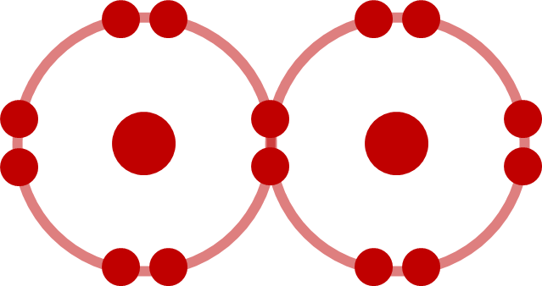  Covalent  (prefixes) | 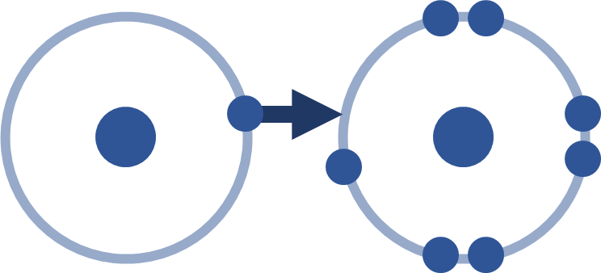  Ionic  (charges) | Ionic  (charges) |  | Multivalent  Multiple charges  (I) (II) (III) (IV) | Multivalent  Multiple charges  (I) (II) (III) (IV) | Multivalent  Multiple charges  (I) (II) (III) (IV) |  | Covalent  (prefixes) | Ionic  (charges) | Ionic  (charges)
Covalent  (prefixes) | Ionic  (charges) | Ionic  (charges) |  | Multivalent  Multiple charges  (I) (II) (III) (IV) | Multivalent  Multiple charges  (I) (II) (III) (IV) | Multivalent  Multiple charges  (I) (II) (III) (IV) |  | Covalent  (prefixes) | Ionic  (charges) | Ionic  (charges)
Covalent  (prefixes) | Ionic  (charges) | Ionic  (charges) |  | Multivalent  Multiple charges  (I) (II) (III) (IV) | Multivalent  Multiple charges  (I) (II) (III) (IV) | Multivalent  Multiple charges  (I) (II) (III) (IV) |  | Covalent  (prefixes) | Ionic  (charges) | Ionic  (charges)
Covalent  (prefixes) | Ionic  (charges) | Ionic  (charges) |  | Multivalent  Multiple charges  (I) (II) (III) (IV) | Multivalent  Multiple charges  (I) (II) (III) (IV) | Multivalent  Multiple charges  (I) (II) (III) (IV) |  | Covalent  (prefixes) | Ionic  (charges) | Ionic  (charges)
Covalent  (prefixes) | Ionic  (charges) | Ionic  (charges) |  | Multivalent  Multiple charges  (I) (II) (III) (IV) | Multivalent  Multiple charges  (I) (II) (III) (IV) | Multivalent  Multiple charges  (I) (II) (III) (IV) |  | Covalent  (prefixes) | Ionic  (charges) | Ionic  (charges)
Covalent  (prefixes) | Ionic  (charges) | Ionic  (charges) |  | Polyatomic  >2 Elements  List on Back | Polyatomic  >2 Elements  List on Back | Polyatomic  >2 Elements  List on Back |  | Covalent  (prefixes) | Ionic  (charges) | Ionic  (charges)
Covalent  (prefixes) | Ionic  (charges) | Ionic  (charges) |  | Polyatomic  >2 Elements  List on Back | Polyatomic  >2 Elements  List on Back | Polyatomic  >2 Elements  List on Back |  | Covalent  (prefixes) | Ionic  (charges) | Ionic  (charges)
Covalent  (prefixes) | Ionic  (charges) | Ionic  (charges) |  | Polyatomic  >2 Elements  List on Back | Polyatomic  >2 Elements  List on Back | Polyatomic  >2 Elements  List on Back |  | Covalent  (prefixes) | Ionic  (charges) | Ionic  (charges)
Covalent  (prefixes) | Ionic  (charges) | Ionic  (charges) |  | Polyatomic  >2 Elements  List on Back | Polyatomic  >2 Elements  List on Back | Polyatomic  >2 Elements  List on Back |  | Covalent  (prefixes) | Ionic  (charges) | Ionic  (charges)
Covalent  (prefixes) | Ionic  (charges) | Ionic  (charges) |  | Polyatomic  >2 Elements  List on Back | Polyatomic  >2 Elements  List on Back | Polyatomic  >2 Elements  List on Back |  | Covalent  (prefixes) | Ionic  (charges) | Ionic  (charges)

