Circuits Breakout – Outline

Game Name: What is the name or title of the game you are designing?
Circuits Breakout

Game Designer: Your Name
Joe Cossette

Content Standards: What must students be able to do in order to complete the breakout
- Calculate equivalent resistance in series, parallel, and combination circuits
- Use Ohm’s Law to calculate Voltage, Current, or Resistance in a circuit
- Calculate Voltage, Current, or Resistance for individual resistors in a circuit

Suggested Time: How long do you anticipate players needing to complete this game?
20-40 minutes

Lock Combinations: What codes will open the locks on the box?
3-Digit Lock - 3 Numbers | 112
4-Digit Lock - 4 Numbers | 6382
ABC Lock - 4 Letters for the ABC Multilock | NEAT
Lockbox - 3 Numbers | 105
Key Lock #1 - Where is the key hidden? | Inside Small Lockbox
Key Lock #2 - Where is the key hidden? | *Not Used*

Process Overview: Diagram representing the path to each lock
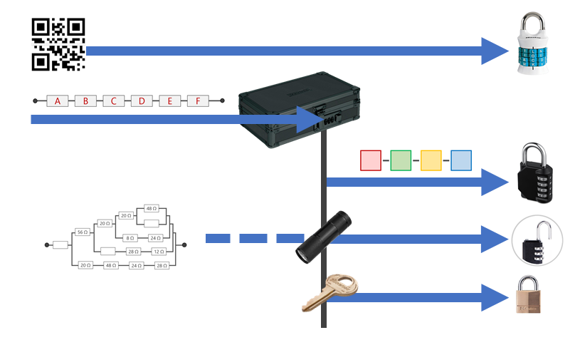

The Clues: Describe the path required to open each lock
Clue #1  [ABC Lock] | Groups have access to everything that they need to unlock the first lock in the one page flyer that they get on their table. This flyer contains a QR code that has been modified by taking out the middle row of information. Because of this, it isn't possible to get information from it until the proper squares have been filled in.  The combination circuit on the bottom of the page is the key for completing the missing QR code information. Once the voltage, current, and resistance have been solved for in the provided table, groups will notice that the numbers that they filled in correspond to numbers written in 12 of the missing cells on the QR code. Once they fill in the proper squares, they will be able to read the message using any QR code reader. The encoded message reveals the combination for the word lock.
Clue #2  [Small Box] | The cards needed to solve for the small box's combination lock are found stored away in the organizers on the top of the large box. Each of these 6 cards has a letter A-F on one side and an equivalent resistance problem on the other side. I intentionally designed this clue to be in 6 different pieces so that students could each contribute on an individual level by taking a card or two. They are of varying levels of difficulty and I was delighted to watch my students differentiating the task by dividing up the cards based on their comfort level tackling problems like this!  Once they figure out all of the cards, they need to find the series resistor taped on the back of the large box to understand that each of the cards must be added to result in the three-digit combination that opens the small box
Clue #3  [4-Digit Lock] | For the third lock, students have access to the color sequence shown below at the start of the task since it is taped to the outside of the small box, but they don't have the clues to help them fill in the blanks until they can unlock the box and get inside  Once inside the small box, they have access to the four clue cards shown on the right. Each of these is a different style of circuit problem to solve. Instead of requesting the information in a word problem, the cards are purely symbolic with a colored box highlighting the information needed to complete the color sequence that the students noticed earlier.  One of my favorite parts about this clue is that the color sequence doesn't have a clear orientation. I had a bunch of groups double and triple checking each other's work (score!) only to find that they had been trying the combination backwards!
Clue #4  [3-Digit Lock] | The combination for lock #4 comes from the equivalent resistance of the beautiful combination of resistors shown here. This problem is actually really fun to solve and the groups have access to it right away at the start of the task (it is taped to the bottom of the large box) but they are missing some necessary information.  Once they unlock the small box, they notice that there is a small ultraviolet flashlight that, when directed at the blank cells, reveals the missing information. This is a super exciting reveal and definitely my student's favorite moment of the challenge. :)
Clue #5  [Key Lock #1] | The fifth lock is the easiest one. Once the groups get inside the small box and search through all of things they now have access to, they find the key for their missing lock inside of a little zippered pouch. In future breakout tasks, I plan to hide this somewhere else in the classroom (or even the building) but I wanted to keep it a little simpler for this first one.

Printing the Clues: Any special instructions about printing any of the clues? (i.e. double-sided, color, etc.)
- Clue 1 is double-sided so that each equivalent resistance problem gets a letter A-F
- Clue 3 requires color printing to help map the solutions to a combination sequence
- Clue 4 requires a little Invisible Ink that students will be able to reveal using the Ultraviolet flashlight. You will need to use an Invisible Ink UV marker to fill in the missing resistors by hand as shown in the picture below
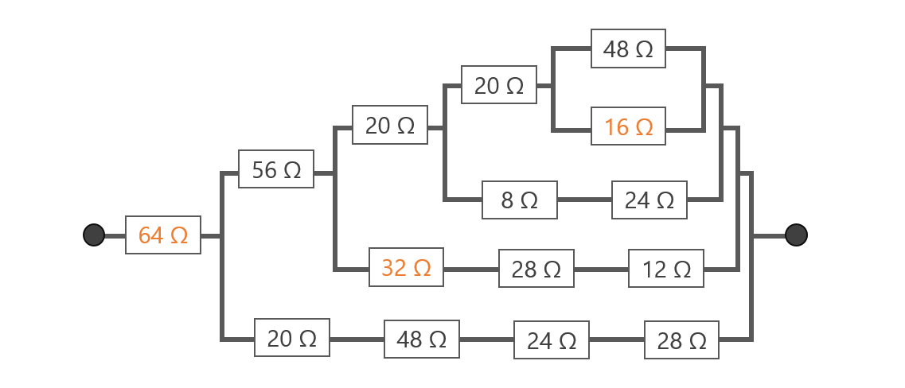

Setting up the Breakout Task: What goes where?
Inside the Big Box | - It’s a good idea to fill the big box with something like candy for students to discover after they solve the puzzle. In this task, the prize is the only thing that you need to prepare for inside the big box before locking it up.
Outside Big Box | - Place the A-F equivalent resistance cards in the organizers on top of the box. If your box doesn't have these handy hiding places. You can just provide these cards in an envelope or something  - Tape the A-B-C-D-E-F series circuit card on the back of the big box  - Tape the large equivalent resistance card (the one with the invisible ink) on the bottom of the box
Inside Small Box | - Hide the key for the Masterlock in one of the pouches on the inside of the small box. If your small box doesn't have this feature, it's ok to have the key loose in the box as well  - Include the Ultraviolet Flashlight. There is a nice little pouch made of netting in mine that the flashlight fit nicely inside  - Place the 4 color clue problems in a stack inside the box.
Outside Small Box | - Tape the color sequence card to the outside of the small box
On the Table | - I just left the QR Code clue on the table with the boxes. You could probably hide this somewhere else as well.  - Dry Erase Markers - Since I laminated my cards, I just had students use the markers to write on these directly. If you have large whiteboards, this could be a good opportunity to pull those out as well  - Something to read a QR code with. This isn't really something that you need to set out, just make sure that someone in the group has an iPad or phone that can scan a QR Code.

Reset Instructions: Diagram for groups to reset after solving
