Circuits Scavenger Hunt – Outline

Game Name: What is the name or title of the game you are designing?
Circuits Scavenger Hunt

Game Designer: Your Name
Joe Cossette

Content Standards: What must students be able to do in order to complete the task
- Calculate equivalent resistance in series, parallel, and combination circuits
- Use Ohm’s Law to calculate Voltage, Current, or Resistance in a circuit
- Calculate Voltage, Current, or Resistance for individual resistors in a circuit

Suggested Time: How long do you anticipate players needing to complete this task?
20-40 minutes

Running the Task
Students will should work in small groups of 3-5. Each group will start with envelope 1 on their desk. The objective is to complete checkpoints by interpreting the clues and determining the secret passwords. Once groups think they have correctly filled in their checkpoint password, they must check in with the gamemaster (most likely the teacher), and if correct, receive their next envelope. Groups successfully complete the scavenger hunt by completing all 5 checkpoints and correctly answering their final problem.

Checkpoint Answers
Checkpoint #1 | 105
Checkpoint #2 | 6382
Checkpoint #3 | 112
Checkpoint #4 | NEAT

Process Overview: Diagram representing the path to each checkpoint answer
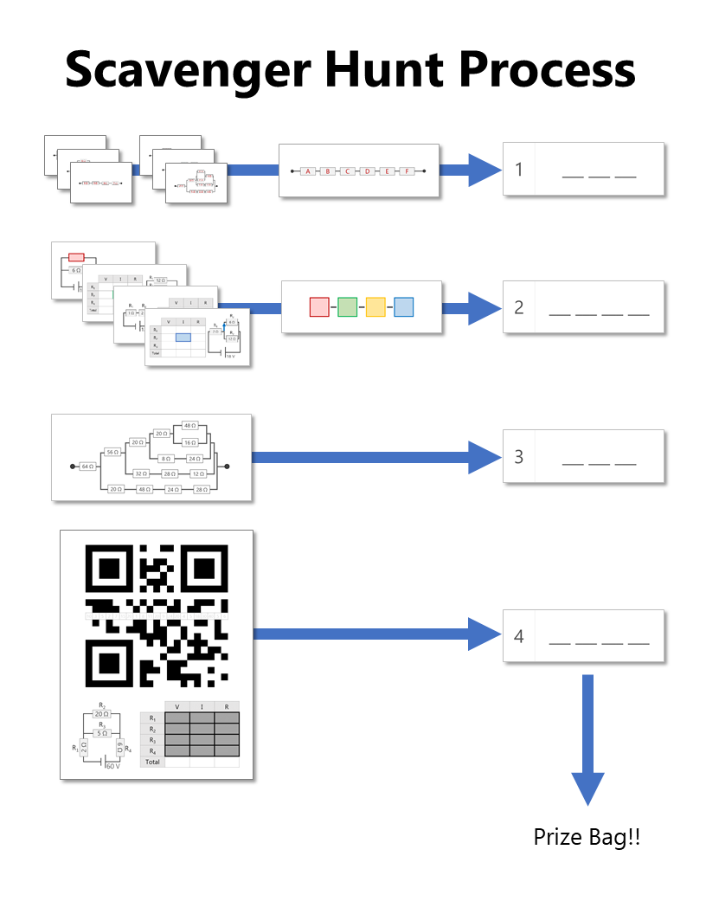

The Clues: Describe the path required to answer each checkpoint
Checkpoint #1  [3 blanks] | ​Groups start the task with an envelope filled with 6 cards with a letter A-F on one side and an equivalent resistance problem on the other side. This clue is intentionally designed to be in different pieces so that students could each contribute on an individual level by taking a card or two. They are of varying levels of difficulty and often students will differentiate the task by dividing up the cards based on their comfort level tackling problems like this.  Once they figure out all of the cards, they need to find the series resistor (shown below) on one side of another card in the envelope to understand that each of the cards must be added to result in the three-digit password to gain access to the next envelope
Checkpoint #2  [4 blanks] | For Checkpoint #2, students have access to the color sequence shown below at the start of the task since it is on the back of the series circuit from checkpoint #1, but they don't have the clues to help them fill in the blanks until they get their next envelope.  Once inside the Clue #2 envelope, they have access to the four clue cards shown on the right. Each of these is a different style of circuit problem to solve. Instead of requesting the information in a word problem, the cards are purely symbolic with a colored box highlighting the information needed to complete the color sequence that the students noticed earlier.  One of my challenging parts about this clue is that the color sequence doesn't have a clear orientation. I've had a bunch of groups double and triple checking eachother's work (score!) only to find that they had been trying the combination backwards!
Checkpoint #3  [3 blanks] | The password for Checkpoint #3 comes from the equivalent resistance of the beautiful combination of resistors shown here. This problem is actually really fun to solve and when it is finally simplified to a single equivalent resistance, it will be a 3 digit number that will gain access to the next envelope
Checkpoint #4  [4 blanks] | In the final envelope, students receive the one page flyer shown here. This flyer contains a QR code that has been modified by taking out the middle row of information. Because of this, it isn't possible to get information from it until the proper squares have been filled in.  The combination circuit on the bottom of the page is the key for completing the missing QR code information. Once the voltage, current, and resistance have been solved for in the provided table, groups will notice that the numbers that they filled in correspond to numbers written in 12 of the missing cells on the QR code. Once they fill in the proper squares, they will be able to read the message using any QR code reader. The encoded message reveals the final password to complete Checkpoint #4.

Printing the Clues: Any special instructions about printing any of the clues? (i.e. double-sided, color, etc.)
- Clue 1 is double-sided so that each equivalent resistance problem gets a letter A-F
- Clues 1 and 2 require color printing to help map the solutions to a combination sequence

Setting up the Breakout Task: What goes where?
1st Clue Envelope  on table | - Checkpoint #1 answer card with 3 blanks  - Card with series circuit on one side and color sequence on the other  - 6 equivalent resistance cards labeled A-F
2nd Clue Envelope | - Checkpoint #2 answer card with 4 blanks  - 4 circuit cards with colored boxes
3rd Clue Envelope | - Checkpoint #3 answer card with 3 blanks  - Large equivalent resistance card
4th Clue Envelope | - Checkpoint #4 answer card with 4 blanks  - QR Code Circuit flyer

Reset Instructions: Diagram for groups to reset after solving
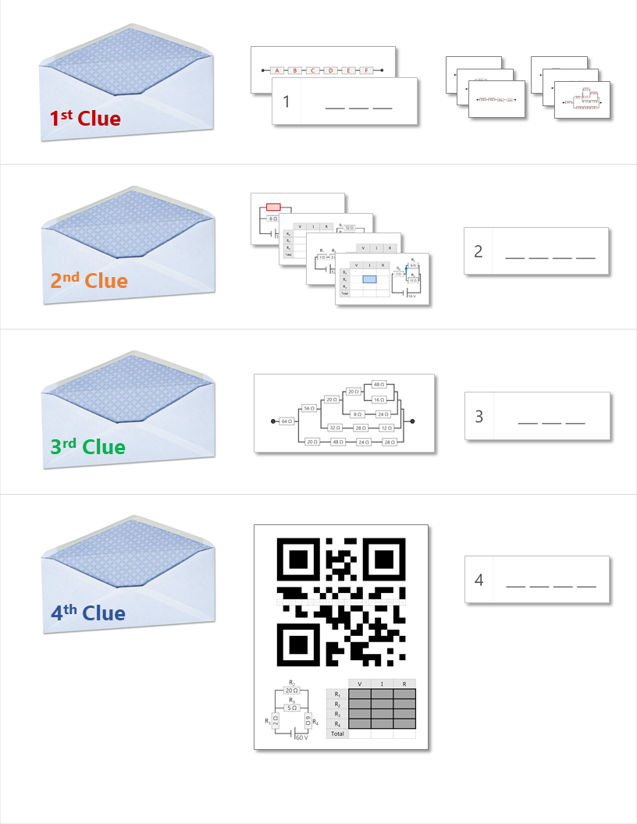

Solutions
