Electricity | IB Physics Content Guide

Big Ideas
- Electricity consists of charged particles moving in a continuous circuit
- Voltage, Current, and Resistance are related to each other though Ohm’s Law
- The total current flowing into a junction must equal the total current flowing out of that same junction
- The voltage dropped around a continuous loop traced in a circuit must equal the voltage provided
- Resistors can be combined in different ways to produce different results
- It is possible that the act of taking a measurement will change the value being measured
- The resistance of a wire is affected by its thickness, length, and material resistivity

Content Objectives

1 – Electrical Current
I can quantify charge in terms of Coulombs
I can calculate the charge of a certain # of electrons and the # of electrons for a given charge
I can describe current in terms of amps and coulombs per second
I can describe the subatomic properties of a conductor to allow charge to flow
I can the electron drift speed for a given current and wire

2 – Electrical Properties
I can describe the properties of Voltage, Current, Resistance, and Power
I can use Ohm’s Law to mathematically relate these electrical properties and solve for an unknown

3 – Circuits
I can describe the direction of conventional current compared to the movement of charges
I can identify component combinations as parallel or series
I can describe how current flows through parallel and series resistors
I can describe the set up to measure current and voltage in a circuit

4 – Calculating Resistance
I can describe the property of resistivity and how it and the wire dimensions affect resistance
I can calculate the equivalent resistance for combinations of resistors in series and parallel
I can step through the calculation of the equivalent resistance for a complex combination

5 – Voltage Dividers and Batteries
I can use Kirchhoff’s First Law to determine an unknown current at a junction
I can use Kirchhoff’s Second Law to determine an unknown current at a junction
I can calculate voltage, current, and resistance for every component in a series or parallel circuit
I can compare and contrast the properties for simple series and parallel circuits

6 – Potential Dividers
I can identify the different circuit diagram symbols for different types of resistors
I can describe how environmental changes can affect the resistance of LDRs and Thermistors
I can describe how changing resistor values can affect the voltage drop in a potential divider circuit
I can design a potential divider circuit to perform a certain task

7 – Voltage Dividers and Batteries
I can connect a meter to measure current or voltage
I can describe the conditions required for an ideal ammeter or voltmeter
I can calculate for a situation when the meter isn’t ideal

8 – Batteries
I can describe the difference between primary and secondary cells
I can define the electromotive force and describe how is it is different than terminal voltage
I can solve for a circuit that includes a battery with internal resistance

Electricity |  |  |  |  |  |  | Shelving Guide
 | Charge |  |  |  |  | Current
 | Symbol | q | Unit | Coulombs [C] |  | Symbol |  | I | Unit | Amperes [A]
 | Charge of 1 Electron |  |  | 1.6 × 10⁻¹⁹ C |  | Unit in terms of Coulombs |  |  |  | $$A=\frac{C}{s}$$
 | # of Electrons per Coulomb |  |  | 6.25 × 10¹⁸ e⁻

Drift Speed | Variable Symbol | Unit |  | Data Booklet Equation:
Current | I | A |  | $$I=nAvq$$
# of Electrons per m³ | n | ---
Cross Sectional Area | A | M²
Drift Speed | v | m s⁻¹ |  | Cross Sectional Area:  $$A=πr^{2}$$
Charge | q | C

Electrical Properties
Property | What is it? | Symbol | Unit
Voltage | Potential Difference | V | Volts [V]
Current | The rate at which charges move through a wire | I | Amperes [A]
Resistance | How hard it is for a current to  flow through a conductor | R | Ohms [Ω]

Power
In terms of V and I | In terms of I and R | In terms of V and R
$$P=V × I$$ | $$P=I^{2}R$$ | $$P=\frac{V^{2}}{R}$$

Ohm’s Law
$$V=I × R$$ | $$I=\frac{V}{R}$$ |  | $$R=\frac{V}{I}$$
Measuring Circuits |  | Ammeter |  | Voltmeter
Ideal Resistance |  | R = 0 Ω |  | R = ∞ Ω
How is it connected to the component being measured? |  | Ammeters must be connected in series |  | Voltmeters must be connected in parallel
Drawing of meter measuring R₁ |  | 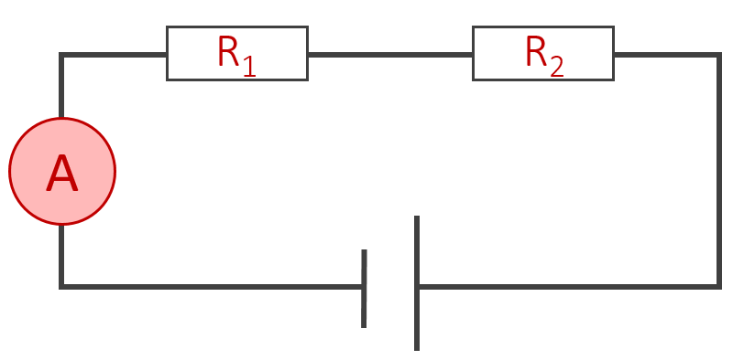 |  | 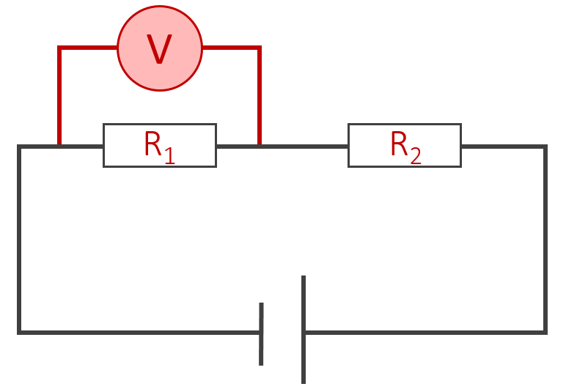

Resistivity | Variable Symbol | Unit |  | Data Booklet Equation:
Resistivity | ρ | Ω m |  | $$ρ=\frac{RA}{L}$$
Resistance | R | Ω
Cross Sectional Area | A | m² |  | Cross Sectional Area:  $$A=πr^{2}$$
Length | L | m
Ohmic Resistor  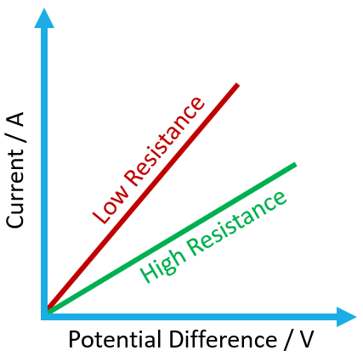 | Non-Ohmic Resistor  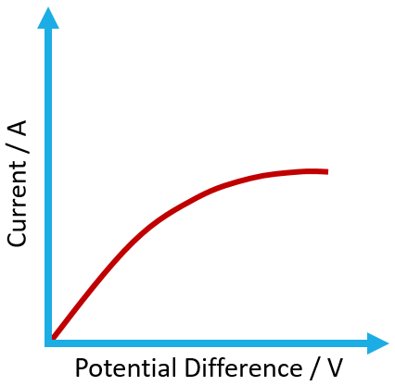

Equivalent Resistance
 | Drawing with R₁ and R₂ | Equation
Series |  | $$R_{total}=R_{1}+R_{2}+…$$
Parallel | 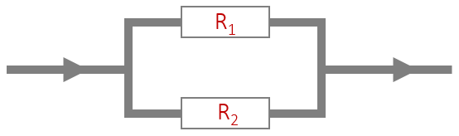 | $$\frac{1}{R_{total}}=\frac{1}{R_{1}}+\frac{1}{R_{2}}+…$$

Kirchhoff’s Laws
$$ΣI=0 (junction)$$ |  |  |  | $$ΣV=0 (loop)$$
The total current coming into a junction must equal the total current leaving the same junction |  |  |  | The sum of the voltages (potential differences) provided must equal the voltages dissipated across components
 |  |  |  | Across resistors | Always Negative
Entering Junction |  | ● | Positive | Negative to Positive |  |  | Positive
Exiting Junction | ● |  | Negative | Positive to Negative |  |  | Negative

Voltage Dividers
 | Light-Dependent Resistor |  | Thermistor
Symbol | 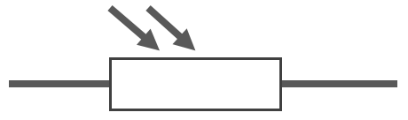 |  | 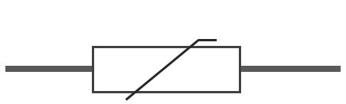
Relationship | Light | Increases | Light | Increases
 | Resistance | Decreases | Resistance | Decreases
Circuit | Switch turns on in the dark:  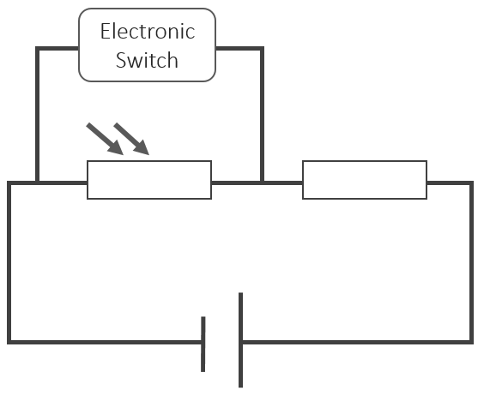 |  | Switch turns on in a fire:  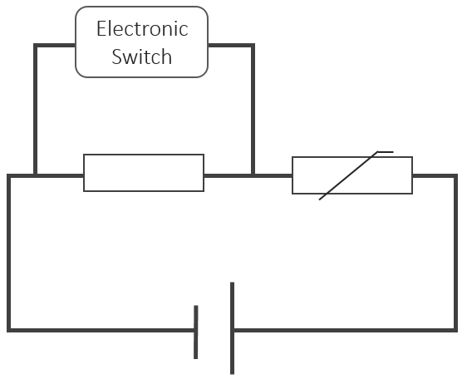

Batteries
Primary Cells | Secondary Cells
Cannot be recharged | Can be recharged by passing a current through the battery in the opposite direction as it would normally travel

 | Variable Symbol | Unit |  | Data Booklet Equation:
Electromotive Force (e.m.f) | ε | V |  | $$ε=I(R+r)$$
Current | I | A
Circuit Resistance | R | Ω
Internal Resistance | r | Ω

