Energy Breakout – Outline

Game Name: What is the name or title of the game you are designing?
Energy Breakout

Game Designer: Your Name
Joe Cossette

Content Standards: What must students be able to do in order to complete the breakout
- Calculating Work and Power
- Calculating Kinetic and Potential Energy
- Conservation of Energy

Suggested Time: How long do you anticipate players needing to complete this game?
30-40 minutes

Lock Combinations: What codes will open the locks on the box?
3-Digit Lock - 3 Numbers | 425
4-Digit Lock - 4 Numbers | 6354
ABC Lock - 4 Letters for the ABC Multilock | PUSH
Lockbox - 3 Numbers | 685
Key Lock #1 - Where is the key hidden? | Inside Small Lockbox
Key Lock #2 - Where is the key hidden? | In labeled envelope taped on the wall in a central location

Process Overview: Diagram representing the path to each lock
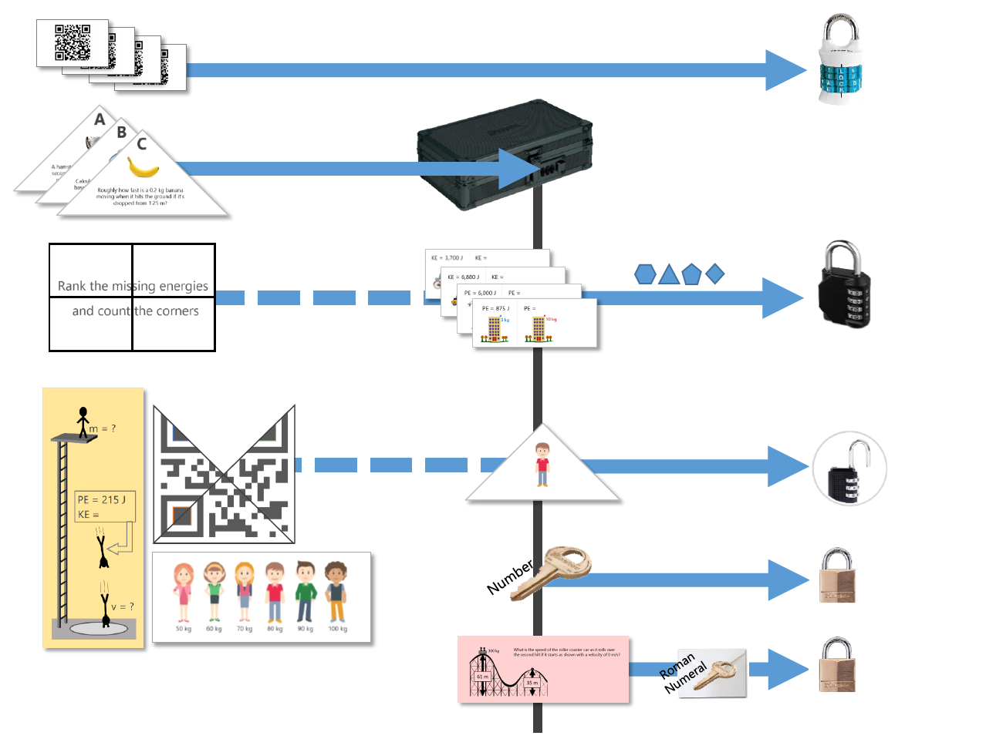

The Clues: Describe the path required to open each lock
Clue #1  [ABC Lock] | Groups have access to everything that they need to unlock the first lock in the 4 QR code cards that they find in the top compartments of the large box.  Each of the QR codes brings students to a different Google Form with one question that has been set up with data validation so that the form cannot be submitted unless the answer is correct. Once the form has been successfully submitted, the confirmation screen will show one of the letters needed for the word combination lock. Students should find that the four letters, when put in the right order, spell out a word that opens lock #1.
Clue #2  [Small Box] | The triangular cards needed to solve for the small box's combination lock are found stored away in the envelope placed on the table. Each of these problems are focused on work, power, and energy and require more than step to complete. Depending on the level of the students, it might be worth providing hints so that students don't get stuck without being able to open the small box to unlock more clues.  Each of the questions should come out to a single digit answer (if 9.8 is used for gravity instead of 10, then problem C needs to be rounded) and when placed in ABC order, should form the combination for the small box.
Clue #3  [4-Digit Lock] | For the third lock, students have access to the puzzle clue written on the backs of the QR code cards since the start of the task, but they don't have the clues needed to interpret this message until they can unlock the box and get inside  Once inside the small box, they have access to the four clue cards shown on the right. Each of these is an energy equation relationship question asking about how the total energy changes if one of the variables is also changed.  Once they find all of the missing energy values, all they need to do is follow the clue and rank them from smallest to largest. On the back of each card is a shape. Counting the corners in this ranked order provides the combination for the 4 digit combination lock.
Clue #4  [3-Digit Lock] | The three digit number lock is probably one of the most involved to open because it requires several different clues. Ultimately, this lock opens up with the kinetic energy of the diver at the position shown in the clue on the right. This clue is taped on the bottom of the toolbox so students have access to it right away even though they are missing important values required to solve the problem.  The three triangle clues used for lock #2 are also puzzle pieces to complete a QR code. Of course, the QR code won't work until they have all of the pieces and the fourth piece is found in the small box. The colored outlines are there to help students assemble the puzzle correctly. Once they have the pieces assembled, the code takes them to a google site with information about the diver's impact velocity  The final piece of information that is required is the mass of the diver. The line up of people is taped to the back of the large box but the group doesn't know which mass to use until they find the final triangle clue in the small box. This clue is simply a picture of the person, and it is up to the group to make the connection that this is the same person as the diver in the problem.  With the impact velocity and the mass, it should be possible to use the conservation of energy to solve for the missing kinetic energy.
Clue #5  [Key Lock #1] | ​The fifth lock is the easiest one. Once the groups get inside the small box and search through all of things they now have access to, they find the key for their missing lock inside of a little zippered pouch.
Clue #6  [Key Lock #2] | To open up the second keyed lock, groups need to solve one last problem that they find in the small box. For this problem, each group in the class will get a different answer that corresponds an envelope taped to the whiteboard or some other central location in the room. It is important that students take the correct envelope because only one of the keys will work with their group's lock.  Since this breakout was designed to be used in several different levels of classes, there are two versions of this clue. Level 1 is a simple conservation of energy ramp question where students need to find the missing energy while Level 2 requires more calculation to find the velocity of a roller coaster at a certain location. Note that these two sets of problems do not lead to the same answers so there are different envelope values needed. All of that information can be found in the set up section below.  Note: if you want to shorten the length of the breakout task, this clue is the easiest one to get rid of because it doesn't interact with any of the other clue paths.

Printing the Clues: Any special instructions about printing any of the clues? (i.e. double-sided, color, etc.)
- Clue 1 is double-sided so that the QR cards make up the puzzle message on the back. (there are two sets of 4 cards included in this file)
- Clue 2 requires color printing include the colored outlines on the QR code to help students assemble it correctly
- Clue 3 is double-sided so that the missing energy cards have shapes on the back
- Clue 5 includes two levels of problems for eight different groups

Setting up the Breakout Task: What goes where?
Inside the Big Box | - It’s a good idea to fill the big box with something like candy for students to discover after they solve the puzzle. In this task, the prize is the only thing that you need to prepare for inside the big box before locking it up.
Outside Big Box | - QR Code cards in the organizers on top of the box. If your box doesn't have these handy hiding places. You can just provide these cards in an envelope or something  - Tape the person line up with masses on the back of the big box  - Tape the diver problem on the bottom of the box
Inside Small Box | - Hide the key for the Masterlock in one of the pouches on the inside of the small box. If your small box doesn't have this feature, it's ok to have the key loose in the box as well  - Place the 4 missing energy cards in a stack inside the box  - Place the triangle with the picture of the cartoon man inside the box  - Place the problem that corresponds with the envelope on the front board inside the box.  To help ensure that that there is agreement with the clue, the solution, and the key, it is important that you put the right clue in each box. This works best if you have the boxes numbered so you can keep track of everything. Each level of the clue has the group number hidden in the problem.  - Level 1 - The group number is the second digit of the initial height  - Level 2 - The group number is the kinetic energy at the top of the ramp
On the Table | - Place the three clue triangles in an envelope and leave it on the table next to the boxes  - Dry Erase Markers - Since I laminated my cards, I just had students use the markers to write on these directly. If you have large whiteboards, this could be a good opportunity to pull those out as well  - Something to read a QR code with. This isn't really something that you need to set out, just make sure that someone in the group has an iPad or phone that can scan a QR Code.
On the Front Whiteboard  (or other  central location) | - Tape the envelopes with the key to the second keyed lock  - It is very important that you label each envelope with the answer that corresponds with the key that it goes to. Reference the table on the right for a list of labels that go with the level 1 and level 2 clues  Box Number Level 1 Level 2  1 3 J 22.80 m/s  2 4 J 18.44 m/s  3 6 J 21.45 m/s  4 2 J 16.73 m/s  5 1 J 17.32 m/s  6 8 J 14.83 m/s  7 5 J 24.08 m/s  8 7 J 13.42 m/s

Reset Instructions: Diagram for groups to reset after solving
