Energy Mini Labs Name: ____________________________
For each of these mini labs, complete the task provided and show all work.
Equations and Constants
$$v=d/t$$ | $${PE}_{g}=mgh$$ | $$KE=\frac{1}{2}mv^{2}$$ | $${PE}_{e}=\frac{1}{2}k{∆x}^{2}$$ | $$W=Fdcosθ$$ | $$g=9.81 m/s^{2}$$

Part 1: Wally and the Fire Extinguisher – (TUTORIAL)
There’s a classic scene in the Pixar movie Wall-E where he propels himself through space using a fire extinguisher. In this lab, you will set initial conditions to predict the final velocity and ultimately the time it takes Wally (no relation to the animated robot surely) to pass through a set of photogates 10 meters apart.
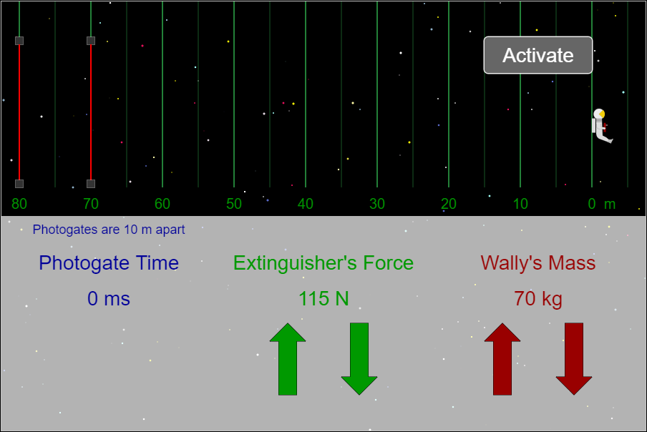
How to use the Simulation: (SIMULATION LINK)
- Click on the up/down arrows to increase/decrease the extinguisher’s force and Wally’s Mass.
- Click on “Activate” to turn on the extinguisher and begin applying the force.
- Once the backpack reaches the desired distance, click on “Shut Off” to stop the force and allow Wally to continue at a constant velocity.
- The photogate time is measured in milliseconds and represents the time it takes for Wally to pass through the 10-meter gap between lasers.
Choose one from each column |  |  | Calculate the work done:
Extinguisher’s Force | Distance | Wally’s Mass
50 N | 5 m | 35 kg
55 N | 10 m | 42 kg
65 N | 15 m | 50 kg | Calculate the final velocity:
85 N | 20 m | 55 kg
100 N | 25 m | 62 kg
115 N | 30 m | 70 kg
130 N | 35 m | 75 kg
155 N | 40 m | 79 kg | Calculate the time to go 10 meters at final velocity:
175 N | 45 m | 82 kg
190 N | 50 m | 85 kg
200 N | 55 m | 90 kg

Calculated Time from above |  |  | Measured Time from Simulation

Part 2: Wally Design Problem
Now that you have a feel for the simulation, your task is to determine a set of conditions that will result in a desired outcome. You will be able to choose any combination of settings but must include both a screenshot of the simulation matching the target time and calculations showing that the values work.
Time to go through 10 m Photogate | 750 ms | Note: Your calculations and simulation run must be within 50 ms of the target (0.7-0.8 seconds)

Extinguisher’s Force | Distance | Wally’s Mass
Hint: While the force and mass have preset values to choose from, distance is much more flexible and can be any value that you choose. Use this fact to help you achieve precision when determine these properties
Calculations:

Screenshot of the Result:

