Energy Production | IB Physics Content Guide

Big Ideas
- Most energy sources can be traced back the sun, our ultimate primary source
- No energy source can be converted to electricity with 100% efficiency
- All energy sources have advantages and drawbacks and it important to understand the complete picture
- Every object with a temperature above 0 K emits thermal radiation
- Radiation intensity is related to separation distance by the inverse square law (similar to force fields)
- The Earth’s climate relies on a delicate thermal energy balance where total energy in equals total energy out

Content Objectives

1 – Energy Sources Overview
I can list the top 6 most common sources in the global energy supply and general % of total
I can distinguish between primary and secondary energy sources
I can define power as a rate of energy usage in terms of watts
I can calculate the efficiency as the percentage of useful energy of the total
I can interpret energy flow from a Sankey Diagram
I can define specific energy and energy density with proper units
I can use specific energy to calculate the amount of fuel needed for a given amount of power

2– Nuclear Power
I can describe the chain reaction that occurs to support a self-sustaining fission reactor
I can describe the concentration of U-235 as a sample is enriched into fuel-grade uranium
I can outline the process of enriching uranium
I can explain how a nuclear reactor transforms the energy of a fission reaction into electricity
I can describe the role of the moderator and control rods in a nuclear reactor
I can discuss the challenges of disposing of nuclear waste

3 – The Renewables
I can list examples of energy sources that are considered renewable
I can list examples of energy sources that are known carbon dioxide emitters
I can calculate the power produced by a wind turbine
I can compare the different styles of solar power and what each is used for
I can calculate the power from a solar panel from the panel area and solar intensity
I can describe the factors that affect the solar intensity in different locations on Earth
I can outline the operation of a hydropower generator
I can explain how a hydropower plant can incorporate pumped storage to store energy
I can list challenges that are facing a future of renewable energy

4 – Thermal Energy Transfer
I can provide examples of conduction, convection, and radiation
I can define black-body radiation in terms of absorption and emission of light
I can describe an object based on its emissivity
I can calculate the power emitted by a black body radiation using the Stefan-Boltzmann Law
I can describe the shape of the emission spectra in terms of radiation wavelength
I can mathematically relate peak wavelength and temperature using Wien’s displacement law

5 – Radiation from the Sun
I can define intensity with proper units
I can describe how intensity changes according to the surface area of a sphere
I can derive the Solar Constant from the sun’s power and distance from earth
I can calculate the average solar intensity on earth from the solar constant and earth’s radius
I can compare the properties of albedo and emissivity
I can list the gases that have the largest impact on the greenhouse effect

6 – Climate Change
I can describe the greenhouse effect as absorption and re-emission of thermal energy
I can describe the concept of thermal equilibrium and how it pertains to earth
I can recognize trends in the climate model based on different factors
I can describe the long term and seasonal trends in the carbon dioxide concentration
I can list examples of positive and negative feedback loops in terms of the climate discussion
I can engage in an evidence-based conversation about climate change

Energy Production | Shelving Guide

Global Energy Usage
Rank | Energy Source | %
1 |  | 31%
2 |  | 27%
3 |  | 23%
4 |  | 9%
5 |  | 5%
6 |  | 2.5%

Efficiency
$$Efficiency=\frac{useful work out}{total work in}=\frac{useful power out}{total power in}$$
Sankey Diagram Rules:

Energy Density
 | Definition | Units
Specific Energy
Energy Density

Primary and Secondary Sources
Primary Energy Sources | Secondary Energy Sources

Nuclear Power
 | Describe | Examples | Challenges
Fission
Fusion

 | % of U-235 |  | Why is the concentration of U-235 important?
Uranium Ore
Fuel-Grade |  |  | What is done with the nuclear waste?
Weapons-Grade

Moderator | Control Rods

Renewable Energy
 | Variable Symbol | Unit |  | Data Booklet Equations:
Power |  |  |  | $$Power=\frac{1}{2}Aρv^{3}$$
Cross-Sectional Area
Air Density |  |  |  | $$A=πr^{2}$$
Air Speed

Photovoltaic Cells | Solar Concentrator | Solar Heating Panel

 | Biomass | Coal | Geothermal | Hydropower | Natural Gas | Nuclear | Petroleum | Solar | Wind
Renewable
Produces CO₂

Thermal Energy Transfer
Conduction | Convection | Radiation

 | Emissivity |  | Black Body Radiation | 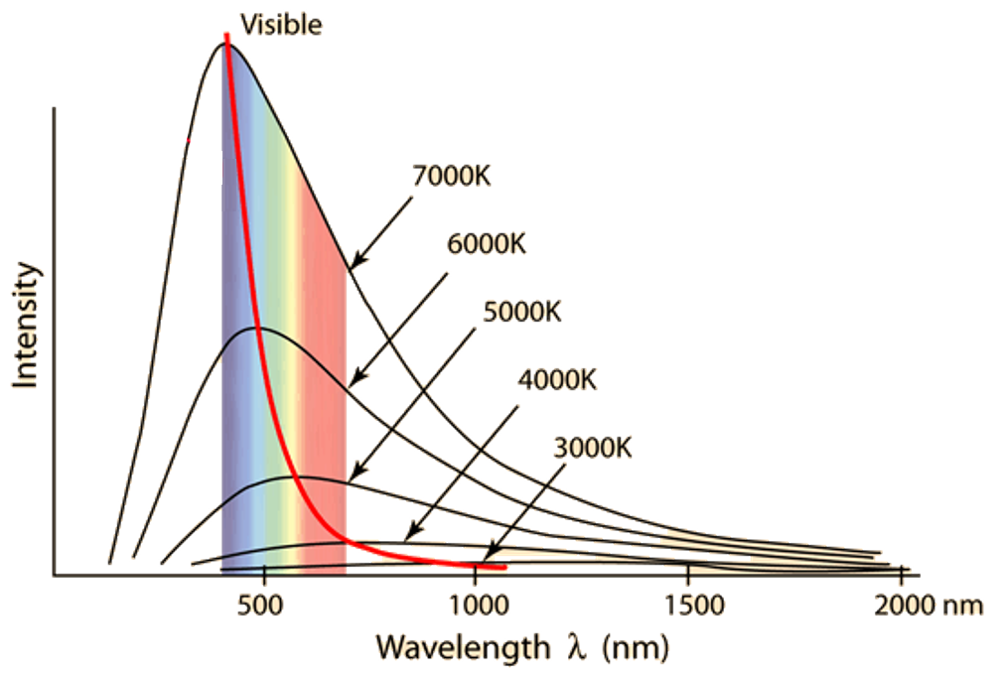
Sun
Earth
Black-Body

Power Emissivity | Variable Symbol | Unit |  | Data Booklet Equations:
Power |  |  |  | $$P=eσAT^{4}$$
Emissivity |  | ---
Surface Area |  |  |  | $$λ_{max}=\frac{2.90×{10}^{-3}}{T}$$
Temperature
Max Wavelength |  |  |  | $$σ=5.67×{10}^{-8} W{ m}^{-2} K^{-4}$$

Solar Radiation and Climate Change
Intensity | Variable Symbol | Unit |  | Data Booklet Equations:
Intensity |  |  |  | $$I=\frac{power}{A}$$
Power
Area |  |  |  | $$A_{sphere}=4πr^{2}$$

Greenhouse Gases |  | Positive Feedback Loop | Negative Feedback Loop

