Free Fall Mini Labs Name: _______________________________
For each of these mini labs, complete the task provided and show all work.

The Tools:
One key variable that's useful to measure precisely and accurately is time. To make this job a little easier, this lab recommends an app called Hudl Technique. You can also time events using the time stamps on the video scrollbar, but it might not be as exact.

Click this link for a tutorial on how to use Hudl Technique to measure time

Importing and Analyzing Videos with Hudl Technique

Equations and Constants
$$v_{f}=v_{i}+at$$ | $$d=v_{i}t+\frac{1}{2}at^{2}$$ | $${v_{f}}^{2}={v_{i}}^{2}+2ad$$ | $$d=\frac{\left(v_{f}+v_{i}\right)t}{2}$$ | $$g=9.81 m/s^{2}$$

Part 1: Tik Tok Cliff Dive
During the summer of 2020, this clip went viral on the video sharing app Tik Tok. People were astonished by how this cliff diver seems to fall forever before hitting the water.
CLICK HERE to download the Tik Tok Cliff Dive video
Your Task: Determine the height of the cliff
Record all assumptions and show all work below ↓

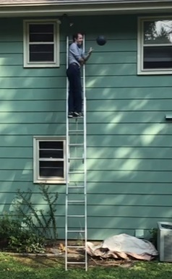
Part 2: Bowling Ball Drop
A totally normal physics teacher hobby is dropping heavy things from high places Luckily, only the bowling ball experienced free fall in the making of this video.

CLICK HERE to download the Bowling Ball Drop video
Your Task: Plot the position of the bowling ball over time

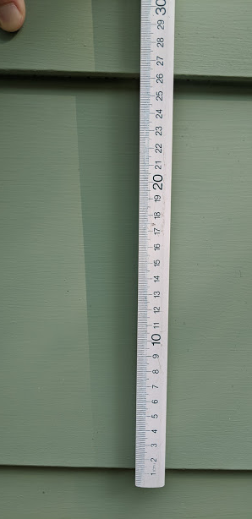
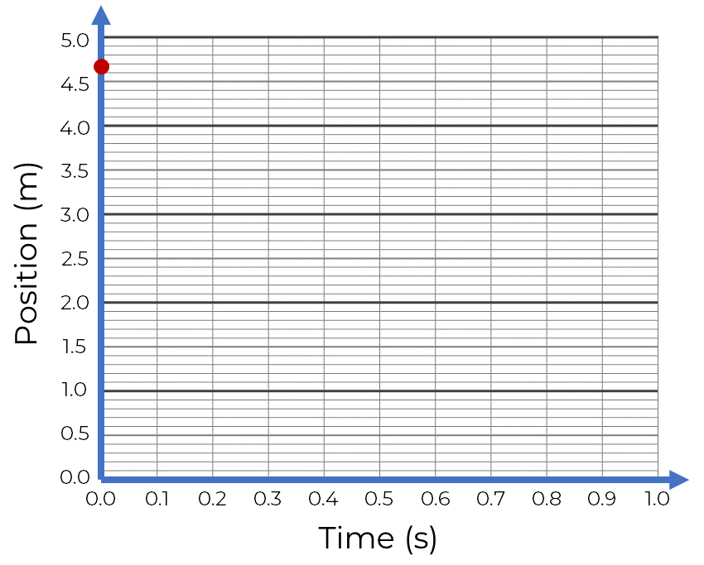
For this video, you will want to zero the time at the moment that the ball is released and then record the time stamp at several different positions as it falls. It is dropped from a height of 4.68 meters and the measurement of the house’s siding is shown in the photo on the right. Assume that the ground is a position of zero. Use the video to collect some data and graph the points below ↓
Position (m) | Time (s)
4.68 | 0.00

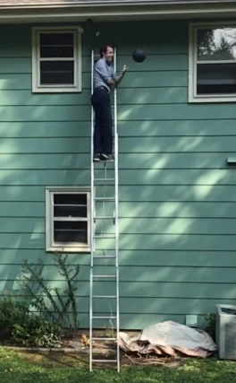
Part 3: Bowling Ball Impact
Now that you’ve watched this bowling ball smack the ground so close to the house, you should be wondering, how fast did it hit??

CLICK HERE to download the Bowling Ball Drop video
Your Task: Calculate the impact velocity of the bowling ball

Record all assumptions and show all work below ↓

Part 4: Air Time
Some athletes have some pretty impressive hops. If we know how high they jump, we should also be able to figure out how long they are airborne.

CLICK HERE to download the Vertical Jump Video

Your Task: Calculate the total air time for Josh Imatorbhebhe

Record all assumptions and show all work below ↓

Once you have a value calculated based on his total height, use Hudl Technique to get an estimate for how long he was in the air. If your answer is not in this ballpark, revisit your calculation. Remember that the total hang time is the time to go up and come back down

Hang Time measured with Hudl

