Free Fall Mini Labs | Name: ______________________ Period: __

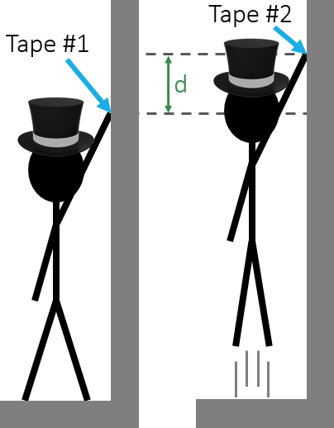
Air Time – Video Tutorial
Calculate the air time of your jump without using a stop watch

Procedure:
- Standing flat footed next to the wall, place a piece of tape as high up as you can reach.
- Stick second piece of tape on the wall as high as you can by jumping straight up.
- Measure the distance between the two pieces of tape and calculate your total air time. Be careful!! Going up to the top is just half of your total air time.

Reaction Time – Video Tutorial
Calculate your reaction time without a stop watch

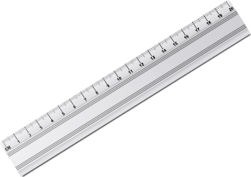
Procedure:
Using your knowledge of physics, calculate your reaction time when catching and dropping a ruler
- It’s probably a good idea to collect multiple trials worth of data and average them before calculating anything with our motion equations…

Check your answer using www.humanbenchmark.com/tests/reactiontime
Online Reaction Time Test

Follow the Bouncing Ball – Video Tutorial
Using a simple bouncing ball, measure and calculate the acceleration due to gravity.
Scientist #1 - Dropper | Scientist #2 - Measurer | Scientist #3 - Timer
Tallest in the Group | Middle height in the Group | Shortest in the Group

Procedure:
- Scientist #1 (the dropper), stands next to the wall, reaches as high as they can and drops the golf ball.
- Scientist #2 (the timer) starts the stopwatch when the ball hits the ground the 1st time.
- Scientist #3 (the measurer) marks the highest spot on the wall that the ball reaches on the first bounce and measures it in meters.
- Scientist #2 (the timer) stops the stopwatch when the ball hits the ground the 2nd time.
- Repeat steps 1-4 five times to complete the table below
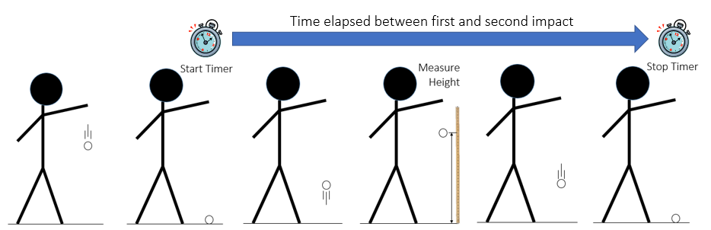
Trial # | Time between 1st and 2nd bounce | Maximum height of first bounce
1
2
3
4
5
Average

Analysis
List the data that you know from your measurements and solve for the acceleration due to gravity. For simplicity, only look at half of the time between bounces (time moving up or time moving down).

