IB Physics MCordle | Challenge #1

- What is the unit of power expressed in fundamental SI units?
  - kg m s^{–2}
  - kg m² s^{–2}
  - kg m s^{–3}
  - kg m² s^{–3}

- A projectile is fired horizontally from the top of a cliff. The projectile hits the ground 4 s later at a distance of 2 km from the base of the cliff. What is the height of the cliff?
  - 40 m
  - 80 m
  - 120 m
  - 160 m

- The efficiency of an electric motor is 20%. When lifting a body 500 J of energy are wasted. What is the useful work done by the motor?
  - 100 J
  - 125 J
  - 250 J
  - 400 J

- In simple harmonic oscillations which two quantities always have opposite directions?
  - Kinetic energy and potential energy
  - Velocity and acceleration
  - Velocity and displacement
  - Acceleration and displacement

- The frequency of the first harmonic standing wave in a pipe that is open at both ends is 200 Hz. What is the frequency of the first harmonic in a pipe of the same length that is open at one end and closed at the other?
  - 50 Hz
  - 75 Hz
  - 100 Hz
  - 400 Hz

- Atomic spectra are caused when a certain particle makes transitions between energy levels. What is this particle?
  - Electron
  - Proton
  - Neutron
  - Alpha particle
- A longitudinal wave moves through a medium. Relative to the direction of energy transfer through the medium, what are the displacement of the medium and the direction of propagation of the wave?
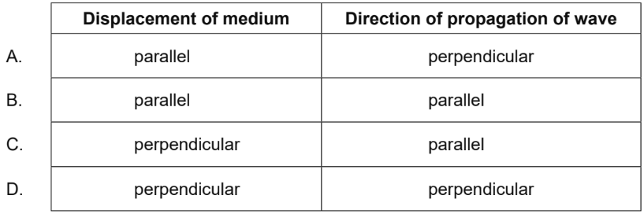

- A bicycle of mass M comes to rest from speed v using the back brake. The brake has a specific heat capacity of c and a mass m. Half of the kinetic energy is absorbed by the brake. What is the change in temperature of the brake?

  - $\frac{Mv^{2}}{4mc}$
  - $\frac{Mv^{2}}{2mc}$
  - $\frac{mv^{2}}{4Mc}$
  - $\frac{mv^{2}}{2Mc}$

IB Physics MCordle | Challenge #2

- Which is a vector quantity?
  - Pressure
  - Electric Current
  - Temperature
  - Magnetic Field

- A ball is tossed vertically upwards with a speed of 5.0 m s⁻¹. After how many seconds will the ball return to its initial position?
  - 0.50 s
  - 1.0 s
  - 1.5 s
  - 2.0 s

- The initial kinetic energy of a block moving on a horizontal floor is 48 J. A constant frictional force acts on the block bringing it to rest over a distance of 2 m. What is the frictional force on the block?
  - 24 N
  - 48 N
  - 96 N
  - 192 N

- A particle moving in a circle completes 5 revolutions in 3 s. What is the frequency?
  - 3/5 Hz
  - 5/3 Hz
  - 3π/5 Hz
  - 5π/3 Hz

- Atomic spectra are caused when a certain particle makes transitions between energy levels. What is this particle?
  - Electron
  - Proton
  - Neutron
  - Alpha particle

- The main role of a moderator in a nuclear fission reactor is to
  - slow down neutrons.
  - absorb neutrons.
  - reflect neutrons back to the reactor.
  - accelerate neutrons.
- In a double-slit experiment, a source of monochromatic red light is incident on slits S1 and S2 separated by a distance d. A screen is located at distance x from the slits. A pattern with fringe spacing y is observed on the screen.
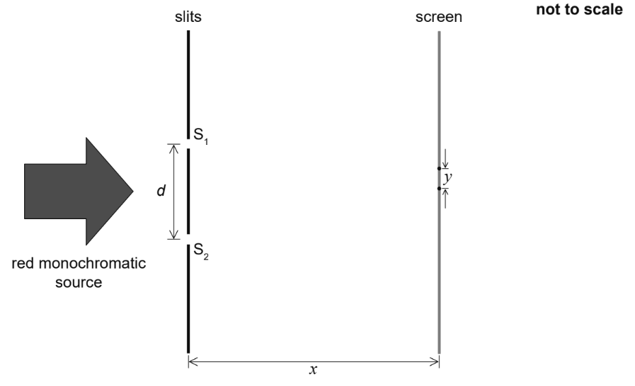
Three changes are possible for this arrangement
I. increasing x
II. increasing d
III. using green monochromatic light instead of red.
Which changes will cause a decrease in fringe spacing y?
  - I and II only
  - I and III only
  - II and III only
  - I, II, and III

- The average temperature of the surface of a planet is five times greater than the average temperature of the surface of its moon. The emissivities of the planet and the moon are the same. The average intensity radiated by the planet is I. What is the average intensity radiated by its moon?

  - $\frac{I}{25}$
  - $\frac{I}{125}$
  - $\frac{I}{625}$
  - $\frac{I}{3125}$

IB Physics MCordle | Challenge #3

- A truck has an initial speed of 20 m s^{–1}. It decelerates at 4.0 m s^{–2}. What is the distance taken by the truck to stop?
  - 2.5 m
  - 5.0 m
  - 50 m
  - 100 m

- A net force acts on a body. Which characteristic of the body will definitely change?
  - Speed
  - Momentum
  - Kinetic Energy
  - Direction of Motion

- The half-life of a radioactive element is 5.0 days. A freshly-prepared sample contains 128 g of this element. After how many days will there be 16 g of this element left behind in the sample?
  - 5.0 days
  - 10 days
  - 15 days
  - 20 days

- The binding energy per nucleon of ${}_{4}^{11}{Be}$ is 6 MeV. What is the energy required to separate the nucleons of this nucleus?
  - 24 MeV
  - 42 MeV
  - 66 MeV
  - 90 MeV

- A mass m of ice at a temperature of –5°C is changed into water at a temperature of 50°C.
Specific heat capacity of ice = c_{i}
Specific heat capacity of water = c_{w}
Specific latent heat of fusion of ice = L
Which expression gives the energy needed for this change to occur?

  - 55 mc_{w} + mL
  - 55 mc_{i} + 5 mL
  - 5 mc_{i} + 50 mc_{w} + mL
  - 5 mc_{i} + 50 mc_{w} + 5 mL

- A projectile is fired at an angle to the horizontal. Air resistance is negligible. The path of the projectile is shown.
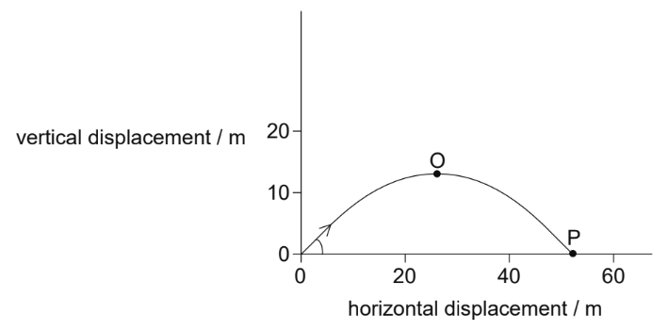
Which gives the magnitude of the horizontal component and the magnitude of the vertical component of the velocity of the projectile between O and P?
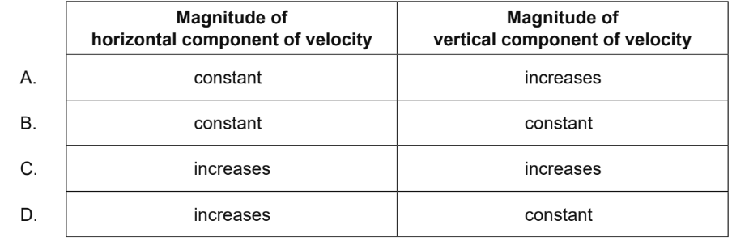
- Two wires, X and Y, are made of the same material and have equal length. The diameter of X is twice that of Y. What is $\frac{Resistance of X}{Resistance of Y}$ ?
  - $\frac{1}{4}$
  - $\frac{1}{2}$
  - 2
  - 4

- A proton collides with an electron. What are the possible products of the collision?
  - Two neutrons
  - Neutron and positron
  - Neutron and antineutrino
  - Neutron and neutrino

