IB Physics SL - Study Guide

Science Skills
List the seven fundamental base units and their abbreviations:
 | Unit | Abbreviation
Length | Meter | m
Mass | Kilogram | kg
Time | Second | s
Electric Current | Ampere | A
Temperature | Kelvin | K
Amount of Substance | Mole | mol
Luminous Intensity | Candela | cd

Metric Prefixes – List the unit prefixes in their appropriate decimal position
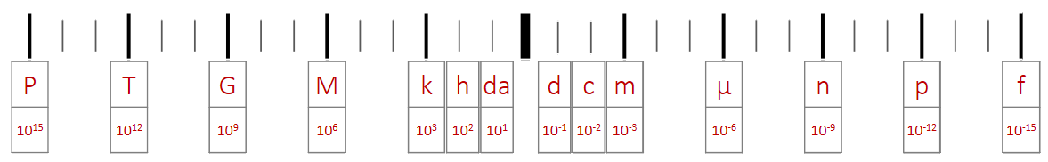

Dimensional Analysis
Convert the following:
20 mi hr⁻¹ m s⁻¹
$$\frac{20 mi}{1 hr}×\frac{1609 m}{1 mi}×\frac{1 hr}{60 min}×\frac{1 min}{60 s}=8.9\frac{m}{s}=8.9 m s^{-1}$$
0.0007 km² m²
$0.0007 {km}^{2}×\frac{1000 m}{1 km}×\frac{1000 m}{1 km}=700 m^{2}$ or $0.0007 {km}^{2}×{\left(\frac{1000 m}{1 km}\right)}^{2}=700 m^{2}$

Determine the units for Q:
Q = mc ΔT  $$Q=\left(kg\right)\left(J {kg}^{-1} K^{-1}\right)\left(K\right)=\frac{\left(kg\right)\left(J\right)\left(K\right)}{kg K}=J$$ | m (mass) | kg
 | c (specific heat) | J kg⁻¹ K⁻¹
 | ΔT (change in temp) | K

Motion

 | Scalar | Vector
How far (m) | Distance | Displacement
How fast (m s⁻¹) | Speed | Velocity

 | Displacement vs Time | Velocity vs Time | Acceleration vs Time
Meaning of the Graph | Slope:  Velocity | Slope: Acceleration  Area under the Curve:  Displacement | Area under the Curve:  Velocity
Constant Displacement | 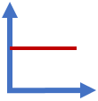 | 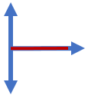 | 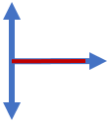
Constant Positive Velocity |  | 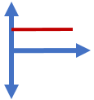
Constant Negative Velocity | 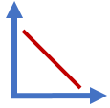 | 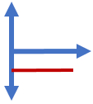
Constant Positive Acceleration  (speeding up) | 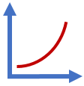 | 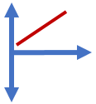 | 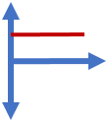
Constant Negative Acceleration  (slowing down) | 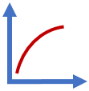 | 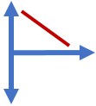 | 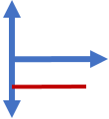

 | Variable Symbol | Unit |  | Kinematic Equations | s | u | v | a | t
Displacement | s | m |  | $$v=u+at$$ |  | ✔️ | ✔️ | ✔️ | ✔️
Initial Velocity | u | m s⁻¹ |  | $$s=ut+\frac{1}{2}at^{2}$$ | ✔️ | ✔️ |  | ✔️ | ✔️
Final Velocity | v | m s⁻¹ |  | $$v^{2}=u^{2}+2as$$ | ✔️ | ✔️ | ✔️ | ✔️
Acceleration | a | m s⁻² |  | $$s=\frac{\left(v+u\right)t}{2}$$ | ✔️ | ✔️ | ✔️ |  | ✔️
Time | t | s

Horizontal Component | $$A_{H}=A\cos{θ}$$ | 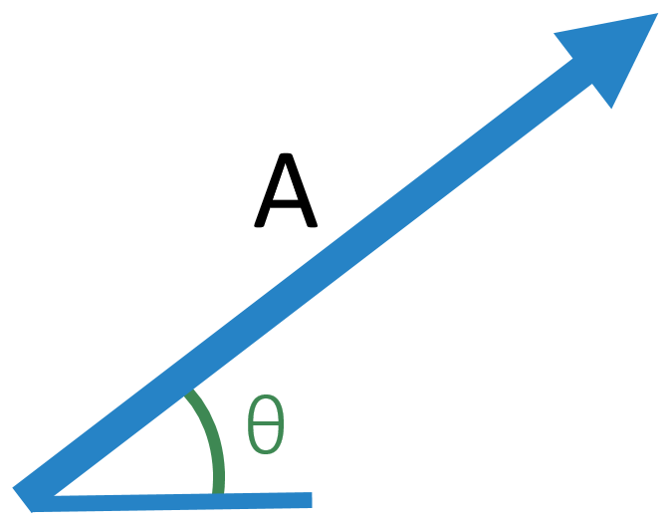
Vertical Component | $$A_{V}=A\sin{θ}$$

 | Vertical | 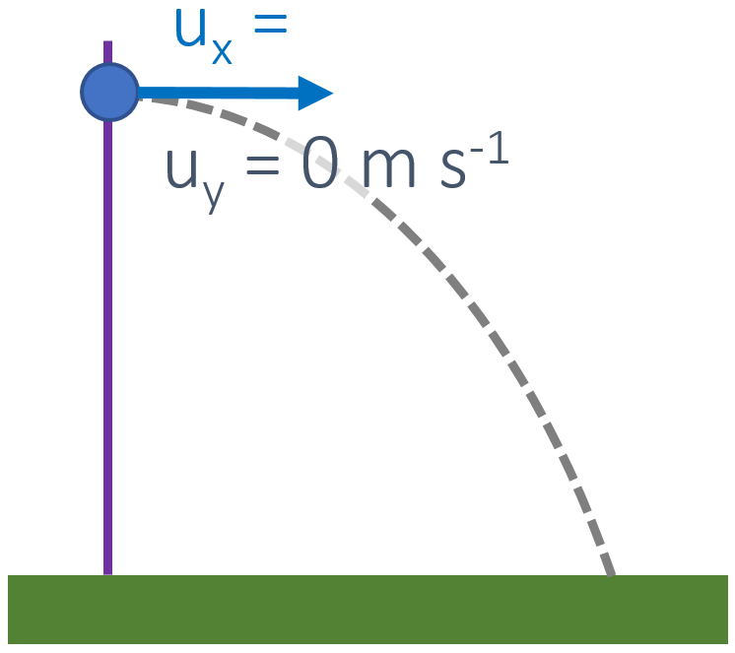
s
u | 0 m s⁻¹
v
a | -9.81 m s⁻²
t

 | Vertical | 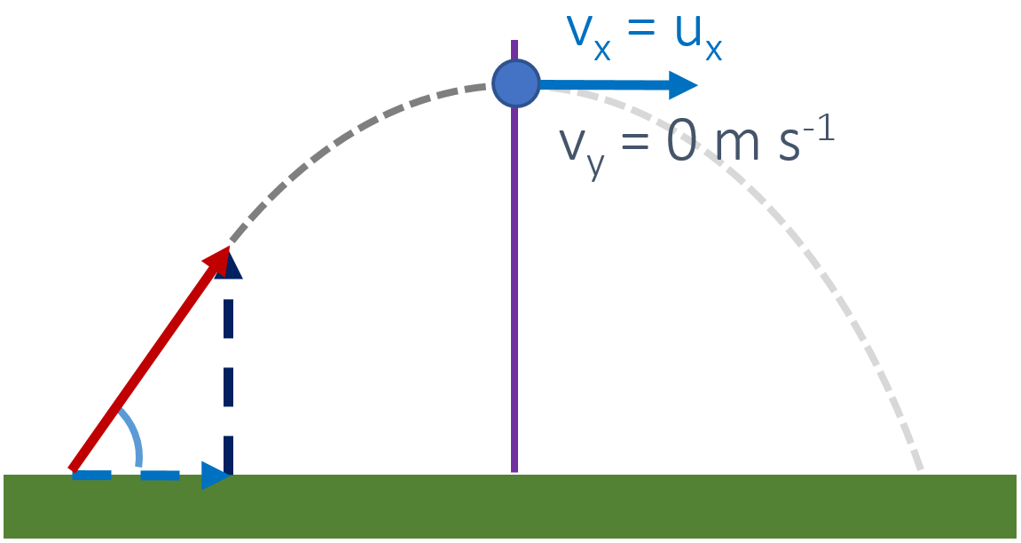
s
u | u sinθ
v | 0 m s⁻¹
a | -9.81 m s⁻²
t

Forces

Type of Force | Variable | Description/Important Properties | Equation
Weight | F_{g} | Force of gravity on an object with mass | F_{g} = mg
Tension | F_{T} | Always pulls in the same direction as the rope or chain providing the tension
Normal Reaction | R | Always perpendicular to a surface
Friction | F_{f} | Always opposes the motion of an object | F_{f} = μR
Air Resistance | F_{air} | Increases with surface area and velocity

If an object has a net force of zero its motion is either:
Not moving (velocity = 0 m s⁻¹) | or | Moving at a constant velocity

Newton’s Laws
Newton’s  First Law | A object at rest remains at rest and an object in motion remains in motion until and unless an external force acts upon it (Unbalanced force).
Newton’s  Second Law | The rate of change of momentum of an object is proportional to the resultant force acting on the body and is in the same direction. (F = ma)
Newton’s  Third Law | All forces occur in pairs. Every action has an equal and opposite reaction
Data Booklet  Equations: |  |  | Variable Symbol | Unit
 |  | Force | F | N
$$F=ma$$ |  | Mass | m | kg
$$F_{f}≤μ_{s}R$$ |  | Acceleration | a | m s⁻¹
$$F_{f}=μ_{d}R$$ |  | Normal Reaction Force | R | N
 |  | Coefficient of Kinetic Friction | μ_{d} | --
 |  | Coefficient of Static Friction | μ_{s} | --

Terminal Velocity | The maximum velocity a falling body can achieve. This occurs when the force of air resistance is equal and opposite to the weight and F_{net} = 0 N.
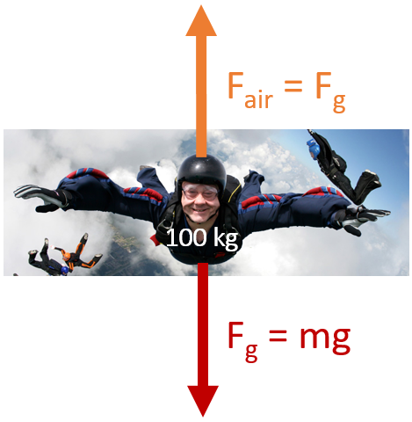 |  | 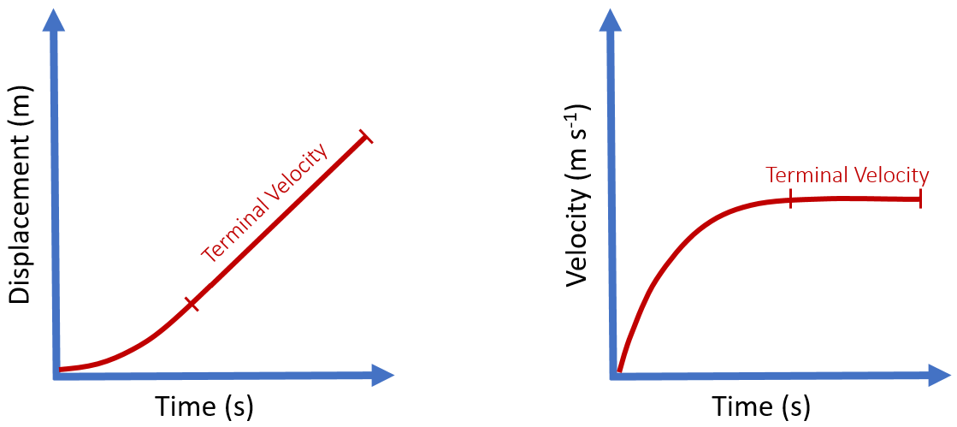
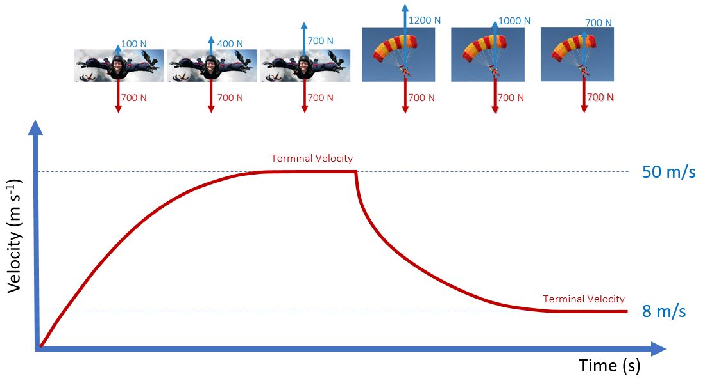

Sliding to a Stop | Constant Velocity
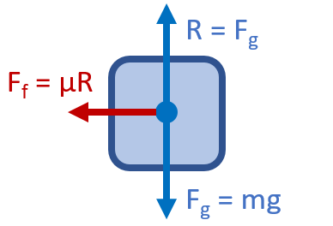 | 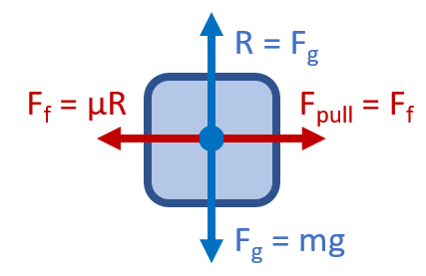
F_{net} = F_{f} | F_{net} = 0 N | F_{pull} = F_{f}

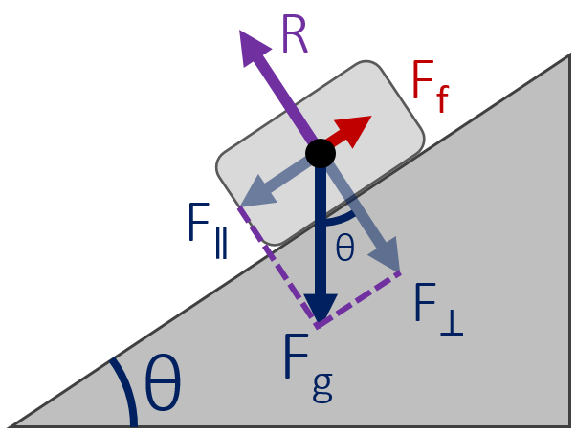 |  | Forces on a Ramp
 |  |  | Equilibrium |  |  | Accelerating
 |  |  | R | F⊥ |  | R | F⊥
 |  |  | F_{f} | F∥ |  | F_{f} | μR
F⊥ | F_{g} cosθ |  | F_{net} | 0 N |  | F_{net} | F∥ - F_{f}
F∥ | F_{g} sinθ |  | a | 0 m s⁻¹ |  | a | F_{net} / m

Circular Motion

 | Variable Symbol | Unit |  | Draw in  vectors  for v, a_{c},  and F_{c} | 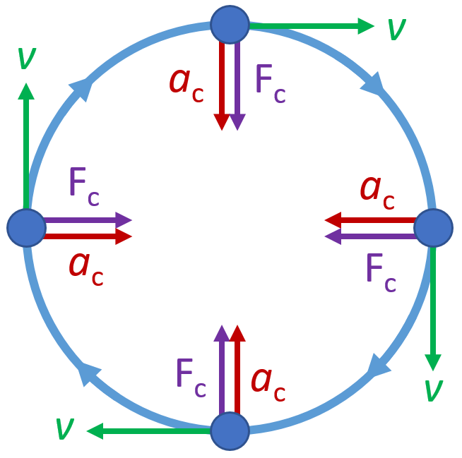
Distance | d | m
Angular Distance | θ | rad
Angular Velocity | ω | rad s⁻¹ |  | Data Booklet Equations:
Linear Velocity | v | m s⁻¹ |  | $v=ωr$
Centripetal Acceleration | a | m s⁻² |  | $a=\frac{v^{2}}{r}=\frac{4π^{2}r}{T^{2}}$
Centripetal Force | F_{c} | N |  | $F=\frac{mv^{2}}{r}=mω^{2}r$

Defining Circular Motion
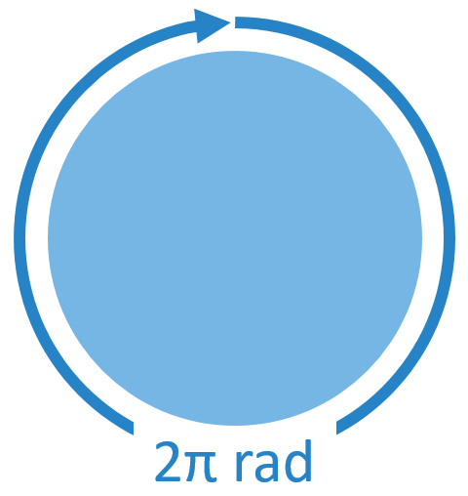 | Period | T | s | Angular Velocity | ω | rad s⁻¹
 | Time per revolution |  |  | $$ω=\frac{2π}{T}$$

Vertical Circular Motion
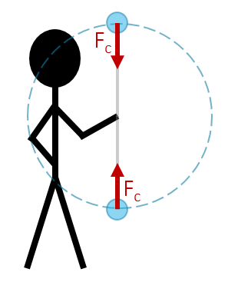 |  | Top:  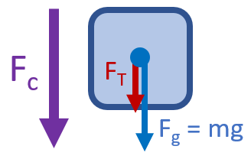 |  | Bottom:  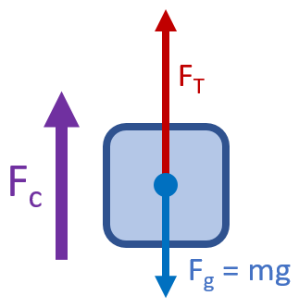
 |  | F_{net} = F_{c} = F_{T} + F_{g} |  | F_{net} = F_{c} = F_{T} - F_{g}
Top: |  |  | Bottom:
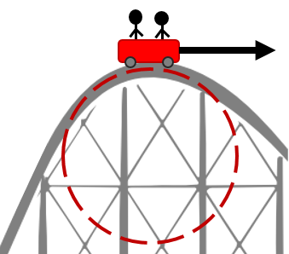 | 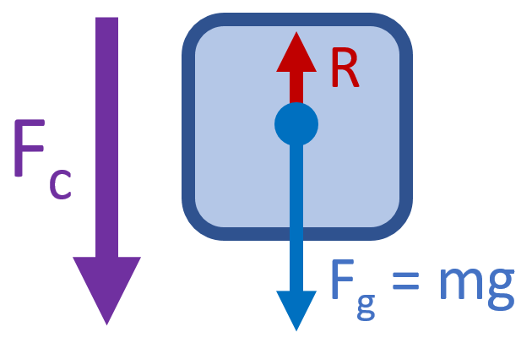 |  | 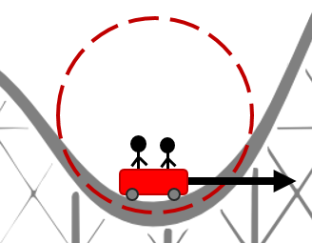 |  | 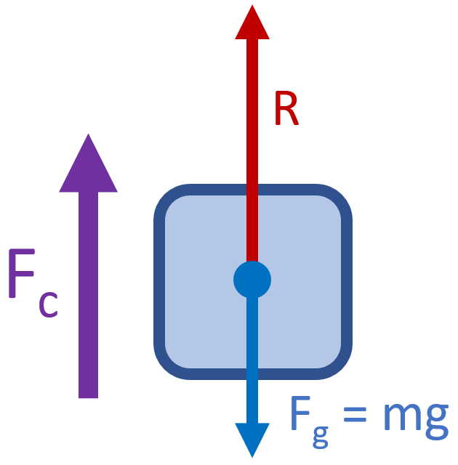
F_{net} = F_{c} = F_{g} - R |  |  | F_{net} = F_{c} = R - F_{g}

Circular Motion with Friction and Angles
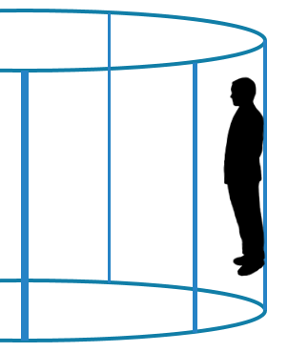 | 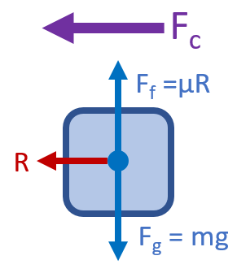 | Relationships between variables:  $$F_{f}=F_{g}$$  $$F_{c}=R$$

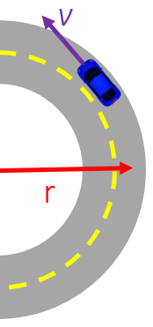 | 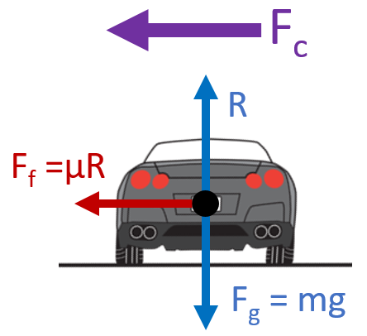 | Relationships between variables:  $$R=F_{g}$$  $$F_{c}=F_{f}$$

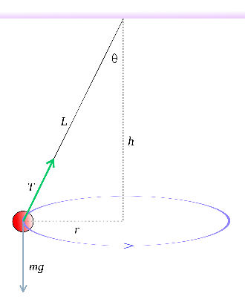 | 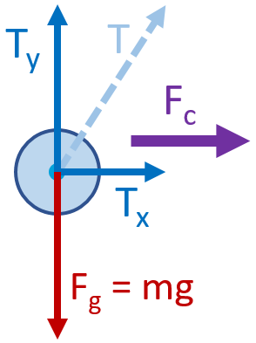 | Relationships between variables:  $$T_{y}=F_{g}$$  $$F_{c}=T_{x}$$

Energy

 | Variable Symbol | Unit |  | Data Booklet Equations:
Work | W | Joules [J] |  | $$W=Fs cosθ$$
Power | P | Watts [W] |  | $$E_{k}=\frac{1}{2}mv^{2}$$
Kinetic Energy | E_{k} | J |  | $$E_{p}=\frac{1}{2}k{∆x}^{2}$$
Elastic Potential Energy | E_{p} | J |  | $${∆E}_{p}=mg∆h$$
Gravitational Potential Energy | ΔE_{p} | J |  | $$power=Fv$$
Spring Constant | k | N m⁻¹
Spring Stretch | Δx | m

Calculating Work
Constant force at an angle:  $$W=Fs\cos{θ}$$ | 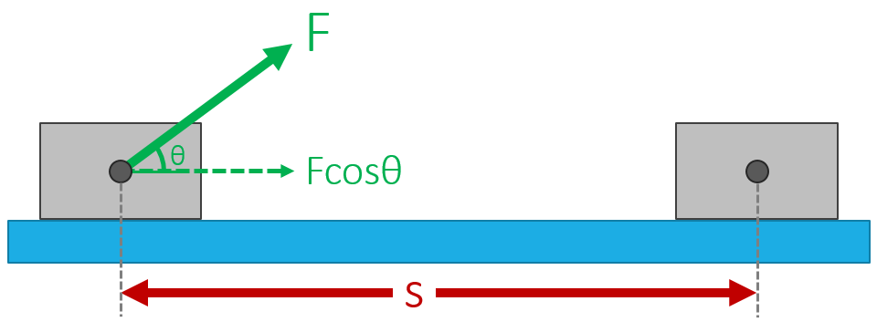
Varying Force:  Area under the curve | 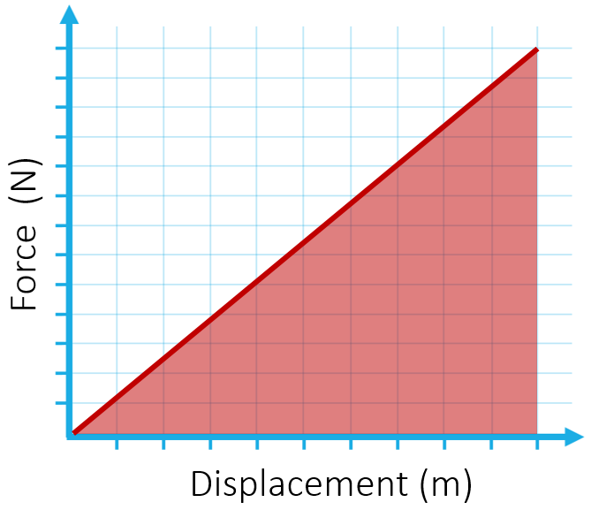 | 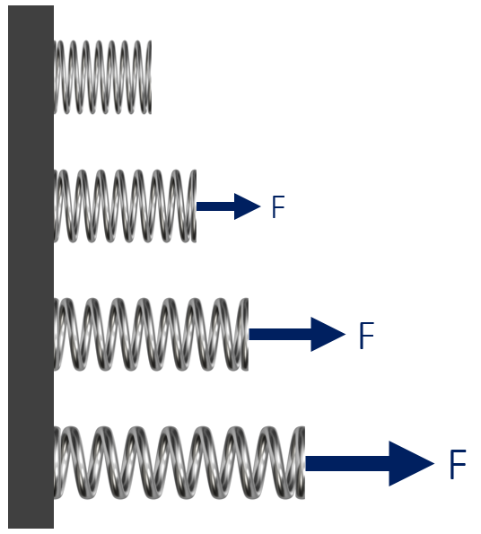

Examples of no work being done for an object in motion:
- Pushing something that doesn’t move (no displacement, no work)
- Waiter carrying a tray horizontally (force is vertical, motion is horizontal)
- Orbiting object (velocity is tangent to path, force is toward the center)

Calculating Power
In terms of work and time:  $$Power= \frac{Work}{Time}$$ | In terms of force and velocity:  $$Power= Force × Velocity=Fv$$

Units
 | Standard Unit | From Equation | Fundamental SI Units
Work | J | N m | kg m² s⁻²
Power | W | J s⁻¹ | kg m² s⁻³

Types of Energy
Kinetic Energy | Elastic Potential Energy | Gravitational Potential Energy
$$\frac{1}{2}mv^{2}$$ | $$\frac{1}{2}k{∆x}^{2}$$ | $$mg∆h$$

Conservation of Energy
Total Energy Before = Total Energy After

Work-Energy Theorem
Work Energy Energy Work
$Fs=\frac{1}{2}mv^{2}$ $\frac{1}{2}mv^{2}=Fs$

Momentum

 | Variable Symbol | Unit |  | Data Booklet Equations:
Momentum | p | kg m s⁻¹ |  | $$p=mv$$
Mass | m | kg |  | $$F=\frac{∆p}{∆t}$$
Velocity | v | m s⁻¹
Time | t | s |  | $$E_{K}=\frac{p^{2}}{2m}$$
Kinetic Energy | E_{K} | J
Impulse | Impulse | N s or kg m s⁻¹ |  | $$Impulse=F∆t=∆p$$

Conservation of Energy Problems
“Explosion”

p_{AB} = p_{A} + p_{B}
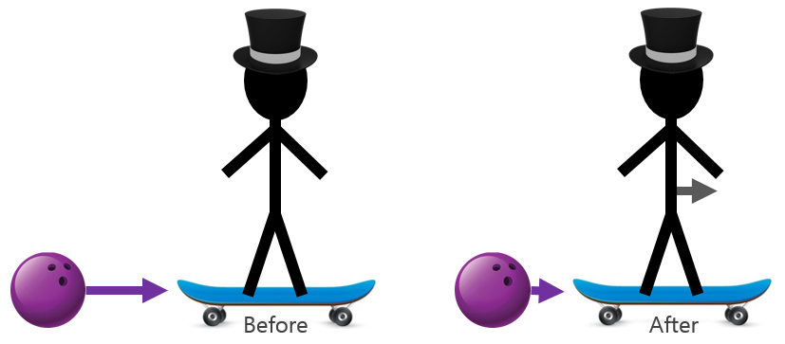 | “Hit and Bounce”  p_{A} + p_{B} = p_{A} + p_{B}
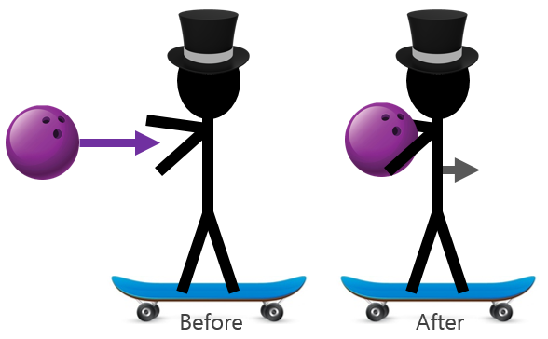 | “Hit and Stick”  p_{A} + p_{B} = p_{AB}

Types of Collisions
Elastic | Kinetic Energy is conserved (perfect hit and bounce)  *Typically just found in particle collisions
Inelastic | Kinetic Energy is not conserved

Calculating Impulse
Constant force:  Force × Time  FΔt | 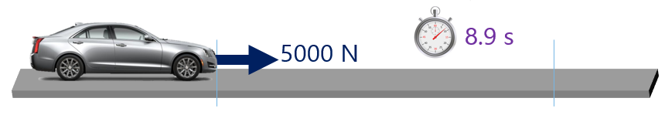
Varying Force:  Area under a  Force vs Time Graph | 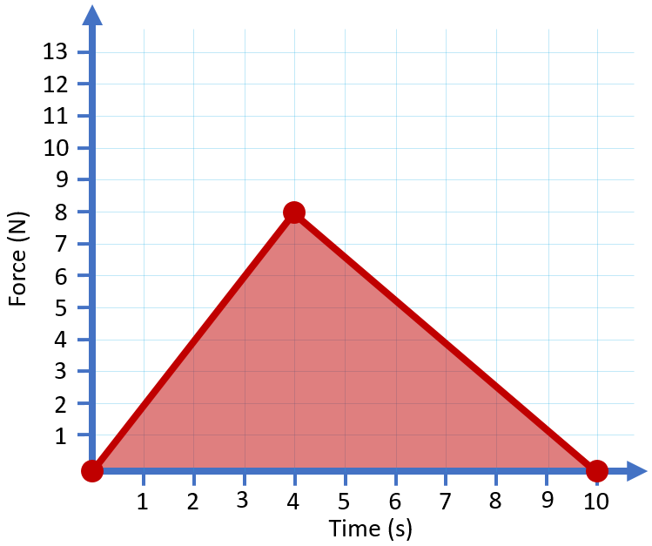

Impulse-Momentum Equation
$$F∆t=∆p=m∆v=mv-mu$$

Collision Safety
Explain (using impulse, force, and time) how to decrease the force acting on an object undergoing a collision:

Impulse is the same overall regardless of the impact style because the object has a set mass and impact velocity. The force can be decreased by increasing the time of the impact.

Impulse = FΔt or Impulse = FΔt

Waves – Sound

 | Variable Symbol | Unit |  | Data Booklet Equations:
Period | T | s |  | $$T=\frac{1}{f}$$
Frequency | f | Hz
Wavelength | λ | m |  | $$c=fλ$$
Amplitude | A | m
Wave Speed | v | m s⁻¹

Simple Harmonic Motion Graphs
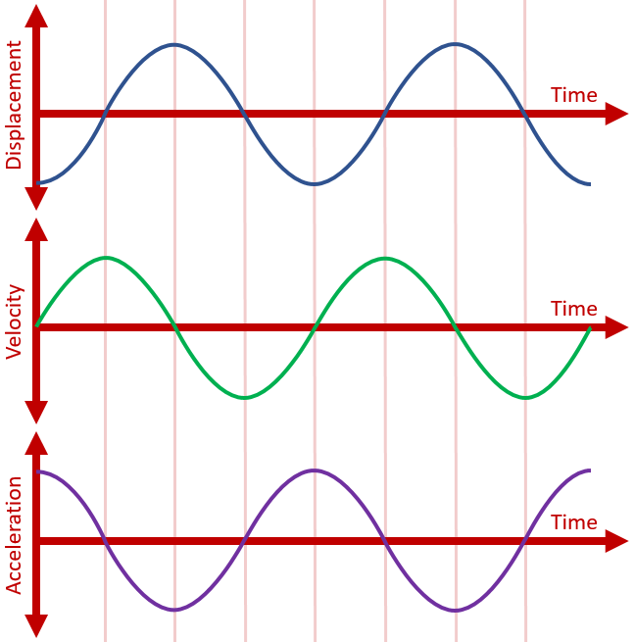 |  |  | Velocity vs Displacement  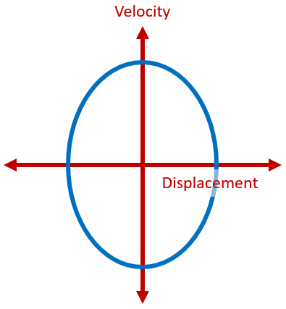

Accel. vs Displacement

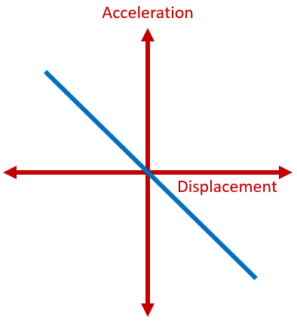
Types of Waves | Picture | Definition |  | Examples
Transverse |  | Particles move perpendicular to the motion of the wave |  | - Light  - Ripples in a Pond  - Earthquakes
Longitudinal |  | Particles move parallel  to the motion of the wave |  | - Sound  - Earthquakes

Parts of a Wave
Label the Wave:  - Amplitude  - Wavelength  - Crest  - Trough | 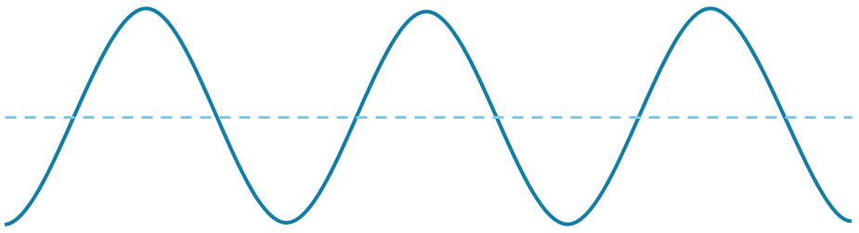

Harmonics
 | Open Pipe |  | Closed Pipe |  | String
End Conditions | Antinode | Antinode | Node | Antinode | Node | Node
3rd Harmonic | 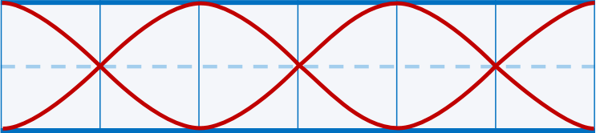 |  | 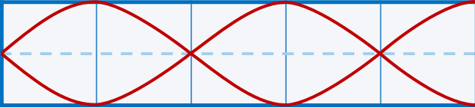 |  | 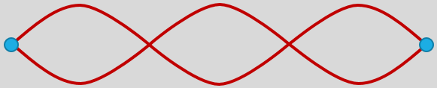
 | $$L=\frac{3}{2} λ$$ |  | $$L=\frac{5}{4} λ$$ |  | $$L=\frac{3}{2} λ$$
2nd Harmonic | 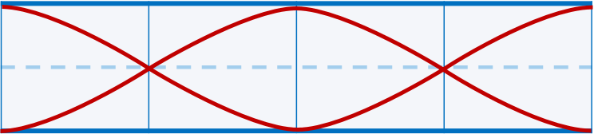 |  | 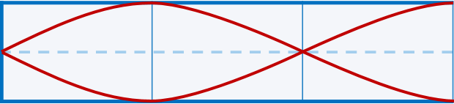
 | $$L=1 λ$$ |  | $$L=\frac{3}{4} λ$$ |  | $$L=1 λ$$
1st Harmonic  (Fundamental) | 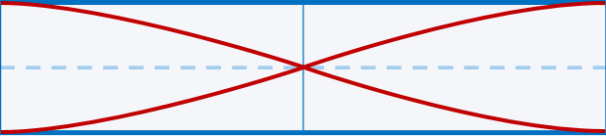 |  | 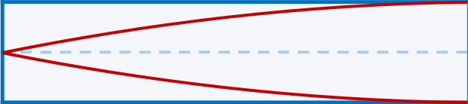
 | $$L=\frac{1}{2} λ$$ |  | $$L=\frac{1}{4} λ$$ |  | $$L=\frac{1}{2} λ$$

Interference
Constructive | Path Difference = n λ | Destructive | Path Difference = (n + ½) λ
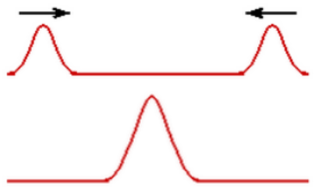 |  | 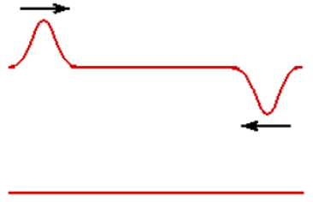

Waves – Light

Electromagnetic Spectrum
A | Radiowaves | 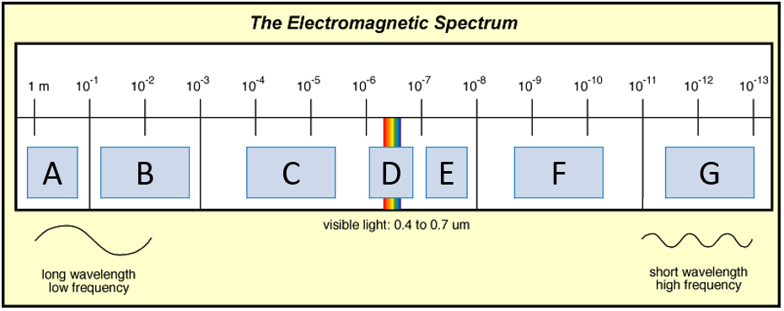
B | Microwaves
C | Infrared
D | Visible Light
E | Ultraviolet
F | X-Rays
G | Gamma Waves

Index of Refraction
Medium | Wave Speed (v) | Index of Refraction (n) | $$\frac{n_{1}}{n_{2}}=\frac{v_{2}}{v_{1}}$$
Vacuum | 3.00 × 10⁸ m s⁻¹ | 1.0000
Air | 2.999 × 10⁸ m s⁻¹ | 1.0003
Water | 2.256 × 10⁸ m s⁻¹ | 1.33
Glass | 1.974 × 10⁸ m s⁻¹ | 1.52

Refraction
$$\frac{n_{1}}{n_{2}}=\frac{sinθ_{2}}{sinθ_{1}}$$  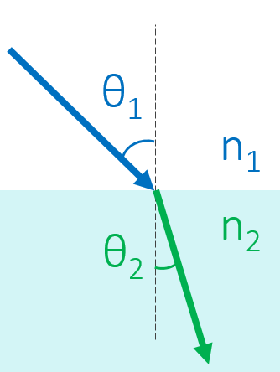 | 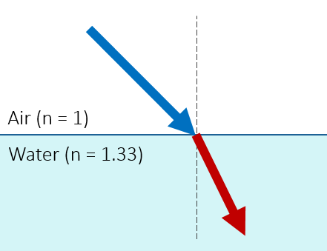 | 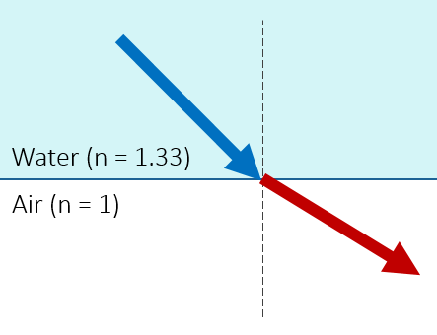
 | 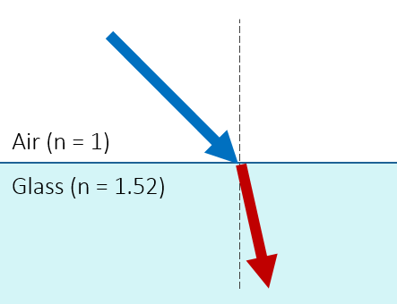 | 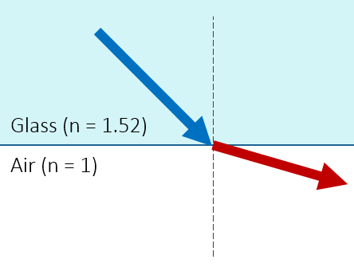
Critical Angle
When $θ_{1}=θ_{c}$  $$θ_{2}=90°$$ | $$θ_{c}= \sin^{-1}\left(\frac{n_{2}}{n_{1}}\right)$$ | 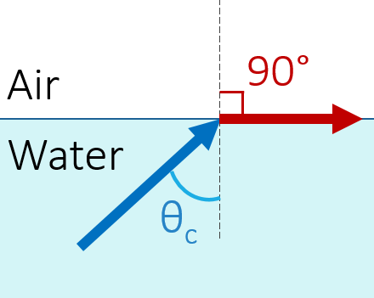

Reflection
Law of Reflection | 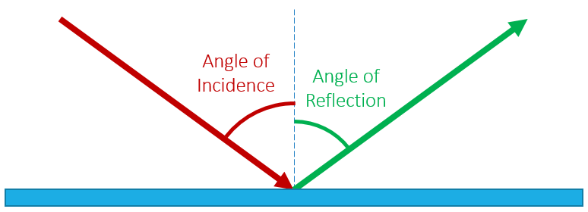
Angle of Incidence = Angle of Reflection
Polarized Light
$$I=I_{0}\cos^{2}θ$$ |  | 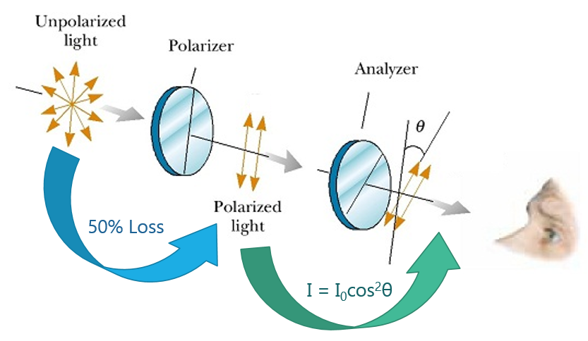
I | Intensity Observed
I₀ | Original Intensity
θ | Difference in Angle

Double Slit Experiment
$$s=\frac{λD}{d}$$ |  | Label this diagram:  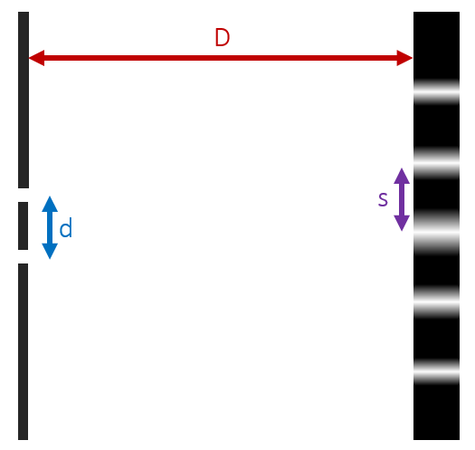
s | Distance between fringes
λ | Wavelength
D | Distance to Screen
d | Distance between slits

Electricity
Charge |  |  |  |  | Current
Symbol | q | Unit | Coulombs [C] |  | Symbol | I | Unit | Amperes [A]
Charge of 1 Electron |  |  | 1.6 × 10⁻¹⁹ C |  | Unit in terms of Coulombs |  |  | $$A=\frac{C}{s}$$
# of Electrons per Coulomb |  |  | 6.25 × 10¹⁸ e⁻

Drift Speed
 | Variable Symbol | Unit |  | Data Booklet Equation:
Current | I | A |  | $$I=nAvq$$
# of Electrons per m³ | n | ---
Cross Sectional Area | A | M²
Drift Speed | v | m s⁻¹ |  | Cross Sectional Area:  $$A=πr^{2}$$
Charge | q | C

Electrical Properties
Property | What is it? | Symbol | Unit
Voltage | Potential Difference | V | Volts [V]
Current | The rate at which charges move through a wire | I | Amperes [A]
Resistance | How hard it is for a current to  flow through a conductor | R | Ohms [Ω]

Kirchhoff’s Laws
$$ΣI=0 (junction)$$ |  |  |  | $$ΣV=0 (loop)$$
The total current coming into a junction must equal the total current leaving the same junction |  |  |  | The sum of the voltages (potential differences) provided must equal the voltages dissipated across components
 |  |  |  | Across resistors | Always Negative
Entering Junction |  | ● | Positive | Negative to Positive |  | 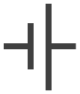 | Positive
Exiting Junction | ● |  | Negative | Positive to Negative |  | 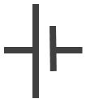 | Negative

Ohm’s Law
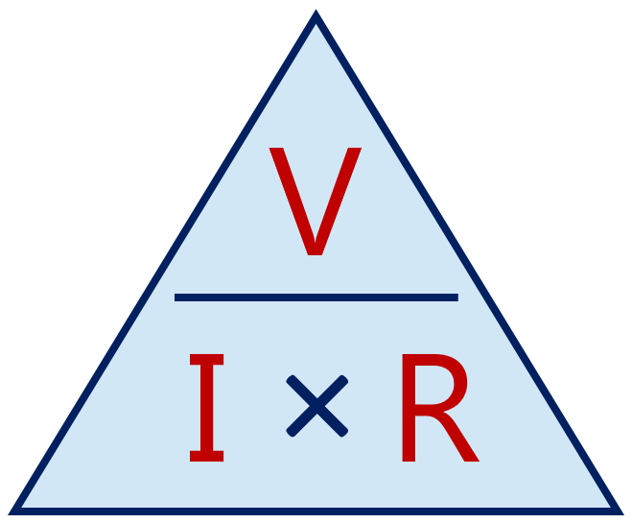 | $$V=I × R$$ | Ohmic Resistor  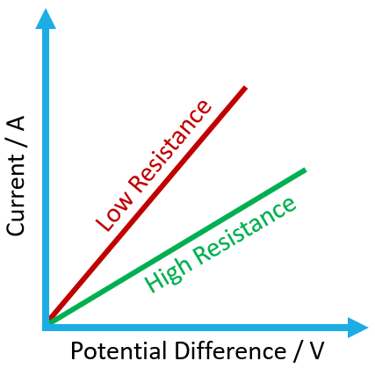 | Non-Ohmic Resistor  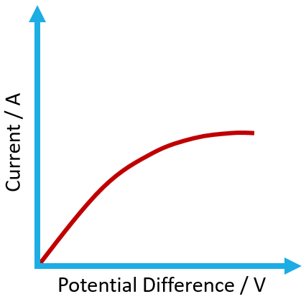
 | $$I=\frac{V}{R}$$
 | $$R=\frac{V}{I}$$

Equivalent Resistance
 | Drawing with R₁ and R₂ | Equation
Series |  | $$R_{total}=R_{1}+R_{2}+…$$
Parallel | 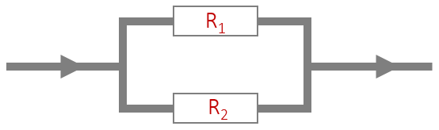 | $$\frac{1}{R_{total}}=\frac{1}{R_{1}}+\frac{1}{R_{2}}+…$$

Measuring Circuits
 | Ammeter | Voltmeter
Ideal Resistance | R = 0 Ω | R = ∞ Ω
How is it connected to the component being measured? | Ammeters must be connected in series | Voltmeters must be connected in parallel
Drawing of meter measuring R₁ | 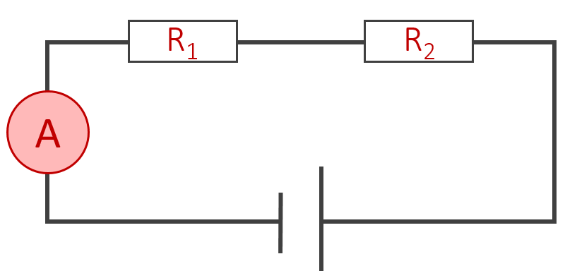 | 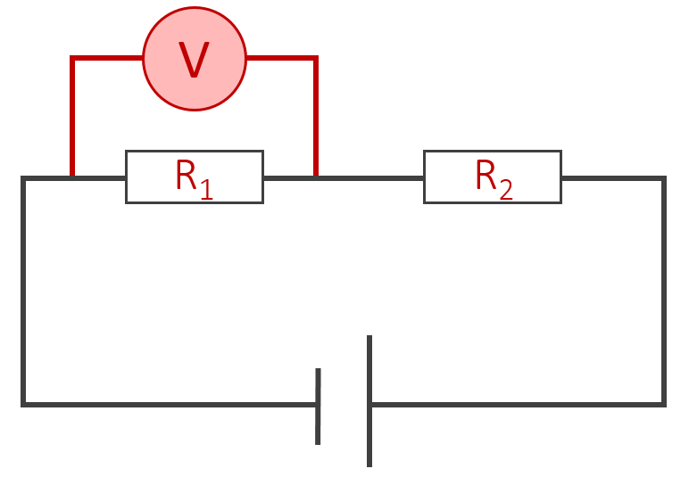

Resistivity
 | Variable Symbol | Unit |  | Data Booklet Equation:
Resistivity | ρ | Ω m |  | $$ρ=\frac{RA}{L}$$
Resistance | R | Ω
Cross Sectional Area | A | m² |  | Cross Sectional Area:  $$A=πr^{2}$$
Length | L | m

Power
In terms of V and I | In terms of I and R | In terms of V and R
$$P=V × I$$ | $$P=I^{2}R$$ | $$P=\frac{V^{2}}{R}$$

Voltage Dividers
 | Light-Dependent Resistor |  | Thermistor
Symbol | 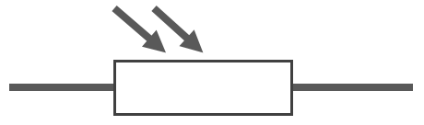 |  | 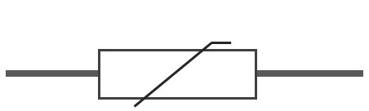
Relationship | Light | Increases | Heat | Increases
 | Resistance | Decreases | Resistance | Decreases
Circuit | Switch turns on in the dark:  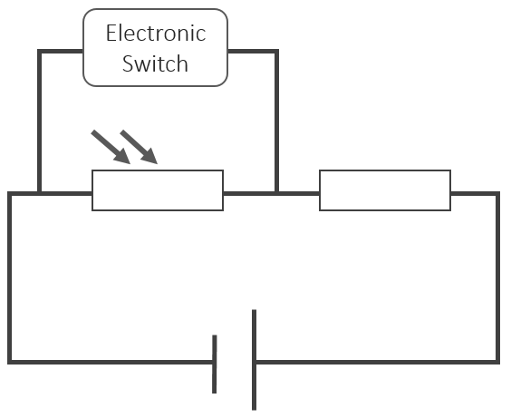 |  | Switch turns on in a fire:  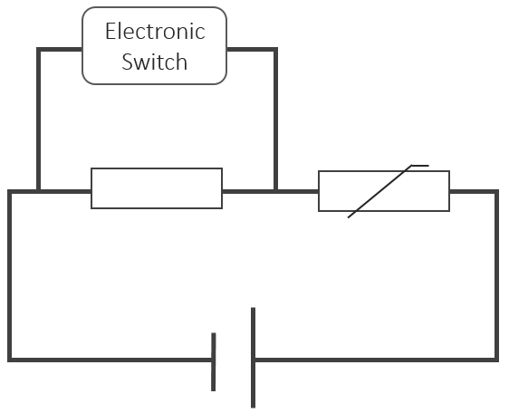

Batteries
Primary Cells | Secondary Cells
Cannot be recharged | Can be recharged by passing a current through the battery in the opposite direction as it would normally travel

 | Variable Symbol | Unit |  | Data Booklet Equation:
Electromotive Force (e.m.f) | ε | V |  | $$ε=I(R+r)$$
Current | I | A
Circuit Resistance | R | Ω
Internal Resistance | r | Ω

Force Fields

Forces between objects

Coulomb’s Law
 | Variable Symbol | Unit |  | Data Booklet Equations:
Electrostatic Force | F | N |  | $$F=k\frac{q_{1}q_{2}}{r^{2}}$$
Object 1 Charge | q₁ | C
Object 2 Charge | q₂ | C |  | $$=\frac{1}{4πε_{0}}$$
Separation Distance | r | M
Coulomb Constant | k | N m² C⁻² |  | k = 8.99 × 10⁹ N m² C⁻²
Permittivity of Free Space | ε₀ | C² N⁻¹ m⁻² |  | ε₀ = 8.85 × 10⁻¹² C² N⁻¹ m⁻²

Universal Law of Gravitation
 | Variable Symbol | Unit |  | Data Booklet Equation:
Gravitational Force | F | N |  | $$F=G\frac{Mm}{r^{2}}$$
Object 1 Mass | M | kg
Object 2 Mass | m | kg
Separation Distance | r | m
Gravitational Constant | G | N m² kg⁻² |  | G = 6.67 N m² kg⁻²

Force Fields
Electric Field |  |  | Gravitational Field
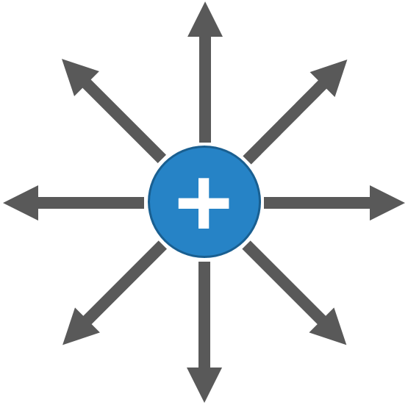 |  | 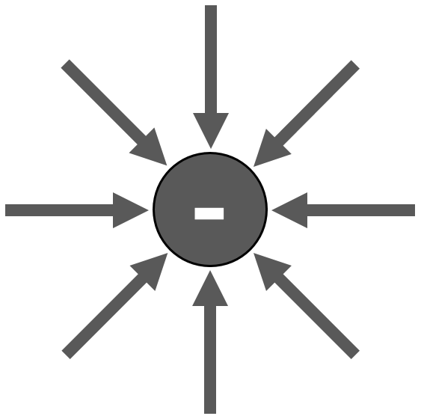 | 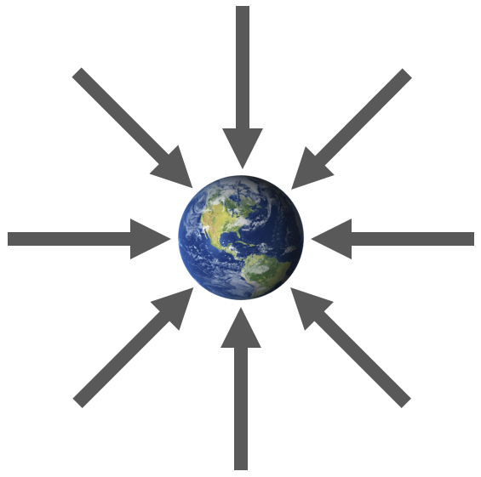 |  | 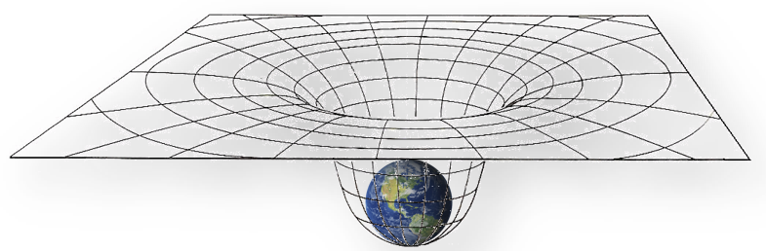
Symbol | E | Data Booklet Equation:  $E=\frac{F}{q}$ | Symbol | g | Data Booklet Equation:  $g=\frac{F}{m}$ $g=G\frac{M}{r^{2}}$
Units | F C⁻¹ |  | Units | F kg⁻¹

Magnetic Fields
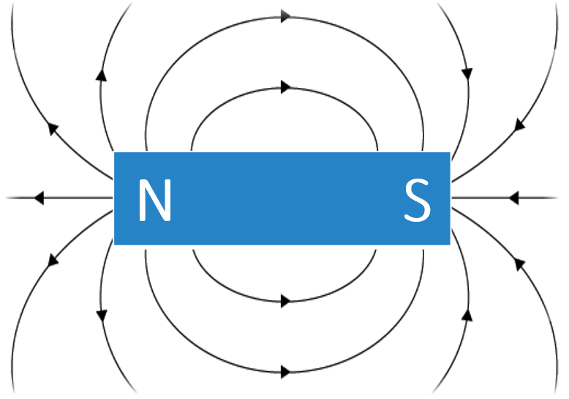 | 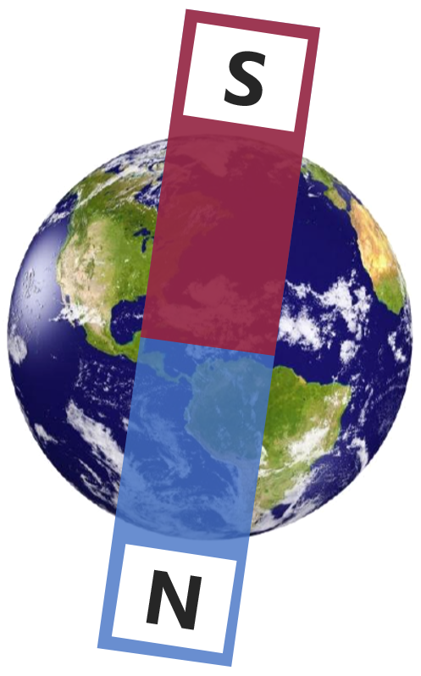

Right Hand Rule:
Right Hand Rule #1 |  |  |  | Right Hand Rule #2 |  |  | Right Hand Rule #3
Magnetic field around a current carrying wire |  |  |  | Pole orientation for a coil of wire (electromagnet, solenoid, etc.) |  |  | Electromagnetic force direction on a wire or moving particle
Thumb |  | Current |  | Thumb | North Pole |  | Thumb | Current
Fingers |  | Magnetic Field |  | Fingers | Current |  | Fingers | Magnetic Field
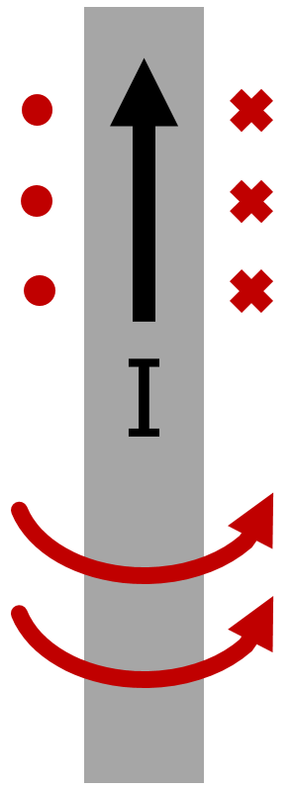 | 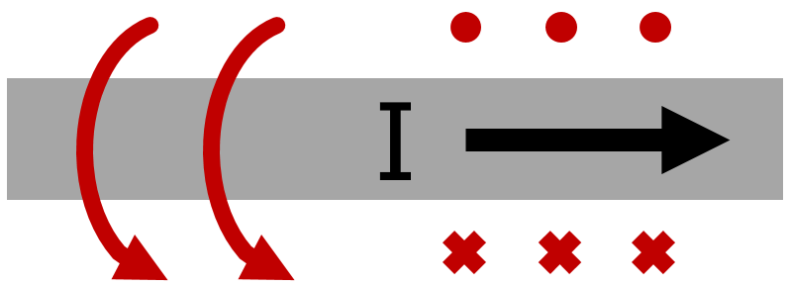 |  | 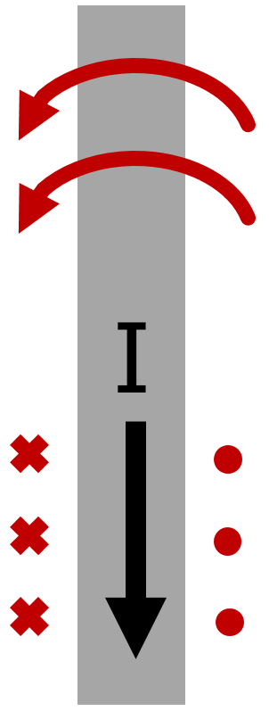 |  |  |  | Palm | Force
 |  |  |  |  |  |  | 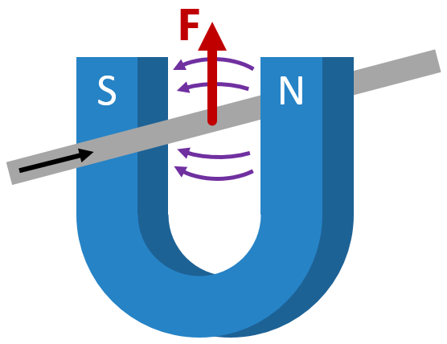 |  | 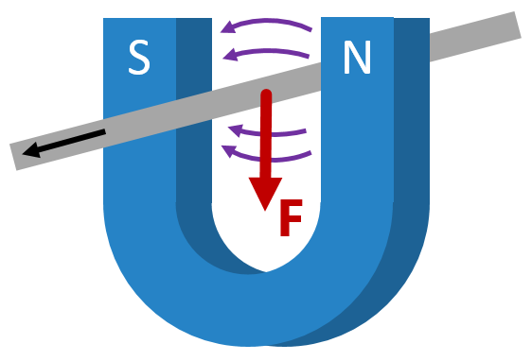
 | 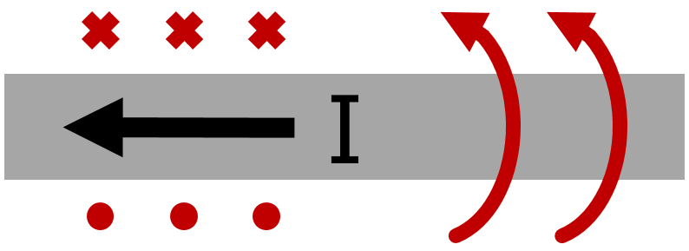

Electromagnetic Force
 | Variable Symbol | Unit |  | Data Booklet Equations:
Magnetic Force | F | N
Magnetic Field Strength | B | T |  | Wire:
Current | I | A |  | $$F=BIL\sin{θ}$$
Wire Length | L | m
Angle to Field | θ | ° |  | Particle:
Particle Charge | q | C |  | $$F=qvB\sin{θ}$$
Particle Velocity | v | m s⁻¹

Charged Particles Moving through a Magnetic Field
 | Magnetic Field | Out of Screen | Magnetic Field | Into Screen
Positive Particle | 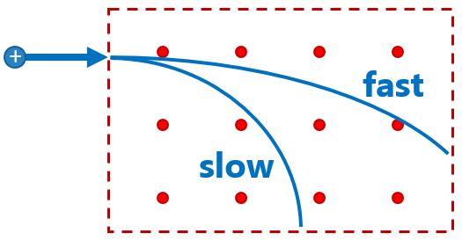 | 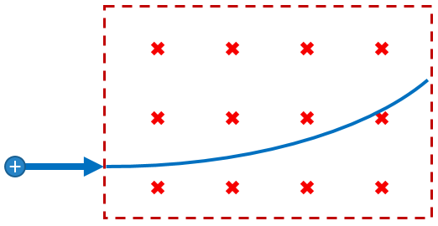
Negative Particle | 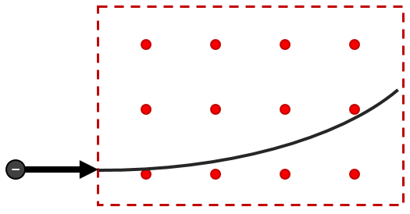 | 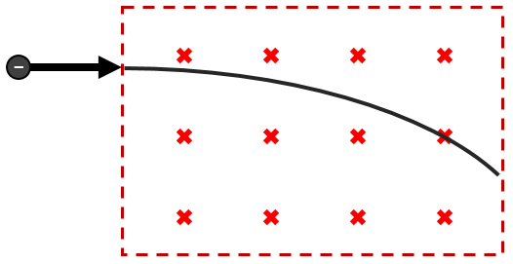

Thermal Physics

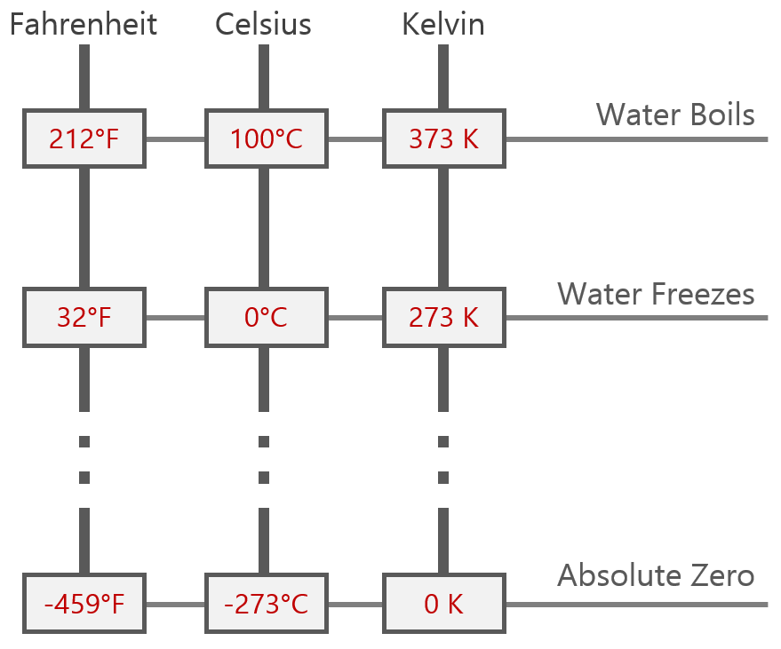 | Data Booklet Equation:  $$Temperature \left(K\right)=Temperature \left(°C\right)+273$$
Conditions for Absolute Zero:

Molecules stop moving. This is the coldest possible temperature.

Absolute Zero = 0 K = -273 K

Specific Heat Capacity and Specific Latent Heat
 | Variable Symbol | Unit |  | Data Booklet Equations:
Heat Energy | Q | J |  | $$Q=mc∆T$$
Mass | m | kg
Specific Heat Capacity | c | J kg⁻¹ K⁻¹ |  | $$Q=mL$$
Change in Temperature | ΔT | K
Specific Latent Heat | L | J kg⁻¹

E_{K} | Kinetic Energy Temperature |  | E_{P} | Potential Energy Phase Change

Heating Curves
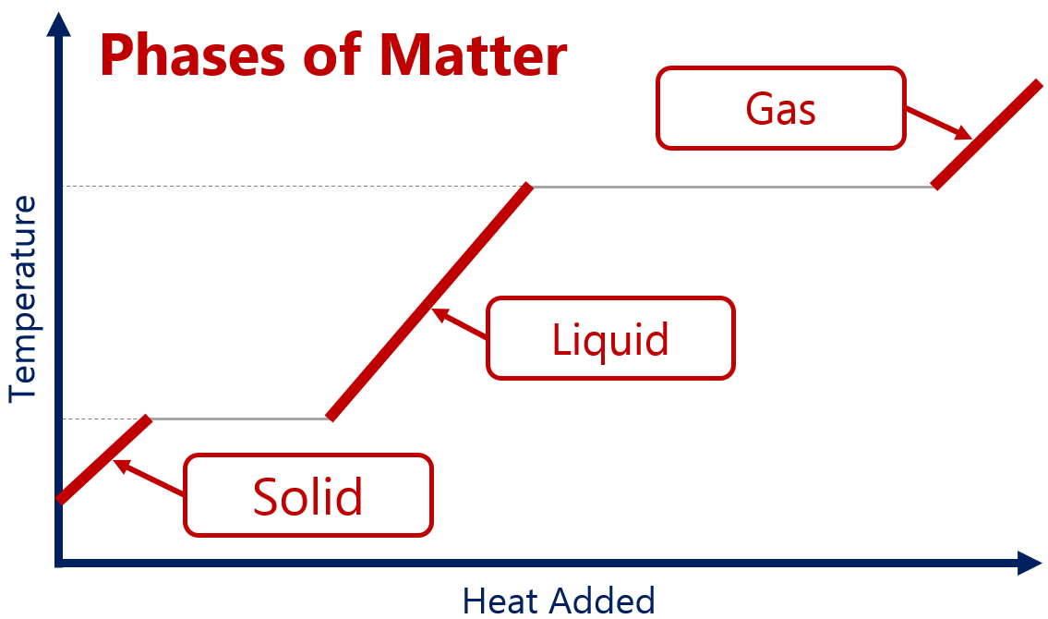 | 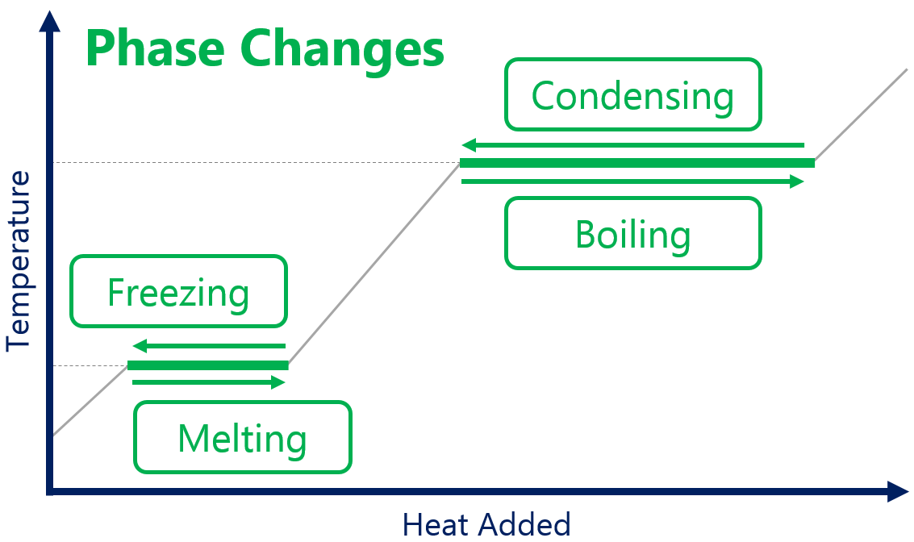

Pressure
 | Variable Symbol | Unit |  |  | Data Booklet Equation:
Force | F | N |  |  | $$p=\frac{F}{A}$$
Area | A | m³
Pressure | p | N m⁻³ | Pa

Kinetic Theory and Temperature
 | Variable Symbol | Unit |  | Data Booklet Equation:
Average Kinetic Energy | $${\overline{E}}_{k}$$ | J |  | $${\overline{E}}_{K}=\frac{3}{2}k_{B}T=\frac{3}{2} \frac{R}{N_{A}}T$$
Absolute Temperature | T | K
Boltzmann’s Constant | k_{b} | J K⁻¹ |  | $k_{B}$ = 1.38 × 10⁻²³ J K⁻¹

Avogadro’s Number | N_{A} | 6.02 × 10²³

Ideal Gas Law
 | Variable Symbol | Unit |  | Data Booklet Equations:
Pressure | p | Pa |  | $$pV=nRT$$ | $R$ = 8.31 J K⁻¹ mol⁻¹
Volume | V | m⁻³ |  | Conditions for Ideal Gases:
Number of Molecules | n | mol
Gas Constant | R | J K⁻¹ mol⁻¹
Temperature | T | K

Ideal Gas Relationships
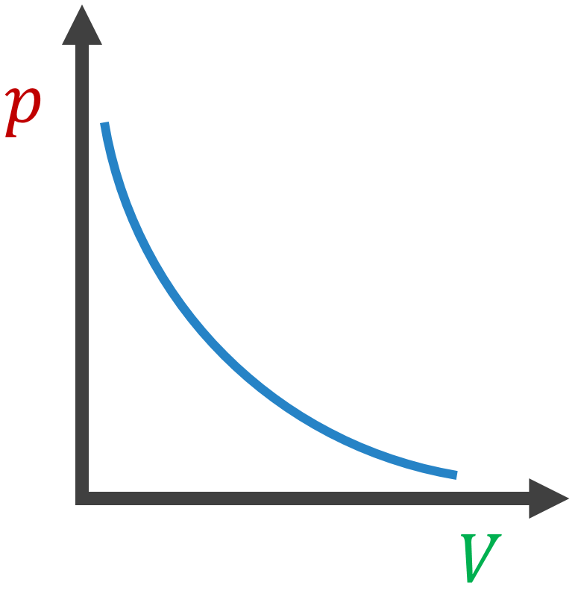 | 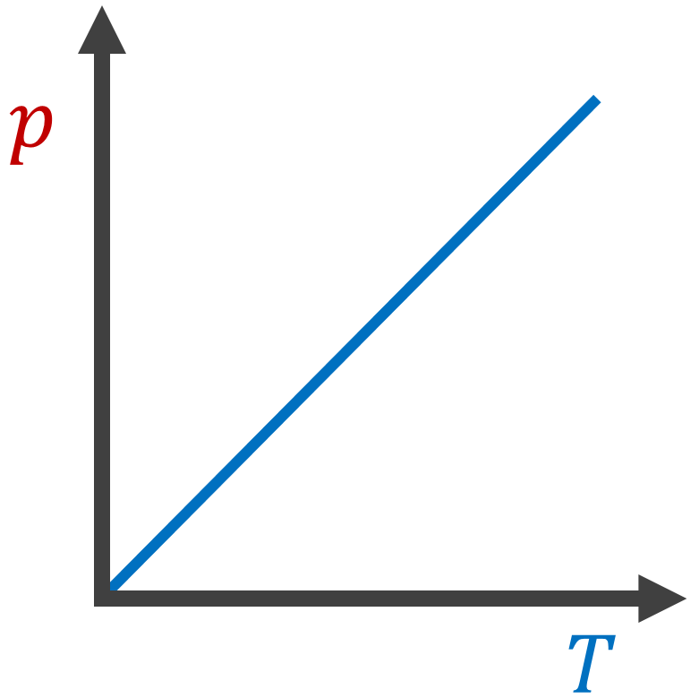 | 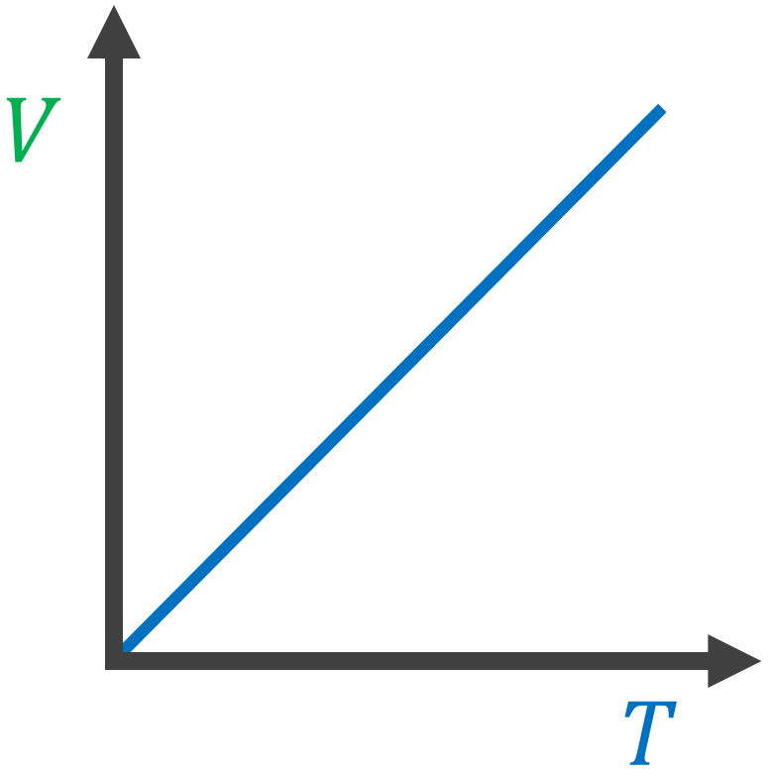

Atomic Physics

Types of Decay
Alpha |  |  |  |  |  | Beta-Negative |  |  |  |  |  |  |  | Beta-Positive
$${}_{Z}^{A}X$$ | $$→$$ | $${}_{Z-2}^{A-4}X$$ | $$+$$ | $${}_{2}^{4}{He}$$ |  | $${}_{Z}^{A}X$$ | $$→$$ | $${}_{Z+1}^{A}X$$ | $$+$$ | $${}_{-1}^{0}e$$ | $$+$$ | $${\overline{v}}_{e}$$ |  | $${}_{Z}^{A}X$$ | $$→$$ | $${}_{Z-1}^{A}X$$ | $$+$$ | $${}_{+1}^{0}e$$ | $$+$$ | $$v_{e}$$
Parent  Nuclide |  | Daughter Nuclide |  | Alpha Particle |  | Parent  Nuclide |  | Daughter Nuclide |  | Electron |  | Anti-neutrino |  | Parent  Nuclide |  | Daughter Nuclide |  | Positron |  | Neutrino

Property | Alpha  (α) | Beta  (β+ or β-) | Gamma  (γ) | 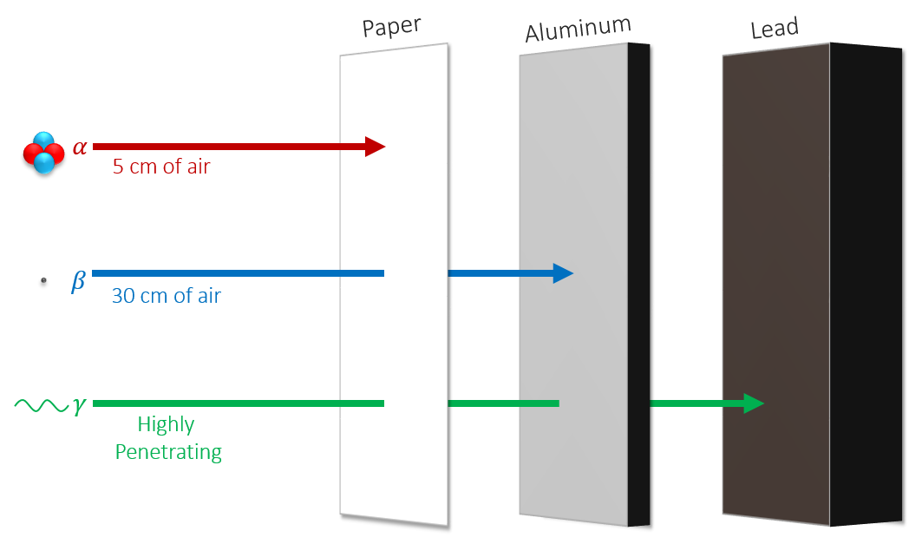
Relative Charge | +2 | +1 or -1 | 0
Relative Mass | 4 | 0.0005 | 0
Typical Speed | 10⁷  m s⁻¹ | 2.5 × 10⁸ m s⁻¹ | 3.0 × 10⁸ m s⁻¹
Ionizing Effect | Strong | Weak | Very Weak

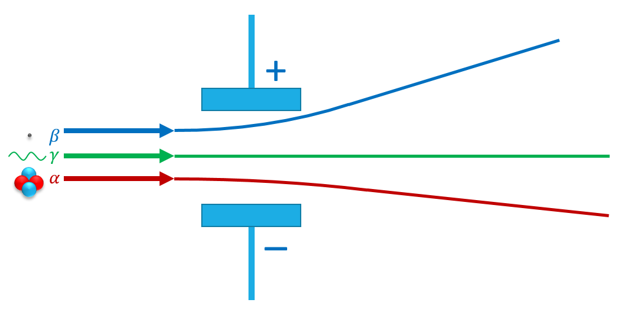 | 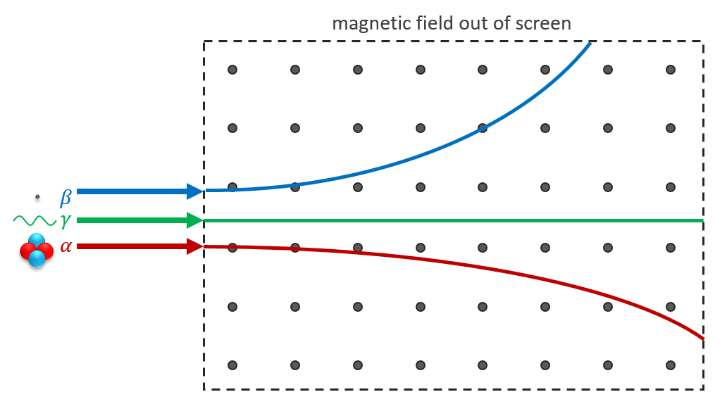

Half Life
# of  Half-Lives | Fraction  Remaining | Percentage Remaining | 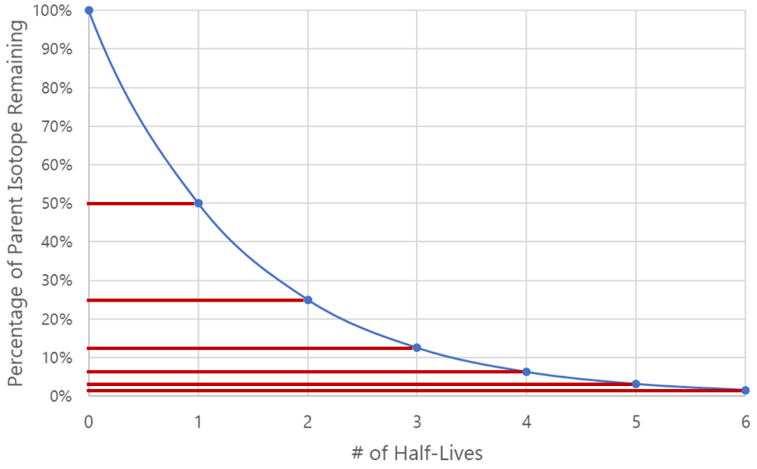
0 | 1 | 100%
1 | 1/2 | 50%
2 | 1/4 | 25%
3 | 1/8 | 12.5%
4 | 1/16 | 6.25%
5 | 1/32 | 3.125%
6 | 1/64 | 1.5625%

Mass-Energy Equivalence
 | Variable Symbol | Unit |  | Data Booklet Equation:
Energy | E | J |  | $$E=mc^{2}$$
Mass | m | kg
Speed of Light | c | m s⁻¹ |  | $$c=3.00×{10}^{8} m s^{-1}$$

Unified Atomic Mass Unit | $$u$$ | 1.661 × 10⁻²⁷ kg | 1.000000 u | 931.5 MeV c⁻²
Electron Rest Mass | $$m_{e}$$ | 9.110 × 10⁻³¹ kg | 0.000549 u | 0.511 MeV c⁻²
Proton Rest Mass | $$m_{p}$$ | 1.673 × 10⁻²⁷ kg | 1.007276 u | 938 MeV c⁻²
Neutron Rest Mass | $$m_{n}$$ | 1.675 × 10⁻²⁷ kg | 1.008665 u | 940 MeV c⁻²

Converting between Joules and Electron-Volts
$$\left\{Energy in eV\right\}=\frac{\left\{Energy in J\right\}}{1.60×{10}^{-19}}$$ | $$\left\{Energy in J\right\}=\left\{Energy in eV\right\}×1.60×{10}^{-19}$$

Process for Calculating Binding Energy
- Add up the “before and after” masses
- Find the mass defect by taking the difference
- Convert atomic mass units (u) into MeV c⁻² by using the conversion factor 1 u = 931.5 MeV c⁻²
- The c⁻² cancels out when converting to energy using E = mc² so this is your binding energy

 | Describe | Examples | Challenges
Fission | Lighter elements are created by splitting heavier elements | Nuclear Power  Nuclear Weapons | Proper amounts of fissionable elements required to maintain chain reaction
Fusion | Heavier elements are created by combining lighter elements | The Sun/Stars | Requires high heat and high pressure

Fundamental Particles
The following two tables are provided in the IB Physics Data Booklet
Charge | Quarks |  |  | Baryon Number |  | Charge | Leptons
$$\frac{2}{3}$$ | $$u$$ | $$c$$ | $$t$$ | $$\frac{1}{3}$$ |  | $$-1$$ | $$e$$ | $$μ$$ | $$τ$$
$$-\frac{1}{3}$$ | $$d$$ | $$s$$ | $$b$$ | $$\frac{1}{3}$$ |  | $$0$$ | $$v_{e}$$ | $$v_{μ}$$ | $$v_{τ}$$
All quarks have a strangeness number of 0 except the strange quark that has a strangeness number of –1 |  |  |  |  |  | All leptons have a lepton number of 1 and antileptons have a lepton number of –1

Quarks |  |  |  |  | Leptons
Symbol | Name | Charge | Baryon # |  | Symbol | Name | Charge | Lepton #
$$u$$ | Up | $$+\frac{2}{3}$$ | $$\frac{1}{3}$$ |  | $$e$$ | Electron | $$-1$$ | $$1$$
$$d$$ | Down | $$-\frac{1}{3}$$ | $$\frac{1}{3}$$ |  | $$μ$$ | Muon | $$-1$$ | $$1$$
$$c$$ | Charm | $$+\frac{2}{3}$$ | $$\frac{1}{3}$$ |  | $$τ$$ | Tau | $$-1$$ | $$1$$
$$s$$ | Strange | $$-\frac{1}{3}$$ | $$\frac{1}{3}$$ |  | $$v_{e}$$ | Electron Neutrino | $$0$$ | $$1$$
$$t$$ | Top | $$+\frac{2}{3}$$ | $$\frac{1}{3}$$ |  | $$v_{μ}$$ | Muon Neutrino | $$0$$ | $$1$$
$$b$$ | Bottom | $$-\frac{1}{3}$$ | $$\frac{1}{3}$$ |  | $$v_{τ}$$ | Tau Neutrino | $$0$$ | $$1$$
Anti-Quarks |  |  |  |  | Anti-Leptons
Symbol | Name | Charge | Baryon # |  | Symbol | Name | Charge | Lepton #
$$\overline{u}$$ | Antiup | $$-\frac{2}{3}$$ | $$-\frac{1}{3}$$ |  | $$\overline{e}$$ | Antielectron (positron) | $$+1$$ | $$-1$$
$$\overline{d}$$ | Antidown | $$+\frac{1}{3}$$ | $$-\frac{1}{3}$$ |  | $$\overline{μ}$$ | Antimuon | $$+1$$ | $$-1$$
$$\overline{c}$$ | Anticharm | $$-\frac{2}{3}$$ | $$-\frac{1}{3}$$ |  | $$\overline{τ}$$ | Antitau | $$+1$$ | $$-1$$
$$\overline{s}$$ | Antistrange | $$+\frac{1}{3}$$ | $$-\frac{1}{3}$$ |  | $${\overline{v}}_{e}$$ | Electron Antineutrino | $$0$$ | $$-1$$
$$\overline{t}$$ | Antitop | $$-\frac{2}{3}$$ | $$-\frac{1}{3}$$ |  | $${\overline{v}}_{μ}$$ | Muon Antineutrino | $$0$$ | $$-1$$
$$\overline{b}$$ | Antibottom | $$+\frac{1}{3}$$ | $$-\frac{1}{3}$$ |  | $${\overline{v}}_{τ}$$ | Tau Antineutrino | $$0$$ | $$-1$$

Explain the phenomenon of Quark Confinement:
Quarks have never been observed on their own. The amount of energy required to overcome the strong nuclear force holding the quarks together gets converted into mass and forms a new quark pair.

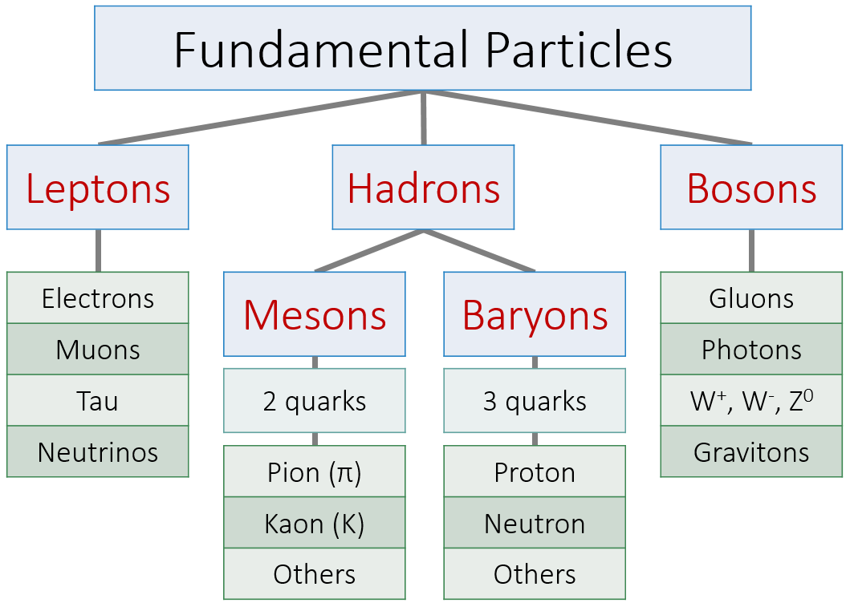

Fundamental Forces  Strength Distance  Gravitational Weakest Long Range  Weak Weak Short Range  Electromagnetic Strong Very Long Range  Strong Strongest Very Short Range | Particle Configurations  Proton Neutron  Total Charge +1 Total Charge 0

Feynman Diagrams
You can only draw two kinds of lines | You can only connect these lines if you have two lines with arrows meeting a single wiggly line | The x-axis represents time and is read from left to right. Everything left of the vertex is the “before” condition.

Beta-Negative Decay | Beta-Positive Decay
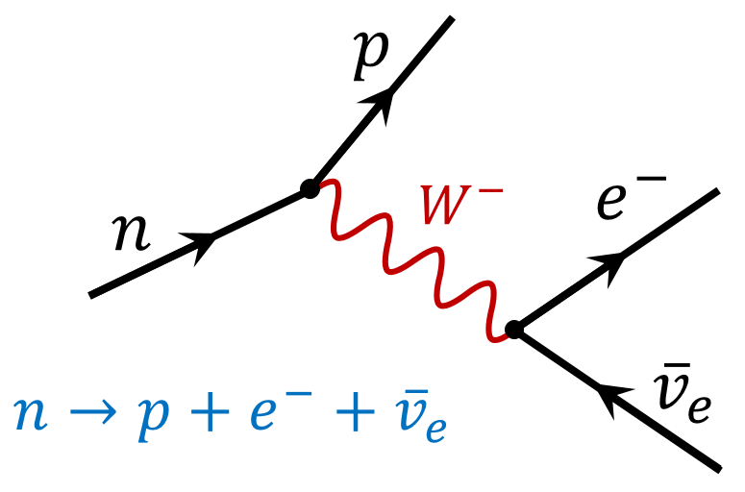 | 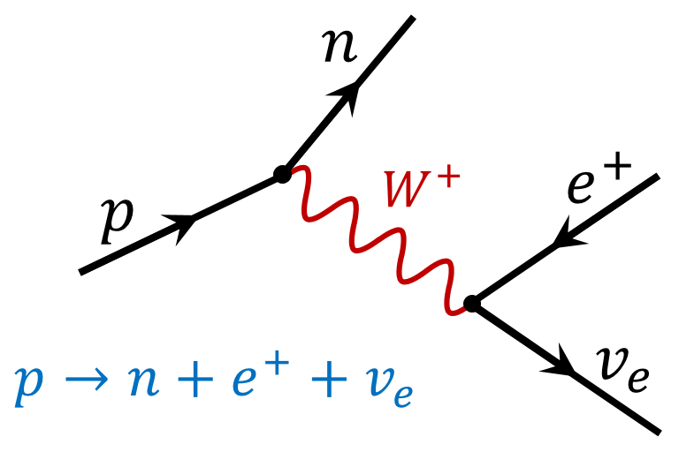

Energy Production

Global Energy Usage
Rank | Energy Source | % | 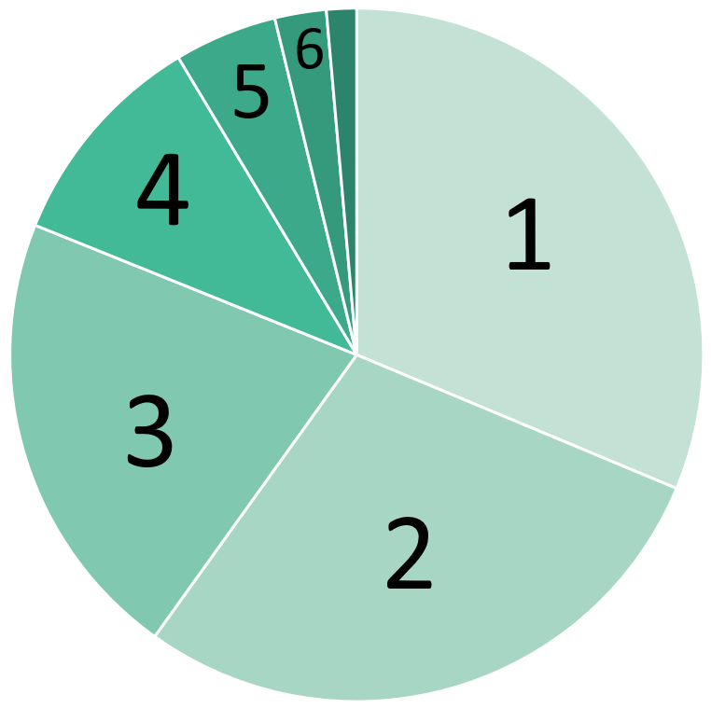
1 | Oil | 32%
2 | Coal | 28%
3 | Natural Gas | 22%
4 | Biomass | 10%
5 | Nuclear | 5%
6 | Hydropower | 2.5%

Efficiency
$$Efficiency=\frac{useful work out}{total work in}=\frac{useful power out}{total power in}$$ | 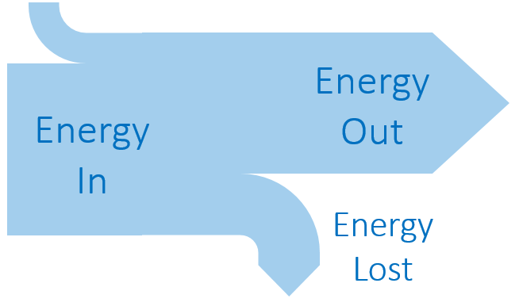
Sankey Diagram Rules:
Width of the arrow proportional to the amount of energy

Energy Density
 | Definition | Units
Specific Energy | Energy transferred per unit mass | J kg⁻¹
Energy Density | Energy transferred per unit volume | J m⁻³

Primary and Secondary Sources
Primary Energy Sources | Secondary Energy Sources
Energy sources found in the natural environment  (fossil fuels, solar, wind, nuclear, hydro, etc.) | Useful transformations of the primary sources  (electricity, pumped storage for hydro, etc.)

Fossil Fuels
Number of years left in global reserves |  |  | Describe the process of Fracking:
Coal | ~100-150 years |  | - Drill hole into shale rock  - Inject fracking fluid at high pressure to create cracks  - Extract newly released natural gas  - Seal fracking fluid in the hole
Oil | ~50 years
Natural Gas | ~50 years

Nuclear Power
 | % of U-235 |  | Why is the concentration of U-235 important?  Only U-235 can undergo a fission chain reaction
Uranium Ore | 0.7%
Fuel-Grade | 3.5% |  | What is done with the nuclear waste?  Stored on-site in spent fuel pools and/or concrete dry cask storage
Weapons-Grade | 90%

Moderator | Control Rods
Slows down neutrons to be absorbed by U-235  Made from Water or Graphite (carbon) | Absorbs neutrons to limit number of chain reactions  Made from Boron

Renewable Energy
 | Variable Symbol | Unit |  | Data Booklet Equations:
Power | P | W |  | $$Power=\frac{1}{2}Aρv^{3}$$
Cross-Sectional Area | A | m²
Air Density | ρ | kg m⁻³ |  | $$A=πr^{2}$$
Air Speed | v | m s⁻¹

Photovoltaic Cells | Solar Concentrator | Solar Heating Panel
Converts solar energy directly into electricity. Useful in solar panels on top of building or solar farms connected to the energy grid | Mirrors focus sunlight onto a central tower. The high thermal energy is converted to steam and runs turbines to produce electricity | Sun’s radiation is absorbed by black pipes that transfer thermal energy to the water flowing through them. Replaces hot water heater.

 | Biomass | Coal | Geothermal | Hydropower | Natural Gas | Nuclear | Petroleum | Solar | Wind
Renewable | ✓ |  | ✓ | ✓ |  |  |  | ✓ | ✓
Produces CO₂ | ✓ | ✓ |  |  | ✓ |  | ✓

Thermal Energy Transfer
Conduction | Convection | Radiation
Energy is transferred through molecular collisions | Energy circulates through the expansion and rising of hot fluids | Energy is transferred through electromagnetic radiation. Can travel through a vacuum

 | Emissivity |  | Black Body Radiation | 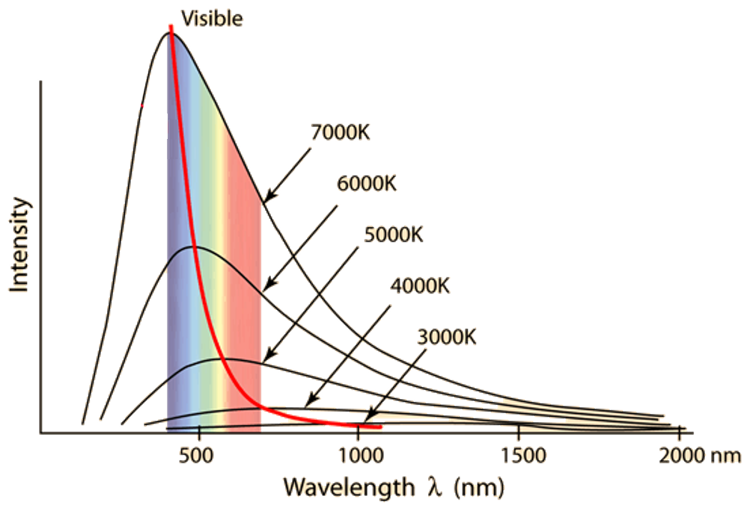
Sun | ~1 |  | An idealized object that absorbs all the electromagnetic radiation the falls on it
Earth | ~0.6
Black-Body | 1

Power Emissivity | Variable Symbol | Unit |  | Data Booklet Equations:
Power | P | W |  | $$P=eσAT^{4}$$
Emissivity | e | ---
Surface Area | A | m² |  | $$λ_{max}=\frac{2.90×{10}^{-3}}{T}$$
Temperature | T | K
Max Wavelength | λ_{max} | m |  | $$σ=5.67×{10}^{-8} W{ m}^{-2} K^{-4}$$

Solar Radiation and Climate Change
Intensity | Variable Symbol | Unit |  | Data Booklet Equations:
Intensity | I | W m⁻² |  | $$I=\frac{power}{A}$$
Power | P | W
Area | A | m² |  | $$A_{sphere}=4πr^{2}$$

Greenhouse Gases |  | Positive Feedback Loop | Negative Feedback Loop
Water Vapor (H₂O) |  | Melting ice (decreases albedo) | Cloud formation (increases albedo)
Carbon Dioxide (CO₂) |  | Melting permafrost (releases methane) | Increased photosynthesis (uses CO₂)
Methane (CH₄) |  | Rising ocean temp releases methane | Climate Change leads to renewables

Astrophysics

The Scale of Astrophysics
Unit Conversion | Definition
1 light year (ly) = 9.46 × 10¹⁵ m | The distance the light travels in an earth year
1 parsec (pc) = 3.26 ly | The average distance between the  earth and the sun
1 astronomical unit (AU) = 1.50 × 10¹¹ m | The distance at which the mean radius of the earth’s orbit subtends an angle of 1 arc second

Stellar Quantities
Brightness | Luminosity
Star intensity to an observer on earth  Units: W m⁻² | How much total power a star emits  Units: W

 | Variable Symbol | Unit |  | Data Booklet Equations:
Distance | d | pc |  | $$d \left(parsec\right)= \frac{1}{p (arc-second)}$$
Parallax Angle | p | sec
Brightness | b | W m⁻² |  | $$b=\frac{L}{4πd^{2}}$$
Luminosity | L | W
Max Wavelength | λ_{max} | m |  | $$λ_{max}T=2.9×{10}^{-3} m K$$
Temperature | T | K |  | $$L=σAT^{4}$$
Surface Area | A | m² |  | $$σ=5.67×{10}^{-8} W{ m}^{-2} K^{-4}$$

Describe the process of Stellar Parallax:  Observe how far a star moves relative to distant stars six months apart so that earth has its maximum displacement and an angle can be measured | 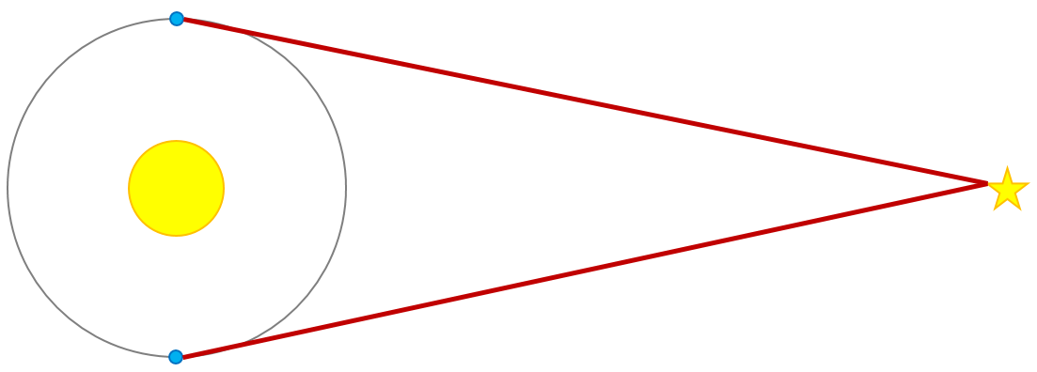

Atomic Spectra
 | Variable Symbol | Unit |  | Data Booklet Equations:
Energy | E | J or eV |  | $$E=hf$$
Planck’s Constant | h | J s |  | $$λ=\frac{hc}{E}$$
Frequency | f | Hz
Speed of Light | c | m s⁻¹ |  | $$h=6.63×{10}^{-34} J s$$
Wavelength | λ | m |  | $$c=3.00×{10}^{8} m s^{-1}$$

$$hc$$ | $$1.99×{10}^{-25} J m$$ | $$1.24×{10}^{-6} eV m$$

H-R Diagrams and Life Cycle of a Star
Label the Following:  - Main Sequence  - White Dwarfs  - Red Giants  - The Sun  - Line representing the life cycle of our sun | 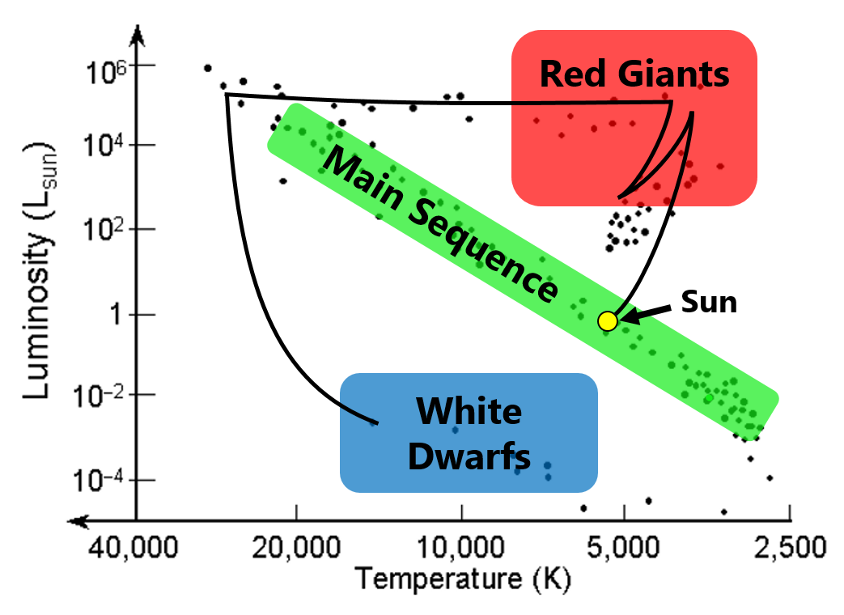

Chandrasekhar Limit |  | Oppenheimer-Volkhoff Limit
The maximum mass of a core that can become a white dwarf is 1.4 times the mass of the sun (1.4 M_{ʘ}) |  | The maximum mass of a core that can become a neutron star is 3 times the mass of the sun (3 M_{ʘ})
Sun Like Stars (< 1.5 M_{ʘ})  ⬇  White Dwarf | Huge Stars (1.5 – 3 M_{ʘ})  ⬇  Neutron Star |  | Giant Stars (> 3 M_{ʘ})  ⬇  Black Hole

The Expanding Universe
Standard Candles | Evidence for Expanding Universe
Objects of known luminosity that can be used with the apparent brightness to measure distance from earth  Cephid Variables and Type Ia Supernovas | Hubble discovered that the farther away stars and galaxies are, the more their light is redshifted.  This means, more distant objects are traveling faster than nearer objects.

 | Variable Symbol | Unit |  | Data Booklet Equations:
Redshift | z | --- |  | $$z=\frac{∆λ}{λ_{0}}≈\frac{v}{c}$$
Change in Wavelength | Δλ | m
Original Wavelength | λ₀ | m |  | $$z=\frac{R}{R_{0}}-1$$
Relative Velocity of Source | v | m s⁻¹
Speed of Light | c | m s⁻¹ |  | $$v=H_{0}d$$
Current Scale Factor | R | ---
Scale Factor when Emitted | R₀ | --- |  | $$c=3.00×{10}^{8} m s^{-1}$$
Hubble’s Constant | H₀ | km s⁻¹ Mpc⁻¹ |  | $$H_{0}≈70 km s^{-1} {Mpc}^{-1}$$

The Big Bang
 | Peak Wavelength | Temperature
Cosmic Microwave Background Radiation | $$\sim 0.001 m (1 mm)$$ | $$\sim 2.9 K$$

Describe why the CMB is evidence of the Big Bang:

The CMB is the heat signature from the early universe. As the universe has expanded to its current size, the wavelength stretched out to the current value seen in the CMB. This radiation is fairly uniform and it can be observed in every direction.

