IB PHYSICS

Practice Problems

=Click here for the Google Form to Check Answers=

Contents
0 | SCIENCE SKILLS 2
1 | Motion 5
2 | Forces 9
3 | Circular Motion 13
4 | Energy and Momentum 16
5 | Sound Waves 20
6 | Light Waves 23
7 | Electricity 25
8 | Force Fields 28
9 | Thermal Physics 31
10 | Atomic Physics 34
11 | Energy Production 38

0 | SCIENCE SKILLS

Units and Conversions

Record the fundamental SI unit for the following properties
- Mass
- Temperature

- The wavelength of red laser pointer is 6.5 × 10⁻⁷ m. Express this wavelength in units of nanometers.

- Convert 86 m³ to cm³

- Convert 32 ft s⁻¹ to mi hr⁻¹ [1 mi = 5280 ft]

- What are the units of ★ in this equality? [p is in kg m s⁻¹, F is in kg m s⁻²]
★ = p/F

Uncertainty
- A student uses a digital stopwatch the time an event at 0.78 seconds. What is the percent uncertainty for this measurement?

- What is the absolute uncertainty (with proper precision) of the measurement 43.8 g ± 7%?

Uncertainty with Calculations
- The thickness of a quarter is measured to be 1.75 ± 0.15 mm. What is the absolute uncertainty of the height of 3 quarters stacked on top of each other?

- The distance traveled by an object accelerating from rest is calculated with the relationship $d=\frac{1}{2}at^{2}$. The uncertainty in a is 5% and the uncertainty in t is 3%. What is the percent uncertainty of d?

- The radius of a circle is 5 cm with an uncertainty of 10%. What is the absolute uncertainty of the area of the circle when calculated with the equation $A=πr^{2}$?

- A car travels 80 ± 12 m in 7.2 ± 0.4 s. What is the percent uncertainty of the speed?

- What is the absolute uncertainty of this set of 3 measurements?
22.3 s
21.7 s
20.5 s

1 | Motion

Equations

Kinematics and Free Fall
- A car was traveling at 12 m s⁻¹ when the driver stepped on the brakes. If the car comes to a full stop in 5.0 s, what was its acceleration in m s⁻²? (pay attention to direction)

- An Olympic sprinter goes from 0 m/s to 16 m/s over the course of the 100-meter dash. Assuming a constant acceleration, how long does this take in seconds?

- A friend drops a ruler between your outstretched fingers and you catch it after it has fallen 26 cm. What is your reaction time in seconds?

- You jump straight in the air and place a piece of tape on the wall 0.45 m above a piece of tape that you stuck on the wall while standing. If this is used as a measure of your maximum jump height, what is your hang time in seconds? (total time that you are in the air)

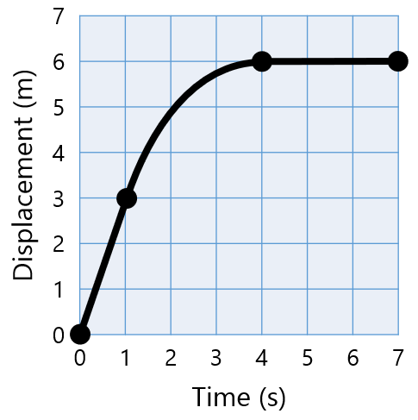
Motion Graphs
- What is the velocity at 0.5 seconds?

- What is the velocity at 5 seconds?

- Is the object speeding up or slowing down at 2 seconds?

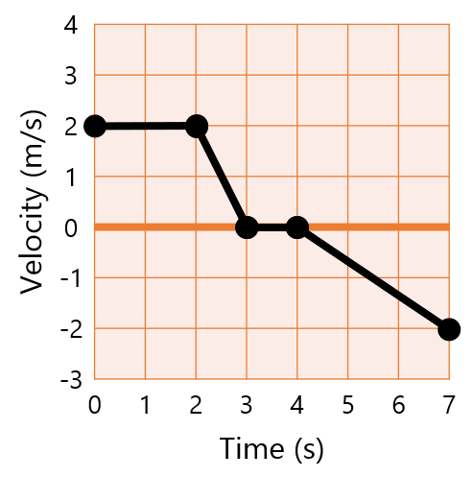
- What is the acceleration at 2.5 seconds?

- What is the displacement from 0-7 seconds?

- List a time when the object is speeding up.

A | B | C | D | E | F
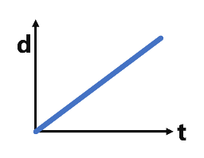 | 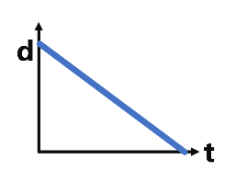 | 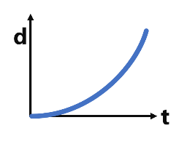 | 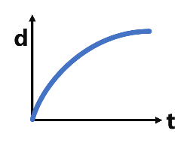 | 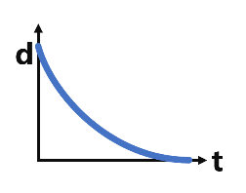 | 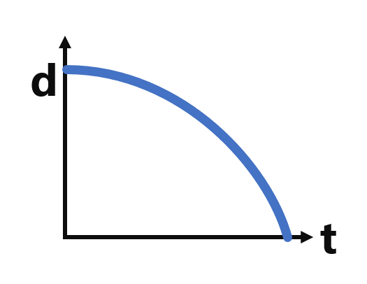
G | H | I | J | K | L
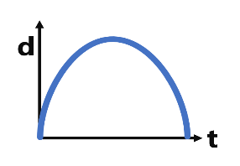 | 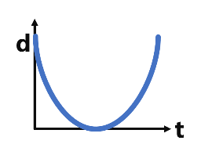 | 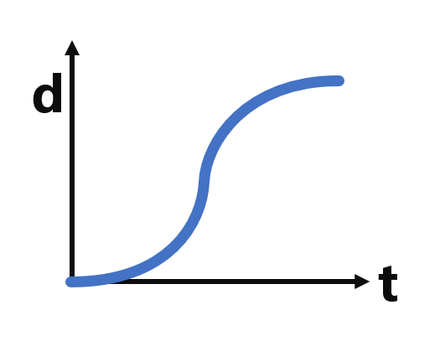 | 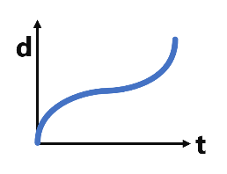 | 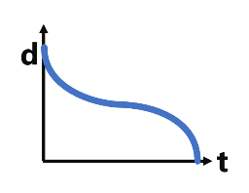 | 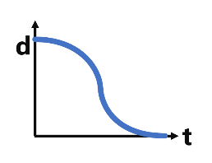
M | N | O | P | Q | R
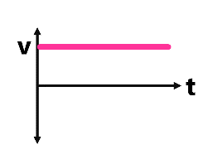 | 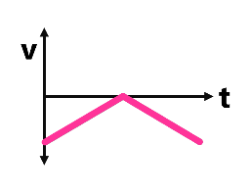 | 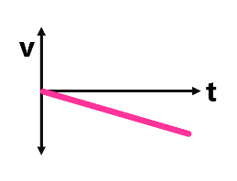 | 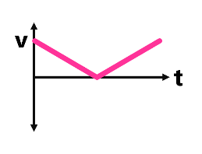 | 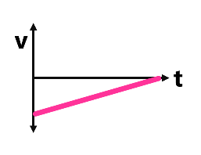 | 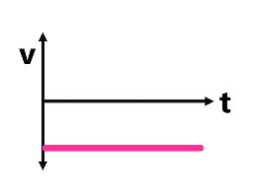
S | T | U | V | W | X
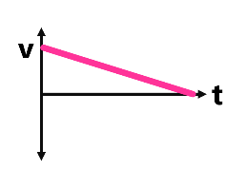 | 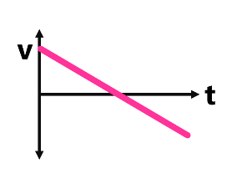 | 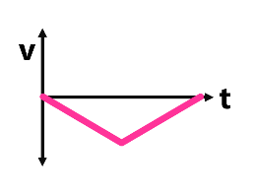 | 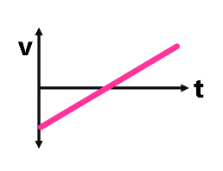 | 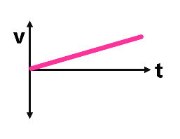 | 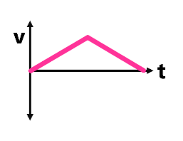

- Name a displacement graph that is moving in the negative direction and speeding up the entire time
- Name a velocity graph that is moving in the negative direction and slowing down the entire time
- Name the matching velocity graph for Graph J
- Name the matching displacement graph for Graph Q
- Displacement graph of an object that is thrown straight up into the air and falls back down
- Velocity graph of an object that is thrown straight up into the air and falls back down

Projectile Motion
- You throw a baseball perfectly horizontally aiming at the bullseye on the target 6 meters away. If the ball hits the target 0.3 m below the bullseye, how fast was it thrown?

Tiger Woods hits a golf ball off the tee at speed of 80 m s⁻¹ and an angle of 15° from the horizontal. Calculate the total distance, total time, and max height of the ball assuming no air resistance.
- Total Distance
- Total Time
- Max Height

2 | Forces

Equations

Inertia and Net Force
- A window washer stands in the middle of a horizontal board which is supported by two vertical ropes, one at each end. If the window washer and his equipment weigh 1,100 N, and the board weighs 500 N how much tension force is in each wire?

- What is the net force on this object?
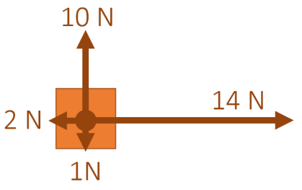
- Starting from rest, how far has this block gone after 6 seconds with the forces shown below?
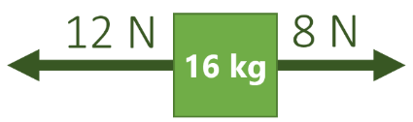

- A 3-kg block is suspended motionlessly by cables as shown in the diagram below. What is the tension force in the cable that is at a 42° angle from the horizontal?
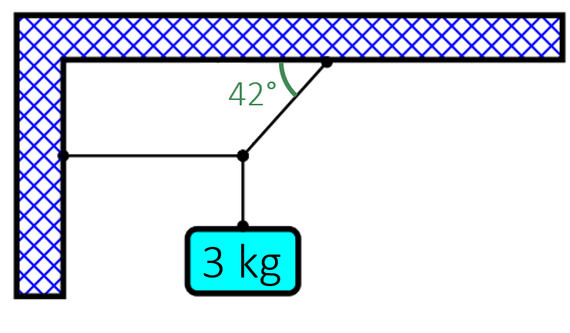
- A 1,500 kg car is stopped at a traffic light and then steps on the gas as soon as the light turns green to accelerate to 20 m/s in 5 seconds. What was the force exerted on the car by the engine?

- What is the net force on 8,000 kg airplane moving at a constant 150 m/s and maintaining a constant altitude?

Free Body Diagrams
Match the following descriptions with the corresponding free body diagram. (Some diagrams can be used more than once or not at all)
- A skydiver overcomes air resistance to accelerate downward and speed up
- A bicycle is moving at a constant velocity to the right down the road
- A disco ball is suspended motionless from the ceiling by a rope
- A car is stopped at a stoplight
- A sled is pulled horizontally to the left and accelerates against the force of friction
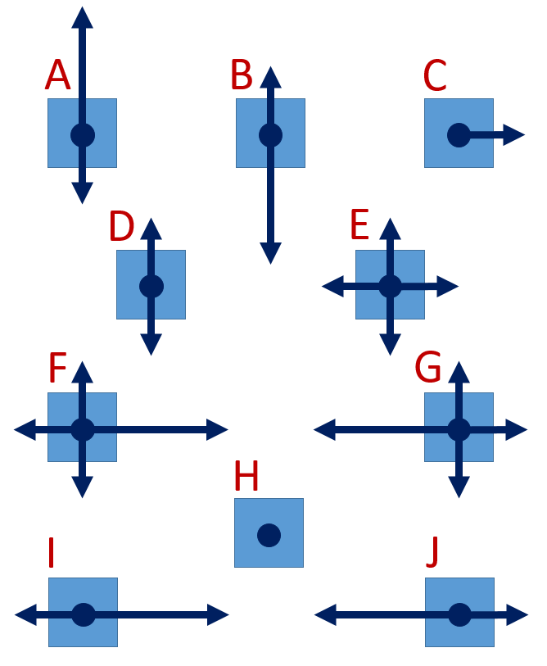

Gravity, Weight, and Terminal Velocity
- What is weight of a 22 kg basket of puppies on earth?

- What is the acceleration of a 60 kg skydiver that is falling while experiencing 150 N of air resistance?

- What air resistance force would be required for that same 60 kg skydiver to be falling at their terminal velocity?

Friction
- It requires 1.5 N of force to drag your shoe (0.25 kg) horizontally across a table at a constant velocity. What is the coefficient of friction of your shoe?

- A 0.15-kg hockey puck is given an initial speed of 34 m s⁻¹ on a frozen pond. The puck remains on the ice and slides 113 m before coming to rest. What is the coefficient of friction between the puck and the ice?

Ramps
You place a 5-kg textbook on a 25° incline with a coefficient of friction of 0.42 and it accelerates downward.
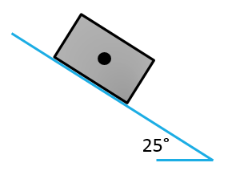
- What is the force of friction opposing the motion of the textbook?

- What is the acceleration of the textbook?

3 | Circular Motion

Equations

Properties of Circular Motion
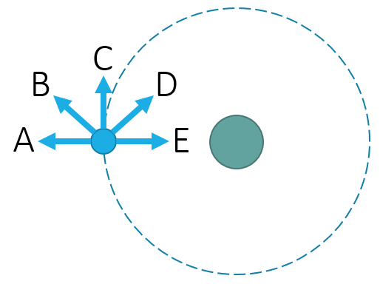
- Which of the following vectors best represents the instantaneous linear velocity of an object in a clockwise orbit in the position shown?

- Which of the following vectors best represents the centripetal acceleration (a_{c}) of an object with a constant speed in a clockwise orbit in the position shown?

- Which of the following vectors best represents the centripetal force (F_{c}) of an object with a constant speed in a clockwise orbit in the position shown?
- What is the angular distance in radians (decimal form) traveled when a merry-go-round with a radius of 4 meters makes 5 complete revolutions in 35 seconds?

- You are twirling a ball around with a string in a horizontal circle using a centripetal force of 25 Newtons. What is the centripetal force if you triple the angular velocity but maintain the same mass and radius?

- A spinning spaceship is designed to recreate Earth’s gravity by traveling with a centripetal acceleration of 9.81 m s⁻². If the radius of the ship’s circular structure is 32 meters, how long would it take to make one complete revolution?

Vertical Circles
- What is the apparent weight (same as normal reaction force R) of a 75 kg rider while zooming through a dip on a roller coaster with a 10-meter radius and a velocity of 15 m s⁻¹.

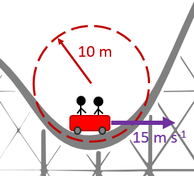

- You twirl a 0.5-kg object on a string in a vertical circle of radius 0.4 m. You maintain a constant speed of 4 m s⁻¹. What is the force of tension acting on the string at the top of the swinging ball’s path?
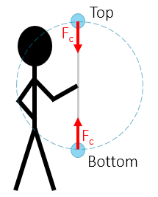

Complex Circular Motion
- The "Rotor" ride is the one which presses you against the walls of the spinning rotor as the floor drops away. The coefficient of static friction between the wall and the 75-kg rider is μ= 0.4. If the rotor has a radius of 5 meters, what is the minimum angular velocity in rad s⁻¹ for the rider to stay stuck to the wall?
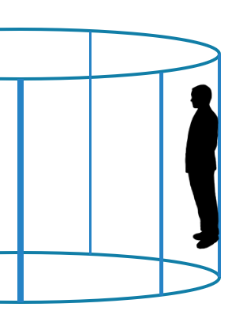
- A car of mass 1700 kg rounds a circular turn. If the road is flat and the coefficient of static friction between the road and tires is 0.75, what is the smallest turning radius that the car could safely complete at 15 m s⁻¹?

- A ball of mass 3 kg is suspended from a string whirled in a circle with a radius of 0.4 m lying in the horizontal plane. The string makes an angle of 27° with the vertical. Find the angular velocity of the ball.

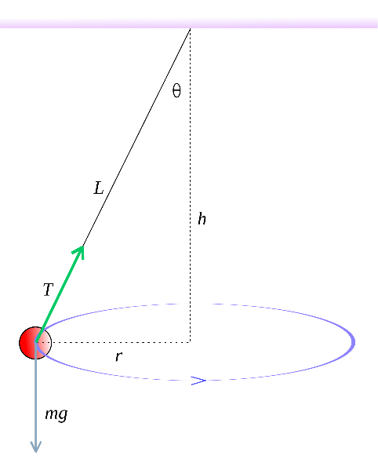

4 | Energy and Momentum

Equations
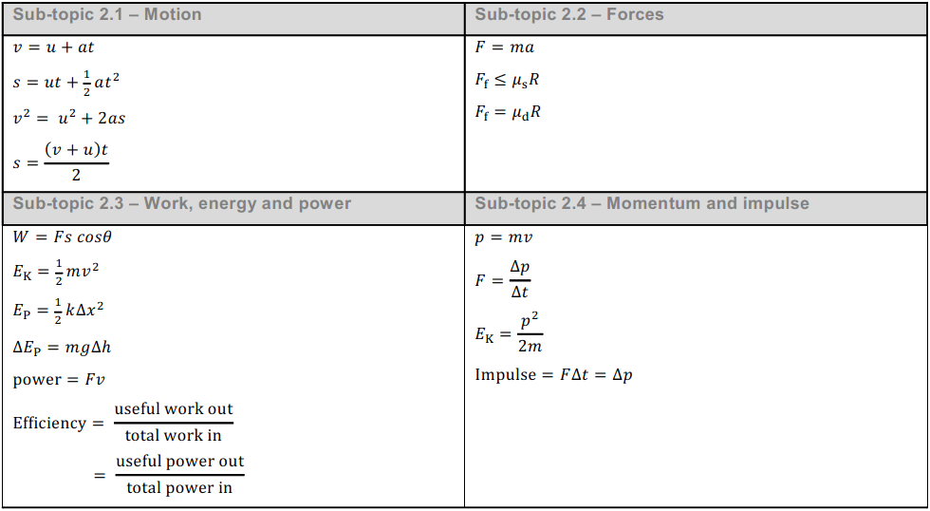

Energy
- A person weighing 600 N gets on an elevator. The elevator lifts the person 6 meters up at a constant velocity for 10 seconds. How much power is used?

- If 68 watts of power are produced in 18 seconds, how much work is done?

- What is the maximum velocity of a 2 kg pendulum that is released from the position shown?
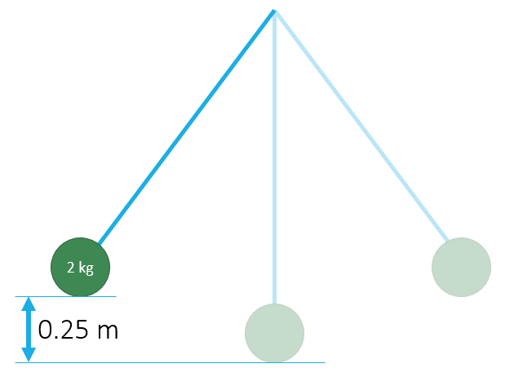

- What is the speed of the roller coaster car as it rolls over the second hill if it starts as shown with a velocity of 0 m s⁻¹?
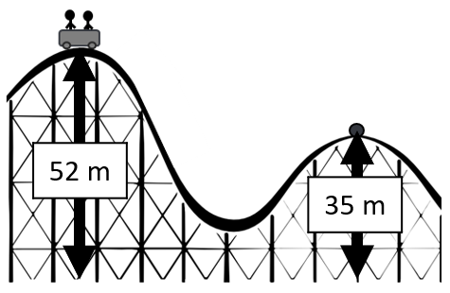

- You push your 60 kg friend on ice skates with a constant horizontal force of 75 N. How fast are they going after traveling a full 50 meters.

- A pole-vaulter of mass 59.7 kg falls from a height of 4.76 m onto some foam.
  - Calculate the maximum kinetic energy on impact.

  - If the foam deforms by 81 cm, calculate the average force exerted on the pole-vaulter.

- How much work (in Joules) is required to stretch the rubber band modeled in the graph below from a stretch distance of 0.1 m to a stretch distance of 0.4 m?
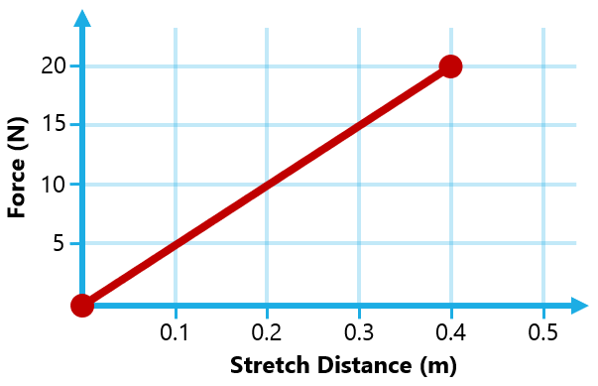

Momentum
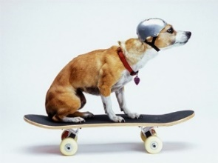
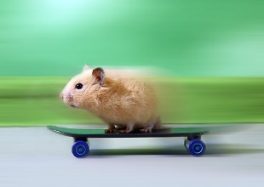
- A 5 kg dog rides a skateboard at 8 m/s? How fast must a 0.1 kg hamster on a skateboard be moving to match the momentum of the dog?

- Charlotte, a 65-kg skin diver, shoots a 2-kg spear with a speed of 15 m s⁻¹ at a fish who darts quickly away without getting hit. How fast does Charlotte move backwards when the spear is shot?

- A 0.150 kg baseball traveling with a horizontal speed of 4 m s⁻¹ is hit by a bat and then moves with a speed of 35 m s⁻¹ in the opposite direction. What is the force of the baseball bat on the ball causing this to happen if the bat is in contact with the ball for 0.2 seconds?

- A railroad diesel engine weighs four times as much as a freight car. If the diesel engine coasts at 7.5 m s⁻¹ into a freight car that is initially at rest, how fast do the two coast after they couple together?

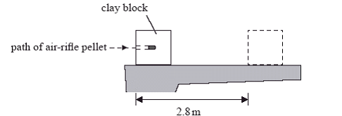
- In an experiment, an air-rifle pellet is fired into a block of modelling clay that rests on a table. The air-rifle pellet remains inside the clay block after the impact. Further data relating to the experiment given below:
Mass of air-rifle pellet | 2.0 g
Mass of clay block | 56 g
Velocity of impact of air-rifle pellet | 140 m s^{–1}
Calculate the initial speed of the clay block after the air-rifle pellet strikes it.

- A rocket of mass 20,000 kg, starting with an initial velocity of 12 m s⁻¹ rest, is acted upon by a force of 15,000 N for 15 seconds. What is the final velocity of the rocket?

- A car of mass 1100 kg moves at 22 m s⁻¹. What braking force is needed to bring the car to a stop in 20 s?

5 | Sound Waves

Equations
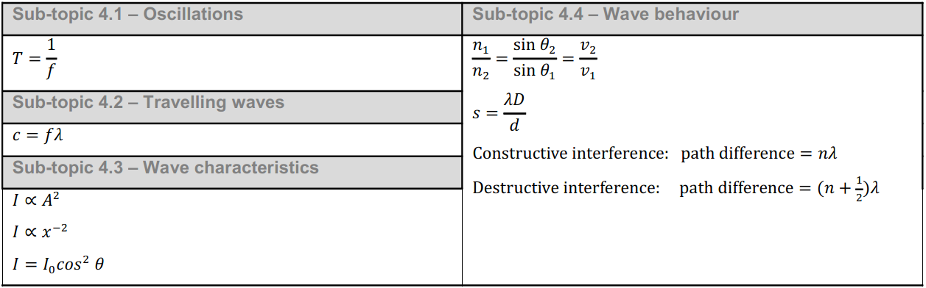

Wave Vocabulary
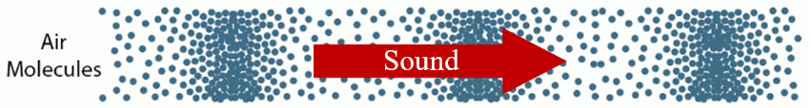
- Sound causes molecules to vibrate in the same direction as the sound travels. This type of wave is called a ________________ wave.

- The number of waves passing a given point each second is called the ____________________.

- Does sound travel fastest through air, water, or steel?

Simple Harmonic Motion and Simple Wave Calculations
- What is the frequency (in Hertz) of the wave shown in the diagram below?
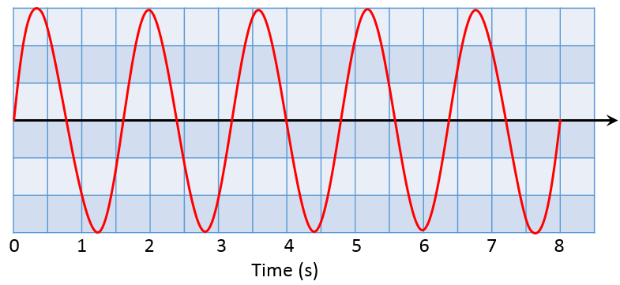
- A water wave with an amplitude of 0.4 meters travels at 0.8 m s⁻¹. If the distance between two wave crests is 5 m, what is the frequency (in Hertz) of the waves?

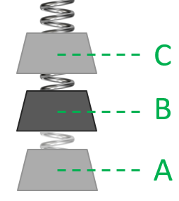
- A spring and mass system oscillates up and down with an overall amplitude of 0.4 m in simple harmonic motion. If the motion has a period of 1.2 seconds, what is the velocity at point C in the diagram shown?

Standing Waves
- What is the wavelength in standing wave shown?
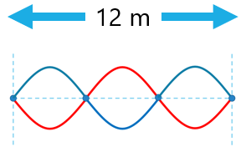

- How long does a closed tube need to be to resonate at a fundamental frequency (1st Harmonic) of 425 Hz. Assume a speed of sound at 340 m s⁻¹.

- What frequency will you hear if you resonate 0.9 meter long open tube instrument at its 3rd harmonic? Assume a speed of sound at 342 m s⁻¹.

Wave Interference
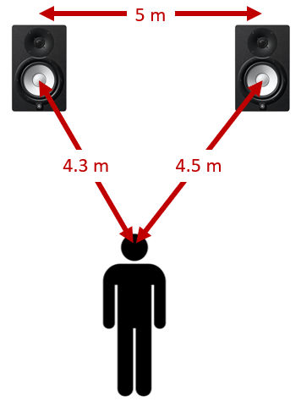
- Two loudspeakers, L₁ and L₂, emit a coherent signal of 850 Hz. Assume a speed of sound of 340 m s⁻¹.

  - Given the following relationship, what is the value of x?
Path Difference = (x)(λ)

  - Is the person shown in the picture below experiencing a maximum or minimum location?

- What is the amplitude of the superposition wave at 9 seconds?
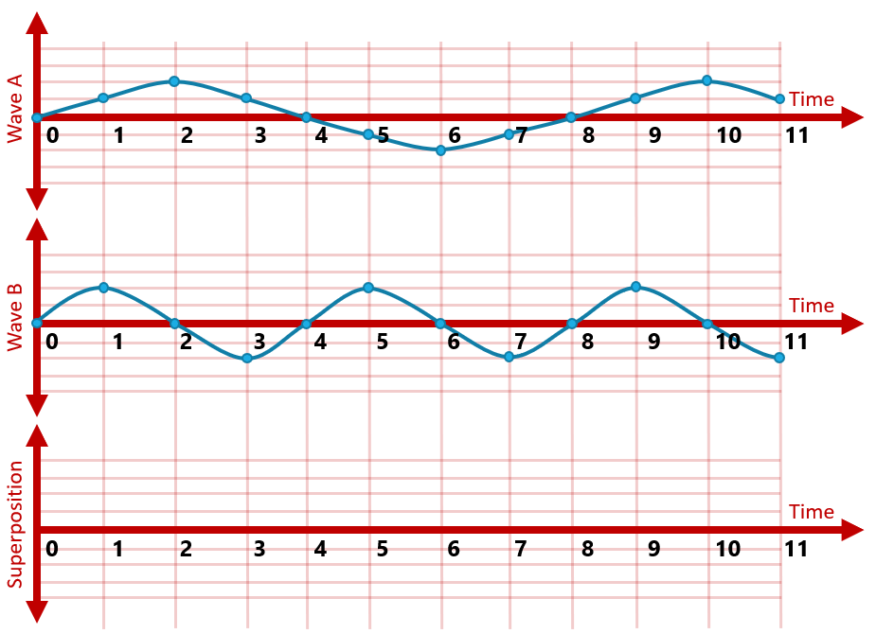

6 | Light Waves

Equations
- What type of electromagnetic wave has a wavelength between visible light and microwaves?

- Light travels through water at about 225,000,000 meters per second. If the light wave's frequency is 4 x 10¹⁴ Hz, what is the exponent of its wavelength?
5.63 x 10 ^{-?} meters
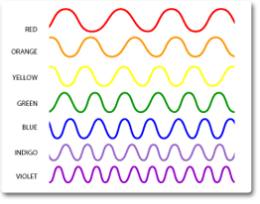
- A depiction of light waves is shown to the right. Based on this picture, which color of light carries the least amount of energy?

- Light travels about 1.695 × 10⁸ m s⁻¹ through a sapphire. What is the index of refraction of sapphire?

- You have an unknown liquid and measure that if light hits a critical angle of 35°, then it cannot escape the material into the air. Calculate the index of refraction for this unknown material.
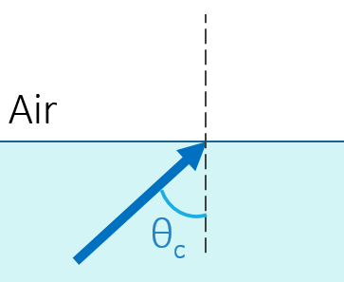
- Light polarized at 15° to the vertical has an intensity of 40 W m⁻². An analyzer is set at 70° to the vertical. What is the intensity of the light after traveling through this second polarized plate?
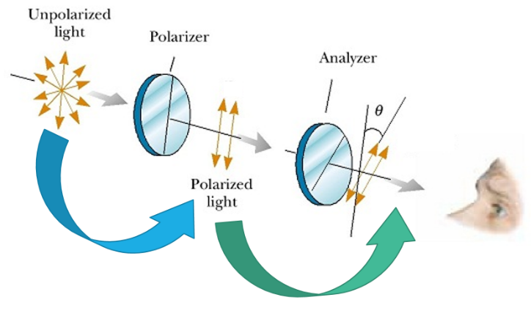

- A large cube is formed from ice. A light ray is incident from a vacuum at an angle of 46˚ to the normal on one surface of the cube. The light ray travels at a speed of 2.27 × 10⁸ m s⁻¹. Calculate the angle of refraction inside the ice cube.
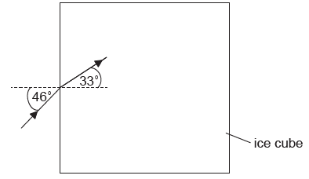

- Red laser light is incident on a double slit with a slit separation of 0.35 mm. A double-slit interference pattern is observed on a screen 2.4 m from the slits. The distance between successive maxima on the screen is 4.7 mm. Calculate the wavelength of the light in nm.
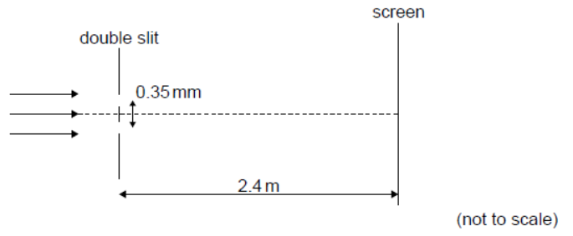

7 | Electricity

Equations
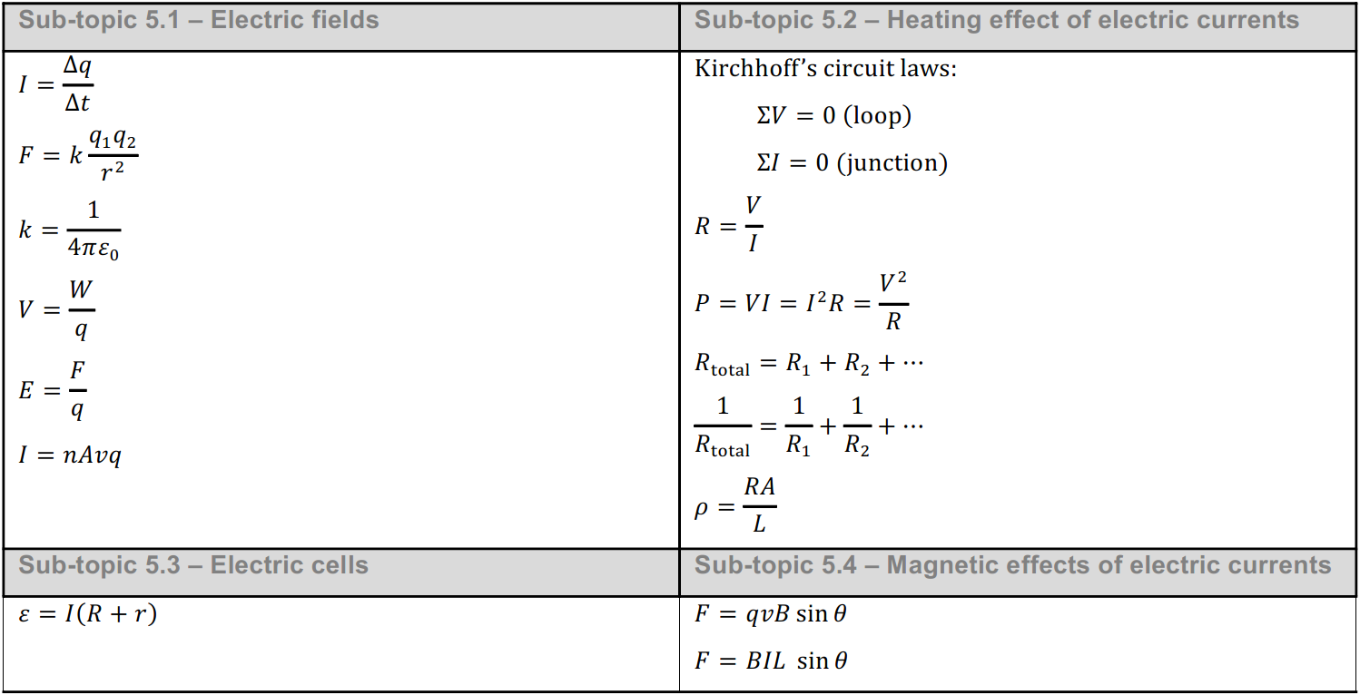
- A ceiling fan is connected to a 120 V electrical source. If the resistance of the ceiling fan is 48 Ω, what is the power (in Watts) used to run this fan?

- How many 3 Ω resistors must be connected in parallel to create a total resistance of 0.5 Ω ?

- What is the equivalent resistance (in Ohms) in the portion of a circuit shown below?
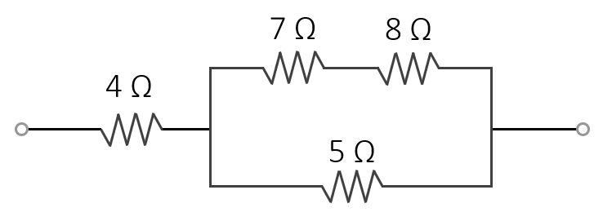
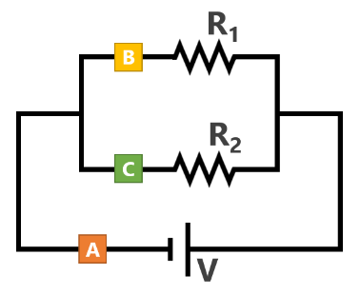
- In the circuit diagram shown to the right, the current was measured at 2 amps for position B and 6 amps for position C. What must the current be at position A?

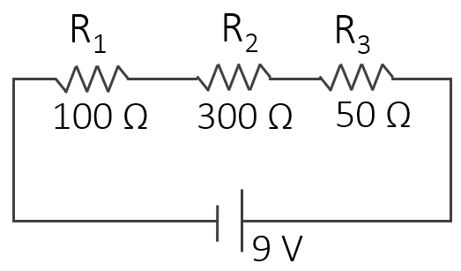
- In the circuit shown to the right, determine the following:
Resistor | V | I | R
R₁ |  |  | 100 Ω
R₂ |  |  | 300 Ω
R₃ |  |  | 50 Ω
TOTAL | 9 V
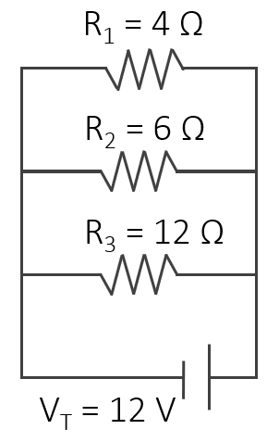
- In the circuit shown to the right, determine the following:
Resistor | V | I | R
R₁ |  |  | 4 Ω
R₂ |  |  | 6 Ω
R₃ |  |  | 12 Ω
TOTAL | 12 V

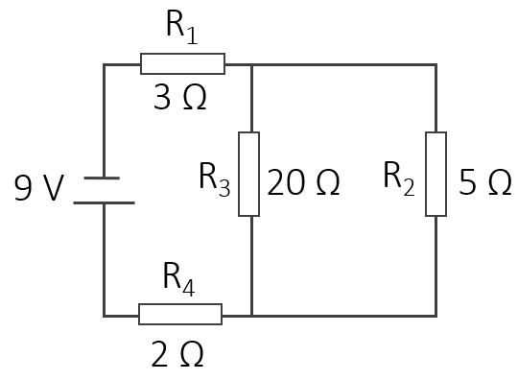
- In the circuit shown to the right, determine the following:
Resistor | V | I | R
R₁ |  |  | 3 Ω
R₂ |  |  | 5 Ω
R₃ |  |  | 20 Ω
R₄ |  |  | 2 Ω
TOTAL | 9 V
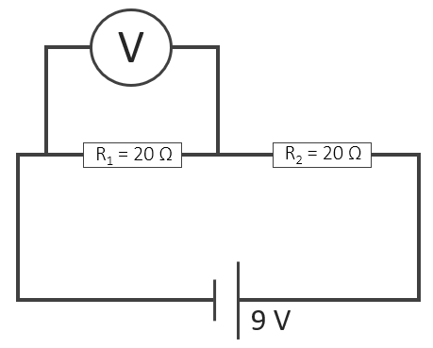
- The non-ideal voltmeter measures a voltage of 4 V. What is its resistance in ohms?
 | V | I | R
Voltmeter | 4 V
R₁ |  |  | 20 Ω
R₂ |  |  | 20 Ω
TOTAL | 9 V

- A resistor of resistance 0.12 Ω is made from copper wire of radius 2 mm. Given that the resistivity of copper is 1.7 × 10⁻⁸ Ω m, determine the length of copper wire used to make the resistor.

- What is the internal resistance for the battery shown?
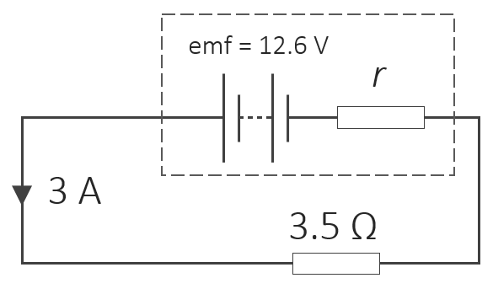

- A certain aluminum wire has an electron density of 5 × 10²³ electrons per m³ and a cross sectional area of 6.25 × 10⁻³ m². If the electrons in the wire travel at a drift speed of 0.005 m s⁻¹, what is the current through the wire in amperes?

8 | Force Fields

Equations
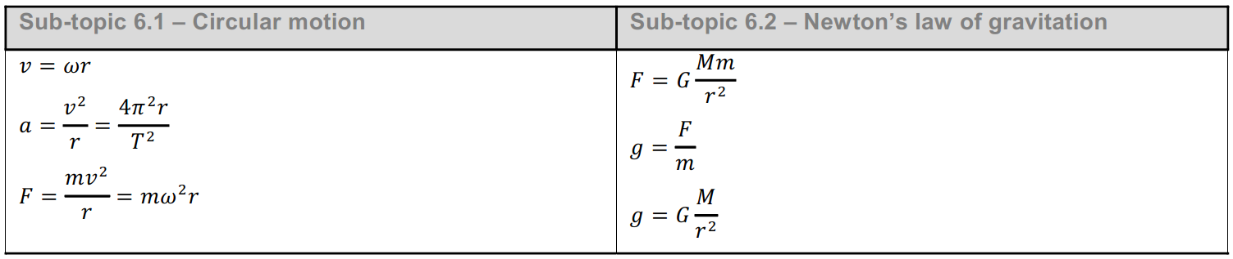
- The gravitational force between two massive objects is 10 N. What is the the new force if the distance between them is decreased from 20 cm to 5 cm?

- What is the charge (in Coulombs) if an object has 3 × 10¹⁹ excess electrons? (answer should be negative)

- What is the gravitational field (g) on the surface of the Pluto if Pluto has a mass of 1.31 × 10²² kg and a radius of 1,188 km?

- Two balloons with charges of +3.37 µC and -8.21 µC attract each other with a force of 0.0626 Newtons. Determine the separation distance between the two balloons.

- Calculate the speed of a negatively charged electron travelling through a B-field of flux density 7 mT if the resulting electromagnetic force is 3.36 × 10⁻¹⁹ N. (hint: what is the charge of a single electron?)

- A power line for a light-rail system carries 1000 A at an angle of 30.0° to the Earth’s 5.00×10⁻⁵ Tesla magnetic field. What is the force on a 100-m section of this line?

Right Hand Rule
Word Bank
Up | Left | Into the Page
Down | Right | Out of the Page
- In what direction must the current be flowing to produce the magnetic field shown?
- In what direction must the magnetic field be pointing to produce the force shown?
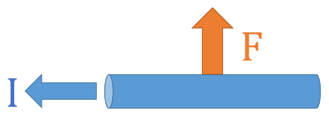
- In what direction must the magnetic field be pointing to produce the force shown?
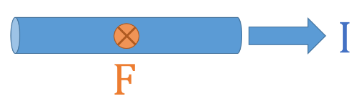
- In what direction will the applied force be on this current carrying wire in a magnetic field?
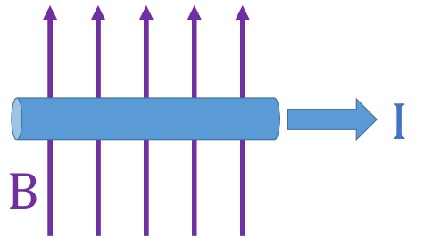
- In what direction will the applied force be on this current carrying wire in a magnetic field?
- In what direction will the electron shown be deflected as it travels through this magnetic field?
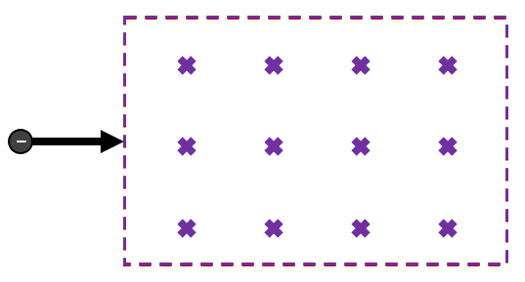

9 | Thermal Physics

Equations
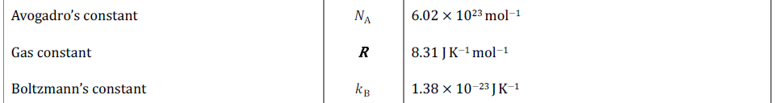
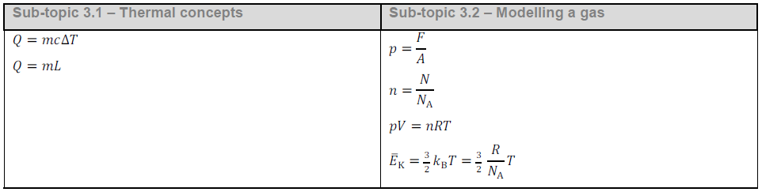
- What is the boiling point of water in Kelvin?

- A metal object with an initial temperature of 26°C is heated by 31 K. What is teh final temperature of the metal in °C?

- If you have 0.4 kg of water (c = 4180 J kg⁻¹ K⁻¹) at 22°C and you put in a 90-gram chunk of an unknown substance at 95°C. If the temperature equalizes at 25°C, what is the specific heat of the unknown substance?

- How much heat is needed to transform 0.3 kg of solid iron at 22°C into liquid iron at 1500°C?
Specific Heat of Solid Iron | 450 J kg⁻¹ K⁻¹
Specific Heat of Liquid Iron | 820 J kg⁻¹ K⁻¹
Latent Heat of Fusion | 247 J kg⁻¹
Melting Point of Iron | 1200 °C

- An electric kettle is used to raise the temperature of 0.5 kg of water (c = 4180 J kg⁻¹ K⁻¹). If the kettle supplies a constant 1700 W of power for 77 seconds, what is the expected temperature change in °C?

- How fast (in m s⁻¹) are the molecules of a neon light moving at its operating temperature of 38°C? Each atom of neon has a mass of 3.35 × 10⁻²⁶ kg.

- What is the force in Newtons holding a suction cup with a radius of 2.5 cm to a window? Use an atmospheric air pressure of 1.00 × 10⁵ Pa.

- The molar mass of aluminum is 26.98 g mol⁻¹. How many moles of aluminum atoms are there in a pure aluminum can that has a mass of 14.9 grams?

- What volume of gas contains 3.01 × 10²³ molecules of gas at 35°C at atmospheric pressure (1.00 × 10⁵ Pa)?

- You start with a floating piston that has a volume of 0.050 m³ at a temperature of 15°C. If the temperature is increased to 80°C, what is the new volume in m³?

10 | Atomic Physics

Equations
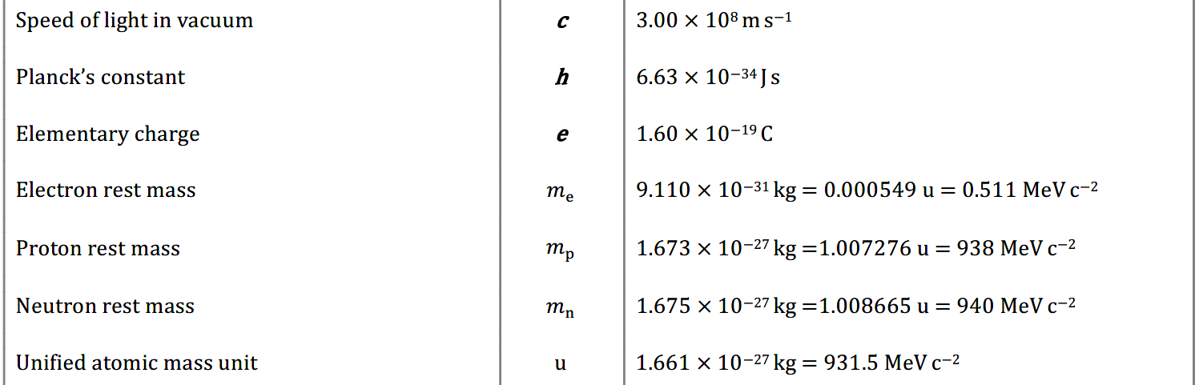
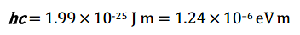
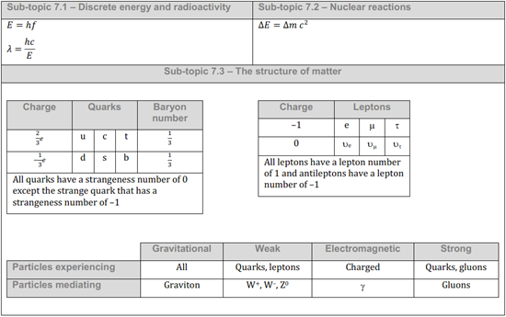

Radioactive Decay
- How many neutrons are there in ${}_{90}^{234}{Th}$?

The following is an example of beta positive decay: ${}_{34}^{68}{Se}→{}_{(\#3)??}^{(\#2)??}{As}+β^{+}+v_{e}$
- What number should take the place of the green (#2)??

- What number should take the place of the blue (#3)??

82  Pb  Lead | 83  Bi  Bismuth | 84  Po  Polonium | 85  At  Astatine | 86  Rn  Radon | 87  Fr  Francium | 88  Ra  Radium | 89  Ac  Actinium | 90  Th  Thorium | 91  Pa  Protactinium | 92  U  Uranium
- What element would you have if an atom of Radon undergoes alpha decay?

- What type of decay is shown going through this magnetic field? Alpha, Beta, or Gamma?
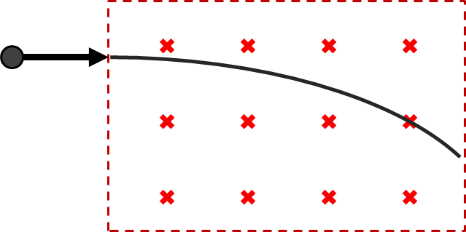

Half Life
- If it takes 12 years for 16g of a radioactive sample to decay into 4g, what is the half-life of the element in years?

- Radon-222 has a half life of about 4 days. How many grams of radon would be remaining from a fresh 240g sample after 20 days?

Mass Defect
- What is the mass defect per nucleon for Sufur-34 if it has 16 protons and a nucleus mass of 33.959083u?

Atomic Spectra
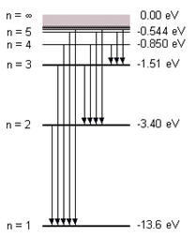
An electron jumps from the n = 3 level to the n = 1 level.
- What is the energy (in eV) of the photon produced?

- What is the wavelength of the produced light in nm?

Particle Physics
- What is the charge of a Pion with a quark configuration shown below?

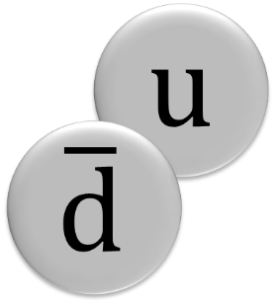

- What is the name of this quark?

- What is the lepton number of ${\overline{v}}_{e}$?

- What is the charge of the particle represented by the question mark in this Feynman diagram?
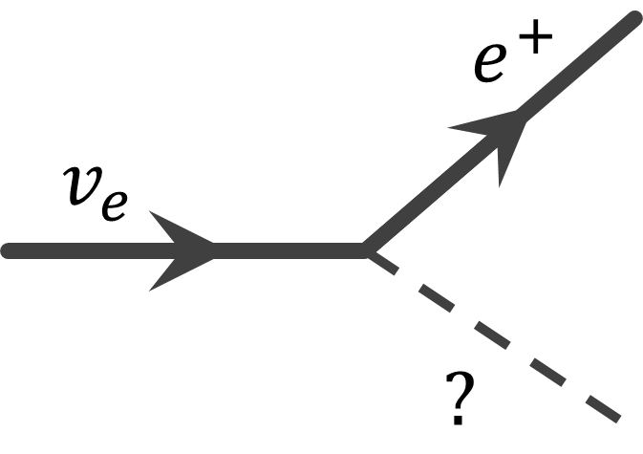

11 | Energy Production

Equations
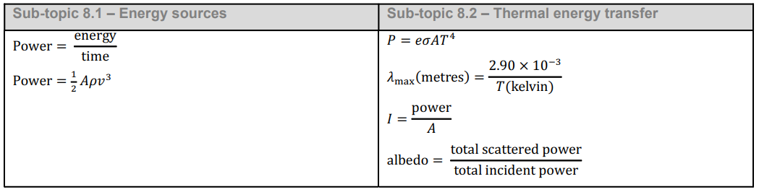
- What source of energy is missing from this list sorted by percentage of the global energy supply?
1 | Petroleum | 31%
2 | Coal | 27%
3 | Natural Gas | 23%
4 | Biomass | 10%
5 |  | 5%
6 | Hydro Power | 2%

- What is the mass number for the isotope of uranium that is fissionable? Uranium-_____

- Which component of a nuclear reactor (usually made of water or graphite) slows down neutrons, allowing them to initiate further nuclear reactions?

- Below is a Sankey diagram for a machine. What is the efficiency of the machine? (record your answer in decimal form. i.e. 45% 0.45)
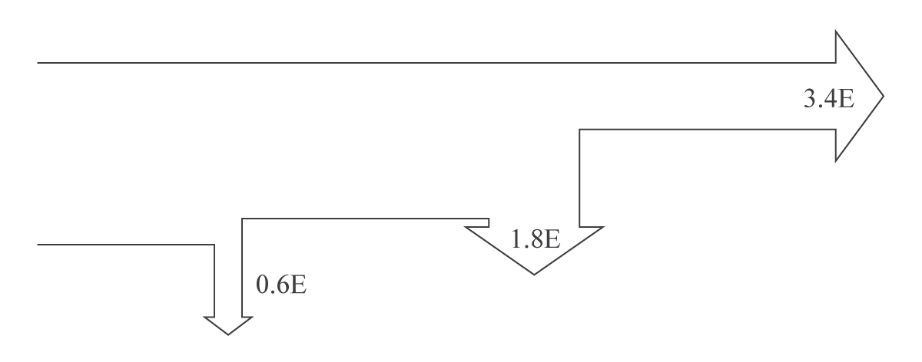
- An air turbine produces 1000 W of power with a wind speed of 6 m s⁻¹, what is the power produced for a wind speed of 12 m s⁻¹? (think about the equation and what happens to the power when you double the wind speed)

- What is the maximum possible power available, in MW, from a wind turbine with blades of length 35 m, when the wind is moving at a velocity of 13 m s⁻¹? The air density is 1.3 kg m⁻³.

- A solar farm is made up of photovoltaic cells of area 60,000 m². The average solar intensity falling on the farm is 340 W m^{–2} and the average power output of the farm is 5 MW. Calculate the efficiency of the photovoltaic cells. (record your answer in decimal form. i.e. 45% 0.45)

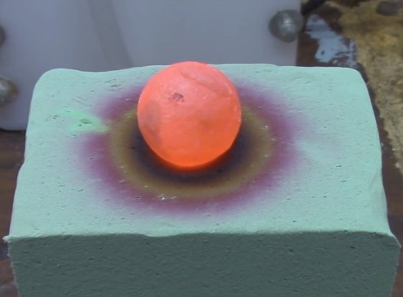
- The red hot ball of nickel shown here has a radius of 0.03 and temperature of 1200°C. Assuming an emissivity of e=1, how much power (in Watts) does it emit?

- The graph shown here is for the spectrum of light emitted by the sun. Using the peak wavelength, what is the sun’s temperature in Kelvin?
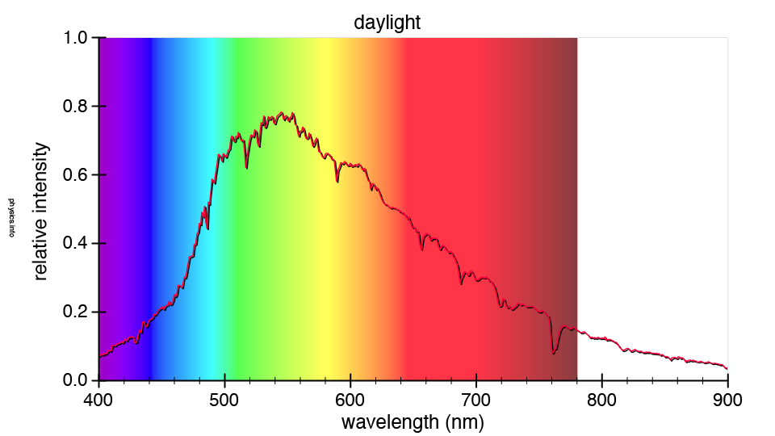

- The top 3 greenhouse gases are Water Vapor, Carbon Dioxide, and __________________

