Momentum Mini Labs Name: _______________________
For each of these mini labs, complete the task provided and show all work.
Equations and Constants
$$v=d/t$$ | $${PE}_{g}=mgh$$ | $$KE=\frac{1}{2}mv^{2}$$ | $$p=mv$$ | $$Impulse=F∆t=∆p$$ | $$g=9.81 m/s^{2}$$

Part 1: Bowling Ball Collision – What’s the Mass?

If there are no external forces causing an impulse on a system, we can assume that the total momentum of the system will be conserved. Use the overlay to measure and the included stopwatch on the slo mo video to measure a change in time in order to calculate velocity

Use the conservation of momentum to calculate the mass of the bowling ball on the left if the one on the right has a mass of 5.6 kg
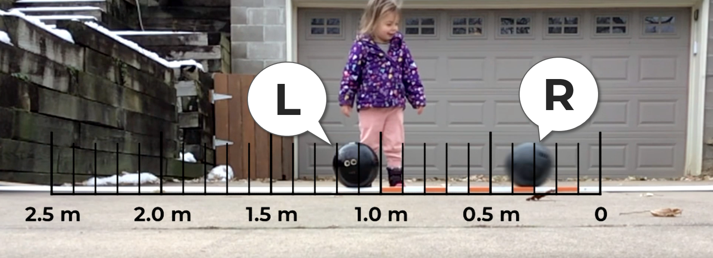 |  |  |  | Click Here for Video
Mass L |  |  | Mass R | 5.6 kg
Initial |  |  | Final
Velocity L | 0 m/s |  | Velocity L
Velocity R |  |  | Velocity R

Part 2: Potato Gun Ballistic Pendulum – What’s the Velocity?
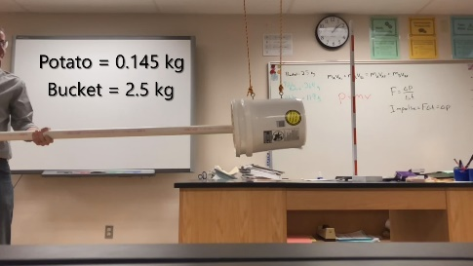
A clever way to measure the velocity of a very fast projectile (like a potato out of a potato gun) is to fire it into a more massive pendulum and measure the highest point in the swing.
Click Here for Video
Step 1: Conservation of Energy
Initial | Final
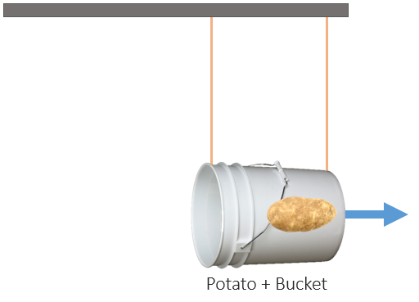 | 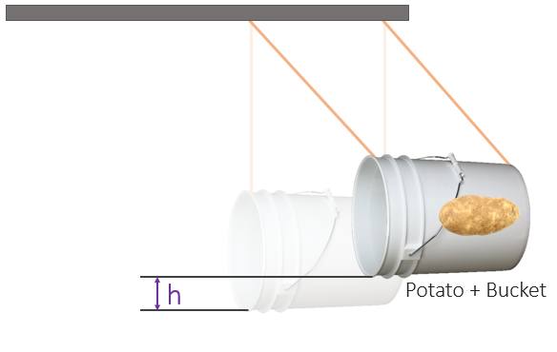
Use the conservation of energy and the maximum height of the bucket’s swing to calculate the top velocity of the bucket and potato when it starts swinging after the collision.

Step 2: Conservation of Momentum
Initial | Final
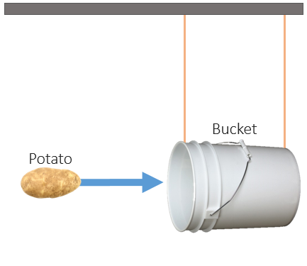
Use the conservation of momentum and the velocity of the potato/bucket system from part 1 to calculate the initial velocity of the potato

Potato Velocity

Step 3: Impulse and Momentum
Use the impulse and momentum with the potato velocity from part 2 and the time the potato was in the barrel to calculate the force of the potato gun

Potato Gun Force

