Motion | IB Physics Content Guide

Big Ideas
- Motion is described relative to a chosen coordinate system.
- Displacement-time, velocity-time, and accel-time graphs are connected in the representation of physical motion.
- When an object is at constant velocity, displacement-time is linear.
- When an object is at constant acceleration, displacement-time is quadratic (curved), and velocity-time is linear.
- Kinematic equations can take three of the suvat variables to solve for the remaining two
- Vector quantities can be combined to find resultant vectors or divided into their component parts
- X and Y motion are independent of each other for a two-dimensional projectile

Content Objectives

1 – Units
I can describe the difference between quantitative and qualitative observations
I can identify the 7 Fundamental SI units
I can define and give an example of a derived unit
I can represent fractional units with negative exponents
I can convert metric units between prefixes
I can convert fraction units and exponential units using Dimensional Analysis
I can use dimensional analysis to verify a formula
I can use dimensional analysis to determine the units for a solution
I can represent large and small numbers using scientific notation
I can compare quantities by orders of magnitude

2 – Displacement Graphs
I can describe the difference between distance and displacement
I can calculate distance and displacement for 1D motion
I can plot constant velocity on a displacement vs time graph
I can plot changing velocity on a displacement vs time graph
I can use a d vs t graph to identify if an object is moving in the positive/negative/speeding/slowing

3 – Velocity Graphs
I can describe the difference between speed and velocity
I can compare the difference between a vector and scalar quantity
I can plot constant velocity on a velocity vs time graph
I can plot changing velocity on a velocity vs time graph
I can use a v vs t graph to identify if an object is moving in the positive/negative/speeding/slowing
I can define acceleration in terms of velocity

4 – Calculating from Graphs
I can use an equation to calculate average speed/velocity
I can calculate instantaneous velocity using the slope of a displacement vs time graph
I can calculate instantaneous acceleration using the slope of a displacement vs time graph
I can calculate overall displacement using the area of a velocity vs time graph

5 – The Kinematic Equations
I can identify the 5 primary variables of accelerating motion (suvat)
I can identify the proper kinematic equation to use for a problem that is presented
I can rearrange to solve for the unknown variable
I can calculate for an unknown using the kinematic equations

6 – Free Fall
I can identify the constant acceleration due to gravity neglecting air resistance
I can interpret a free fall problem to identify hidden values and understand
I can use the kinematic equations to solve free fall problems
I can experimentally determine the acceleration due to gravity

7 – Horizontal Projectiles
I can add and subtract vectors to find a resultant
I can calculate an angle from two components of a right triangle
I can calculate the x and y components of a vector given the magnitude and angle
I can identify hidden values for a horizontal projectile problem
I can use information about a horizontal projectile’s motion to calculate the initial velocity
I can use the x and y velocity components to calculate a projectile’s impact velocity and angle

8 – Projectile Motion
I can identify hidden values for a projectile launched at an angle
I can calculate the x and y components for an initial velocity at an angle
I can calculate max height for a projectile launched at angle
I can calculate distance traveled for a projectile launched at angle
I can calculate total air time for a projectile launched at angle

Motion | Shelving Guide

List the seven fundamental base units and their abbreviations:
 | Unit | Abbreviation
Length | Meter | m
Mass | Kilogram | kg
Time | Second | s
Electric Current | Ampere | A
Temperature | Kelvin | K
Amount of Substance | Mole | mol
Luminous Intensity | Candela | cd

Metric Prefixes – List the unit prefixes in their appropriate decimal position
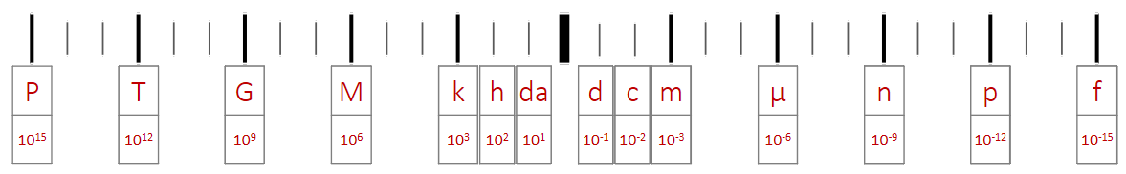

Dimensional Analysis
Convert the following:
20 mi hr⁻¹ m s⁻¹
$$\frac{20 mi}{1 hr}×\frac{1609 m}{1 mi}×\frac{1 hr}{60 min}×\frac{1 min}{60 s}=8.9\frac{m}{s}=8.9 m s^{-1}$$

0.0007 km² m²
$0.0007 {km}^{2}×\frac{1000 m}{1 km}×\frac{1000 m}{1 km}=700 m^{2}$ or $0.0007 {km}^{2}×{\left(\frac{1000 m}{1 km}\right)}^{2}=700 m^{2}$

Determine the units for Q:
Q = mc ΔT  $$Q=\left(kg\right)\left(J {kg}^{-1} K^{-1}\right)\left(K\right)=\frac{\left(kg\right)\left(J\right)\left(K\right)}{kg K}=J$$ |  |  | m (mass) | kg
 |  |  | c (specific heat) | J kg⁻¹ K⁻¹
 |  |  | ΔT (change in temp) | K
 | Scalar | Vector
How far (m) | Distance | Displacement
How fast (m s⁻¹) | Speed | Velocity

 | Displacement vs Time | Velocity vs Time | Acceleration vs Time
Meaning of the Graph | Slope:  Velocity | Slope:  Acceleration  Area under the Curve:  Displacement | Area under the Curve:  Velocity
Constant Displacement |  | 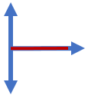 | 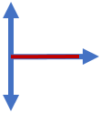
Constant Positive Velocity |  | 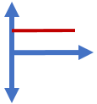
Constant Negative Velocity | 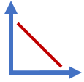 | 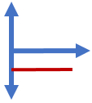
Constant Positive Acceleration  (speeding up) |  | 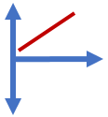 | 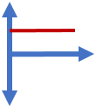
Constant Negative Acceleration  (slowing down) | 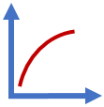 | 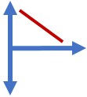 | 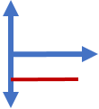

 | Variable Symbol | Unit |  | Kinematic Equations | s | u | v | a | t
Displacement | s | m |  | $$v=u+at$$ |  | ✔️ | ✔️ | ✔️ | ✔️
Initial Velocity | u | m s⁻¹ |  | $$s=ut+\frac{1}{2}at^{2}$$ | ✔️ | ✔️ |  | ✔️ | ✔️
Final Velocity | v | m s⁻¹ |  | $$v^{2}=u^{2}+2as$$ | ✔️ | ✔️ | ✔️ | ✔️
Acceleration | a | m s⁻² |  | $$s=\frac{\left(v+u\right)t}{2}$$ | ✔️ | ✔️ | ✔️ |  | ✔️
Time | t | s

Horizontal Component | $$A_{H}=A\cos{θ}$$ | 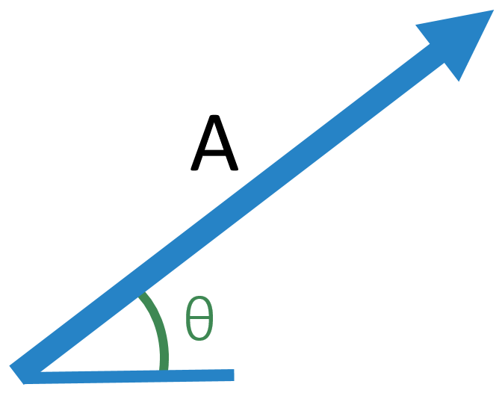
Vertical Component | $$A_{V}=A\sin{θ}$$

 | Vertical | 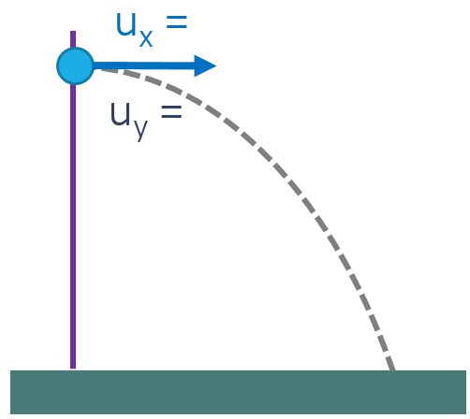
s
u | 0 m s⁻¹
v
a | -9.81 m s⁻²
t

 | Vertical | 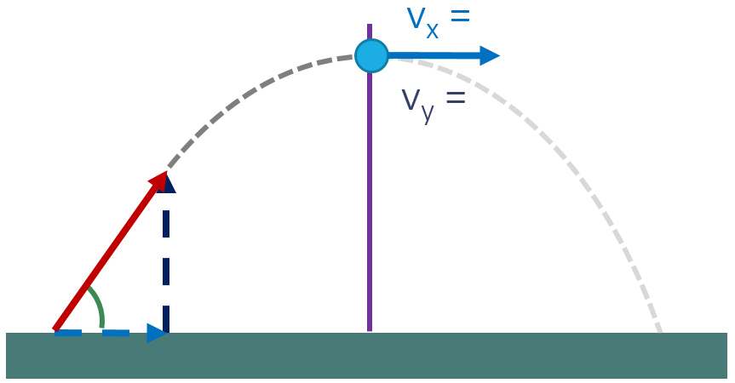
s
u | u sinθ
v | 0 m s⁻¹
a | -9.81 m s⁻²
t

