Motion | IB Physics Content Guide

Big Ideas
- Motion is described relative to a chosen coordinate system.
- Displacement-time, velocity-time, and accel-time graphs are connected in the representation of physical motion.
- When an object is at constant velocity, displacement-time is linear.
- When an object is at constant acceleration, displacement-time is quadratic (curved), and velocity-time is linear.
- Kinematic equations can take three of the suvat variables to solve for the remaining two
- Vector quantities can be combined to find resultant vectors or divided into their component parts
- X and Y motion are independent of each other for a two-dimensional projectile

Content Objectives

1 – Units
I can describe the difference between quantitative and qualitative observations
I can identify the 7 Fundamental SI units
I can define and give an example of a derived unit
I can represent fractional units with negative exponents
I can convert metric units between prefixes
I can convert fraction units and exponential units using Dimensional Analysis
I can use dimensional analysis to verify a formula
I can use dimensional analysis to determine the units for a solution
I can represent large and small numbers using scientific notation
I can compare quantities by orders of magnitude

2 – Displacement Graphs
I can describe the difference between distance and displacement
I can calculate distance and displacement for 1D motion
I can plot constant velocity on a displacement vs time graph
I can plot changing velocity on a displacement vs time graph
I can use a d vs t graph to identify if an object is moving in the positive/negative/speeding/slowing

3 – Velocity Graphs
I can describe the difference between speed and velocity
I can compare the difference between a vector and scalar quantity
I can plot constant velocity on a velocity vs time graph
I can plot changing velocity on a velocity vs time graph
I can use a v vs t graph to identify if an object is moving in the positive/negative/speeding/slowing
I can define acceleration in terms of velocity

4 – Calculating from Graphs
I can use an equation to calculate average speed/velocity
I can calculate instantaneous velocity using the slope of a displacement vs time graph
I can calculate instantaneous acceleration using the slope of a displacement vs time graph
I can calculate overall displacement using the area of a velocity vs time graph

5 – The Kinematic Equations
I can identify the 5 primary variables of accelerating motion (suvat)
I can identify the proper kinematic equation to use for a problem that is presented
I can rearrange to solve for the unknown variable
I can calculate for an unknown using the kinematic equations

6 – Free Fall
I can identify the constant acceleration due to gravity neglecting air resistance
I can interpret a free fall problem to identify hidden values and understand
I can use the kinematic equations to solve free fall problems
I can experimentally determine the acceleration due to gravity

7 – Horizontal Projectiles
I can add and subtract vectors to find a resultant
I can calculate an angle from two components of a right triangle
I can calculate the x and y components of a vector given the magnitude and angle
I can identify hidden values for a horizontal projectile problem
I can use information about a horizontal projectile’s motion to calculate the initial velocity
I can use the x and y velocity components to calculate a projectile’s impact velocity and angle

8 – Projectile Motion
I can identify hidden values for a projectile launched at an angle
I can calculate the x and y components for an initial velocity at an angle
I can calculate max height for a projectile launched at angle
I can calculate distance traveled for a projectile launched at angle
I can calculate total air time for a projectile launched at angle

Motion | Shelving Guide

List the seven fundamental base units and their abbreviations:
 | Unit | Abbreviation
Length
Mass
Time
Electric Current
Temperature
Amount of Substance
Luminous Intensity

Metric Prefixes – List the unit prefixes in their appropriate decimal position
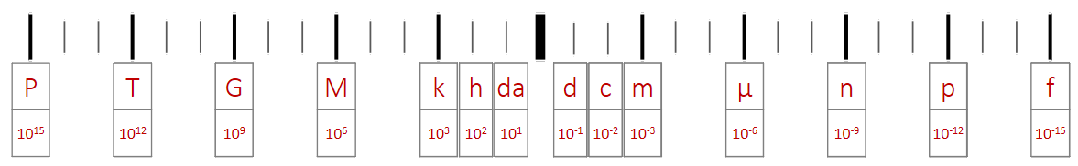

Dimensional Analysis
Convert the following:
20 mi hr⁻¹ m s⁻¹

0.0007 km² m²

Determine the units for Q:
Q = mc ΔT |  |  | m (mass) | kg
 |  |  | c (specific heat) | J kg⁻¹ K⁻¹
 |  |  | ΔT (change in temp) | K
 | Scalar | Vector
How far (m)
How fast (m s⁻¹)

 | Displacement vs Time | Velocity vs Time | Acceleration vs Time
Meaning of the Graph | Slope: | Slope:  Area under the Curve: | Area under the Curve:
Constant Displacement
Constant Positive Velocity
Constant Negative Velocity
Constant Positive Acceleration
(speeding up)
Constant Negative Acceleration
(slowing down)

 | Variable Symbol | Unit |  | Kinematic Equations | s | u | v | a | t
Displacement |  |  |  | $$v=u+at$$
Initial Velocity |  |  |  | $$s=ut+\frac{1}{2}at^{2}$$
Final Velocity |  |  |  | $$v^{2}=u^{2}+2as$$
Acceleration |  |  |  | $$s=\frac{\left(v+u\right)t}{2}$$
Time

Horizontal Component |  | 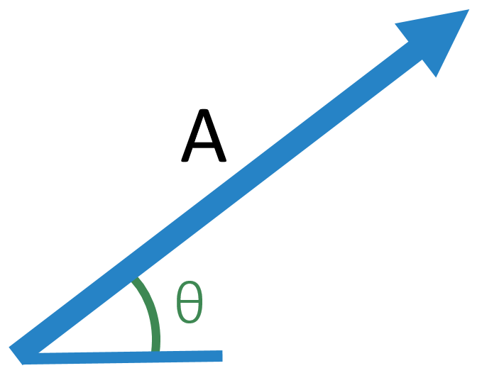
Vertical Component

 | Vertical | 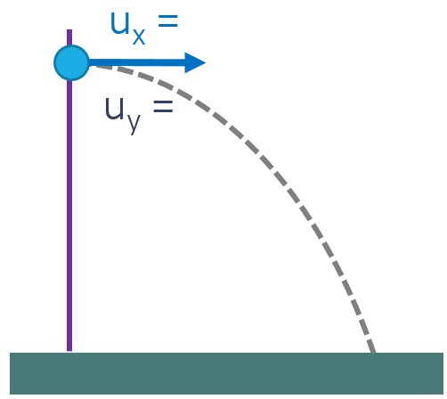
s
u
v
a
t

 | Vertical | 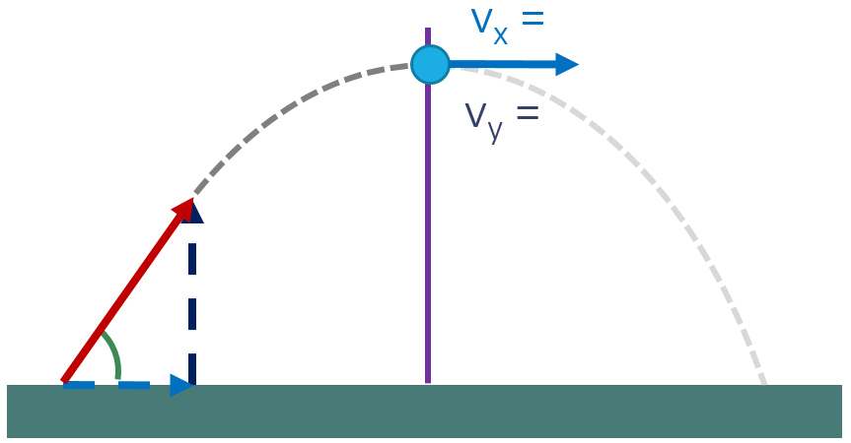
s
u
v
a
t

