Motion Design Problem
A ball is dropped from a bridge directly above a dot on the floor. At the same time, a constant velocity cart is released from its starting position with a path pointed at the same mark. The two objects make it to the dot at the exact same time.

- The ball accelerates due to gravity with negligible air resistance (assume free fall)
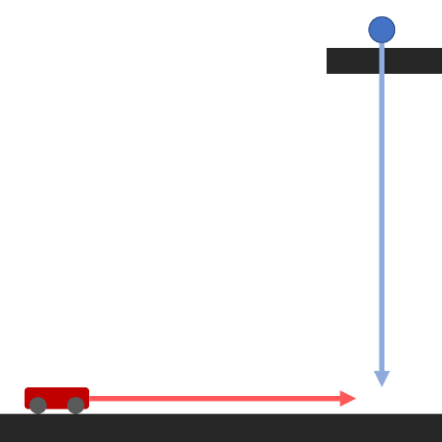
- The cart moves at a constant velocity in a straight line path from the moment it is released

Property | Range to Choose From | Selected Value
Height of the Ball | 2 m - 20 m
Cart Distance from Dot | 1 m - 15 m
Cart Velocity | 1.5 m/s - 5 m/s

Determine a set of three variables within the provided range that satisfy this situation. Show all work below and write final variable values in the table above.

