Quiz 2B: Graphing Motion Name: _____________________ Period: ___

Draw the corresponding graph for the following:
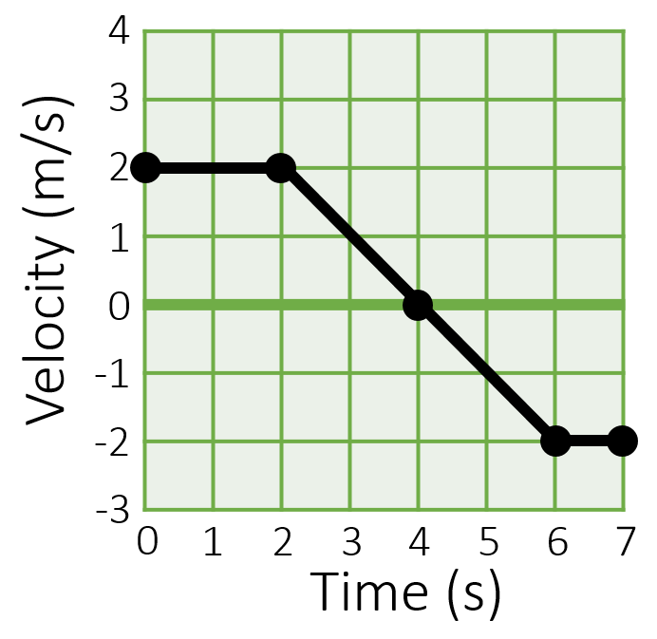
- What is the velocity at 1 second?

- What is the acceleration at 5 seconds?

- What is the displacement between 0-7 seconds?

Quiz 2B: Graphing Motion Name: _____________________ Period: ___

Draw the corresponding graph for the following:
- What is the velocity at 1 second?

- What is the acceleration at 5 seconds?

- What is the displacement between 0-7 seconds?

