2 | Motion | Review Name _________________________ Period ____
- Describe the difference between distance and displacement

- A snowboarder bombs straight down a hill starting from rest at the top, accelerating at a constant 2.6 m s⁻² for 4.5 seconds. Calculate the snowboarder’s displacement during this time.

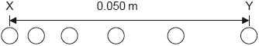
- A ball starts from rest and moves horizontally. Six positions of the ball are shown at time intervals of 1.0 ms. The horizontal distance between X, the initial position, and Y, the final position, is 0.050 m. What is the average acceleration of the ball between X and Y?
  - 2000 m s⁻²
  - 4000 m s⁻²
  - 5000 m s⁻²
  - 8000 m s⁻²

- A weather balloon is floating at a constant height above the earth when it releases a pack of instruments. If the pack hits the ground with a speed of 73.5 m s⁻¹, how high is the balloon?

- A ball is tossed vertically upwards with a speed of 5.0 m s^{–1}. After how many seconds will the ball return to its initial position?

- Calvin and Hobbes are in a treehouse 3.5 m directly above Susie. Hobbes decides to throw his balloon straight up with an initial speed of 8.5 m s⁻¹, how much time does Lucy have to move before it hits her feet? Draw a picture of the water balloon’s path and solve for total air time.

- An object is projected vertically upwards at time t = 0. Air resistance is negligible. The object passes the same point above its starting position at time 2 s and 8 s. If g = 10 m s⁻², What is the initial speed of the object?
  - 50
  - 30
  - 25
  - 4

- Sketch the corresponding velocity vs time graph:
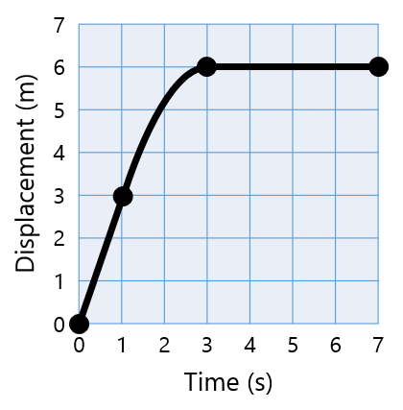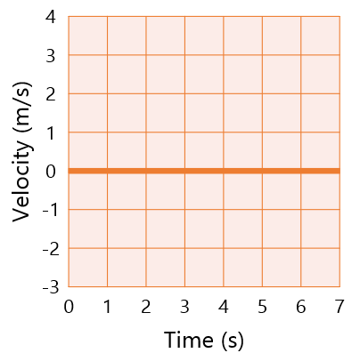

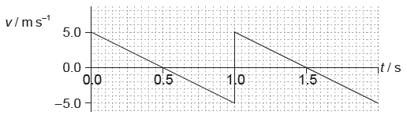
- An object is thrown upwards. The graph shows the variation with time t of the velocity v of the object. What is the total displacement at a time of 1.5 s, measured from the point of release?
  - 0 m
  - 1.25 m
  - 2.50 m
  - 3.75 m
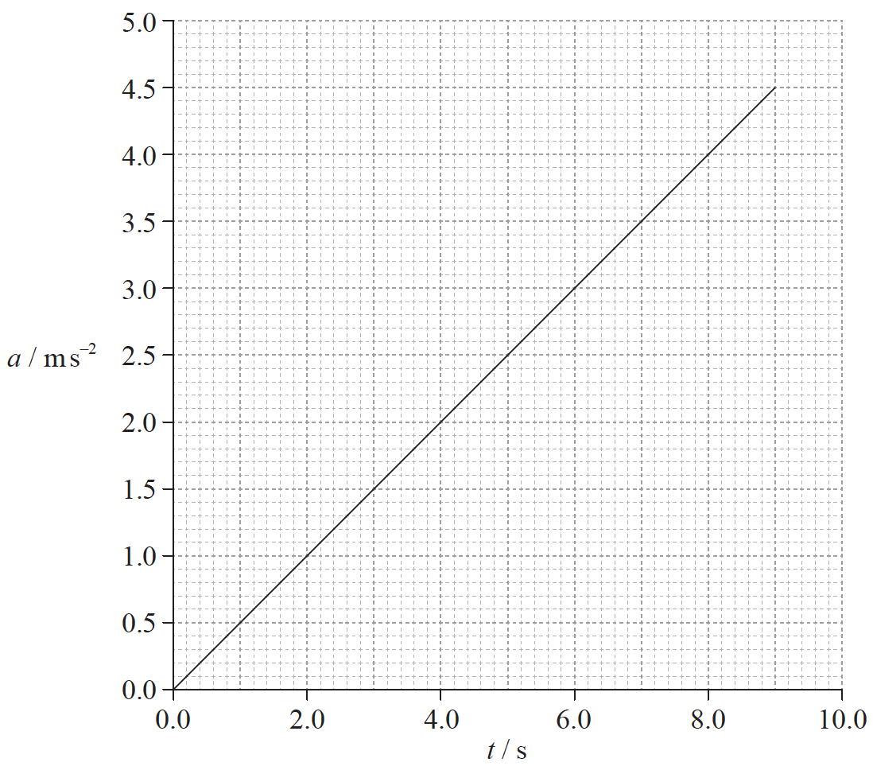
- A particle accelerates from rest. The graph shows how the acceleration a of the particle varies with time t. What is the speed of the particle at t = 6.0s?
  - 0.5 m s⁻¹
  - 2.0 m s⁻¹
  - 9.0 m s⁻¹
  - 18 m s⁻¹

- A ball is thrown from point X and follows path XYZ. Air resistance is negligible.
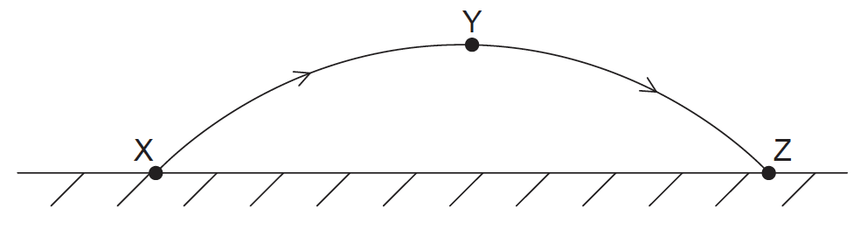
Which quantity is zero when the ball is at the highest point Y of the path?
  - The horizontal component of the ball’s acceleration
  - The vertical component of the ball’s acceleration
  - The horizontal component of the ball’s velocity
  - The instantaneous velocity of the ball

- The horizontal component v_{h} and the vertical component v_{v} of velocity of an object are shown on the graphs. Air resistance is negligible.
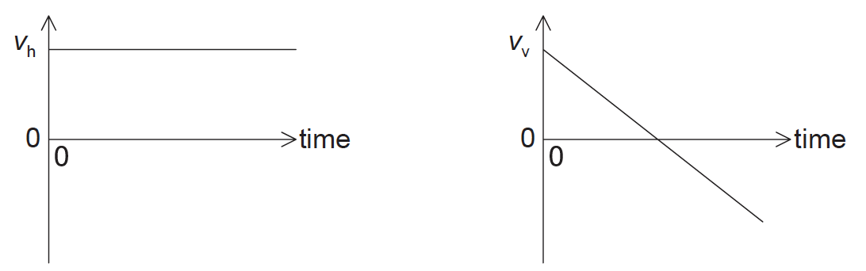
These graphs could represent the motion of an object fired from a cliff
  - vertically upwards
  - at an angle above the horizontal
  - horizontally
  - at an angle below the horizontal

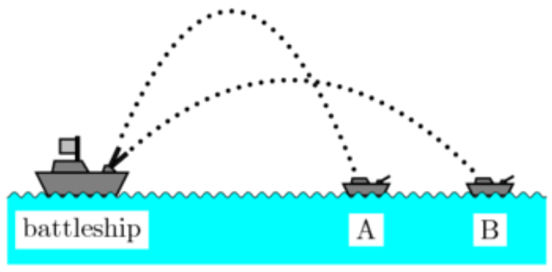
- The battleship and enemy ships A and B lie along a straight line. Neglect air resistance. A battleship simultaneously fires two shells at these two enemy ships. If the shells follow the parabolic trajectories shown in the figure, which ship gets hit first?
  - A
  - B
  - Both at the same time
  - Need more information

- Sally stands on the edge of a seaside cliff and kicks a rock over the edge with a horizontal speed of 23 m s⁻¹. The cliff is 37 m above the surface of the water. How far from the edge of the cliff will the rock hit the water?

- Sam hits a golf ball with an initial velocity of 35 m s⁻¹ at an angle of 21° off of the ground. How far away will the ball land?

