Part 1: Building Circuits
Build the circuits below and verify that it operates correctly by unscrewing each lightbulb one at a time and comparing the result with the table provided. Once the circuit set up has been confirmed, highlight the bulbs in the diagram to indicate if they are Bright, Medium, or Dim

Circuit 1
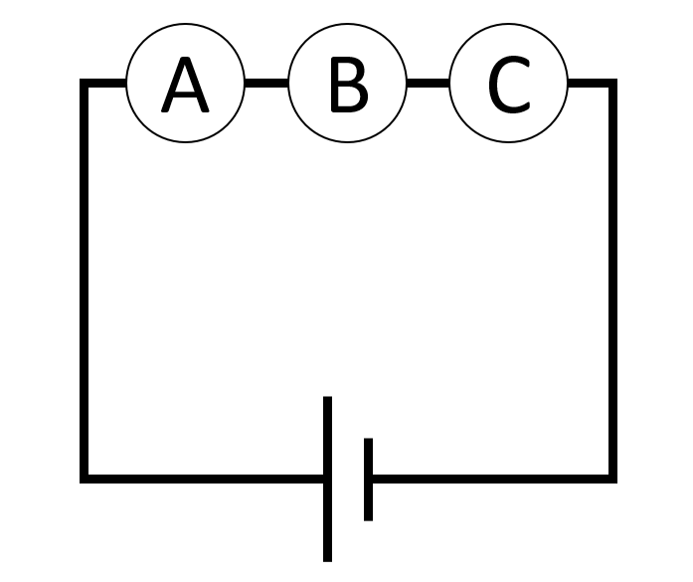 | Unscrew the lightbulb indicated in the far left column of the table the corresponding bulbs that also turn off are marked with an X  A B C  A out X X X  B out X X X  C out X X X

Circuit 2
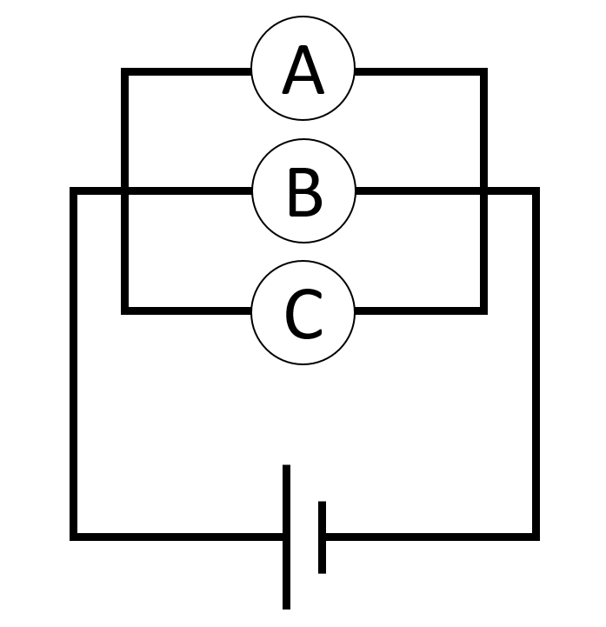 | Unscrew the lightbulb indicated in the far left column of the table the corresponding bulbs that also turn off are marked with an X  A B C  A out X  B out X  C out X

Circuit 3
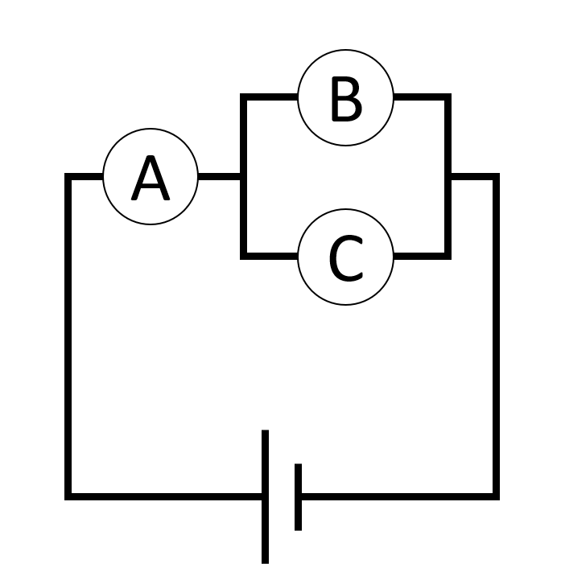 | Unscrew the lightbulb indicated in the far left column of the table the corresponding bulbs that also turn off are marked with an X  A B C  A out X X X  B out X  C out X

Build the circuits below and highlight the bulbs to indicate if they are Bright, Medium, or Dim

Circuit 4
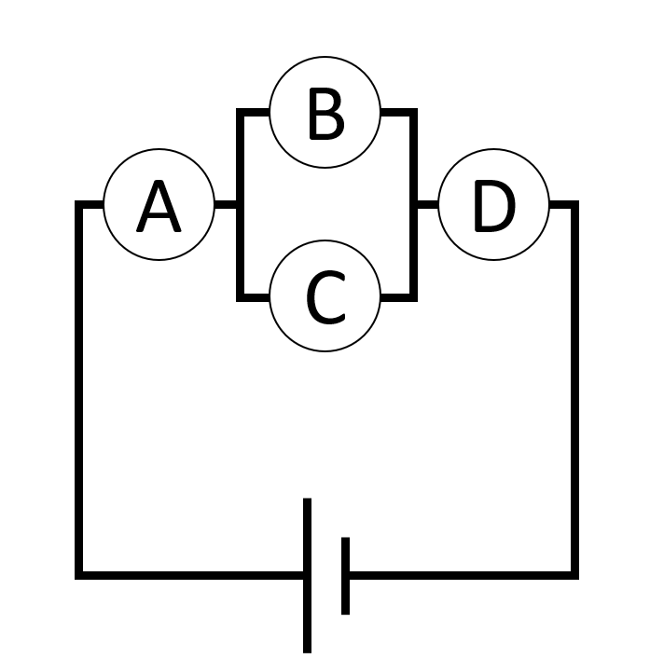 | Unscrew the lightbulb indicated in the far left column of the table the corresponding bulbs that also turn off are marked with an X  A B C D  A out X X X X  B out X  C out X  D out X X X X

Circuit 5
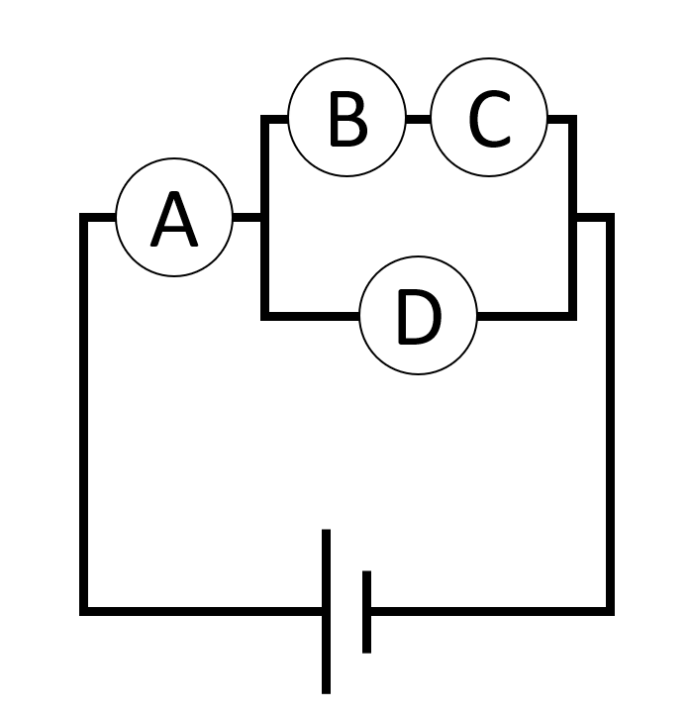 | Unscrew the lightbulb indicated in the far left column of the table the corresponding bulbs that also turn off are marked with an X  A B C D  A out X X X X  B out X X  C out X X  D out X

Circuit 6
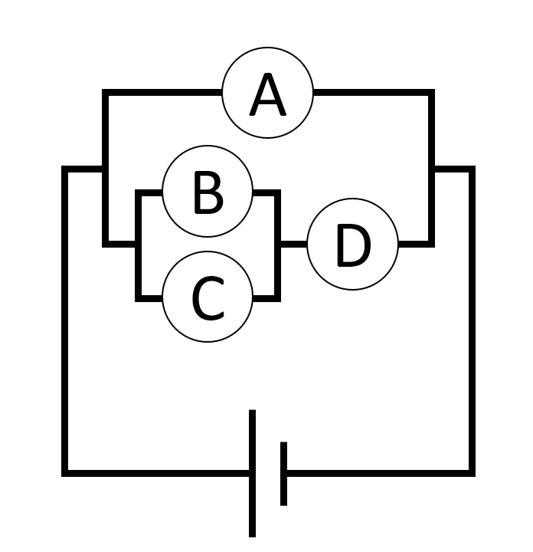 | Unscrew the lightbulb indicated in the far left column of the table the corresponding bulbs that also turn off are marked with an X  A B C D  A out X  B out X  C out X  D out X X X

Part 2: Measuring Circuits
Build the following two circuits to learn how to use the voltmeter and ammeter
Voltmeter  - Set the meter to the “5V” setting  - Connect contacts “across” the component that you wish to measure the voltage for  - This voltmeter only measures in the positive direction so if the needle doesn’t move, try flipping the meter or the power supply  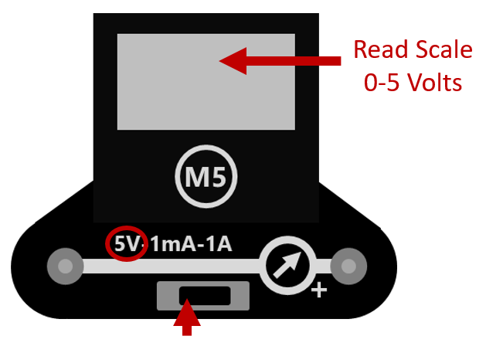 |  | 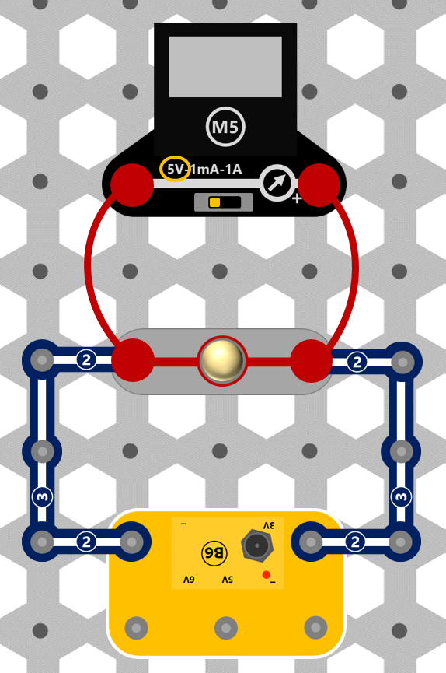
Measured Voltage
Ammeter  - Set the meter to the “1A” setting  - Connect contacts “in line” with the component that you wish to measure the current for  - This ammeter only measures in the positive direction so if the needle doesn’t move, try flipping the meter or the power supply  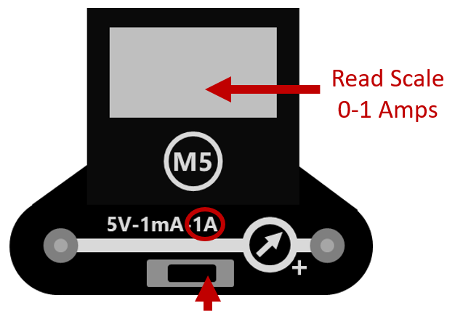 |  | 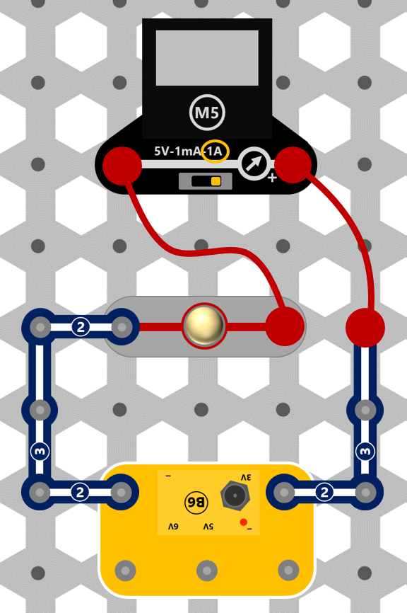
Measured Current

Setting up the Voltage
The power supply has three different settings to produce voltage. See the diagram below for the contacts to use to produce 3, 5, and 6 volts.

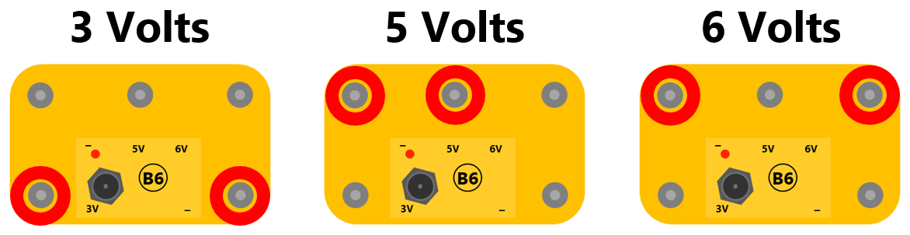

Circuit 1
Build the circuit below and take the following measurements | Measure the voltage using the Voltmeter
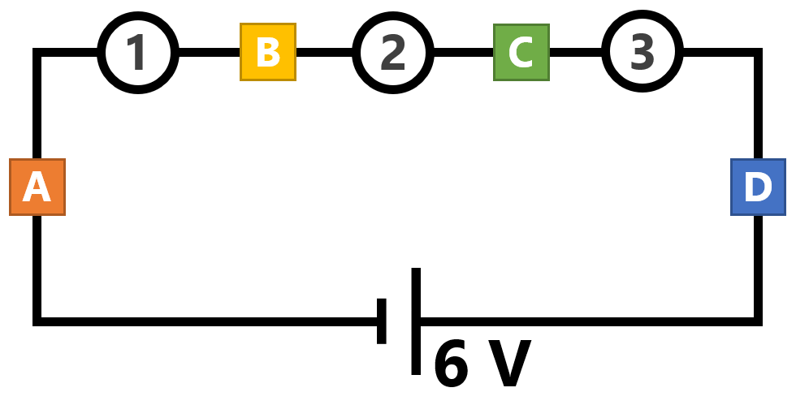 | Voltage across 1
 | Voltage across 2
 | Voltage across 3
 | Measure the current using the Ammeter
 | Current at point A
 | Current at point B
 | Current at point C
 | Current at point D

Circuit 2
Build the circuit below and take the following measurements | Measure the voltage using the Voltmeter
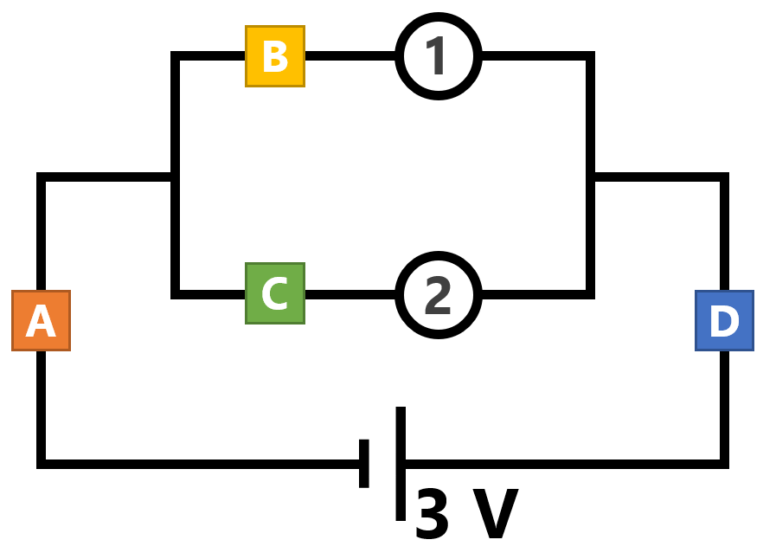 | Voltage across R₁
 | Voltage across R₂
 | Measure the current using the Ammeter
 | Current at point A
 | Current at point B
 | Current at point C
 | Current at point D

