Thermal Physics | IB Physics Content Guide

Big Ideas
- The macroscopic effects of volume, pressure, and temperature can be understood with a microscopic model
- Kinetic Energy on a molecular level is observed as temperature and heat
- The heat required to change the temperature or phase of a material is a property of the material itself
- The properties of an ideal gas are proportional to each other and can be calculated under certain conditions

Content Objectives

1 – Heat vs Temperature
I can explain the relationship between temperature and molecular kinetic energy
I can describe the energies present in an object’s total internal energy
I can convert between Celsius and Kelvin
I can describe the nature of molecules when at a temperature of absolute zero
I can compare temperature (average KE) and heat (total KE)
I can describe the molecular process that allows heat to flow

2 – Specific Heat
I can define specific heat capacity with proper units
I can describe the effect of larger or smaller specific heat values
I can relate specific heat capacity to the heat energy and temperature change
I can describe how a calorimeter uses the conservation of heat to study a material’s specific heat
I can experimentally determine the specific heat capacity of a material

3 – Latent Heat
I can identify key features in a material’s heating curve
I can describe why a heating curve plateaus during phase changes
I can describe the different ways that the heat added to a system can become internal energy
I can define specific latent heat with proper units
I can calculate the heat required to cause a certain amount of a substance to change phases
I can compare the processes of evaporation and boiling

4 – Kinetic Gas Theory and The Mole
I can describe the conditions necessary for a substance to be considered an ideal gas
I can define pressure with appropriate fundamental and derived units
I can relate average molecular kinetic energy with absolute temperature
I can calculate the average molecule speed for a molecule at a certain temperature
I can discuss how the mass of a molecule changes its overall speed at a given temperature
I can describe the importance of having a large quantity like the “mole” defined
I can identify the difference between different isotopes of an element
I can calculate an atom’s mass number when given the number of protons and neutrons
I can use the average atomic weight of an element to convert between mass and moles

5 – Gas Laws
I can identify conditions when a substance is no longer considered an ideal gas
I can describe the relationship between volume and pressure for an ideal gas (Boyle’s Law)
I can describe the relationship between temperature and pressure for an ideal gas (Pressure Law)
I can describe the relationship between temperature and volume for an ideal gas (Charles’s Law)
I can use the Ideal Gas Law to solve for pressure, volume, amount, or temperature
I can use the Ideal Gas Law to describe how changing one or more variable(s) would affect another

Thermal Physics | Shelving Guide

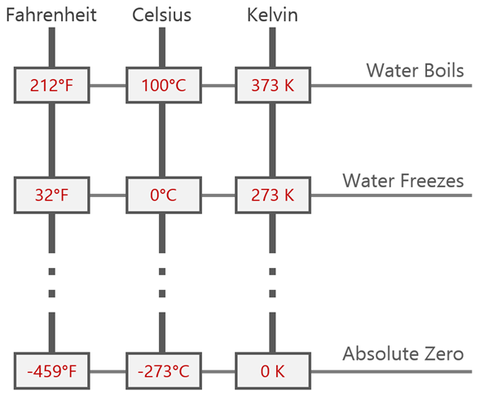 | Data Booklet Equation:  $$Temperature \left(K\right)=Temperature \left(°C\right)+273$$
Conditions for Absolute Zero:

Molecules stop moving. This is the coldest possible temperature.

Absolute Zero = 0 K = -273 K

Specific Heat Capacity and Specific Latent Heat
 | Variable Symbol | Unit |  | Data Booklet Equations:
Heat Energy | Q | J |  | $$Q=mc∆T$$
Mass | m | kg
Specific Heat Capacity | c | J kg⁻¹ K⁻¹ |  | $$Q=mL$$
Change in Temperature | ΔT | K
Specific Latent Heat | L | J kg⁻¹

E_{K} | Kinetic Energy Temperature |  | E_{P} | Potential Energy Phase Change

Heating Curves
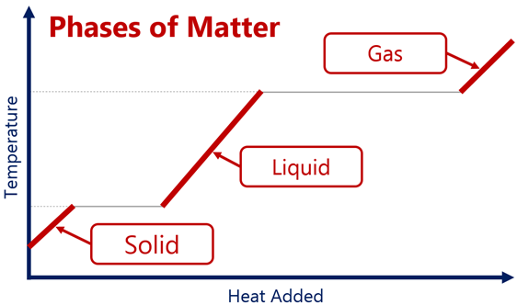 |  |  | 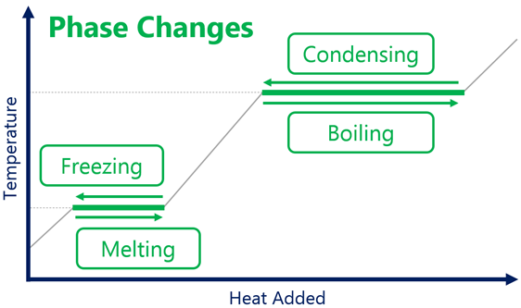
Pressure | Variable Symbol | Unit |  |  |  | Data Booklet Equation:
Force | F | N |  |  |  | $$p=\frac{F}{A}$$
Area | A | m²
Pressure | p | N m⁻² |  | Pa

Kinetic Theory and Temperature
 | Variable Symbol | Unit |  | Data Booklet Equation:
Average Kinetic Energy | $${\overline{E}}_{k}$$ | J |  | $${\overline{E}}_{K}=\frac{3}{2}k_{B}T=\frac{3}{2} \frac{R}{N_{A}}T$$
Absolute Temperature | T | K
Boltzmann’s Constant | k_{b} | J K⁻¹ |  | $k_{B}$ = 1.38 × 10⁻²³ J K⁻¹

Avogadro’s Number | N_{A} | 6.02 × 10²³

Ideal Gas Law | Variable Symbol | Unit |  | Data Booklet Equations:
Pressure | p | Pa |  | $$pV=nRT$$ | $R$ = 8.31 J K⁻¹ mol⁻¹
Volume | V | m⁻³ |  | Conditions for Ideal Gases:
Number of Molecules | n | mol
Gas Constant | R | J K⁻¹ mol⁻¹
Temperature | T | K

Ideal Gas Relationships
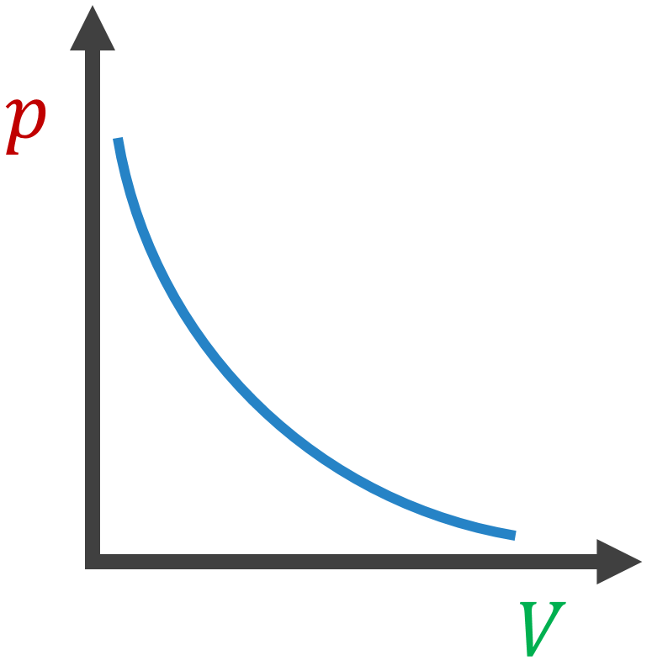 | 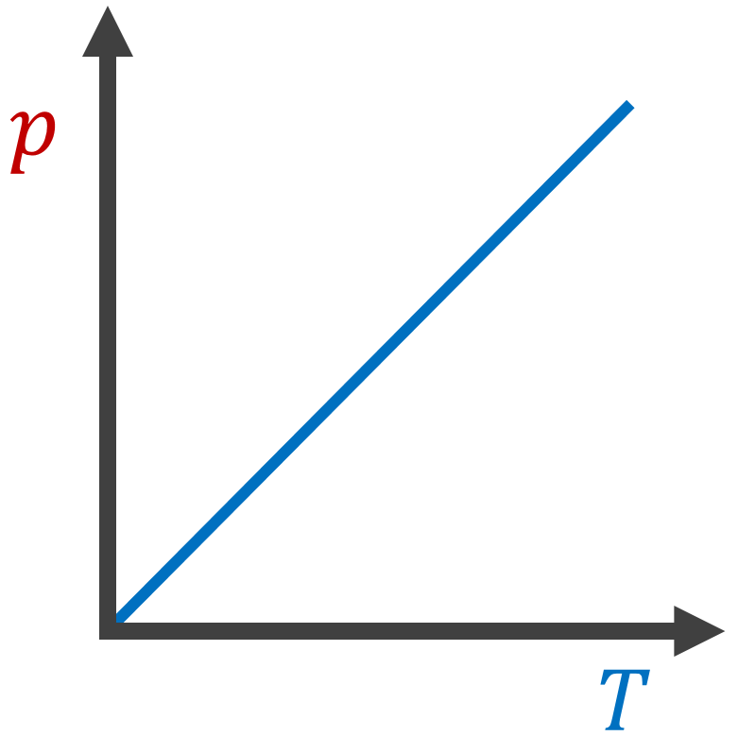 | 