Waves - Sound | IB Physics Content Guide

Big Ideas
- Simple harmonic motion is a repeating relationship between an object’s position, velocity, and acceleration
- Waves are formed and transferred by particles oscillating in a medium
- All waves have properties can be measured and mathematically related
- Instruments resonate at specific frequencies due to the number of standing waves that fit in the length of the system
- Waves can occupy the same space at the same space to create constructive or destructive interference

Content Objectives

1 – Simple Harmonic Motion
I can qualitatively describe the motion of an oscillating system
I can relate the acceleration of an object in simple harmonic motion to its position
I can graph the displacement, velocity, and acceleration vs time for simple harmonic motion
I can interpret an SHM graph to describe the conditions at a specific point in an object’s motion
I can describe and relate the properties of period and frequency
I can calculate period and frequency from a scenario
I can qualitatively describe the energy changes that take place during an oscillation

2 – Properties of Traveling Waves
I can describe how waves carry energy through a medium
I can compare the properties of transverse and longitudinal waves
I can read a wave’s amplitude, wavelength, period, and frequency from a graph
I can label a graph with the location of a wave’s crest/compression and trough/rarefaction
I can describe the number of complete wavelengths represented in a picture
I can use the wave speed equation to mathematically relate speed, wavelength, and frequency
I can relate pitch and frequency for sound waves

3 – Sound
I can describe why sound travels at different speeds in different media
I can calculate how far a distant object is by timing an echo
I can describe the motion of a standing wave
I can identify and label the node and antinodes on a standing wave diagram

4 – Instruments
I can identify and label the node and antinodes on a standing wave diagram
I can describe the end conditions and nodes/antinodes for open/closed pipes and vibrating strings
I can calculate the wavelength or instrument length of a standing wave for different harmonics

5 – Wave Interference
I can qualitatively and quantitatively interpret cases of constructive and destructive interference
I can add up two waves with superposition to create a new waveform
I can describe applications and real-world examples for wave interference
I can use wavelength and source distance to identify maxima and minima for interference

Waves - Sound | Shelving Guide

 | Variable Symbol | Unit |  | Data Booklet Equations:
Period | T | s |  | $$T=\frac{1}{f}$$
Frequency | f | Hz
Wavelength | λ | m |  | $$c=fλ$$
Amplitude | A | m
Wave Speed | v | m s⁻¹

Simple Harmonic Motion Graphs
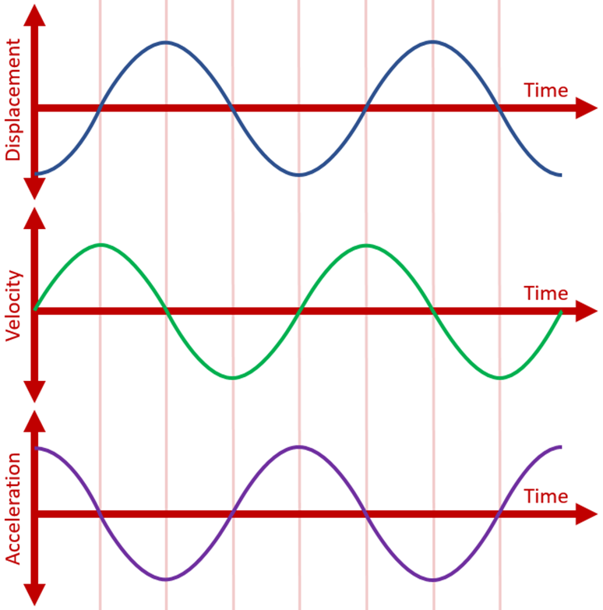 |  |  | Velocity vs Displacement  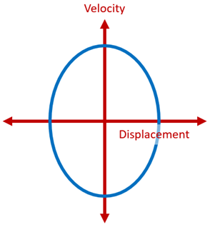

Accel. vs Displacement

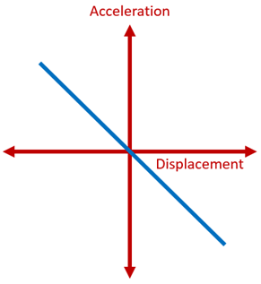
Types of Waves | Picture | Definition |  | Examples
Transverse |  | Particles move perpendicular to the motion of the wave |  | - Light  - Ripples in a Pond  - Earthquakes
Longitudinal |  | Particles move parallel  to the motion of the wave |  | - Sound  - Earthquakes

Parts of a Wave
Label the Wave:  - Amplitude  - Wavelength  - Crest  - Trough | 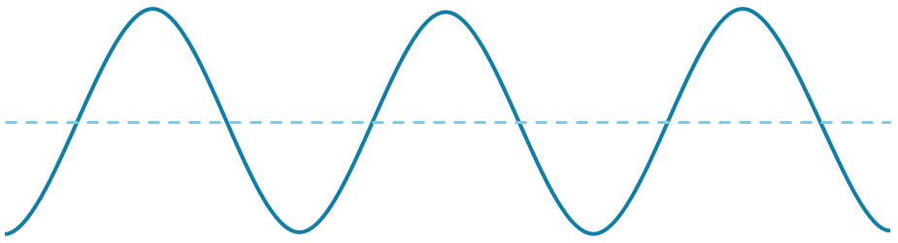

Harmonics
 | Open Pipe |  | Closed Pipe |  | String
End Conditions | Antinode | Antinode | Node | Antinode | Node | Node
3rd Harmonic | 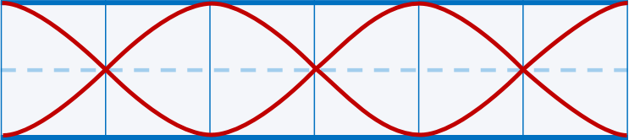 |  | 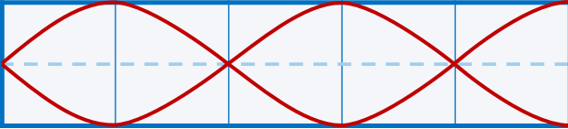 |  | 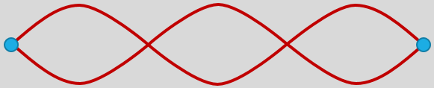
 | $$L=\frac{3}{2} λ$$ |  | $$L=\frac{5}{4} λ$$ |  | $$L=\frac{3}{2} λ$$
2nd Harmonic | 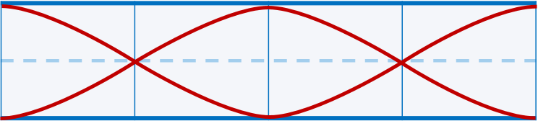 |  | 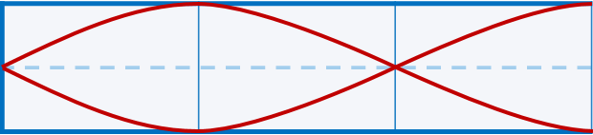
 | $$L=1 λ$$ |  | $$L=\frac{3}{4} λ$$ |  | $$L=1 λ$$
1st Harmonic  (Fundamental) | 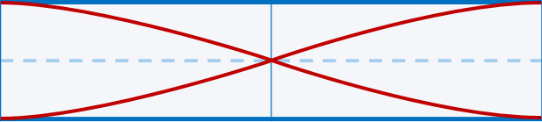 |  | 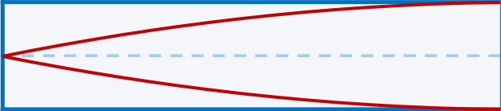
 | $$L=\frac{1}{2} λ$$ |  | $$L=\frac{1}{4} λ$$ |  | $$L=\frac{1}{2} λ$$

Interference
Constructive | Path Difference = n λ | Destructive | Path Difference = (n + ½) λ
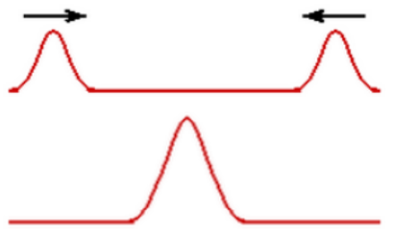 |  | 