Waves - Sound | IB Physics Content Guide

Big Ideas
- Simple harmonic motion is a repeating relationship between an object’s position, velocity, and acceleration
- Waves are formed and transferred by particles oscillating in a medium
- All waves have properties can be measured and mathematically related
- Instruments resonate at specific frequencies due to the number of standing waves that fit in the length of the system
- Waves can occupy the same space at the same space to create constructive or destructive interference

Content Objectives

1 – Simple Harmonic Motion
I can qualitatively describe the motion of an oscillating system
I can relate the acceleration of an object in simple harmonic motion to its position
I can graph the displacement, velocity, and acceleration vs time for simple harmonic motion
I can interpret an SHM graph to describe the conditions at a specific point in an object’s motion
I can describe and relate the properties of period and frequency
I can calculate period and frequency from a scenario
I can qualitatively describe the energy changes that take place during an oscillation

2 – Properties of Traveling Waves
I can describe how waves carry energy through a medium
I can compare the properties of transverse and longitudinal waves
I can read a wave’s amplitude, wavelength, period, and frequency from a graph
I can label a graph with the location of a wave’s crest/compression and trough/rarefaction
I can describe the number of complete wavelengths represented in a picture
I can use the wave speed equation to mathematically relate speed, wavelength, and frequency
I can relate pitch and frequency for sound waves

3 – Sound
I can describe why sound travels at different speeds in different media
I can calculate how far a distant object is by timing an echo
I can describe the motion of a standing wave
I can identify and label the node and antinodes on a standing wave diagram

4 – Instruments
I can identify and label the node and antinodes on a standing wave diagram
I can describe the end conditions and nodes/antinodes for open/closed pipes and vibrating strings
I can calculate the wavelength or instrument length of a standing wave for different harmonics

5 – Wave Interference
I can qualitatively and quantitatively interpret cases of constructive and destructive interference
I can add up two waves with superposition to create a new waveform
I can describe applications and real-world examples for wave interference
I can use wavelength and source distance to identify maxima and minima for interference

Waves - Sound | Shelving Guide

 | Variable Symbol | Unit |  | Data Booklet Equations:
Period |  |  |  | $$T=\frac{1}{f}$$
Frequency
Wavelength |  |  |  | $$c=fλ$$
Amplitude
Wave Speed

Simple Harmonic Motion Graphs
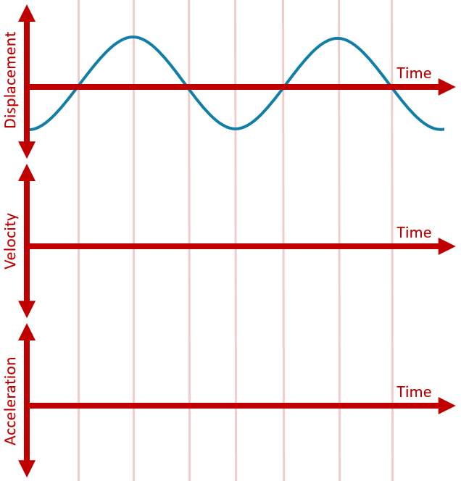 |  |  | Velocity vs Displacement
 |  |  | Accel. vs Displacement
Types of Waves | Picture | Definition |  | Examples
Transverse
Longitudinal

Parts of a Wave
Label the Wave:  - Amplitude  - Wavelength  - Crest  - Trough | 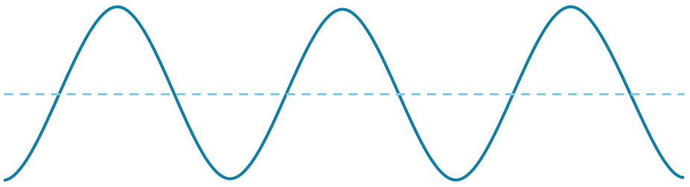

Harmonics
 | Open Pipe |  | Closed Pipe |  | String
End Conditions
3rd Harmonic
 | L = ( ) × λ |  | L = ( ) × λ |  | L = ( ) × λ
2nd Harmonic
 | L = ( ) × λ |  | L = ( ) × λ |  | L = ( ) × λ
1st Harmonic
(Fundamental)
 | L = ( ) × λ |  | L = ( ) × λ |  | L = ( ) × λ

Interference
Constructive | Path Difference = | Destructive | Path Difference =

